Make it in Mansfield strategy launch

Social media content

Post content | Accompanying Image
Thank you to everyone who helped to develop a new story for a successful Mansfield. We’re launching our new vision for a district where everyone can MAKE IT in life. We will BUILD communities, CREATE opportunities, GROW our economy and help you ENJOY life. Read more at www.makeitinmansfield.uk #MakeItInMansfield | 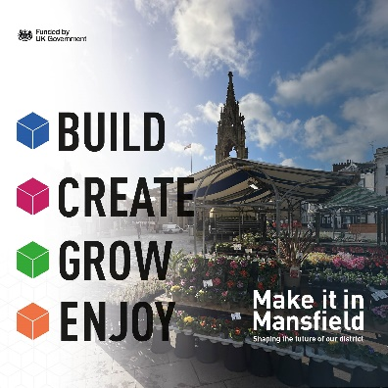
#MakeItInMansfield – a new strategy to BUILD strong and vibrant communities across the district of, so they have the ability, confidence and self-belief to make a positive difference  www.makeitinmansfield.uk | 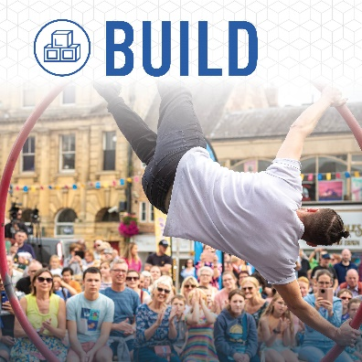
There’s a new vision for Mansfield – to CREATE a more equal district, where people have opportunities and are financially secure. #MakeItInMansfield  www.makeitinmansfield.uk | 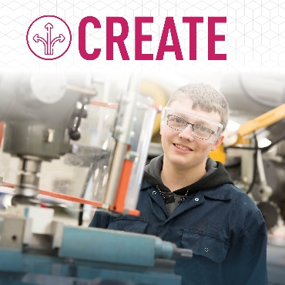
Learn about the new strategy to GROW Mansfield’s economy – creating more high value jobs and a more prosperous district. #MaketInMansfield  www.makeitinmansfield.uk | 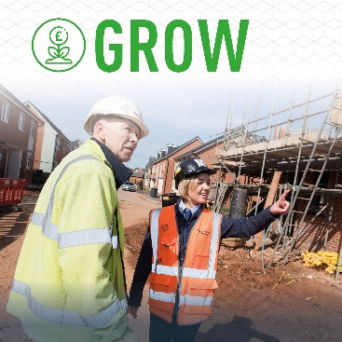
#MakeItInMansfield is the ambitious new vision for our district – where people in all our towns and villages can ENJOY a good quality of life and are supported to stay fit and well. www.makeitinmansfield.uk | 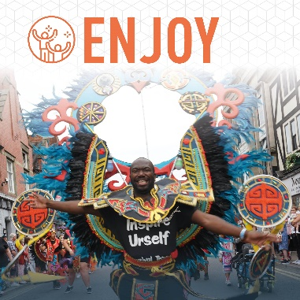
More opportunities and jobs, a more vibrant town centre, a better environment, more investment, more local pride. All part of the ambitious new vision for Mansfield.
www.makeitinmansfield.uk #MakeItInMansfield
Organisations and leaders have come together to develop a new vision for Mansfield’s future:  BUILD strong communities  CREATE opportunities  GROW our economy  …so that people can ENJOY life.  www.makeitinmansfield.uk  #MakeItInMansfield | 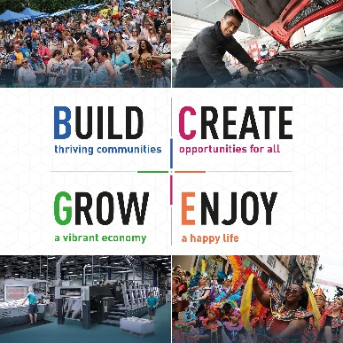
Creating opportunities is a key part of the new strategy for Mansfield. Find out more. www.makeitinmansfield.uk  #MakeItInMansfield | 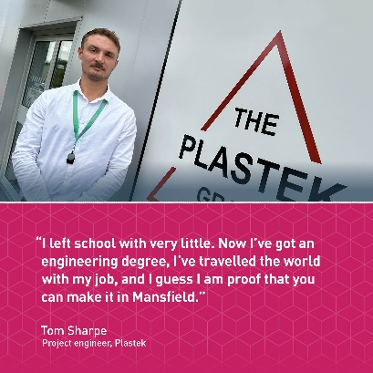
Family business Linney has been succeeding in Mansfield for over 170 years. It’s the district’s largest private sector employer, with around 1,000 staff.  See our vision for the future of Mansfield www.makeitinmansfield.uk  #MakeItInMansfield | 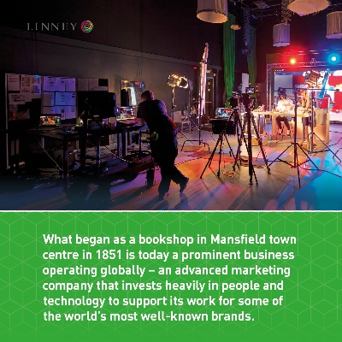
Charlotte Inkle helped to set up The Friends of Bellamy group in her community during the pandemic. Now it runs a wide range of activities, and helps families to see panto at @MansfieldPalace.  www.makeitinmansfield.uk  #MakeItInMansfield | 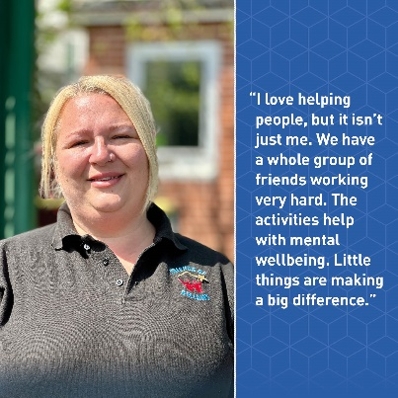
Rachel Richards shows how you can ‘make it in Mansfield’. After 20 years in social care, she launched award-winning @toffeehut. (on Insta, @Toffee Hut on FB) Now she has 2 local shops and a thriving online business selling toffees, fudge, lollies & other goodies.  www.makeitinmansfield.uk  #MakeItInMansfield | 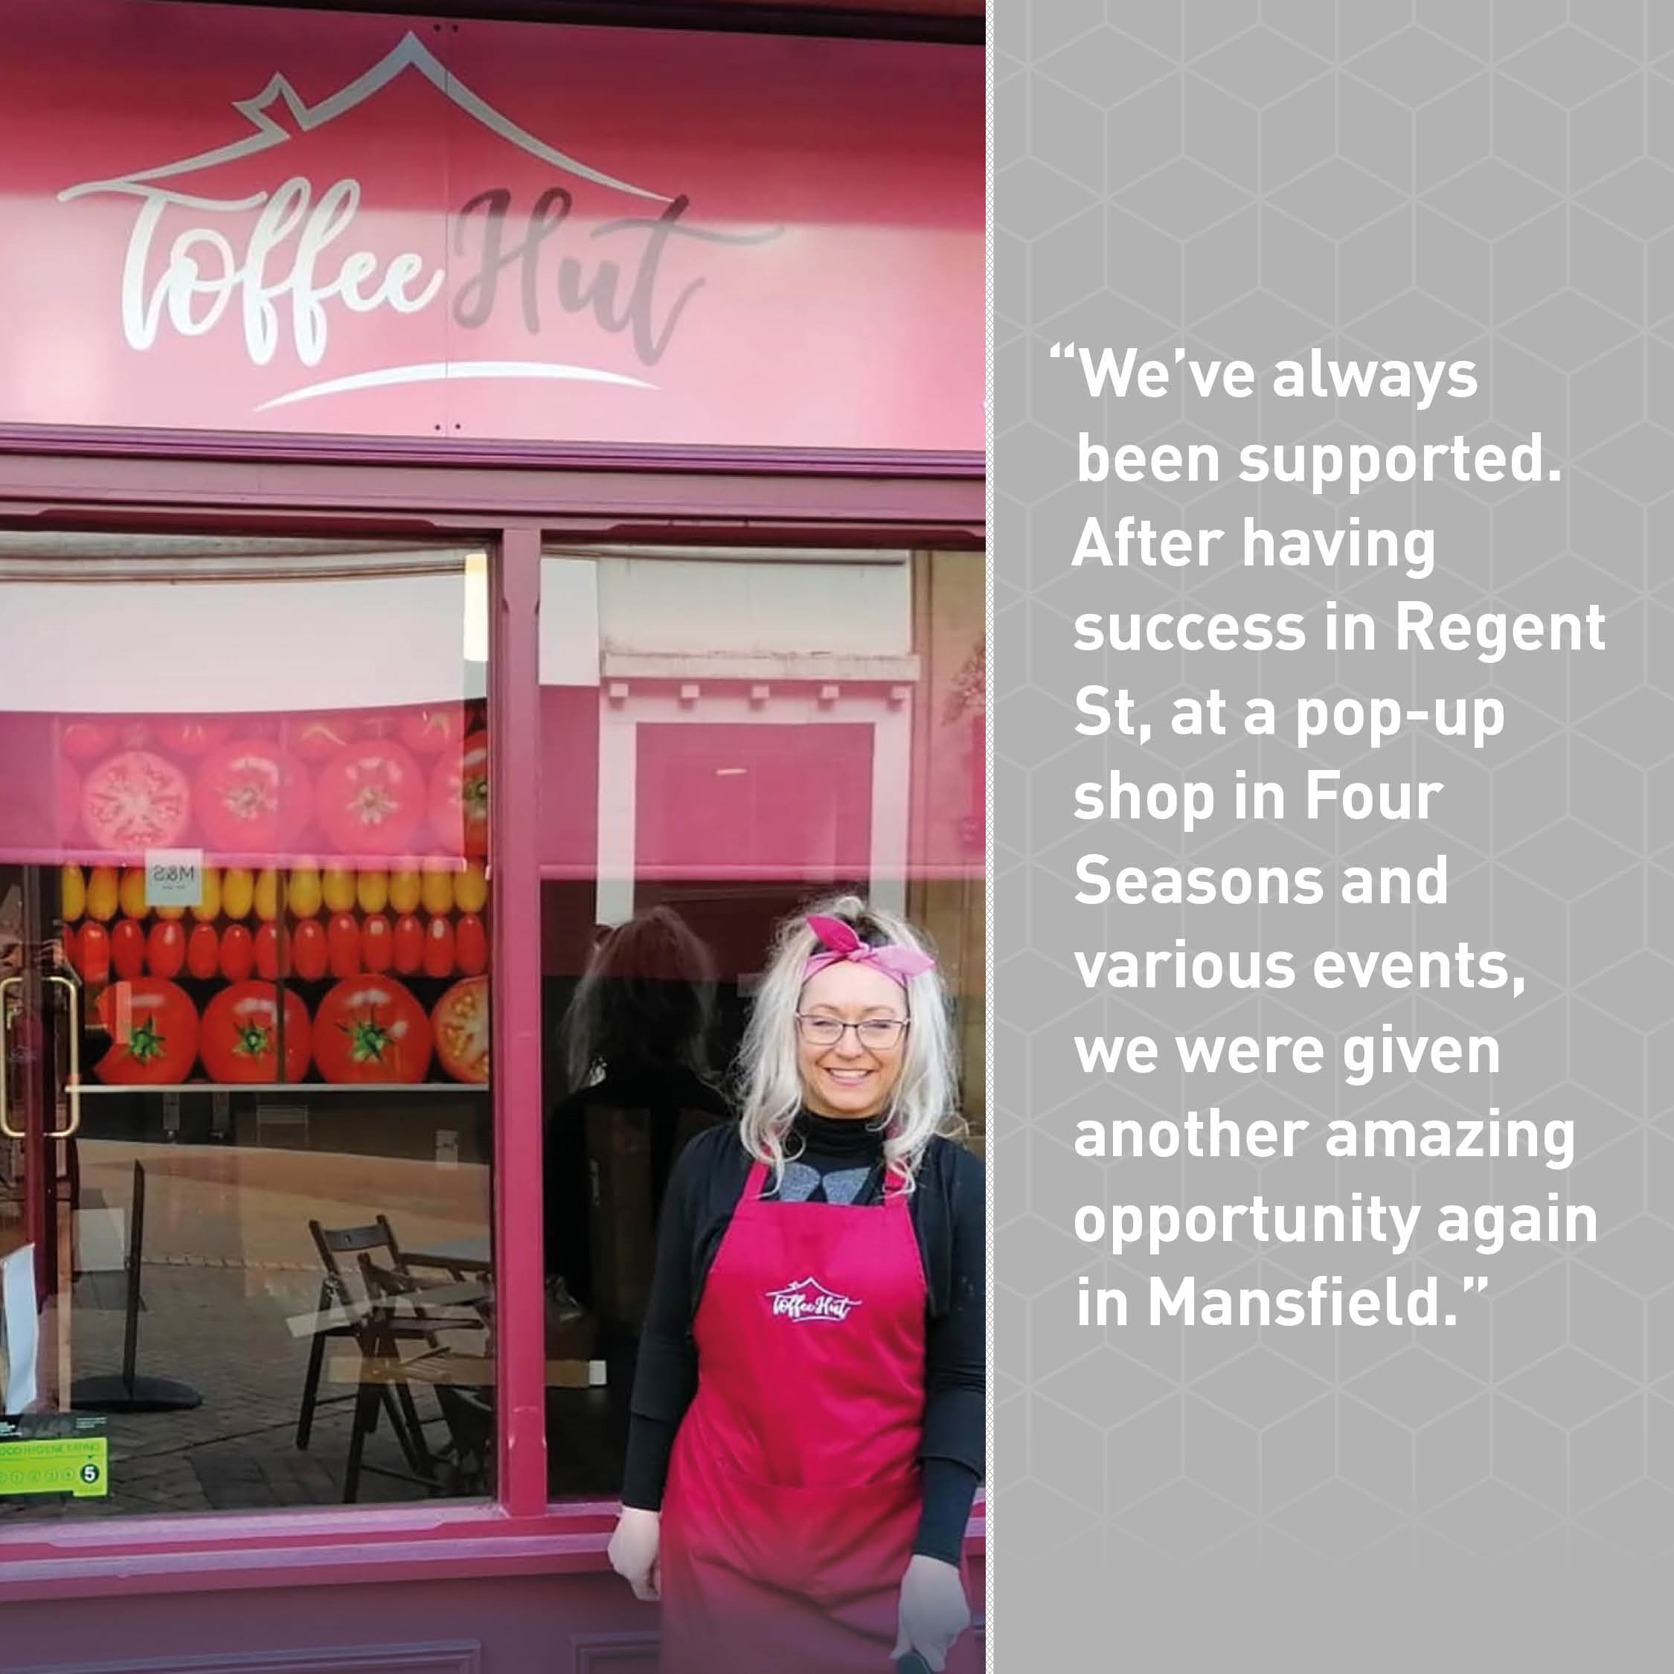
LinkedIn  There’s a major new vision for the future of Mansfield – a place where we can BUILD thriving communities, CREATE opportunities for all, GROW a vibrant economy and ENJOY a happy life.  It's been developed by the Mansfield Place Board, an alliance of leaders and organisations – including the Council, Mansfield and Ashfield 2020, Vision West Nottinghamshire College, Mansfield and Ashfield 2020, Mansfield Building Society (tag all these) and many more.  Read more here  www.makeitinmansfield.uk  MakeItInMansfield | 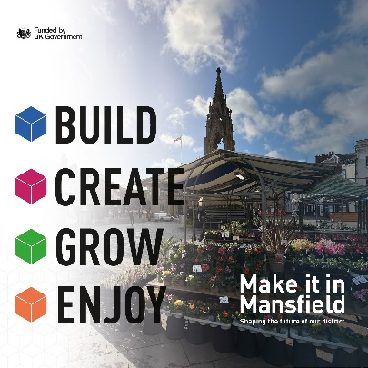
The Linney and Tom Sharpe case study tweets can also be used on Instagram with suitable tags (@plastek and @linney)

