
Key Issues and Perspectives: An Evidence Paper 2013/2014

Contents
Forward |  |  |  |  |  | Page 3
Part One: Resources |  |  |  |  |  | Page 4
Part Two: Context |  |  |  |  |  | Page 5
Part Three: Mansfield’s Housing |  |  |  |  |  | Page 14
Part Four: Mansfield’s People |  |  |  |  |  | Page 28

Figures
3.1: Breakdown of housing stock by tenure Page 14
3.2: % households living in private rented sector Page 15
3.3: Dwellings per council tax band Page 15
3.4: Comparison of level of vacant dwellings Page 16
3.5: Vacant dwellings in Mansfield Page 16
3.6: Total Number of new homes built Page 17
3.7: Sites that are suitable/available within 5 years Page 18
3.8: Average house prices Page 19
3.9: Pricing levels over time Page 20
3.10: Annual turnover by type and age Page 20
3.11: Annual turnover by type and age Page 21
3.12: rent levels in Mansfield Page 21
3.13: % difference between social / market rents Page 22
3.14: % of households priced out of the market Page 22
3.15: House price to income ratio Page 23
3.16: Supply and demand for social housing Page 23
3.17: Demand by bedroom size Page 24
3.19: Area of preference Page 25
4.1: 2008 sub national population projections Page 28
4.2: Household growth 1996 – 2006 Page 28
4.3: Household projections 2008 – 2033 Page 29
4.4: Population aged 16-64 Page 29
4.5: Economic activity Page 30
4.6: Economic activity - unemployed Page 30
4.7: Median weekly income Page 31
4.8: Need for adaptations Page 32
4.9: Moving intentions of households seeking support Page 32
4.10: Under occupancy / overcrowding Page 33
4.12: Number of people presenting as homeless Page 34
4.13: Total decisions/total accepted Page 34
4.14: Numbers presenting / numbers prevented Page 35

Forward
This document sets out a comprehensive overview of housing in Mansfield in 2013/2014. It is intended to provide the evidence base to Mansfield’s Housing Strategy 2014 to 2019 which describes the Council’s housing priorities for the coming five years.
The evidence paper sets housing in its policy context and takes account of the wide range of housing reforms introduced by the Coalition Government since 2010 including the Government’s Housing Strategy for England, the Localism Act 2011, the Welfare Reform Act 2012 and the Health and Social Care Act 2012.
In addition to the national context, the evidence paper also sets housing in its regional and local context taking into account housing’s supporting role and the contribution it makes to meeting the council’s priorities and statutory functions.
It uses a range of secondary information sources to build a comprehensive picture of housing including local statistical returns as well as national data sets. The document also uses primary data collated from the recent Housing Needs Survey to identify the housing aspirations and preferences of local households.

Part One: Resources
Regional Housing Pot
New Homes Bonus
Supporting People
Homelessness grant
DFG allowance
Affordable housing programme

Part Two: Context
National Policy
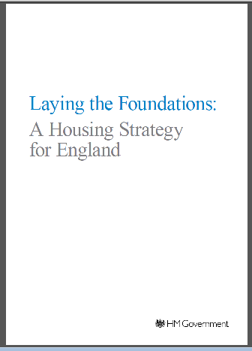
Laying the Foundations: The Housing Strategy for England

The Housing Strategy for England was launched on 21 November 2011. It sets out, in one overarching document, the Government’s plans to address problems in the country’s housing market through increasing the supply of homes, reforming social housing, supporting growth in the private rented sector, encouraging local authorities to bring empty homes back into use and improving choice and housing support. Much of the strategy restated policies that had already been announced, however, there were some new initiatives designed to breathe life into the country’s stagnant housing market. Among the most significant announcements were

- A new £400 million “get Britain Building” fund for small and medium sized developers whose developments had come to a halt due to uncertain market conditions
- Introduction of a mortgage indemnity scheme to provide 95% mortgages on new build homes for first time buyers struggling to secure mortgage finance through conventional means
- A comprehensive bidding process to encourage large scale, locally planned and community driven development
- Plans to release enough public sector land to build 100,000 new houses through a ‘buy now, pay later’ deal with developers
- Consultation on reducing the length of time that must elapse before developers can seek to renegotiate section 106 agreements with local planning authorities
- Proposals to reform stamp duty to support large scale investment in the buy to let market
- An allocation of £400 million for homelessness prevention and the launch of a ministerial working group to address the cause of homelessness
- A new deal for older peoples housing and encouraging local authorities to make proper provision for a wide range of housing types including specialised housing for older people.

Localism Act 2011
The Localism Act received Royal Assent on 16 November 2011. The Act sets out plans to give communities and local authorities greater5 powers and freedoms and introduces new Community Rights such as the Community Right to Challenge the delivery of local authority run services; the Community Right to Bid for assets of community value and the Community Right to Build small developments in their area without the need for planning permission. The Act also introduced a General Power of Competence for local authorities to do anything not specifically forbidden by law and paved the way for neighbourhood planning and directly elected mayors.

The Act also contains a number of Housing Reforms which have a direct impact on the Council’s local authority strategic housing role, including:

- Giving local authorities greater freedom to decide who is eligible to apply for social housing. More recently, the Government has issued new guidance for allocation schemes which amongst other provisions, gives greater priority for housing to ex-service men and women. The Homefinder allocations policy was reviewed in light of the new guidance
- Introduction of new fixed term tenancies for social housing tenants and requirements for the local authority to produce a Tenancy Strategy to guide Registered Providers in their use.
- The power for local authorities to discharge their statutory homelessness duty through an offer of accommodation in the private rented sector without the applicants consent.

The Act also changes the regulatory framework for Registered Providers by abolishing the Tenant Service Authority and placing greater emphasis on tenant involvement in regulation with the remaining regulatory functions transferring to the Homes and Community Agency (HCA)

Welfare Reform Act 2012.
The Welfare Reform Act received Royal Assent on 8 March 2012. The Act has been described as the biggest shake up of the benefits system in 60 years. It aims to simplify the system and create the right incentives to get people into work by ensuring that no individual is better off by not working. Key features of the Act e=will have the most significant impact on Mansfield’s residents are:

- Introduction of Universal Credit. The level of Universal Credit is to be capped at £26,000. While it is estimated that only a small number of Mansfield’s residents will see their income reduce as a result of the cap, some will be significantly affected. In addition, Housing Benefit is to be paid directly to tenants of social housing. There are fears that this will lead to an increase in rent arrears which, in turn, could lead to a rise in homelessness and could impact upon the ability of Registered Providers to secure private investment at competitive rates to maximise their capacity to deliver additional affordable housing
- Replacement of Disability Living Allowance with a Personal Independent Payment (PIP) for those of working age.
- Changes to Housing Benefit including the introduction of an under occupancy penalty for households whose homes are deemed to be too large for their needs. Described as the ‘Bedroom Tax’, this change has had an impact in Mansfield with approximately 800 social housing tenants being affected. The situation is compounded by a shortage of smaller properties in the District to facilitate downsizing. Changes to the Local Housing Allowance (LHA), most significantly the extension of the age threshold for the shared accommodation rate from 25 to 35. Private tenants will also be affected by plans to uprate the LHA by the Consumer Price Index rather than the Retail Price Index currently used.

It is too early to assess the impact of other reforms such as the ongoing assessment of incapacity benefit claimants against the stricter criteria of the Employment Support Allowance, changes to the Community Care Grants and Crisis Loans and forthcoming reforms.


National Planning Policy Framework
The new National Planning Policy Framework (NPPF) was published on 27 March 2012. It sets out, in a more condensed version of previous guidance, the Government’s planning policies and how it expects these to be applied and aims to simplify the country’s planning system to achieve sustainable development.

Affordable Rents
Affordable rent is the new rent model which the Homes and Communities Agency (HCA) expect that Registered Providers will adopt for new build housing for an agreed proportion of existing stock as it becomes vacant. Affordable rents are set at up to 80% of market rents in the area. The additional income raised through affordable rents is to be invested in new housing development and it is anticipated that it will help fund the shortfall as a result of significant cuts to the HCA National Affordable Housing Programme. This could lead to an increase in rent levels for some tenants and could result in a tow tier system whereby tenants in similar properties are paying different rents.

The Plan for Growth

The Plan for Growth was published alongside the 2011 budget and announced a programme of structural reforms to achieve the Government’s growth aims. The Government’s economic policy objective is to achieve strong, sustainable and balanced growth that is more evenly shared across the country and between industries. The Plan for Growth contains four overarching ambitions that will ensure the progress is made towards achieving this economic objective. The ambitions are:

- To create the most competitive tax system in the G20;
- To make the UK one of the best places in Europe to start, finance and grow a
business;
- To encourage investment and exports as a route to a more balanced economy; and
- To create a more educated workforce that is the most flexible in Europe.

Health and Social Care Act 2012
The Health and Social Care Act 2012 abolishes Primary Care Trusts (PCT) and transfers their commissioning responsibilities to the Clinical Commissioning Groups )CCG) Local Authorities are now required to establish Health and Wellbeing Boards to promote more joined up commissioning of health and social care and public health services. The Boards are responsible for the production of the Joint Strategic Needs Assessment which is the evidence base used to agree the priorities for the Health and Wellbeing Strategy. This helps to shape local health and social care commissioning plans.


Sub Regional Context
The Sherwood Forest Area Housing Strategy
Mansfield, Ashfield and Newark and Sherwood District Councils have worked successfully together on a number of housing related projects and initiatives. The 2009 – 2018 Sherwood Forest Area Joint Housing Strategy sets out where the three authorities could work together to deliver outcomes for the areas’ residents.

Although the three authorities have separate local housing strategies, many of the themes outlined in the joint strategy are still relevant and where appropriate, the authorities work together to deliver elements of the local housing strategy to maximise resources and ensure that the best services are available to our residents. Current areas of joint working are:
- The delivery of Homefinder – a sub-regional choice based lettings scheme between Ashfield District Council and Mansfield District Council
- Homeless prevention initiatives
- Joint landlord forums which share information and best practice at regular events

‘Ambition’ A Plan for Growth: Ashfield and Mansfield Joint Economic Masterplan

Both District Councils, working together and in partnership with other local organisations, have recognised that there is a shared interest in achieving local economic growth and attracting and retaining investment, whilst improving our towns and the lives of all those who live in the area.
Within the Sherwood Growth Zone, across the districts of Ashfield and Mansfield, there is a determination to tackle challenges as the economy comes out of recession.
The Ashfield and Mansfield Joint Economic Masterplan provides a view of how to best achieve this, acting as a catalyst for action and investment in the three identified key areas: people, business and place.It provides a "road map", setting out how to achieve a shared vision and consists of a Strategy Document and a Delivery Plan. The focus of the document is on "Ambition", meaning that all local people will not only benefit from these improvements, but will also be given the opportunity to contribute towards them.


Nottinghamshire Health and Wellbeing Strategy
The Strategy sets out the ambitions and priorities for the Health and Wellbeing Board with the overall vision to improve the health and wellbeing of people in Nottinghamshire.
The strategy has four ambitions to support the overall vision:
- A good start - for everyone to have a good start in life
- Living well - for people to live well, making healthier choices and living healthier lives
- Coping well - that people cope well and that we help and support people to improve their health and wellbeing, to be independent and reduce their need for traditional health and social care services where we can
- Working together - to get everyone working together.
To achieve these ambitions there are a number of priorities based on:
- evidence of the Joint Strategic Needs Assessment
- consultation with key stakeholders and the public

The Strategy concentrates on areas where joint working across health, local government and other partners can make further improvements to health & wellbeing. Individual health and local government organisations still have their own plans in place for delivering health and social care services.

Nottinghamshire Affordable Warmth Strategy
National Energy Action (NEA) developed this strategy to provide a consistent approach for partner organisations across Nottinghamshire when addressing households in fuel poverty.

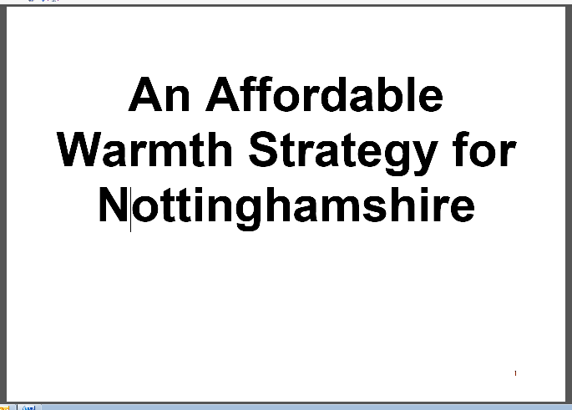
The strategy was developed by National Energy Action (NEA) in partnership with organisations across Nottinghamshire from a range of sectors including local authorities, rural community councils, voluntary sector agencies, police and fire services, health organisations and other social housing providers.

The strategy provides an action plan for partners to work together to provide support and information and ensure resources are targeted effectively to households.


Local Context

The Big Picture: Mansfield’s Sustainable Community Strategy 2010 – 2020
This Sustainable Community Strategy has been produced by the Mansfield Area Strategic Partnership (MASP) in conjunction with Mansfield District Council. It is the overarching strategic plan for Mansfield and links directly to both regional plans and strategies and to the plans developed at community and neighbourhood level. It is based on the things that Mansfield residents and businesses have told us are important.

The strategy builds on the first ‘Big Picture’ published in 2003. Its purpose remains the same: to set a shared vision and agreed priorities for the district of Mansfield and to provide a framework for co-operation and delivery of services
The seven prioriti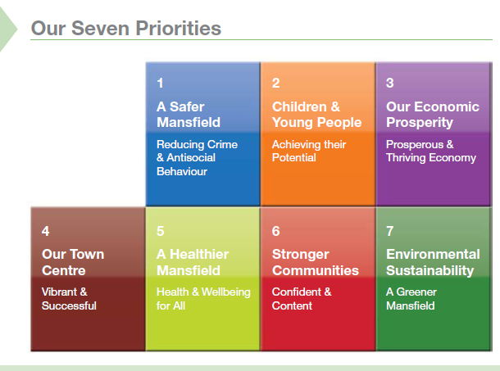es 1
A Sa
Behaviou
My Mansfield: Corporate Plan 2013

The five corporate plan priorities for 2013/2014 are:
Vulnerable people
Regeneration & Employment

Housing
Protecting the environment
Reducing Crime and Disorder

Vulnerable People

Housing

Protecting the Environment

The Corporate Plan presents the Council’s response to how it will help implement the Community Strategy. This is achieved through individual Service Plans that are directly aligned to ensure that the priorities are cascaded down through the organisation through outcome focused targets.

Progress in achieving the objectives contained in the Service Plans is reviewed regularly as part of the Council’s performance management culture.

Mansfield’s Local Plan
The Planning Policy team are currently working towards the 'Preferred Options' for the Local Plan. This is a change in approach, which previously followed the 'Local Development Framework' (LDF) system that was introduced by the 2004 Planning and Compulsory Purchase Act. This intended to guide development through a series of Development Plan Documents (DPDs) that were to be prepared in stages.
At the time, the Core Strategy was to be the first DPD that the Council would prepare. It would set out spatially that vision, strategic objectives, the overarching strategy and core policies for the area, together with a monitoring and implementation framework. The document would focus on matters of strategic importance and aim to cover the long-term, i.e. up to 2031. As such a Core Strategy Issues and Options Report was published for public consultation in 2010. It considered the major issues facing the District and set them in context. It also considered various options open to the Council to address the issues and posed a number of questions to assist public debate.
Before the Core Strategy DPD was progressed any further, the Localism Act 2011 gained Royal Assent. This Act sought to further improve the planning system and allow much more local discretion by removing the regional tier of planning policy. It also removed much of the process that was associated with the LDF system, and started to refer to a 'Local Plan'. The Council started work on determining a local housing target and consulted the public on the options during early 2012.
The National Planning Policy Framework (NPPF) was then published in March 2012, and along with bringing together most Government Planning Policy Statements and Guidance Notes into a much shorter, single document, it also did not refer to the term 'Local Development Framework' but preferred to use the term 'Local Plan'.
Planning officers decided that the best course of action would be to rebrand the existing Core Strategy work as the strategic policies of the Local Plan, which will be supported by more detailed development management policies and land allocation / designation policies. A formal decision to adopt this approach and produce one single planning document was made by Full Council on 30th July 2013.
This document will be known as the 'Mansfield District Local Plan 2011 - 2031'.
This change of approach utilises all of the earlier work and consultations that have been undertaken to inform the strategic approach to development across the District.
To date the strategic policies have been agreed by the Council. These involve:-
- Maintaining a proactive approach to growth and regeneration in the District.
- Utilising the locally agreed housing requirement of 391 units pa over the plan period, committing to finding 54ha of employment land to meet our employment needs, and 29,800 sqm of new retail and leisure floorspace to support the role and function of our town and district centres.
- Recognising the permitted urban extension to the south of Mansfield (at Lindhurst) - the overarching planning strategy being to balance this growth with an urban concentration approach, focusing development on sustainable locations within the urban areas.
- Recognising our key environmental, transport, and other infrastructure assets through our approach to green infrastructure, historic environment, and transport policies.
- Emphasising the importance of the Mansfield urban area, and the Warsop urban area with policies that aim to support their role and promote major development sites in need of regeneration and renewal.
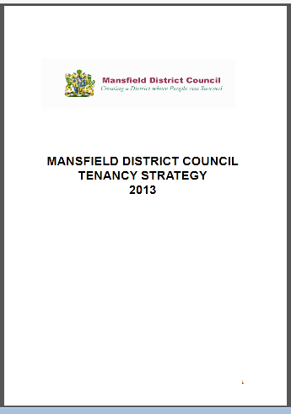
Work is currently continuing in relation to the drafting of development management policies and considering the best locations for allocating new development. Once completed these policies and proposals will help deliver the agreed planning strategy and form part of the new Local Plan.
Tenancy Strategy
In accordance with the Localism Act 2011, Mansfield has developed a Tenancy Strategy which sets out what types of tenancies the Council recommends that Registered Providers should offer locally, the length of those tenancies and the circumstances in which they should be offered and renewed. The Strategy, which was formally adopted in 2012, states that;

Whilst it is accepted that some Registered Providers may wish to use fixed term tenancies, Mansfield District Council would like to see them exercising caution about introducing this. In the case of the Council’s own stock, it will not be introducing fixed term tenancies but will take account of the key issues for consideration above and the Regulatory Framework which requires social landlords to grant tenancies that are compatible with the:

  - Needs of individual households
  - Efficient use of the housing stock
  - Purpose of the accommodation
  - Sustainability of the community

Mansfield Homeless Prevention Strategy
The Homeless Prevention Strategy has been developed with local partners and forms the foundation for Mansfield’s homelessness prevention activity over the next five years. Mansfield will work with the District Interagency Homelessness Forum and other key partners to deliver the following impact and outcomes:

- To help people at risk of homelessness to come forward for help and advice before their housing situation reaches crisis. As a result fewer people will become homeless in Mansfield
- To house people who do become homeless as soon as possible and provide support so that they are less likely to
become homeless for a second time

Private Sector Housing Renewal Strategy

In July 2003, the Regulatory Reform (Housing Assistance) (England and Wales)
Order 2002 came into force and fundamentally changed the legislation relating to the grants that Councils could give to improve housing conditions in their areas.

Apart from the duty to provide Disabled Facilities Grants, the Order repealed all of the previous legislation relating to grants and gave Councils a wider power to choose how they provide assistance and for what.

To be able to do this however, a Council must prepare and publish a Private Sector Housing Renewal Strategy. Accordingly, this strategy sets out the basis on which the Council will provide assistance for improving housing conditions.

The strategy also considers the financial limitations facing the authority following the Comprehensive Spending Review (CSR) along with the removal of a specific private sector housing funding stream from government office. Any available
resources must therefore be effectively targeted and prioritised.

Part Three: Mansfield’s Housing

Overview

Tenure
Mansfield’s housing stock can be characterised by a slightly higher proportion of social rented stock (18.7%) when compared to the national average of 17.5%.

Figure 3.1 illustrates the relatively small growth in both the private sector (2%) and the social rented sector since 2009. The growth in the social rented sector however is due to an increase in other Registered Providers housing stock (8%) as opposed to Local Authority stock which has declined by 2%.

Figure 3: Breakdown of housing stock by tenure in Mansfield
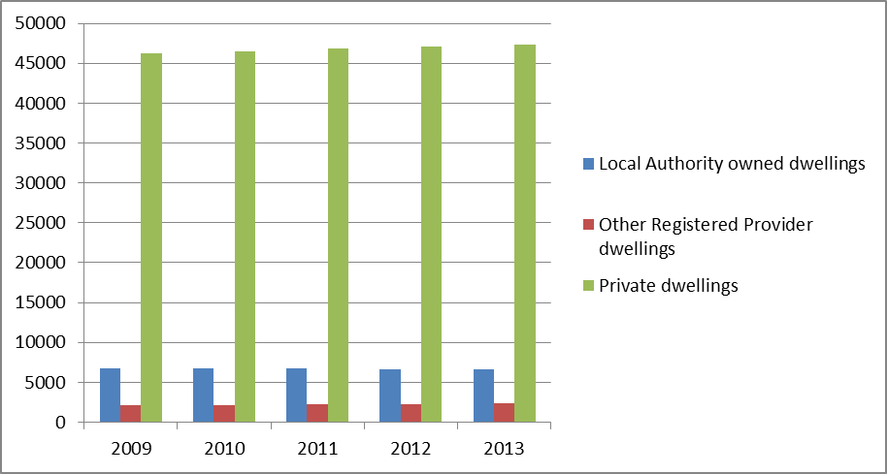
Source: CLG

The District has seen a dramatic growth in the private rented sector, from only 6.31% of the total housing stock at the time of the 2001 census to 12.5% in 2011. This increase is consistent with the growth of the private rented sector both regionally and nationally as illustrated in figure 3.2

Figure 3.2: % of households living in the private rented sector
Source: Census 2001 / 2011

It is thought that this is due to limited mortgage availability and long waiting lists for social housing fuelling demand for the sector, and the availability of Buy to Let mortgages.

Property values
The stock profile in Mansfield is skewed towards lower value properties, with 77.3% of dwellings in Council Tax Bands A and B as illustrated in figure 3.3 below

Table 3.3: Dwellings per Council Tax Band - Mansfield
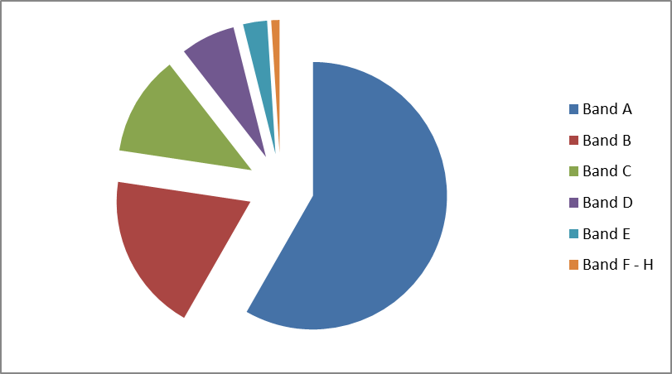
Source: ONS 2006

Empty Homes
The proportion of empty / long term empty private homes in Mansfield is around 3.88% and 1.8% respectively which is higher than both regional and national levels as illustrated below

Figure 3.4: Comparison of the level of vacant dwellings locally/regionally/nationally
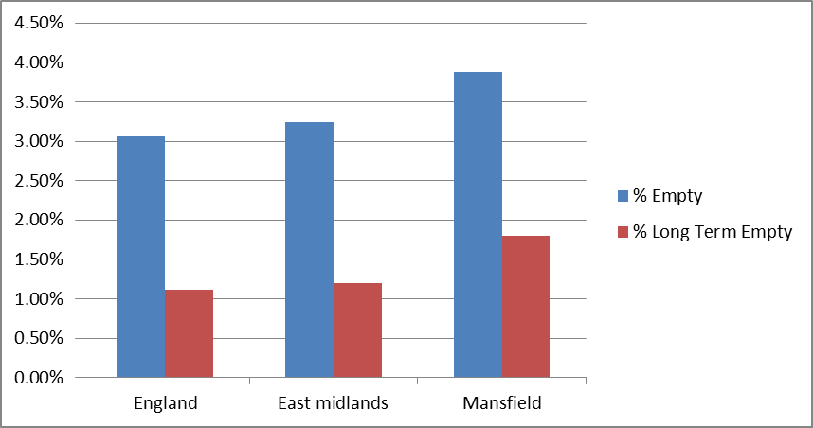
Source: Council Tax

Levels of vacant dwellings has however decreased from the levels recorded in 2008 as illustrated in figure 3.5

Figure 3.5: Vacant dwellings in Mansfield 2008 / 2012
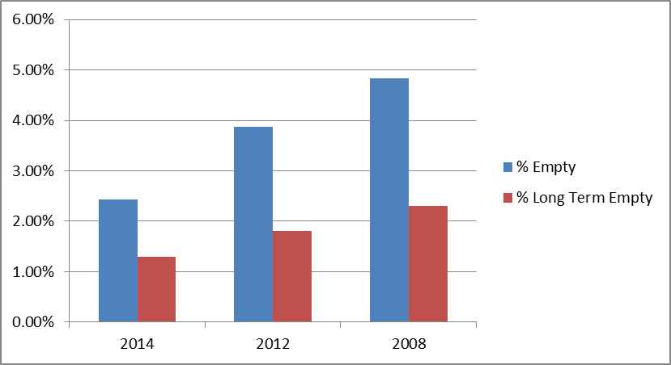
Source: Council Tax

The Council has achieved considerable success in returning empty homes back in to use through the preferred route of cooperation and assistance and has worked with a Registered Provider partner to bring empty homes back into use through purchase and renovation using funding from the Homes and Communities Agency (HCA).
Nottingham Community Housing Association has secured HCA funding for a three year period over which they will purchase and renovate 10 homes with assistance from the Council’s Empty Properties Officer.

The Council has also bid for HCA funding for 2013/14 to continue this work and return around 12 long term empty homes back into use during the year.

The number of long term vacant properties in the social housing stock has reduced over recent years due mainly to demolition and regeneration programmes and as a result the number of social housing properties empty is less than 1% of the total stock and as such is not a cause for concern.

New Housing
Figure 3.6 illustrates the number of newly built properties in the District as reported in the Housing Flows Reconciliation returns.

Figure 3.6: Total Number of New Homes Built (Net Completions)
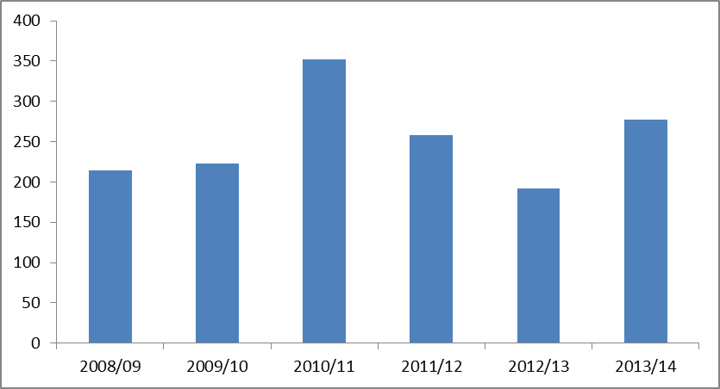
Source: Mansfield Annual Monitoring Report 2014

Following the abolition of Regional Spatial Strategies, work carried out by Edge Analytics Ltd in 2011 set the net dwelling requirement for Mansfield at 7,820 or 391 dwellings per annum based on 2008 sub national population projections.

Following consultation, the figure of 391 was adopted by Council as the long term dwelling requirement for the District from March 2011 to March 2031.

To date the original net requirement is 1173, however the net completions to date is 727. Therefore, the updated requirement based on making up for under provision within 5 years is now 480 net completions per annum.

Social housing developments

A £5 million development project, which was part-funded by the Homes & Communities Agency (HCA) to the tune of over £2.5 million delivered 43 new family homes on the Colston, Shelston and Syerston areas of the Bellamy Road estate.
The new homes, for which the council provided the remaining £2.5 million funding, replaced a series of outdated flats that were demolished to make way for the new three and four bedroomed homes for rent.
The homes were built by William Davis and were designed by NCHA Design. They were built to Level 4 of the Code for Sustainable Homes, with half of the properties making use of ground source heat pumps for domestic hot water, while the other half use photo-voltaic tiles to help reduce electricity costs.
Other features include water saving appliances and low energy lighting to contribute to the homes’ eco-efficiency. They were also built to the Lifetime Homes standard, enabling residents to remain in their homes for as long as possible.
In addition to the above, the council funded the development of a one bedroomed property at Laurel Avenue.

The Council is keen to fulfil its role in facilitating new housing development through the Local Development Framework and has prepared a comprehensive list of potential housing development sites that are likely to come forward over the next five years as illustrated in figure 3.7

Figure 3.7: Sites that are considered Suitable, Available and Deliverable within 5 years
White Hart Development | 145
Former Mansfield General Hospital | 42
Victoria Court / land off Princes Street | 66
Moorfield Farm, Church Warsop | 9
Bould Street / Chesterfield Rd, Mansfield | 93
Rosebrook Prim School field, Mansfield | 77
Sandy Lane / Sherwood Close, Mansfield | 110
Land at Windmill Lane, Mansfield | 38
Land at Flint Avenue | 16
Land at or adj Brick Kiln Lane, Mansfield | 86
Dallas Street, Mansfield | 50
Former Ravensdale School, Mansfield | 110
Former Sherwood Hall School, Mansfield | 169
Pleasley Regeneration Area | 163
Land astride Victoria Street, Mansfield | 43
Total | 1217
Source: Mansfield Annual Monitoring Report 2014

The Housing Market

House Prices
Average house prices in Mansfield are lower than regional averages and significantly lower than national averages as illustrated in figure 3.8 with figure 3.9 illustrating pricing levels overtime within Mansfield.

Figure 3.8 Average House Prices
 | Mansfield | East Midlands | England
Aug-12 | 122,177 | 123,428 | 161,926
Sep-12 | 124,509 | 121,855 | 161,006
Oct-12 | 122,164 | 121,582 | 160,129
Nov-12 | 122,796 | 122,133 | 159,872
Dec-12 | 120,090 | 121,734 | 159,940
Jan-13 | 120,590 | 121,478 | 161,395
Feb-13 | 119,308 | 121,807 | 161,258
Mar-13 | 119,891 | 121,765 | 160,058
Apr-13 | 122,655 | 121,256 | 161,207
May-13 | 122,846 | 122,533 | 161,254
Jun-13 | 123,985 | 121,323 | 161,783
Jul-13 | 123,679 | 123,470 | 163,985
Aug-13 | 121,719 | 123,872 | 164,257
Sep-13 | 123,918 | 123,850 | 165,565
Oct-13 | 123,932 | 124,332 | 164,990
Nov-13 | 127,464 | 124,719 | 165,205
Dec-13 | 125,521 | 126,268 | 166,494
Jan-14 | 125,756 | 127,345 | 168,658
Feb-14 | 125,532 | 128,623 | 169,562
Mar-14 | 124,311 | 128,106 | 169,431
Apr-14 | 125,761 | 128,567 | 171,431
Source: Land Registry

Average prices however have risen significantly since 2009 where the average house price in Mansfield fell to £118,223. As at April 2014 average house prices were slightly higher than the peak figure of 2007 (£124,789)

Figure 3.9: Pricing Levels over time (Mansfield)
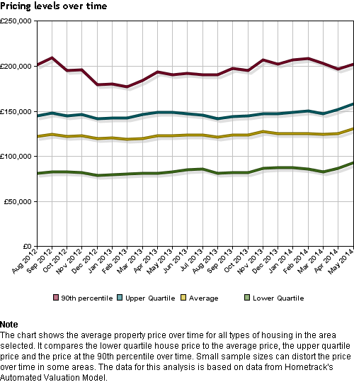

In common with the regional and national position, the economic downturn and consequential housing market conditions led to a decrease in the number of sales during 2010, however whilst second hand sales have increased during 2013, new build house sales have fallen as demonstrated in figure 3.10.and 3.11

Figure 3.10: Annual Turnover by type and age
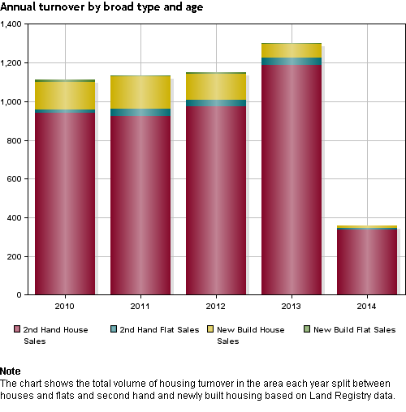

Figure 3.11: Annual Turnover by type and age
Year | 2nd Hand House Sales | 2nd Hand Flat Sales | New Build House Sales | New Build Flat Sales | Total
2010 | 939 | 19 | 144 | 9 | 1111
2011 | 926 | 36 | 166 | 4 | 1132
2012 | 976 | 32 | 136 | 6 | 1150
2013 | 1,190 | 36 | 71 | 5 | 1302
Source: Housing Intelligence

Despite the increase in volume of sales, levels have still not reached those seen during the peak period of 2007 where annual sales stood at 2293. The volume of sales has however risen by 25% since 2009 (975)

Rent Levels
Figure 3.12 illustrates the differential between rent levels in the social and market rented stock.
Figure 3.12: Rent levels in Mansfield
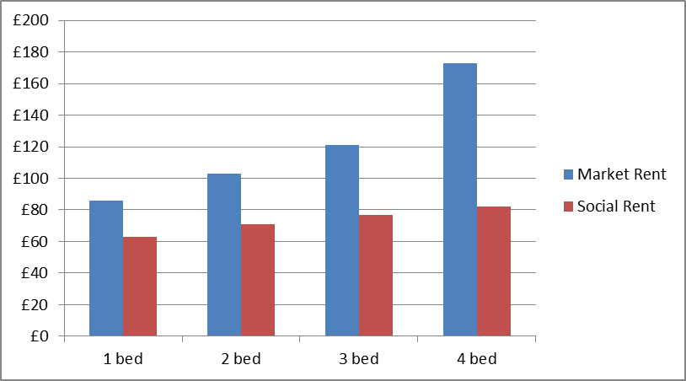
Source: Housing Intelligence

As shown in the following table social rents were found to equate to between 26% to 52% of prevailing market rents, indicating the potential impact of the new affordable rent regime which if rents are raised to the full 80% threshold, would see the average weekly rent for a 3 bedroomed social rented property rise to around £97.

Figure 3.13: % difference between social / market rents
 | Market Rent | Social Rent | % Difference
1 bed | £86 | £63 | 26%
2 bed | £103 | £71 | 31%
3 bed | £121 | £77 | 36%
4 bed | £173 | £82 | 52%
Source: Housing Intelligence

Affordability
Using the government recommended model which takes into account backlog and newly arising need and likely future supply, an additional 339 affordable housing units per year for the next 5 years are required. However, given an overall target of new homes within Mansfield of 480 would mean 70% of all new dwellings would need to be affordable.

The following table shows the percentage of households priced out of the market (3 times income) in the area. The analysis differentiates between house type and whether or not the purchasers are first time buyers.

Figure 3.14: Percentage of households priced out of the market
Percent of households priced out of market

FTB households - Flats | 32.47%
FTB households - Terraced houses | 43.23%
FTB households - Semi-detached houses | 51.75%
FTB households - Detached houses | 71.59%
Owner occupier - Flats | 32.47%
Owner occupier - Terraced houses | 32.47%
Owner occupier - Semi-detached houses | 51.75%
Owner occupier - Detached houses | 65.50%
Source: Housing Intelligence

Analysis of median house prices compared to median incomes reveals that Mansfield has an affordability ratio of 5.11, lower than the ration for Nottinghamshire ratio of 5.57 and significantly lower than the national affordability ratio of 6.72.

Figure 3.15 below illustrates how the affordability ratio has increased since the house price boom at the turn of the century.

Figure 3.15: House price to income affordability ratio
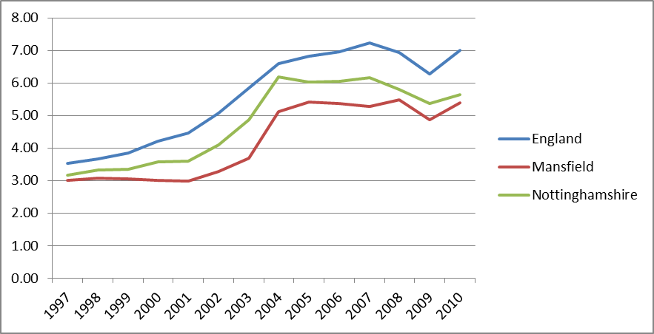
Source: Housing Intelligence

Supply and demand for housing
Information on the supply and demand for social housing can be obtained from Local Authority Housing Statistics (LAHS), formerly known as Housing Strategy Statistical Appendix (HSSA), which collects data on the number of people on the Council’s waiting list and the number of homes available for letting during the year. Figure 3.16 below illustrates the gap between the number of people registered for social housing and the total available for letting during the year

Figure 3.16: supply and demand for social housing
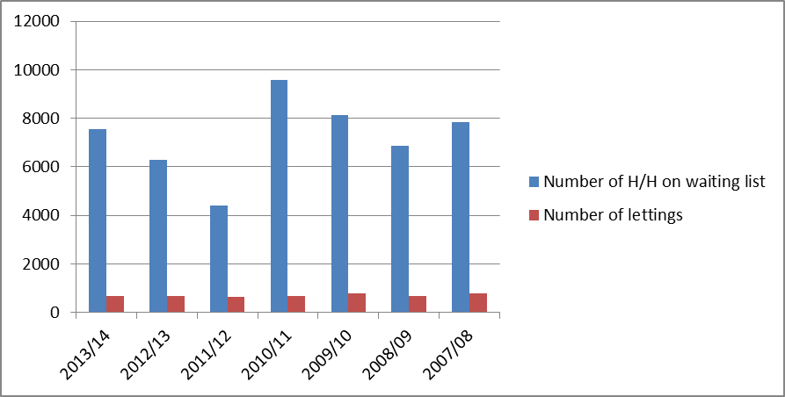
Source: HSSA

The drop in the number of applications in 2011/12 as shown above reflects the fact that at the time the data was collected Mansfield was midway through a re-registration exercise
Further analysis of the waiting list reveals the need for smaller one and two bedroom accommodation, as illustrated in figure 3.17. This is reflective of the smaller household sizes and the number of single people and couple households on the waiting list.

Figure 3.17: Demand by bedroom size
No. Of Beds | No of Beds required | Actual no of properties available
1 | 4371 | 2422
2 | 2081 | 1997
3 | 704 | 1996
4 | 99 | 124
5 | 7 | 2
Source: LAHS 2014

The Housing Needs Survey collected information on tenure aspirations and expectations of existing and concealed households who indicated that they needed or were likely to move within the next five years. The results illustrated in figure 3.18 reveal the strength of demand for home ownership. There is a relatively high demand for private rented housing which could reflect the extent to which the private rented is seen as more attainable and is to some extent “plugging the gap” in meeting housing need.

Figure 3.18: Tenure aspiration of movers
What type of housing would they like to move too
Buy own home | 46.7
Rent from the council | 3.5
Rent from a housing association | 4.2
Rent from a private landlord | 23.7
Rent from a relative or friend of a household member | 4.9
Tied or linked to a job | 3.7
House/flat share in the private sector | 9.8
Other | 3.5
Total | 100.0
Source: Mansfield Housing Needs Survey 2013

When asked about where they would like to move to the majority expressed a preference for Berryhill and Forest Town. The areas they would least like to move to were Meden Vale, Parkhill and Brown Avenue

Figure 3.19: Area of preference
Where would you like to move to (%)
Mansfield Central | 1.6
Warsop | 4.8
Church Warsop | 1.6
Pleasley Hill | 3.2
Berryhill | 17.2
Clipstone | 2.7
Ladybrook | 10.8
Bull Farm | 3.8
Bellamy | 2.7
Oak Tree | 7.0
Ravensdale | 4.3
Meden Vale | 0.5
Parkhill | 0.5
Brown Avenue | 0.0
Peafield Lane | 2.7
Sherwood Street | 2.2
Forest Town | 12.4
Mansfield Woodhouse | 4.8
Other | 17.2
Total | 100.0

Source: Mansfield’s Housing Needs Survey 2014

Housing Conditions

Decent Homes
The Decent Homes Standard uses four broad criteria to assess housing conditions, that is that housing should:
- Be above the legal minimum standard for housing (measured by the presence of Category 1 hazards under the Housing, Health and Safety rating System)
- Be in a reasonable state of repair
- Have reasonably modern facilities (such as kitchens and bathrooms) and services
- Provide a reasonable degree of thermal comfort (effective insulation and efficient heating)

Private Rented
Section 605 of the Housing Act 1985 (as amended) placed a duty on local authorities to consider the condition of the stock within their area. Section 3 of the Housing Act 2004 replaced this with a similar duty to keep housing conditions under review.

A Private Sector House Condition Survey undertaken in 2007 estimated that 11,540 dwellings in Mansfield (31.3% of the private sector) were non decent. This compared with the national average of 30.2%.

The most common reason for non-decency was poor thermal comfort (17.6%) followed by Disrepair (11.4%) followed by failures due to Category 1 hazards (10.6%).

Non decent dwellings in Mansfield were more associated with pre 1919 properties, the private rented sector and converted flats and terraced houses with the highest rate of non-decency found in Warsop.

No up to date information regarding conditions in the private rented sector is available at this time and given the recent growth in this tenure, a priority for Mansfield will be to undertake a further stock condition survey.

LA Stock
In 2007 2316 dwellings owned by Mansfield District Council we classed as non-decent this equated to 33% of all council owned stock.

The most common reason for non-decency in council owned properties was again due to poor thermal comfort, dwellings not in a reasonable state of repair and dwellings without a reasonably modern amenities and services.

In 2006 Mansfield entered into a partnership arrangement with Bullock Construction to undertake a £38m programme of works to bring all Mansfield District Council owned properties up to the decent homes standard. Mansfield achieved 100% decency in March 2011.

Energy Efficiency
The Standard Assessment Procedure (SAP) uses a scale of 1 to 100 to assess the relative energy efficiency of dwellings with higher ratings indicating higher levels of energy efficiency. The Council, as part of their Decent Homes work has carried out a programme to improve the energy efficiency of their own stock including insulation work, window replacement and replacing inefficient boilers and district heating schemes. The impact of this work has yet to be assessed.

According to the English Housing Survey 2009: updated 2011, Mansfield has a higher proportion of energy efficient homes in the private rented sector at 24% compared to 7% nationally.

In Mansfield as stated previously in the “Housing Conditions” section, the most common reason for non-decency was poor thermal comfort. Housing in poor condition causes excess cold and can be an indication of fuel poverty with those people most likely to experience fuel poverty being older and disabled people, people on low incomes, benefit recipients, private rented households and those living in homes built before 1919.

Using 2010 Department of Energy and climate Change (DECC) data, 19% of households in Nottinghamshire are vulnerable to fuel poverty. In Mansfield that figure is 19.9% (or 8,782 households). The average across England is 16.3%.

The Council has adopted the Nottinghamshire Affordable Warmth Strategy which approaches fuel poverty by focusing on activities that include education, advice and support to householders to enable them to maximise their income and achieve greater financial capability.

However rising energy costs, lower than average incomes and an increasing reliance on the private rented sector presents a challenge for Mansfield in reducing fuel poverty within the District.

The Private Rented Sector
As mentioned earlier in this document, the private rented sector is the fastest growing sector in Mansfield and in the current climate is to an extent filling the gap in meeting housing needs as a result of limited mortgage availability and reduced mobility in the social housing sector. This is borne out of the recent Housing Needs Survey, which found that a much higher percentage of households expected that their next move would be to privately rented accommodation (23.7%) than the previous Housing Needs Survey undertaken in 2009 which stood at 17.7%.

The Council uses a range of enforcement powers to deal with poor conditions and is also a member of the Decent and Safe Homes (DASH) accreditation scheme which recognises residential landlords and letting agents who provide decent quality homes. It is a scheme that encourages and rewards good property standards and management practices. It is however a voluntary scheme and other than for certain categories of Houses in Multiple Occupation (of which there are very few in Mansfield) the sector is largely unregulated.

Part Four: Mansfield’s People
Overview

Population
Demographic indicators help explain the levels of demand and the 2011 Census provided a comprehensive picture of Mansfield’s demography. In March 2001 there were some 98.1 (thousand) people living in Mansfield; by 2011 this had risen to 104,700. The most recent population projections for the period 2012 to 2037 indicate the following trends.

- Overall population is set to increase to 112.2 by 2037.
- The number of children under 15 is set to increase slightly from 19.0 to 19.3
- There will be a slight decline in the working age population (16-64) from 68.4 (2012) to 60.5 in 2037
- The number of people of pensionable age will grow from 21.1 in 2012 to 32.3 in 2037 with the number of people over the age of 75 increasing from 8.4 in 2012 to 15.9 in 2037

Figure 4.1: 2012 sub national population projections by broad age group
Age Group | 2012 | 2037 | + / -
Children | 19.0 | 19.3 | +0.3
Working Age | 68.4 | 60.5 | -7.9
Older people | 21.1 | 32.3 | +11.2
All ages | 104.7 | 112.2 | +7.5
Note: Children (0-15), Working age (16-64), Older people (65 and over)

Of particular significance to housing provision is the projected growth in the older population

Households
From the point of view of understanding the housing market, the rate of household formation is of more significance than population growth.

Whilst figures would indicate a slower rate of household growth in Mansfield when compared to the both the Nottinghamshire and East Midlands average (figure 4.2) The rate of household growth in Mansfield slowed down in the period 1996 – 2006 when compared to the previous period.

Figure 4.2: Household growth 1996 - 2006
Period | Area | Value | Nottinghamshire average | East Midlands Average | All England Average
1996 -2006 | Mansfield | 2.4% | 7.49% | 11.85% | 9.75%
1986-1996 | Mansfield | 7.7% | 10.04% | 12.51% | 10.57%
Source: CLG household estimates

According to the Census data (2011) there were 44,928 households living in Mansfield, 3327 more households since the last census in 2001. This constitutes a rise of 7% and is comparable to the rise in the national figure.

Figures for the period 2008 – 2033 (figure 4.3), indicate that there will be an additional 9,000 (18%) households by 2033 in Mansfield, primarily due to population growth, but also due to the changing age structure and the continuing trend towards smaller single person households

Figure 4.3: Household Projections 2008 – 2033
 |  |  |  |  |  |  | Thousands
Year | 2008 | 2013 | 2018 | 2023 | 2026 | 2028 | 2033
Household | 43 | 45 | 47 | 49 | 50 | 51 | 52
Note: Data for 2008 are based on ONS mid year population estimates and projected rates of household formation trends in the Census and Labour Force Survey.

Economic Analysis
The most direct influence on developments in the housing market is the state of Mansfield’s local economy.

Deprivation
Deprivation is an acknowledged local factor that helps to influence local market change and again helps to explain market issues in an area, as well as being a key issue in itself.

The English Indices of Multiple Deprivation (IMD) measures relative levels of deprivation to Lower layer Super Output Areas (LSOA). The IOD ranks 326 local authority areas; the local authority district with a rank of 1 is the most deprived, and the local authority district with a rank of 326 is the least deprived. According to the 2010 IMD Mansfield has a rank of 36 (calculated by averaging all the LSOA ranks in Mansfield).

This indicates that Mansfield is marginally outside the10% most deprived local authority areas within the country. However 12 of the lower super output areas in Mansfield are in the top 10% most deprived areas. There is also a direct correlation between levels of deprivation and levels of social housing within the area notably in Oak Tree (85% social housing) and Lindhurst (69% social housing).

Employment
Employment, unemployment and worklessness are key labour market indicators which impact on the health of the housing market.

According to the Census 2011, 63.7% of Mansfield’s total population were estimated to be of working age. As illustrated in figure 4.4
Figure 4.4: Population aged 16-64
Top of Form  Bottom of Form | Mansfield | Mansfield | East Midlands | Great Britain
Top of Form  Bottom of Form | (numbers) | (%) | (%) | (%)
All people aged 16-64 | 67,100 | 63.78 | 63.4 | 63.8
Males aged 16-64 | 33,400 | 64.5 | 64 | 64.6
Females aged 16-64 | 33,700 | 63.0 | 62.7 | 63.1
Source: Census 2011
Employment (including employees, self-employed and those on Government training programmes) rose from 72% in January 2012 to 75% in December 2013.Mansfield’s employment rate however is still below the regional and national figure of around 77% illustrated in figure 4.5

Figure 4.5: Economic Activity
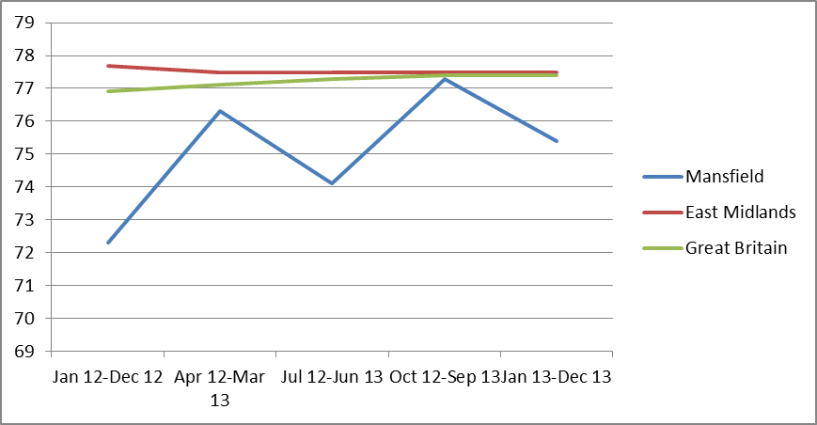
Source: ONS Annual Population Survey

Mansfield’s unemployment rate (the proportion of those who are of working age and economically active but unemployed) is 10.2% (Dec 2013) Unemployment has increased from 7% in March 2006 by 3% in December 2013, having fell to 6% between 2007 and 2009.

Mansfield’s unemployment rate is 2.6% higher than that of the East Midlands and 2.7% higher than Great Britain as a whole.

Figure 4.6: All people economically active - unemployed
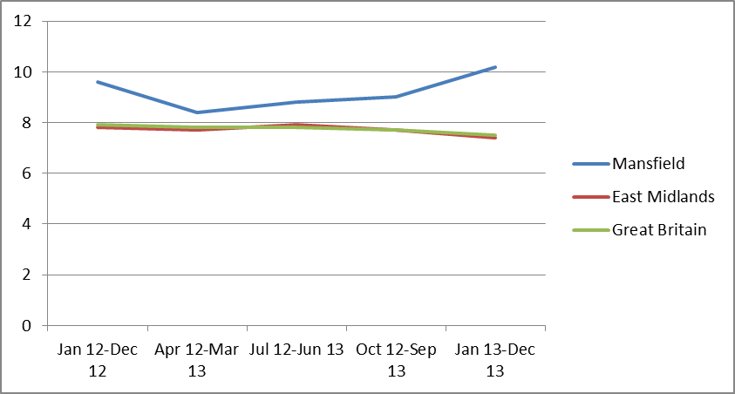

Income
Figure 4.7 illustrates the gap between weekly earnings of Mansfield residents and those living in the East Midlands and Great Britain. Whilst medium weekly earnings have rose in the East Midlands and Great Britain since 2010, income levels for Mansfield were below the levels of 2010.

Figure 4.7: Median Weekly Income
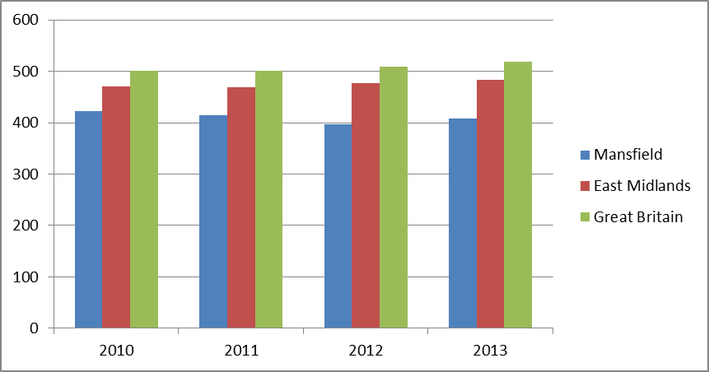
Source: ONS annual survey of hours and earnings - resident analysis

Health and Housing
The links between health and housing are wide ranging and well documented. Improving housing conditions and energy efficiency of housing can bring numerous health benefits as highlighted in the 2010 Marmot review of Health inequalities “Fair Society, Healthy Lives”. This study found that countries with more energy efficient housing have fewer excess winter deaths and that there is a strong relationship between cold housing and cardio vascular and respiratory disease. For example, it found that children living in cold homes are more than twice as likely to suffer from a variety of respiratory problems than children living in warm homes and that cold housing negatively affects children’s educational attainment, emotional well-being and resilience to illness.

The relationship between health and housing is not just confined to the energy efficiency of housing. The removal of hazards in a property can help reduce the number of accidents in the home, in turn removing the need for unnecessary hospital admissions and surgery and maintaining the independence of the occupier.

There are also links between housing and mental health. For example, fuel poverty, poor quality housing and overcrowding are associated with stress, anxiety, depression and poor mental health and studies have shown a relationship between insecurity of tenure and poor mental health.

Need for adaptations
The Housing Needs Survey 2014 found that an estimated 24.2% households in Mansfield contained someone with a support need. The main support needed amongst respondents was due to a physical disability. Extra handrails and other alterations to the bathroom/toilet are the adaptations that residents with a support need require the most (21.2% and 19.3% respectively) however, the requirement for a low level shower unit and other alterations to improve accessibility were also relatively high as illustrated in figure 4.8.

Figure 4.8: Need for adaptations
Adaptations Required (%)
Adaptation
Lift/Stair Lift | 11.2
Extra Handrails | 21.2
Other alterations to improve accessibility | 15.0
Downstairs WC | 14.3
Low level shower unit | 17.8
Other alterations to the bathroom/toilet | 19.3
Alterations to the kitchen | 8.2
Emergency or warden call alarm | 11.0
Car parking space near to front door of home | 10.3
More support services to your present home (such as home carer etc) | 11.7
Need to move to alternative housing with specialist adaptations/care/support | 6.9
Source: MDC Housing Needs Survey 2014

The figures shown in 4.8 need to be treated with a degree of caution since they are based on survey respondents assessment of need rather than an assessment by a qualified Occupational Therapist.

Demand for supported Housing
The Housing Needs Survey also collected information about the moving intentions of households and, in particular, asked respondents who were seeking a move whether they would be seeking supported housing.

The majority of households with support needs wanted to move to a ‘bungalow’ (63.0%) or ‘other’ accommodation (31.6%) rather than supported housing (2.6%).
Figure 4.9: Moving intentions of households seeking supported housing
Supported Households / Type of Accommodation
Sheltered housing | 2.9
Supported housing | 2.6
Bungalow | 63.0
Other accommodation | 31.6
Total | 100.0
Source: MDC Housing Needs Survey 2014
Sheltered Housing
The Housing Needs Survey asked residents who wanted to move within the next two years what type of accommodation they would expect to move to. 2.0% of respondents said they wish to move to sheltered housing, 0.8% said they expected to move to supported housing, 1.2% to residential care / nursing home.

Overcrowding / Under-occupation
Data from the Survey of English housing (SHE) suggests that nationally levels of overcrowding stands at 3%.

Figure 4.10 below shows occupancy ratings calculated by the 2011 census. A negative figure indicates overcrowding whereas figures of +2 and above would typically be seen as indicating under-occupancy. The data shows that levels of overcrowding in Mansfield are lower than that of the East Midlands but higher than national levels. Levels of under-occupation are slightly lower in Mansfield than those found nationally or regionally.

4.10: Under occupancy / Overcrowding
Source: Census 2011

Homelessness

Levels of Homelessness
The levels of households presenting as homeless has fluctuated over the last five years as illustrated in figure 4.11. However, despite a slight rise in numbers presenting in 2013/2014 there was a decrease in number of households interviewed and accepted as homeless and in priority need as illustrated in figure 4.11

4.11: Number of households presenting as homeless
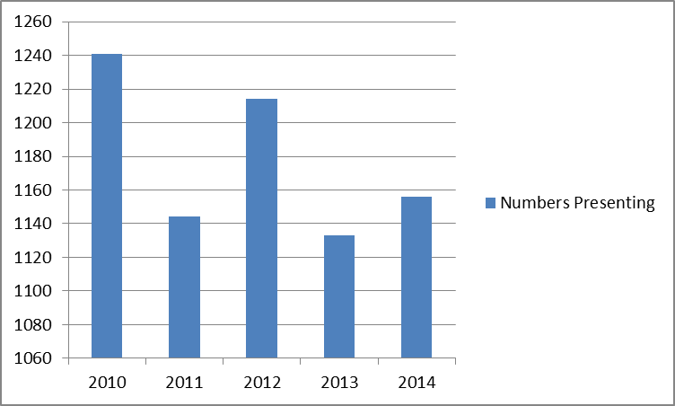
Source: P1E: CLG

4.12: Total decisions / total accepted
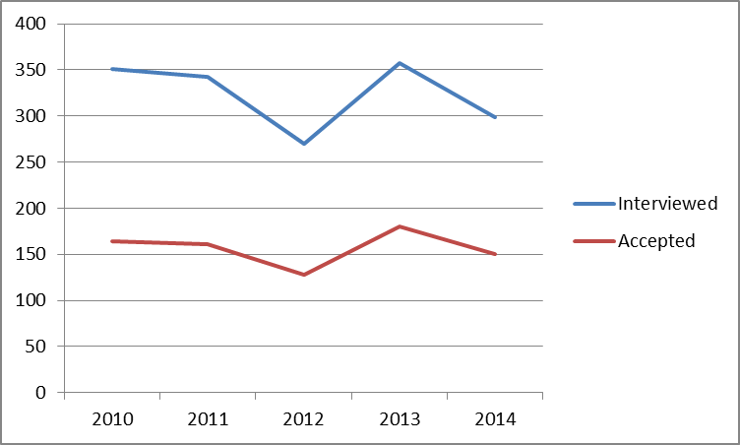
Source: P1E: CLG

Evidence would indicate that the one of the main reasons for this downward trend would be the focus on preventative measures. Figures for 2013 / 2014 show that the total numbers of households presenting as homeless was 1156, however 65.22% were prevented from becoming homeless removing the need to offer a full homeless interview.

Figure 4.13: Numbers presenting / Numbers prevented
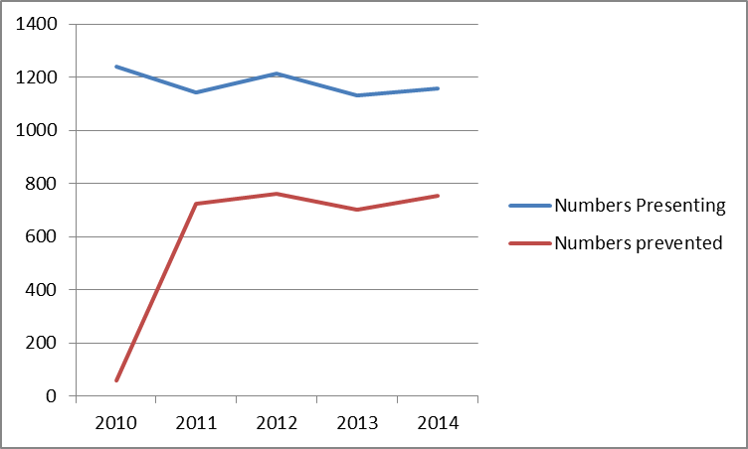
Source: P1E: CLG

The relative importance of the causal factors in homelessness has changed little. The dominant factor in relation to those presenting as homeless remains Fleeing violence: 37 (25%) of those accepted as homeless and in priority need in 2013/2014 did so for this reason. The other key factors remain family and friends no longer willing to accommodate (22%) and termination of an assured shorthold tenancy (20%)

Costs of homelessness
According to figures released by the Department for Communities and Local Government (CLG), the average cost to the local authority of statutory homelessness is £5,500 per household. This compares to an estimated cost of preventing homelessness of £500 per household

The Housing needs of specific groups
Section C of the Housing Needs questionnaire asked a series of questions on the support needs of the household. Results suggest that 24% of residents in Mansfield have a support need. The results also show a substantial support need for residents with a physical disability (45%) followed by frail elderly (23%) and residents with a mental health problem (12.9%).

However, households with a support need expressed a preference for general needs accommodation rather than any form of supported housing indicating a need for some kind of targeted support rather than specialist accommodation.

Older people
The projected increase in the proportion of older person households illustrated in figure 4.1 could have significant implications for housing provision and related care and support services.

Findings contained in the document “A Strategic Approach to Older Persons Accommodation: Mansfield Report” identified that Mansfield had the highest level of limiting long term illness in the county, meaning a higher demand on health care services for the older population. Mansfield also had a larger proportion of its older population claiming pension credits, another indicator of deprivation in the area.

The report produced a series of recommendations that should form part of a joint strategic approach:
- For housing to deliver a practical set of public and private sector solutions for the growing needs of older people in Mansfield.
- For Supporting People, Adult Social Care and Health services to develop appropriate care, support and health strategies for older people
- For providers to consider their own housing strategies and housing provision for older people
- For practical service delivery links be made across disciplines that result in services that older people want

