Mansfield District Council
  - Annual Complaint Handling and Service Improvement Report 2025/26

Executive Summary
This annual report summarises Mansfield District Council’s complaint handling performance, compliance position, tenant feedback and service improvement activity during 2025/26. It shows that the Council has continued to strengthen its complaints approach in line with the Housing Ombudsman’s Complaint Handling Code, while recognising that complaint handling remains a key area for further improvement.
During the year, the Council maintained broad compliance with the Complaint Handling Code and continued to improve its policy, monitoring and quality assurance arrangements. Complaint performance was strongest at Stage 1, with 88% of Stage 1 complaints handled on time. Stage 2 performance was lower, with 70% handled on time, reflecting the greater complexity of escalated complaints and the need for improved consistency.
Tenant satisfaction with complaint handling improved from 33.3% in 2024/25 to approximately 41.9% in 2025/26, representing the strongest improvement across the Tenant Satisfaction Measures. However, complaint handling remains one of the Council’s lowest performing satisfaction areas. Feedback continues to highlight the importance of clear communication, timely updates, fair outcomes and visible evidence that complaints lead to change.
The main themes arising from complaints were repairs and maintenance, communication, customer care, response times and case handling. In response, the Council has already introduced service improvements including a Complex Cases Team, enhanced quality assurance checks, a discretionary compensation policy and targeted process reviews to reduce escalation and improve resolution.
For 2026/27, the Council’s improvement priorities are to strengthen communication throughout the complaints process, improve the consistency and quality of responses, embed root cause analysis, improve data quality and reporting, and make better use of tenant feedback through clear “You Said, We Did” reporting. Progress will be monitored through existing governance arrangements, including reporting to the Housing Executive Group and tenant oversight through the Tenant Assurance Panel.

1. Foreword
Mansfield District Council is committed to delivering a positive complaints culture, where feedback from tenants is encouraged, listened to and used to improve services.
Over the past year, we have continued to strengthen our approach to complaint handling in line with the Housing Ombudsman’s Complaint Handling Code. This includes improving performance in responding to complaints within timescales, enhancing quality assurance processes, and embedding learning from complaints into service improvements.
Whilst progress has been made, we recognise that complaint handling remains a key area for improvement. Tenant feedback, survey results and complaint analysis highlight that communication, consistency of responses and demonstrating how feedback leads to change are ongoing priorities.
This report brings together performance data, tenant feedback, complaints analysis and learning to show how the Council is responding to these challenges and where further improvement is planned.
Councillor Craig Whitby – Portfolio Holder for Corporate and Finance (MRC)

2. Purpose of the Report
This report provides:
- An overview of complaint handling performance during 2025/26
- An assessment of compliance with the Housing Ombudsman Complaint Handling Code
- Analysis of complaints and identification of key themes
- Performance against Tenant Satisfaction Measures (TSMs)
- Findings from transactional customer satisfaction surveys
- A summary of learning from complaints and resulting service improvements
- A forward-looking service improvement plan
The production of this report is a statutory requirement and forms part of the Council’s annual submission to the Housing Ombudsman.
The following section sets out the complaints framework and compliance position that underpin the performance and learning described later in the report.

3. Complaint Handling Framework and Compliance

3.1 Complaint Handling Framework
The Council operates a two-stage complaints procedure, in line with the Housing Ombudsman’s Complaint Handling Code:
- Stage 1: Initial complaint investigation and response
- Stage 2: Independent review where the complainant is dissatisfied
The process:
- Is accessible through multiple channels (online, telephone, in writing)
- Includes defined timescales for responses
- Ensures fairness, transparency and tenant focus

3.2 Compliance with the Complaint Handling Code
The Complaint Handling Code became statutory in April 2024, requiring landlords to demonstrate compliance annually.
During 2025/26:
- The Council maintained alignment with the Code requirements
- Regular self-assessment and reporting arrangements were in place
- Improvements were made to processes, policy and monitoring
Overall, the Council is broadly compliant, with further work required to ensure consistency and embed learning across all service areas.
Building on this compliance position, the self-assessment summary below explains how the Council has reviewed its arrangements and identified the areas that need further development.

4. Self-Assessment Summary
The Housing Ombudsman carried out a review of our policy in June 2025 as part of its duty to monitor compliance with the Complaint Handling Code. As a result of that review, it put forward a series of recommendations, which we responded to by amending our policy to reflect the recommendations, including:
- Defining a complaint in line with the Housing Ombudsman’s definition
- Dealing with all complaints through a clear two-stage process
- Giving tenants a choice in how they make a complaint
- Providing further details in our acknowledgement of Stage 1 and Stage 2 complaints
- Agreeing suitable intervals for regular updates where timescales are extended
- Setting clear timescales for acknowledging complaints that are escalated to Stage 2
Following the Housing Ombudsman review, the Council completed its annual self-assessment against the Complaint Handling Code and confirms that:
- Policies and processes are aligned with the Code
- Performance is monitored and reported
- Learning from complaints is used to drive service improvements
Areas requiring further development include:
- Consistency of responses
- Visibility of tenant influence
- Strengthening data assurance and insight
Having confirmed the compliance and self-assessment position, the next section considers how the complaints service performed in practice during the year.

5. Complaint Handling Performance

5.1 Complaint Volumes
During 2025/26:
- Complaint volumes increased compared to the previous year, reflecting increased service demand and improved accessibility
- The majority of complaints were resolved at Stage 1
- A smaller proportion progressed to Stage 2
This aligns with previous trends where Stage 2 escalation remains a key indicator of service quality.
Key facts:
- 295 complaints at Stage 1
- 24 complaints at Stage 2

5.2 Performance Against Timescales
Performance against the Complaint Handling Code timescales shows:
- Strong performance at Stage 1, with the majority of complaints responded to within target
- Variability at Stage 2, indicating inconsistency in handling more complex cases
Key facts:
- 88% of Stage 1 complaints handled on time
- 70% of Stage 2 complaints handled on time

5.3 Escalations and Ombudsman Cases
If a tenant is unhappy with the way we have dealt with their complaint, they can refer their complaint to the Housing Ombudsman. Each year the Housing Ombudsman produces a performance report about us as a landlord.
During 2025/26, the Housing Ombudsman made two determinations. It is important to note that each defined complaint must have its own determination. Therefore, in a case involving two or more defined complaints, there may be two or more different findings.
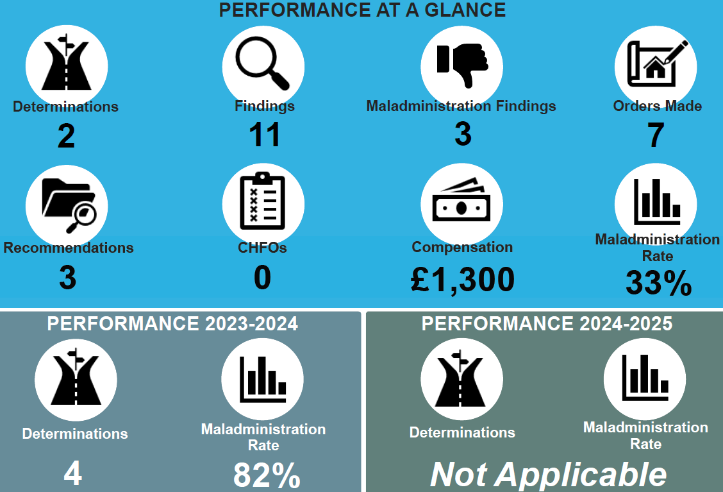
Performance data provides an important measure of how the complaints process is working, but it must be considered alongside tenant experience. The next section therefore looks at satisfaction and feedback from tenants who have used the service.

6. Tenant Satisfaction and Customer Feedback

6.1 Tenant Satisfaction Measures (TSMs)
We work with Housemark, the leading data and insight company for the UK housing sector, to collect data for the Tenant Satisfaction Measures (TSMs), which provide a comprehensive set of performance measures, including satisfaction with our complaint handling.
The Tenant Satisfaction Measure relating to complaint handling (TP09) shows:
- An improvement in satisfaction compared to the previous year
- Performance is above or in line with sector benchmarks in some areas
Key facts:
Satisfaction with complaint handling increased from 33.3% in 2024/25 to approximately 41.9% in 2025/26, representing a notable improvement and the strongest improvement across TSM measures.
However:
- Complaint handling remains one of the lowest performing satisfaction areas, indicating ongoing challenges

6.2 Transactional Survey Results
Our tenants’ views of our complaint handling service are very important to us. We therefore ask tenants to complete a survey after a complaint is logged and closed, to help us understand how the complaint was managed, what worked well and where improvements are needed.
Findings indicate:
- Low overall satisfaction with complaint outcomes
- Concerns about communication and updates
- Mixed feedback regarding timeliness
Key facts:
- Only a minority of tenants reported overall satisfaction with how their complaint was handled (66.2%)
- Just over half felt they were kept informed throughout the process (60.5%)
- Ease of making a complaint remains an area requiring improvement (63%)

6.3 Key Insight from Tenant Feedback
Combining TSM and transactional survey data shows:
- Complaint handling is a key driver of overall tenant satisfaction
- Communication and repairs performance are closely linked to complaint dissatisfaction
Key facts:
Tenants value:
  - Clear communication
  - Timely updates
  - Resolution of issues first time
These satisfaction results provide useful insight into tenant experience and help explain the complaint themes explored in the following section.

7. Complaints Analysis and Key Themes

7.1 What tenants complained about
Analysis of complaints during 2025/26 identified the following key themes:
Repairs and Maintenance
- Delays in completing repairs
- Poor quality of work
- Repeat visits and unresolved issues
Communication
- Lack of updates on progress
- Difficulty contacting services
- Unclear expectations
Customer Care / Staff Conduct
- Perceptions of staff not listening
- Lack of empathy in responses
Response Times and Case Handling
- Delays in complex cases
- Inconsistent handling at Stage 2
These themes are consistent with prior analysis, particularly in relation to repairs and communication issues.

7.2 Why complaints were escalated to Stage 2
We looked at why complaints get escalated. The main reasons are:
Reason for escalation | Critical success factor | Assurance comment
Issue not resolved at Stage 1 | Fix core issues such as repairs / ASB, not just the complaint process | Escalation happens most often where the underlying problem remains unresolved.
Poor or absent communications | Eliminate communication gaps | Tenants are more likely to escalate when they do not receive clear updates or explanations.
Excessive delays | Reduce avoidable delay | Long delays weaken confidence in fairness and effectiveness.
Distrust in complaint handling process | Restore trust through fair, transparent decisions | Escalation increases where tenants do not believe the process is independent or impartial.
Perceived unfair or inadequate outcome | Make Stage 2 responses genuinely independent | A procedurally compliant response is not enough if the tenant does not feel heard or the outcome does not feel fair.
The themes and escalation reasons identified above have informed the Council’s learning from complaints and the service improvements described in the next sections.

8. Learning from Complaints
The Council has used complaints as a key source of insight to identify service weaknesses and improvement opportunities.
Key learning points include:
- The need to strengthen the “feedback loop” to demonstrate how tenant feedback leads to change
- Further work required to improve data quality and assurance processes
- The importance of improving consistency in complaint responses, particularly at Stage 2
- The need to improve tenant access and representation, ensuring all groups can raise complaints
The following section sets out the practical changes already made in response to this learning.

9. What we have already changed
As a result of learning from complaints, the Council has implemented a number of service improvements:
Issue Identified | Action Taken | Outcome
Poor handling of complex repairs complaints | Introduction of a Complex Cases Team | Improved case management and resolution
Inconsistent quality of complaint responses | Enhanced quality assurance checks | Improved compliance with Code requirements
Lack of appropriate remedies | Introduction of discretionary compensation policy | Greater flexibility in resolving complaints
High escalation levels | Targeted review and process improvements | Reduction in Stage 2 escalation rates
These completed actions provide a foundation for the further improvement priorities set out below.

10. What we will improve next
The Council has identified the following action-focused improvement priorities for 2026/27. Each priority responds directly to the themes identified through complaints, tenant feedback, escalation analysis and self-assessment.
1. Improve communication during the complaints process
- Issue identified: Tenants told us they do not always receive clear or timely updates, particularly where complaints involve repairs or complex case handling.
- Action we will take: Introduce clear update standards, including agreed contact points at acknowledgement, investigation, extension, decision and closure stages.
- Expected outcome: Tenants receive clearer information about what is happening, when they will be contacted and what action is being taken.
2. Strengthen contact before complaint closure
- Issue identified: Some tenants remain dissatisfied because the original issue has not been fully understood, resolved or clearly explained before the complaint is closed.
- Action we will take: Introduce a “contact before closure” approach for appropriate cases, so officers check that the tenant understands the outcome and any remaining actions before issuing the final response.
- Expected outcome: Fewer avoidable escalations caused by unresolved issues, unclear explanations or missed follow-up actions.
3. Improve quality and consistency of complaint responses
- Issue identified: Complaint responses are not always consistent in how they explain findings, evidence considered, decisions made, remedies offered and learning identified.
- Action we will take: Strengthen quality assurance checks, refresh response templates and deliver targeted staff training on fair, evidence-based and tenant-focused complaint handling.
- Expected outcome: More consistent responses that clearly explain the outcome, address all complaint points and meet Complaint Handling Code expectations.
4. Embed root cause analysis and learning
- Issue identified: Escalated complaints show that some problems are linked to underlying service issues, repeat repairs, communication gaps or case ownership rather than the complaint process alone.
- Action we will take: Apply root cause analysis to Stage 2 complaints and selected complex Stage 1 complaints, with learning recorded and shared with relevant service managers.
- Expected outcome: Better identification of recurring issues and clearer links between complaints, service improvement and prevention of repeat failure.
5. Improve complaint data quality and reporting
- Issue identified: Data quality and assurance need to be strengthened so that performance, themes, remedies, learning and outcomes are reported consistently.
- Action we will take: Improve data capture fields, strengthen validation checks and develop regular reporting that links complaint volumes, timescales, themes, outcomes, remedies and learning.
- Expected outcome: Better evidence for decision-making, stronger assurance reporting and clearer visibility of complaint trends and improvement impact.
6. Show tenants how complaints lead to change
- Issue identified: Tenants do not always see how their feedback has influenced decisions, service changes or wider learning.
- Action we will take: Introduce clearer “You Said, We Did” reporting through tenant-facing updates and assurance reports to show what has changed as a result of complaints and feedback.
- Expected outcome: Tenants have greater confidence that complaints are listened to, acted on and used to improve services.
Progress against these priorities will be monitored through complaint performance reporting, quality assurance checks, tenant feedback, escalation analysis and governance reporting to the Housing Executive Group and Tenant Assurance Panel.
To ensure these actions lead to measurable improvement, they will be supported by clear governance, monitoring and tenant oversight arrangements.

11. Assurance and Governance
The improvement priorities set out above will be monitored through the Council’s existing assurance and governance arrangements. This will help ensure that actions are followed through, impact is understood, and progress remains visible to both senior managers and tenants.
- Quarterly reporting to the Housing Executive Group
- Tenant oversight through assurance reporting to the Tenant Assurance Panel
These arrangements provide a clear route for monitoring performance, identifying where further corrective action is required, and maintaining effective oversight, scrutiny and accountability before the report concludes.
The Tenant Assurance Panel recently reviewed how we manage housing complaints. It found strong evidence that complaints are being handled in line with the Housing Ombudsman Complaint Handling Code. It also found that performance has improved, with more complaints being answered within expected timescales.
The Panel has asked us to keep improving communication during complaints, make complaint timescales clearer, improve easy-read information and continue checking that tenants feel able to raise concerns

12. Conclusion
Mansfield District Council has made measurable progress in improving complaint handling during 2025/26, including:
- Improved performance against timescales
- Increased tenant satisfaction
- Reduced escalation rates
- Enhanced governance and oversight
However, complaint handling remains a key priority area. Feedback from tenants highlights the need for:
- Improved communication
- Greater consistency in responses
- Clear evidence of how complaints lead to change
The Council is committed to addressing these areas and continuing to strengthen its approach, ensuring it delivers a fair, effective and tenant-focused complaints service.

