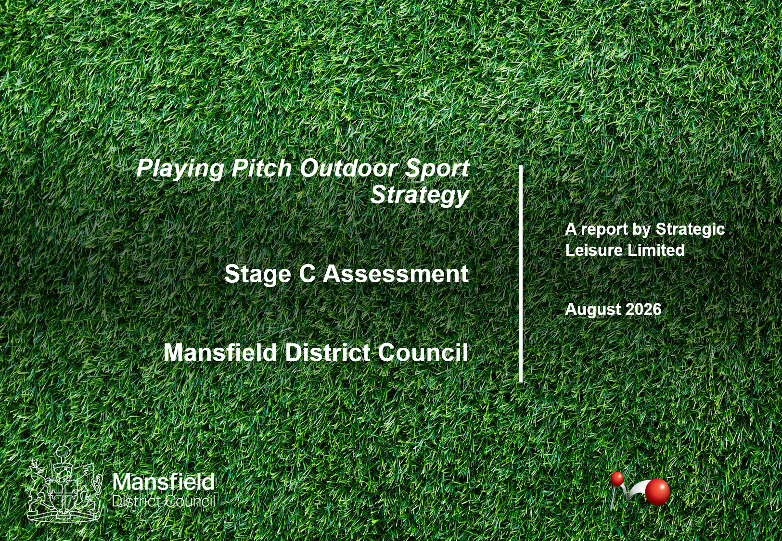
Document Version Control

Date | Author | Organisation | Version Number | Revision Details
04.02.26 | JH/KR | SLL | 1 | Initial Draft
05.02.26 | ACS | SLL | 1 | Formatting
04.03.26 | ACS | SLL | 1 | Formatting
12.08.26 | ACS | SLL |  | Formatting

Contents

1 Introduction 1
Study Area 1
Current and Future Population 2
Project Scope and Objectives 2
Methodology 4
Report structure 7

2 Football Stage C Assessment 8
Introduction 8
Strategic Priorities for Football 8
Supply 9
Disused Provision 13
Proposed Supply changes 14
Current Position for Football 14
Ancillary Facilities 16
Current Demand 17
Demand Driven by Exported/Imported Demand 22
Demand Driven by Latent Demand 22
Football Supply and Demand information 23
Future Demand 27
Demand Driven by Population Growth 27
Current and Future Peak Time Capacity Analysis 29
Adult 11v11 Analysis Total Peak Capacity 29
Youth 11 v 11 Analysis - Peak 30
Youth 9 v 9 Analysis Peak 30
Mini 7 v 7 pitch supply Peak 31
Mini 5 v 5 pitch supply Peak 31
Football Summary 32

3 3G Artificial Grass Pitch (AGP) Analysis 35
Introduction 35
3G AGP Usage for Football 35
3G AGP Usage for Rugby 35
Supply 36
Current Supply and Demand Analysis for Football / 3G AGP 40
Football - Current Supply and Demand Analysis for use of 11v11 3G AGP 41
Rugby Union and Rugby League – Current Supply and Demand Analysis for use of 3G AGP. 43
Football – 3G AGP Future Supply and Demand Analysis 43
Meeting the Current and Future Demand for 3G AGP Facilities Across Mansfield 44
Football Demand for Sand Dressed AGPs 46
AGP summary 46

4 Hockey Analysis 48
Introduction and Strategic Context 48
England Hockey Strategic Direction (2023 - 2028) 48
Supply 50
Demand 53
Exported Demand 53
Pitch Usage 56
Demand Driven by Informal Demand 56
Supply and Demand Balance 57
Supply and Demand Balance – Spatial Analysis 57
Future Demand 58
Demand driven by Population Growth 58
Hockey Summary 59

5 Rugby Union Analysis 61
Introduction and Strategic Context 61
RFU Strategic Plan (2026 - 2030) 61
England Rugby Women and Girls Action Plan (2025-2030) 62
Supply 63
Quantity and Quality Assessment 63
Current Demand 67
Supply and Demand Balance 68
Future Demand 70
Future Demand Driven by Latent Demand. 71
Current and Future Position 72
Rugby Union Summary 73

6 Rugby League Analysis 74
Introduction and Strategic Context 74
RFL Strategic Report 2022 to 2030 74
Community Rugby League – Strategy and Vision 2022 to 2030 75
Supply (Grass) 76
Quantity Overview 76
Quality Assessment 78
Demand 78
Current Demand 78
Supply and Demand Balance 79
Future Demand 79
Rugby League Summary 79

7 Cricket Analysis 81
Introduction and Strategic Context 81
Inspiring Generations (2025 - 2028) 81
Nottinghamshire County Cricket – Facilities Strategy 2023 - 2032 82
All Stars Cricket (2017) 83
Dynamos Cricket (2020) 83
Women and Girls’ Cricket 83
Supply 84
Tenure and Management 86
Quality Assessment 86
Current Demand 88
Club and Team Profile 88
Consultation Overview 89
Displaced Demand 90
Supply and Demand Balance 90
Spare Capacity and Overplay 91
Site by Site Analysis 93
Future Demand 94
Demand Driven by Population Growth 94
Future growth driven by latent demand 95
Current and Future Position of Grass Pitches 95
Understanding the Process and Key Terminology 95
Total Wicket Analysis 96
Cricket Summary 97

8 Tennis Analysis 99
Introduction and Strategic Context 99
Tennis Opened Up 2024-2026 100
Pickleball 100
Supply 100
Active Lives Survey 106
Membership Data 106
Future Demand 107
Supply and Demand Balance 107
Club Balance 108
Public Parks 108
Additional Court Provision 109
Tennis Summary 109

9 Padel Analysis 111
Padel Summary 113

10 Netball Analysis 115
Introduction and Strategic Context 115
Supply 116
Demand 119
Future Demand 119
Netball Summary 120

11 Bowls Analysis 122
Introduction and Strategic Context 122
Strategic Plan – Fit for The Future 2021 - 2026 122
Supply 123
Club and Site Consultation 126
Demand for Outdoor Bowls Facilities 126
Future Demand 127
Bowls Summary 127

12 Pétanque Analysis 129
Introduction and Strategic Context 129
Growing Participation 129
Supporting Clubs, Regions and Coaching Development 129
Performance and Competitive Pathways 129
Governance, Compliance and Sustainability 130
Enhancing the Member Experience and Engagement 130
Pathways and Skill Development 130
Supply 130
Club Consultation 133
Demand for Pétanque Facilities 133
Future Demand 134
Pétanque Summary 134

Disclaimer 135

Tables

Table 1: Current and Future Population for Mansfield District Council Area 2
Table 2: Summary of Grass Football Pitches in Mansfield. 10
Table 3: Summary of Unavailable Grass Football Pitches in Mansfield. 10
Table 4: Disused or Unused Pitches Mansfield 13
Table 5: Pitch Quality in for Grass Football Sites in Mansfield 15
Table 6: Site by site analysis of ancillary facility quality 16
Table 7: Football Consultation Summary 17
Table 8: Football Demand – 2025/2026 21
Table 9: Female Only Football Provision 21
Table 10: Disability Football Provision 22
Table 11: Latent Demand Predictions 23
Table 12: Future demand driven by latent demand in MES 23
Table 13: Carrying Capacity per Pitch Type. All Figures in MES 24
Table 14: Capacity Analysis for Grass Football Pitches 25
Table 15: Future demand driven by population growth. 27
Table 16: Future team numbers by 2043 – population growth only. 28
Table 17: Future demand driven by population growth in MES. 28
Table 18: Adult 11v11 Supply and Demand Analysis - Peak. All Figures in MES 29
Table 19: Youth 11v11 Supply and Demand Analysis - Peak. All Figures in MES 30
Table 20: Youth 9v9 Supply and Demand Analysis. All Figures in MES 30
Table 21: Mini 7v7 Supply and Demand Analysis. All Figures in MES 31
Table 22: Mini 5v5 Supply and Demand Analysis. All Figures in MES 31
Table 23: Summary of Supply and Demand Mansfield Peak time of Play 32
Table 24: Key PPOSS findings for football in the Mansfield study area 33
Table 25: 3G Pitch Audit 36
Table 26: Sand-Dressed / Sand-Filled AGP Audit 37
Table 27: Supply and Demand Analysis for all available 3G AGP Provision 40
Table 28: Capacity Analysis for AGPs per Pitch Typology 42
Table 29: Current Capacity Analysis for 3G AGPs 42
Table 30: Future Capacity Analysis for 3G AGPs in Mansfield 44
Table 31: Proposed New 3G Pitch Development 44
Table 32: Key PPOSS Findings for AGPs in Mansfield 46
Table 33: England Hockey Guidelines on Artificial Surface Types Suitable for Hockey 49
Table 34: Quality Overview for Hockey Facilities in Mansfield 51
Table 35: Mansfield Hockey Demand 53
Table 36: Exported Hockey Demand 54
Table 37: Hockey Consultation 54
Table 38: Hockey Team Overview - Mansfield 55
Table 39: Sand Dressed Pitch Usage 56
Table 40: Supply and Demand Balance for Hockey in Mansfield 57
Table 41: Future Demand Projections for Hockey Teams in Mansfield 58
Table 42: Key PPOSS Findings for Hockey in Mansfield 59
Table 43: Rugby Union - Performance Quality Standard 63
Table 44: Ownership of Rugby Union Sites in Mansfield 63
Table 45: Rugby Site Breakdown of Security of Community Use 64
Table 46: Rugby Union Club Profiles 67
Table 47: Rugby Club Consultation Summary 67
Table 48: Supply and Demand Capacity Balance by Site (All Figures in MES) 68
Table 49: Future Demand Projections for Rugby Teams in Mansfield Based on TGR Data 70
Table 50: Rugby Union Club – Latent Demand Predictions 71
Table 51: Current and Future Position for All Community Available Rugby Grass Provision 72
Table 52: Key PPOSS Findings for Rugby Union in Mansfield 73
Table 53: Breakdown of Sites and Pitches 76
Table 54: RFL guidance on how quality affects playing capacity 78
Table 55: Community Sites and Individual Pitch Capacity 78
Table 56: Team Profile of Clubs in Mansfield 78
Table 57: Supply and Demand Balance – Rugby League 79
Table 58: Key PPS Findings for Rugby League in Mansfield 80
Table 59: Supply of Cricket Pitches in Mansfield 84
Table 60: Cricket site ownership and management in Mansfield 86
Table 61: Summary of Cricket Pitch Scoring in Mansfield 87
Table 62: Cricket Site Breakdown in Mansfield 87
Table 63: Cricket Club Profiles 89
Table 64: Cricket Consultation Summary 89
Table 65: Current Position for Cricket in Mansfield 91
Table 66: Potential Spare Capacity for Cricket in Mansfield 93
Table 67: Site by Site Summary for Cricket Provision in Mansfield 93
Table 68: Impact of Population Projections on the Need for Cricket Provision in Mansfield (TGRs) 94
Table 69: Latent Demand Predictions by Cricket Clubs 95
Table 70: Current and Future Position of Adult Grass Wickets – All Figures in MPS 96
Table 71: Key PPOSS Findings for Cricket in Mansfield 97
Table 72: Club Sites - Outdoor Tennis Provision by Site 101
Table 73: Parks Sites - Outdoor Tennis Provision by Site 101
Table 74: Education and Other Non-Registered Sites - Outdoor Tennis Provision by Site 102
Table 75: Outdoor Tennis Ancillary Provision by Site 103
Table 76: Tennis Club Consultation 103
Table 77: Tennis Venue Membership in Mansfield 106
Table 78: Future Demand Estimates 107
Table 79: Current and Projected Utilisation of Tennis Club Courts in Mansfield 108
Table 80: Key PPOSS Findings for Tennis in Mansfield 110
Table 81: Padel Provision by Site 111
Table 82: Key PPOSS Findings for Tennis in Mansfield 113
Table 83: Outdoor Netball Facilities in Mansfield 117
Table 84: Key PPOSS Findings for Netball in Mansfield 120
Table 85: Ownership and Management of Bowls Sites in Mansfield 123
Table 86: Bowls Sites in Mansfield 123
Table 87: Club Consultation 126
Table 88: Club Demand on Each Site 126
Table 89: Key PPOSS Findings for Bowls in Mansfield 127
Table 90: Petanque Sites in Mansfield 130
Table 91: Club Consultation 133
Table 92: Club Demand on Each Site 133
Table 93: Key PPOSS Findings for Pétanque in Mansfield 134

Maps

Map 1: The Mansfield Study Area 1
Map 2: All available pitch sites across Mansfield 12
Map 3: AGP sites in Mansfield 39
Map 4: Hockey AGP sites in Mansfield 52
Map 5: Rugby Pitch Audit in Mansfield 66
Map 6: Rugby League Pitch Audit in Mansfield 77
Map 6: Cricket sites in Mansfield 85
Map 7: Outdoor Tennis Court Audit in Mansfield 105
Map 8: Outdoor Netball Court Audit in Mansfield 118
Map 9: Outdoor Bowling Greens Audit in Mansfield 125
Map 9: Outdoor Pétanque Sites Audit in Mansfield 132

Figures

Figure 1: Developing and Delivering a Playing Pitch Strategy – The 10 Step Approach (Sport England, 2013) 4
Glossary of Terms

Abbreviation | Definition
PPOSS | Playing Pitch and Outdoor Sport Strategy
MDC | Mansfield District Council
SLL | Strategic Leisure Limited
MES | Match Equivalent Session
MPS | Matches Per Season
TGR | Team Generation Rate
AGP | Artificial Grass Pitch
NTP | Non-Turf Pitch
RFU | Rugby Football Union
FA | Football Association
FF | Football Foundation
LFFP | Local Football Facilities Plan
LTA | Lawn Tennis Association
EN | England Netball
BE | Bowls England
EH | England Hockey
NAP | Nottinghamshire Active Partnership
NFA | Nottinghamshire FA
PP | PitchPower
MUGA | Multi Use Games Area
DDCMS | Department for Digital, Culture, Media and Sport
NPPF | National Planning Policy Framework

Introduction

Study Area

- The study area is the Mansfield District Council (MDC) boundary area. Due to the small size of the study area, Mansfield will be considered as one singular area and will not be divided into sub areas. Map 1 shows the study area.

Map 1: The Mansfield Study Area

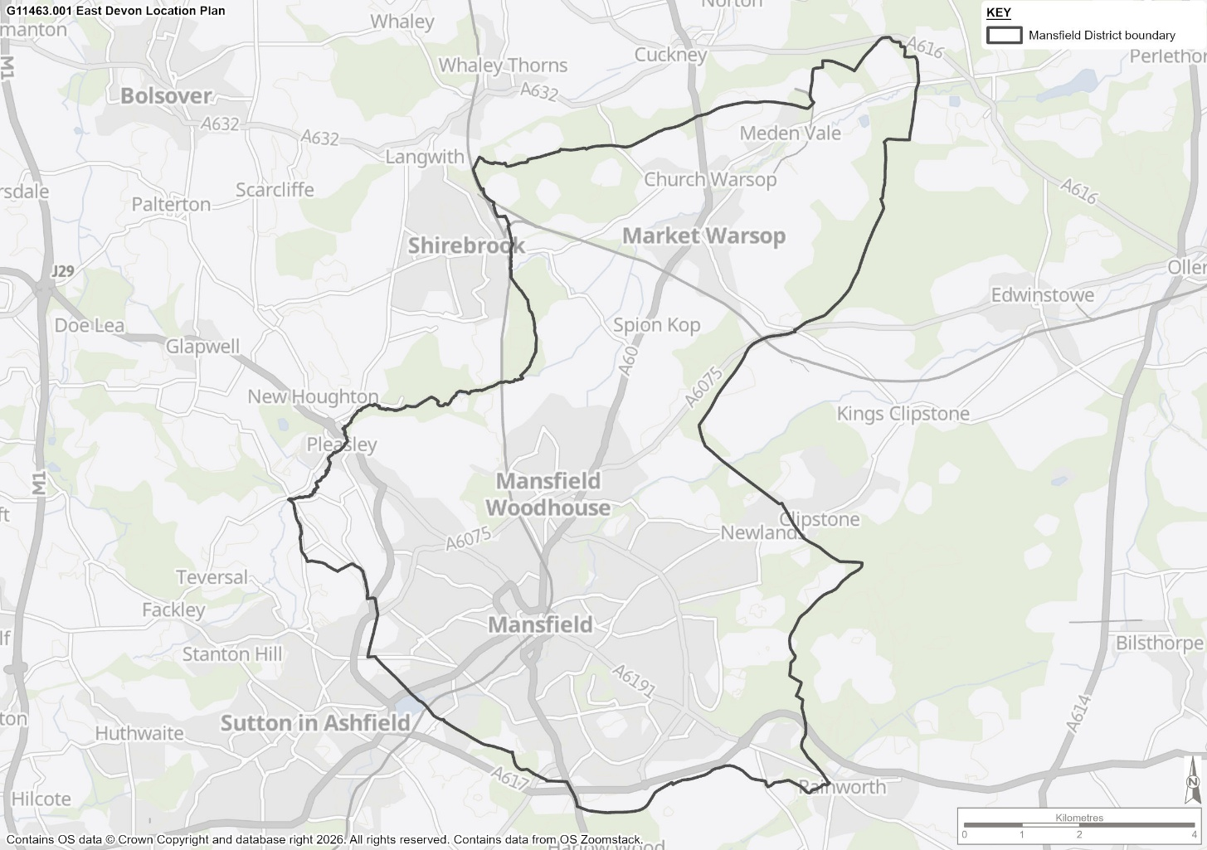

Current and Future Population

- The current and future population figures used in this PPOSS, have been developed by Justin Gardner Consulting on behalf of MDC. These population projections are in line with the Mansfield Local Plan Review and have been developed to ensure that this PPOSS is able to accurately reflect impact of population growth on the demand for outdoor sports facilities to 2043.

- Table 1 shows the current and future population figures that will be used to inform this PPOSS:

Table 1: Current and Future Population for Mansfield District Council Area

 | Population 2026 | Population 2043
Mansfield | 114,638 | 126,887

- It must be noted that although these figures consider housing development and its associated growth, that additional large scale housing sites may be allocated, providing further population growth. As a result of this, the future growth of team numbers in sports such as football, rugby union and cricket identified in this assessment report, may be provide a conservative estimate of growth. However, the impact of projected and allocated housing development on the demand for outdoor sports facilities will be explored in depth as part of the Strategy and Action Plan (Stage D) and will inform accurate and targeted recommendations for all pitch sports in Mansfield to 2043.

Project Scope and Objectives

- A PPOSS is a strategic assessment that provides an up-to-date analysis of supply and demand for playing pitches (grass and artificial) and its current and future demand in the local authority. The strategy and the evidence base upon which it is based is delivered using national guidance and facility insight from specific Governing Bodies of Sport. The assessment will focus on facilities used by the following sports:

- Football
- Rugby Union
- Rugby League
- Cricket
- Hockey
- Tennis
- Padel
- Netball
- Outdoor Bowls
- Pétanque
- Within these sports included in this strategy, the strategy will seek as far as is practicable to include consideration of all forms of play, whether;

- Club and league based (formal) competitions and training.

- Less formal programmed forms of the respective sports (e.g. turn up and play products such as Rush Hockey, Walking Football, All Stars Cricket, and Touch Rugby)

- Informal and un-programmed play by groups of residents, workers, students, school friends (out of school).

- The PPOSS will provide a holistic analysis of sports facilities across the Study Area. This will lead to a comprehensive set of recommendations for the future development of leisure / health and wellbeing provisions, in line with the needs of local residents.

- The steering group has worked with the Council to provide a strategy that is fit-for-purpose and addresses the specific issues and risks for the area. It is key that this Playing Pitch and Outdoor Sport Strategy reflects the local context and enables the Council to maximise the amount of high-quality sporting provision for its residents, while understanding the need to meet planning and housing requirements.

Methodology

- The assessment methodology adopted for the PPOSS follows the published guidance from Sport England. The guidance used is the 2013 version, ‘Playing Pitch Strategy Guidance – An Approach to Developing and Delivering a Playing Pitch Strategy’. Figure 1.1 summarises the approach proposed in this guidance and is broken down into 10 steps.

Figure 1: Developing and Delivering a Playing Pitch Strategy – The 10 Step Approach (Sport England, 2013)

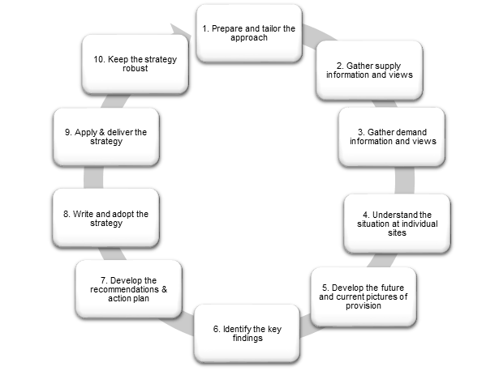

- The PPS methodology involves the gathering of supply and demand information from a range of sources. An initial audit of outdoor sports facilities is gathered using Sport England’s Active Places Power (APP) online tool. This audit will then form the basis of the supply information, before being informed through other sources. Non-technical site assessments, club surveys, and Council officer and NGB consultation will also influence this information.

- The supply information gathered should include the following:

- Site name and location
- Ownership and management type
- Number and type of pitches
- Accessibility
- Pitch and ancillary facility quality
- Maintenance information
- Security of tenure or community use agreements
- The views of users, providers and other relevant groups.

- The audit of playing pitch provision should also include any sites that are currently disused. Although any such sites are not included in the current supply, they should be recorded and considered as part of the PPOSS development, as their reinstatement could be considered where suitable, as a method of meeting any current or future shortfalls.

- In addition to supply data, it is important to gather information regarding the demand for outdoor sports facilities. Using information provided by NGBs at Stage A, club affiliation data, league secretaries, education information and club surveys etc, it is possible to build an accurate picture of the demand for that each specific site caters for. The demand information required to inform the PPOSS is as follows:

- Sport clubs matches and training.
- Casual and other demand
- Educational demand
- Displaced demand
- Unmet and latent demand
- Trends and changes
- Future demand

- All pitch sports are subject to the Playing Pitch Strategy (PPS) methodology, whereas other outdoor sports (e.g. tennis) are assessed using the Assessing Needs and Opportunities Guidance (ANOG). There are 4 stages to the ANOG assessment:

- Stage A – Prepare and tailor the approach.
- Establish a clear understanding of the purpose, scope and scale of the assessment. This will be undertaken in line with Stage A of the PPS methodology.

- Stage B – Gather information on supply and demand.
- To build a clear picture of the supply of outdoor facilities, information will be gathered on the quality, quantity, accessibility and availability of individual sites.
- Demand data such as local population, club affiliation, educational demand, unmet/latent demand, future growth and sport specific priorities will be gathered.
- Supply and demand data will be gathered alongside Stage B of the PPS methodology, using consultation, club surveys, site assessments etc.

- Stage C – Assessment – bringing the information together.
- Development of the key findings regarding quality, quantity, accessibility and availability of outdoor sports provision in the area. Implications of each site will be developed on the principle of protect, enhance and provide.

- Application – Application of the assessment
- All key findings and priorities from Stage A – C will be applied and used to inform sports strategy, planning policy, infrastructure planning and funding applications.

- The findings in this report are based on data collected from several credible sources, including but not limited to;

- Local authority and public policy strategic documentation;
- Sport England tools, including the Active Places Power, the Active Lives Survey, the Playing Pitch Calculator and the Sports Facility Calculator;
- Stakeholder consultation, including Mansfield District Council Officers and Members, Sport England, relevant National Governing Bodies of Sport, education providers, key user clubs; and
- Site visits, undertaken at all strategically important sites across the Study Area.

- A project steering group comprising representation from the Council, Sport England and National Governing Bodies of Sport (NGBs) has guided the study from its commencement. At critical milestones, the Steering Group members have reviewed and verified the data and information collected to allow the work to proceed efficiently through each stage.

Report structure

- The structure of the PPOSS report is as follows:

- Section 1 – Introduction and Methodology
- Section 2 – Football
- Section 3 – 3G Artificial Grass Pitches
- Section 4 – Hockey
- Section 5 – Rugby Union
- Section 6 – Rugby League
- Section 7 – Cricket
- Section 8 – Tennis
- Section 9 - Padel
- Section 10 – Netball
- Section 11 – Bowls

- In addition to this needs assessment, a strategy document has also been produced, which provides future recommendations, scenario testing and a site-by-site action plan for key sites across the local authority.

Football Stage C Assessment

Introduction

  - This section of the report focusses on the supply and demand for grass football pitches. There is a separate standalone section that covers all Artificial Grass Pitches (AGP) including the 3rd Generation (3G) pitches, that are becoming increasingly important to service the needs of football for both competitive play and training.

  - This section includes the headline findings from the PPOSS, as well as a site-by-site analysis of football sites across Mansfield.

Strategic Priorities for Football

  - Football in the study area is governed by Nottinghamshire FA (NFA), who work to administer the provision of football in Mansfield and support the strategic priorities highlighted below.

  - The Football Association’s (FA) National Football Facilities Strategy (NFFS) provides a strategic framework that sets out key priorities and targets for the national game (i.e., football) over a ten-year period.

  - The Strategy sets out shared aims and objectives it aims to deliver on in conjunction with The Premier League, Sport England and the Government, to be delivered with support of the Football Foundation.

  - These stakeholders have clearly identified the aspirations for football to contribute directly to nationally important social and health priorities. Alongside this, the strategy is clear that traditional, affiliated football remains an important priority and a core component of the game, whilst recognising and supporting the more informal environments used for the community and recreational game. Its vision is: “Within 10 years we aim to deliver great football facilities, wherever they are needed”

  - The NFFS investment priorities can be broadly grouped into six areas, recognising the need to grow the game, support existing players and better understand the different football environments:

- Improve 20,000 Natural Turf pitches, with a focus on addressing drop off due to a poor playing experience.
- Deliver 1,000 3G AGP ‘equivalents’ (mix of 11v11 and small sided provision, including Multi Use Games Area (MUGAs) - small, sided facilities are likely to have a key role in smaller / rural communities and encouraging multi-sport offers), enhancing the quality of playing experience and supporting a sustainable approach to grass roots provision.
- Deliver 1,000 changing pavilions/clubhouses, linked to multi-pitch or hub sites, supporting growth (particularly in women and girls’ football), sustainability and providing a facility infrastructure to underpin investment in coaching, officials and football development.
- Support access to flexible indoor spaces, including equipment and court markings, to support growth in futsal, walking football and to support the education and skills outcomes, exploiting opportunities for football to positively impact on personal and social outcomes for young people.
- Refurbish existing stock to maintain current provision, recognising the need to address historic under-investment and issues with refurbishment of existing facilities.
- Support testing of technology and innovation, building on customer insight to deliver hubs for innovation, testing and development of the game.

  - Work carried out as part of the updated Football Foundation’s Mansfield Local Football Facility Plan (LFFP) in 2025, established a 10-year vision for football facilities that aims to transform the playing pitch stock and ‘built’ facilities in a sustainable way. It will build on existing local evidence and strategic planning work. For example, an LFFP will complement and take forward relevant actions from a Local Authority’s ‘Playing Pitch Strategy’ (PPOSS) rather than acting as a substitute for having a PPOSS in place. By doing so, an LFFP will identify the FA and FF’s priority projects to deliver and will act as an investment portfolio for schemes that require funding. As such, we estimate that 90% of all national football investment (FA, Premier League, Sport England and Department for Digital, Culture, Media and Sport (DDCMS) via the Football Foundation) in your Authority will be identified via your LFFP’.

  - The LFFP is intended for footballs use towards potential projects. This Playing Pitch Strategy is the key strategic planning document, superseding the LFFP and should help to inform its recommendations and priority projects. Therefore, it is recommended the LFFP should be updated following the completion of the PPOSS.

Supply

  - The audit identifies a total of 82 grass football pitches across 31 sites in Mansfield. 59 pitches are available for community use, across 16 sites.

  - Table 2 highlights the breakdown of different pitch types across available sites in Mansfield, as well as stating the number of unavailable sites. An unavailable site is one which does not provide access or opportunity for the wider community to participate in sporting activity. Although these are often education sites, professional club pitches can also be classed as unavailable. It must be noted that although currently unavailable sites are not included in the total capacity analysis, it does not mean they cannot be utilised to help meet demand for playing pitches in the future. Securing community use agreements on education sites is often an effective way to minimise any deficit of grass pitch provision and provide additional opportunities for people to engage in football activity. A list of unavailable sites is included in Table 3.

Table 2: Summary of Grass Football Pitches in Mansfield.

Analysis area | No. unavailable pitch sites | No. available Playing Pitch Sites |  | Total Pitches Available for Community Use |  |  |  |  | Total Available Pitches | Total Secure Pitches
Analysis area | No. unavailable pitch sites | Secure | Unsecure | Adult | Youth 11v11 | Youth 9v9 | 7v7 | 5v5 | Total Available Pitches | Total Secure Pitches
Mansfield | 15 | 11 | 5 | 24 | 7 | 12 | 10 | 6 | 59 | 44

  - Of the 59 available pitches in Mansfield, 24 are adult 11v11, 7 are youth 11v11, 12 are youth 9v9, 10 are 7v7 and 6 are 5v5 pitches. However, only 44 pitches across 11 sites offer secure community access. Map 2 shows the locations of all available pitch sites in Mansfield.

  - There are a number of pitches across the study area that are overmarked with smaller-sided pitches. Where this is the case, the smaller sided pitch has not been included in Table 3’s figures and any demand for them will be attributed to the larger pitches in the supply and demand analysis. Overmarked pitches are present at Forest Town Arena, Samworth Church Academy and John Fretwell Sporting Complex.

  - Table 3 identifies the unavailable pitches in the study area, of which there are 23.

Table 3: Summary of Unavailable Grass Football Pitches in Mansfield.

Site Name | Number of Unavailable Pitches by Type |  |  |  |  | Total Pitches
Site Name | Adult | Youth 11v11 | Youth 9v9 | 7v7 | 5v5 | Total Pitches
All Saints Catholic Academy | 1 | 1 |  |  |  | 2
Dawn House School |  |  |  |  | 1 | 1
Farmilo Primary School and Nursery |  |  |  | 1 |  | 1
Forest Town Primary School |  | 1 |  |  |  | 1
High Oakham Primary School |  |  |  | 1 |  | 1
Holly Primary School |  |  |  |  | 1 | 1
King Edward Primary and Nursery School |  |  | 1 |  | 2 | 3
Manor Sport and Recreation Centre | 2 | 1 | 1 | 1 |  | 5
Mansfield Primary Academy |  |  |  | 1 |  | 1
Meden School | 1 |  |  |  |  | 1
St Philip Neri With St Bede Catholic Voluntary Academy |  |  |  | 1 |  | 1
Sutton Road Primary And Nursery School |  |  |  | 2 |  | 2
The Flying High Academy |  |  |  | 1 |  | 1
Wainwright Primary Academy |  |  | 1 |  |  | 1
Total | 5 | 3 | 3 | 8 | 4 | 23

  - Although currently unavailable for community use, both Manor Sport and Recreation Centre and Meden School have aspirations to open their facilities to the community. However, issues such as staff capacity, funding and operational responsibility are barriers in providing access to the wider community outside of school hours.

  - Manor Sport and Recreation Centre has previously had a formal community use agreement in place; but this lapsed during Covid-19. However, other schools in the same academy trust, but outside of Mansfield, have recently reopened their facilities to the community.

  - Although the above issues require consideration by the schools, MDC and Nottinghamshire County Council, the NFA could help to signpost and link community clubs to the education sites and Nottinghamshire Active Partnership could also play a role in assisting schools in opening up their facilities. The impact of increasing external use of education sites will be explored as part of the strategy and action plan of this PPOSS.

Map 2: All available pitch sites across Mansfield

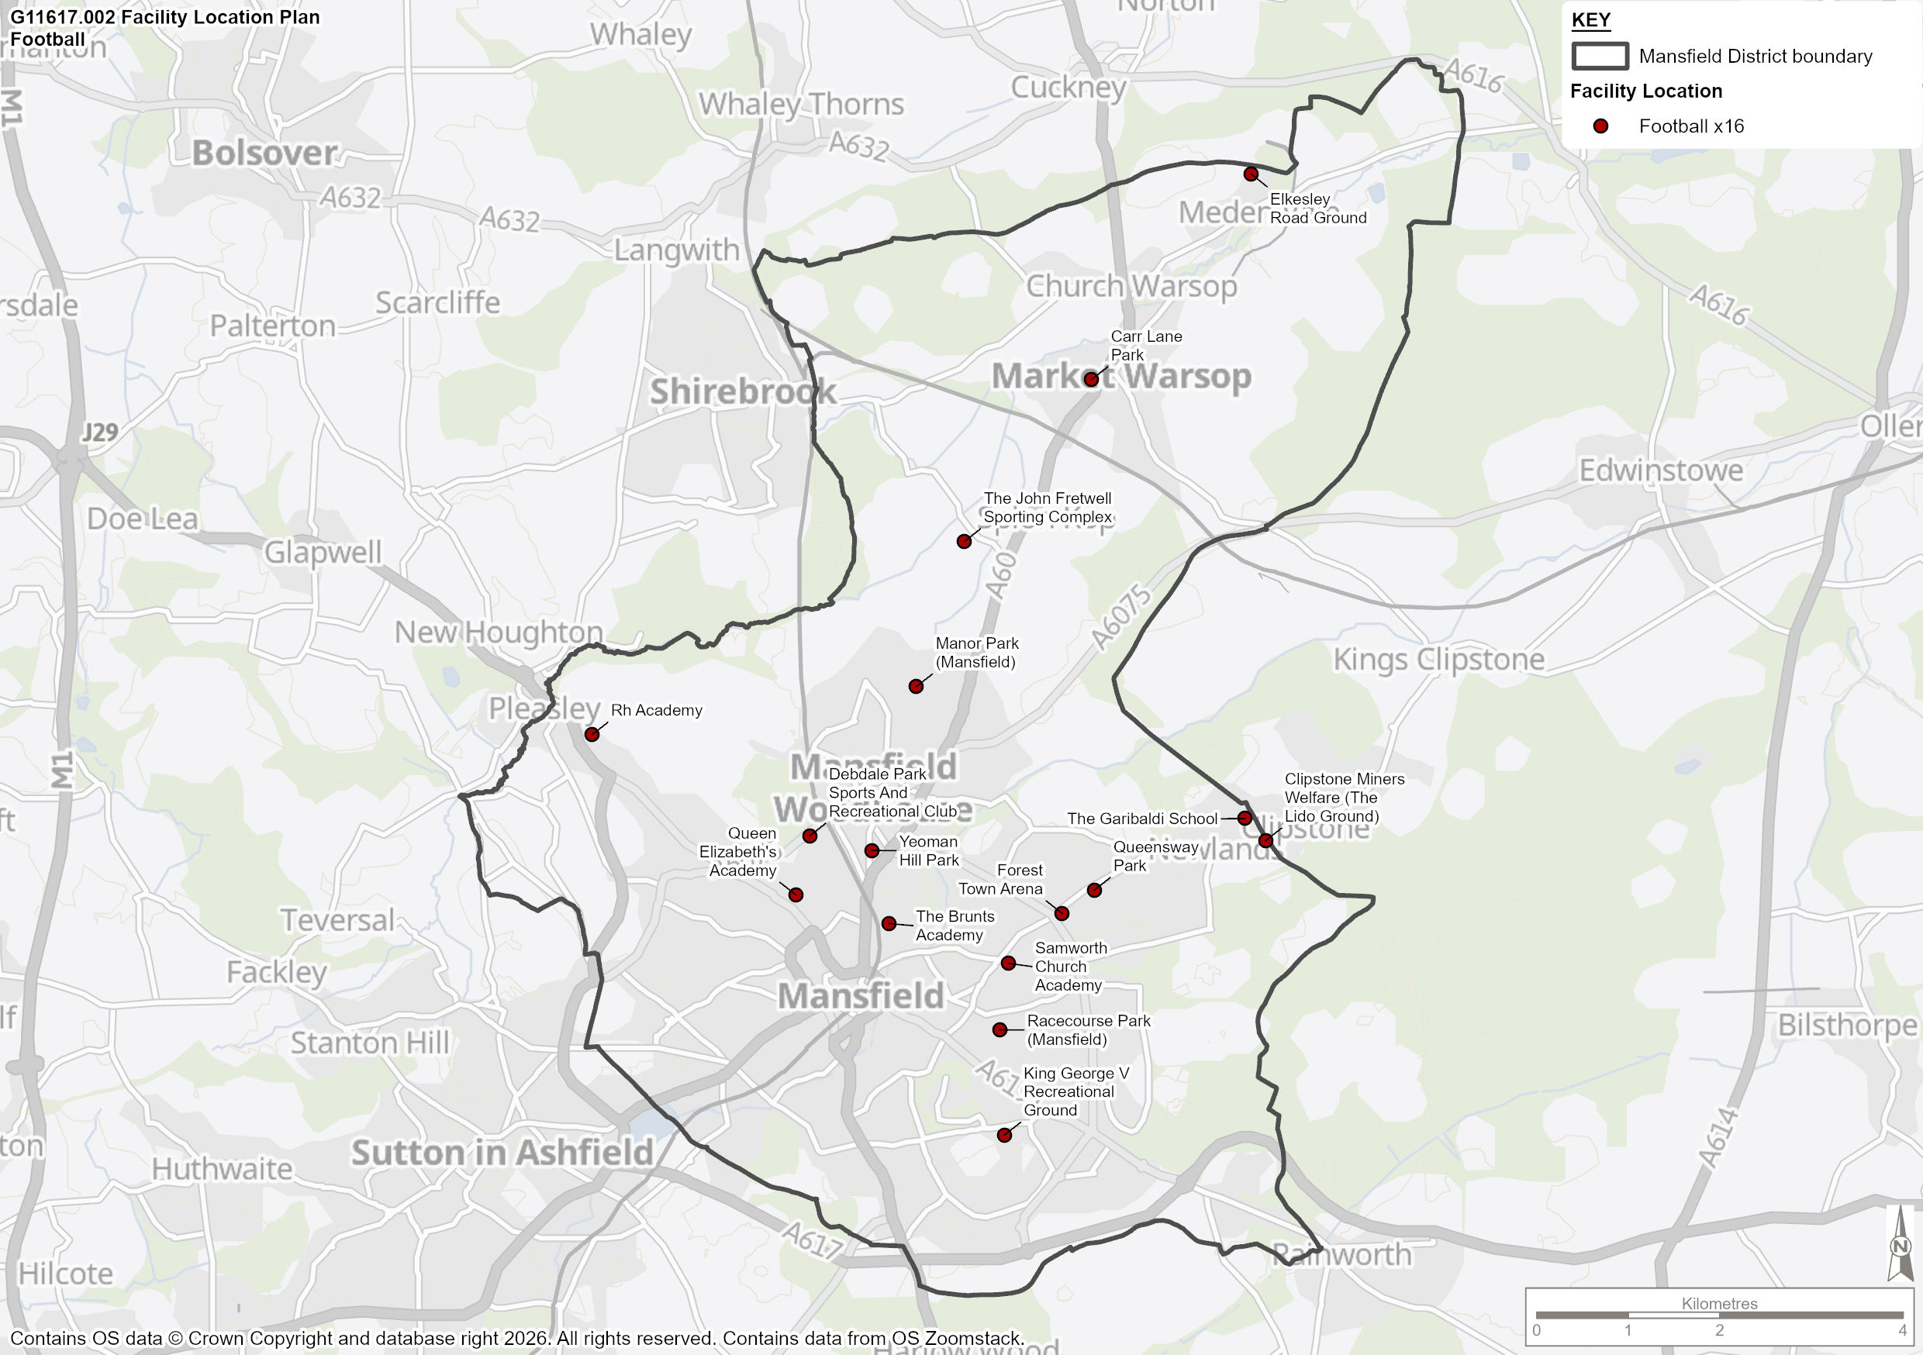

Disused Provision

  - The National Planning Policy Framework (NPPF) defines a playing field as “the whole of a site which encompasses at least one playing pitch as defined in the Town and District Planning Order 2015”. A disused site is defined by Sport England’s PPOSS guidance “is any site where pitches were once, but are no longer, marked out and remain undeveloped”.

  - Disused pitches must still be assessed using the criteria in paragraph 104 of the National Planning Policy Framework and Sport England may challenge a proposed loss of playing pitches/playing field which fails to meet such criteria.

Table 4: Disused or Unused Pitches Mansfield

Site Name | Postcode | Previous Pitch Size | Reason for no use
Abbots Road Playing Fields | NG19 6NB | Adult Football | No grass pitches currently marked out
Bull Farm Park | NG19 7JJ | Junior Football 11v11 | No grass pitches currently marked out
Church Warsop Sports And Social Club (Closed) | NG20 0SS | Adult Football | Closed
Eastlands Junior School | NG20 9PA | Junior Football 11v11 | No grass pitches currently marked out
Maun Valley Park | NG19 0QH | Adult Football | No grass pitches currently marked out
Oak Tree Leisure Centre | NG18 3RT | Adult Football | No grass pitches currently marked out
Sandy Lane | NG18 2LT | Adult Football | No grass pitches currently marked out
The Beech Academy | NG19 6DX | Junior Football 11v11 | No grass pitches currently marked out
The Carrs | NG20 0AT | Junior Football 11v11 | No grass pitches currently marked out
The Carrs | NG20 0AT | Adult Football | No grass pitches currently marked out
Vision West Nottinghamshire College | NG18 5BH | Adult Football | No grass pitches currently marked out
Woburn Lane (Closed) | NG19 7RT | Adult Football | No grass pitches currently marked out

Proposed Supply changes

  - There are planning application (2024/0007/OUT) in place for the development of 120 residential homes to be developed on the site of Clipstone Lido Ground. The site currently has adult 11v11, youth 9v9 and 5v5 pitches, as well as 1 cricket pitch with 9 grass wickets. Although planning proposals include the relocation of provision to an alternative site a short distance away, the new site is outside of the MDC area in Newark and Sherwood.

Current Position for Football

  - This section presents the current position for grass football pitches for the study area. It will first highlight the supply information regarding sites, number of pitches and their quality. Data regarding the demand for all types of football in Mansfield will then be set out before a supply and demand analysis is undertaken for each site and Mansfield as a whole.

  - Nottinghamshire FA (NFA) and the Football Foundation utilise PitchPower to revolutionise the state of grass football pitches across England, ensuring that by 2030, grassroots football has 20,000 'good' quality pitches to enjoy. PitchPower is a web app that allows organisations to quickly and easily inspect, grass pitch(es) directly from a mobile phone. The app is used to submit information about pitch(es) to the Grounds Management Association who assess the site. After the assessment is complete, a report is received which evidences the technical quality score and provides recommendations as to what is needed to improve the pitch(es). The pitch quality scores given in Table 5 have been informed by the Pitch Power assessments provided by Nottinghamshire FA, however changes to quality may have occurred since the assessments were carried out. Further, site specific details regarding PitchPower are provided below.

  - The following clubs/sites are being supported by Nottinghamshire FA and the Football Foundation through the PitchPower process defined above. Through this initiative, these clubs and sites will have improved maintenance regimes with the aim of improving the quality of pitches, allowing additional usage during the season.

  - The PitchPower quality ratings reflect the pitch assessment ratings in this report.

- John Fretwell Sporting Complex
- Debdale Park Sports and Recreation Club
- Elkesley Road Ground
- Forest Town Arena

  - Table 5 indicates the quality assessments for each available site and pitch in Mansfield. The following information includes only sites which are available for community use.

Table 5: Pitch Quality in for Grass Football Sites in Mansfield

Mansfield | Adult Pitches |  |  | Youth 11v11 Pitches |  |  | Youth 9v9 Pitches |  |  | Mini 7v7 |  |  | Mini 5v5 |  |  | Total No. Pitches
Mansfield | Good | Standard | Poor | Good | Standard | Poor | Good | Standard | Poor | Good | Standard | Poor | Good | Standard | Poor | Total No. Pitches
Carr Lane Park |  |  | 1 |  |  | 1 |  |  |  |  |  |  |  |  |  | 2
Clipstone Miners Welfare (The Lido Ground) | 1 |  |  |  |  |  |  | 1 |  |  |  |  |  | 1 |  | 3
Debdale Park Sports And Recreation Centre | 2 |  |  |  |  |  |  |  |  | 1 |  |  |  |  |  | 3
Elkesley Road Ground |  |  | 2 |  |  |  |  |  | 1 |  |  |  |  |  | 2 | 5
Forest Town Arena | 2 |  |  |  |  |  | 1 |  |  | 1 |  |  |  |  |  | 4
King George V Recreational Ground |  | 1 | 2 |  |  |  |  |  |  |  |  |  |  |  |  | 3
Manor Park (Mansfield) |  | 2 |  |  |  |  |  | 4 |  |  | 4 |  |  |  |  | 10
Queen Elizabeth's Academy |  | 1 |  |  |  |  |  |  |  |  |  |  |  |  |  | 1
Queensway Park |  |  |  |  |  | 1 |  | 1 |  |  | 1 |  |  |  | 1 | 4
Racecourse Park (Mansfield) |  | 1 |  |  |  | 1 |  | 1 |  |  |  |  |  |  | 1 | 4
RH Academy | 2 |  |  |  |  |  | 1 |  |  |  |  |  |  |  |  | 3
Samworth Church Academy |  | 3 |  |  |  |  |  |  |  |  |  |  |  |  |  | 3
The Brunts Academy |  | 2 |  |  | 1 |  |  |  |  |  |  |  |  |  |  | 3
The Garibaldi School |  | 2 |  |  | 2 |  |  | 1 |  |  |  |  |  |  |  | 5
The John Fretwell Sporting Complex |  |  |  | 1 |  |  | 1 |  |  | 2 |  |  | 1 |  |  | 5
Yeoman Hill Park |  |  |  |  |  |  |  |  |  |  | 1 |  |  |  |  | 1
TOTAL | 7 | 12 | 5 | 1 | 3 | 3 | 3 | 8 | 1 | 4 | 6 | 0 | 1 | 1 | 4 | 59

  - Based on the information in Table 5, of the 59 available pitches in Mansfield, 24 are Adult 11v11, 7 are Youth 11v11, 12 are 9v9, 10 are 7v7 and 6 are 5v5.

  - PitchPower ratings and non-technical site assessments suggest that there is a mixture of quality across the supply of pitches, with 27% (16) being of good quality, 51% (30) standard quality and 22% (13) poor quality.

Ancillary Facilities

  - The quality of ancillary facilities across Mansfield have been assessed via a combination of site visits and user consultation to reach and apply an agreed rating as follows:

Good
Standard
Poor

  - Ancillary facility ratings are primarily influenced by the type of amenities which are available on a site accompanied by their quality, such as a clubhouse, changing rooms, showering provision, car parking, dedicated official and spectator facilities and boundary fencing. Table 6 below identifies the findings for football sites that are actively utilised for football across Mansfield.

Table 6: Site by site analysis of ancillary facility quality

Site | Ancillary facility quality
Carr Lane Park | Poor
Clipstone Miners Welfare (The Lido Ground) | Good
Debdale Park Sports And Recreation Centre | Good
Elkesley Road Ground | Good
Forest Town Arena | Good
King George V Recreational Ground | Poor
Manor Park (Mansfield) | Good
Queen Elizabeth's Academy | Standard school changing – not accessible
Queensway Park | Standard
Racecourse Park (Mansfield) | Poor
RH Academy | Good
Samworth Church Academy | Standard school changing – not accessible
The Brunts Academy | Standard school changing – not accessible
The Garibaldi School | Standard school changing – not accessible
The John Fretwell Sporting Complex | Good
Yeoman Hill Park | No ancillary provision

Current Demand

  - Football is the most popular team sport across Mansfield with a total of 217 teams across 35 clubs. As part of the PPOSS process, all clubs were given the opportunity to respond to consultation, allowing them to provide their views on facilities, developments, issues and growth plans. Responses cover 167 teams or 76% of the total number of teams in the study area. An overview of the consultation is included in Table 7.

Table 7: Football Consultation Summary

Club | Primary Site Name | Consultation Summary
Clipstone Welfare Colts | Clipstone Miners Welfare (The Lido Ground) | Clipstone Welfare Colts utilize the Lido Ground, which is owned and managed by the club. The club also uses additional training areas including a grass pitch and several artificial surfaces, with usage ranging from a few hours to several hours per week. The club runs multiple youth teams from U7 to U16 competing in league formats from 5v5 through to 11v11, including female teams at U12 and U14 level, and in recent years the number of youth teams has generally increased while junior numbers have stayed the same. The club expects further growth over the next three seasons across boys’, girls’, and adult teams. The main site has basic ancillary provision including toilets, floodlights, storage, perimeter barriers, and compliant goalposts, with maintenance carried out regularly but with mixed pitch quality across sites. The club hires additional pitches at significant annual cost and has indicated plans to move to a new facility in the future in order to support development and improve playing provision.
Market Warsop FC | John Fretwell Sporting Complex | Market Warsop Football Club is based at the John Fretwell Sports Complex, where it rents multiple standard-quality pitches on long-term agreements of over 10 years, leased from the Warsop Sporting Trust and managed and maintained by the site itself; maintenance includes cutting, line marking, and seeding, and overall pitch upkeep is rated as good. The club uses several training venues—Brunt’s School, Garibaldi School, Joseph Whitaker School, Shirebrook Academy, as well as additional sites—for 2–3 hours per week on standard-quality 3G/4G surfaces. The club fields a wide range of youth teams from U7 to U15, including both boys’ and girls’ teams, with four female-only teams overall, and has seen growth in youth participation over the past three years. All competitive matches are played locally, primarily at the main ground. The club has access to good-quality ancillary facilities including changing rooms, showers, toilets, a kitchen, a bar, equipment storage, disabled access, and FA-compliant goalposts. Future development plans include a 3G pitch, for which planning permission has been secured but funding is still required, and the overall cost of hiring and leasing pitches across all sites is approximately £4,000 per month.
Silva FC | Brunts Academy | Silva FC is a community football club operating across four main sites—Nottingham Football Centre (Rushcliffe School), Carlton Football Centre, Southglade Park Hub, and Brunts Football Centre—which serve as both home and training grounds, all with good-quality pitches; three sites are leased long-term from schools while one is club-owned, and all are maintained by the club with excellent maintenance programmes focused on pitch and goal upkeep.  The club uses 3G/4G surfaces extensively, averaging around 25 hours per week per site, and has access to ancillary facilities of generally good or standard quality, including changing rooms, officials’ rooms, showers, kitchen, toilets, and bar, as well as floodlights, storage, disabled access, pitch barriers, and FA-standard goalposts. Silva FC currently fields a large and growing number of teams, predominantly in competitive league football, spanning U7 to U14 boys’ teams, a veterans’ team, and four female-only teams (three U8 and one U13), with significant growth over the past three years across junior, youth, and girls’ football.  The club has ambitious plans to further expand across multiple formats (5v5, 7v7, 9v9, and 11v11) for both boys and girls over the next three seasons, does not require teams to travel outside the county, and has facility development plans in place, including a new kiosk at Brunts and a new pavilion at Carlton, while sites also accommodate regular school use.
FC Skegby | Racecourse Park | FC Skegby is a football club that plays its home matches at Mansfield Racecourse, where it rents a pitch from the local council on a one-year agreement; the site is both managed and maintained by the council, although pitch quality is rated as poor and maintenance is perceived to be minimal. The club currently operates one senior men’s team competing in 11v11 competitive league football, with no female teams and no recent change in team numbers over the past three years, but it has realistic plans to add one 7v7 boys’ team and one 7v7 girls’ team over the next three seasons. The club does not use a training ground, does not travel outside the county for provision, and has no facility development plans. Ancillary facilities at the main ground are available and rated as good, including changing rooms, officials’ room, showers, and toilets, alongside disabled access and FA-standard goalposts. Pitch hire costs are recorded for the home ground, informal use such as dog walking occurs on the site, and overall ground maintenance is rated as standard.
M&J Ballers | Samworth Church Academy | M&J Ballers is a football club based at Samworth Church Academy, which serves as both its home and training ground, The club trains extensively and pays £176 per month for pitch hire, with maintenance described as standard but infrequent, as grass cutting has not occurred for several months. The club currently runs one under-9s team and has realistic plans to expand over the next three seasons by adding additional youth teams across boys’ and girls’ formats. All teams play within the local area, and the club does not have access to ancillary facilities or any current facility development plans. However, as a regular user of the park, the club has expressed concern about limited maintenance and outlined long-term aspirations to secure local land for modern facilities such as changing rooms, storage, social spaces, and a 3G artificial pitch to reduce weather-related cancellations and support the development of local young footballers.
Manor FC Youth | Manor Park | Manor FC Youth is a grassroots football club that plays its home matches at Manor Sports Complex, a council-owned and rented grass pitch which is currently in poor condition and receives minimal maintenance from the council, leading club volunteers to undertake pitch marking, grass cutting, and matchday setup themselves.  The club also trains at North Notts Hockey Astro for around 4–5 hours per week on a poor-quality artificial surface, with limited access due to availability and a hire cost of £60 per hour. The club fields multiple junior boys’ teams ranging from U6 to U11, primarily competing in 5v5, 7v7, and 9v9 formats, with one U12 team planned, and has seen growth particularly in junior boys’ teams over the past three years. There are currently no female-only teams, although there is one girl training with the U8s and the club would like to develop girls’ teams if interest increases. All teams play locally within the county, access to facilities is limited to basic amenities such as toilets, and there are no current development plans, with overall pitch quality and maintenance identified as key challenges affecting both match and training provision.
Woodhouse Colts FC | Forest Town Arena | Woodhouse Colts operate primarily from Forest Town Arena and Queensway, managing two home sites: Forest Town Arena, which is privately owned by the club and maintained to a standard quality, and Queensway, a council-owned site that is maintained by the club but currently rated poor in quality. The club also uses Forest Town Arena and All Saints School for training, with limited weekly hours across grass and 3G/4G surfaces. The club currently fields two U12 teams playing 9v9 competitive league football at their main ground, with no teams traveling outside the county. Ancillary facilities are available at both main sites at a standard level, though no facility development plans are in place. Maintenance is rated good at Forest Town Arena and poor at Queensway. The club highlights significant challenges in sourcing an additional 9v9 pitch following recent FA rule changes, as well as a lack of suitable training facilities locally, particularly midweek access to 4G pitches, compounded by the poor condition and misuse of many council-managed pitches.
Meden Vale Colts | Elkesley Road | Meden Vale Colts FC is a community football club based at the Elkesley Road Complex, where it operates on a leased site (10+ years) from Coal Industry Social Welfare Organisation (CISWO) that is managed and maintained by the club and its volunteers; both match and training pitches are grass and currently rated poor, with heavy usage exceeding 10 hours per week across weekdays and weekends.  The club runs a large and diverse football programme including junior, youth, senior, veteran, and female-only teams, totalling numerous sides across age groups from under-5s to adults, with eight dedicated female teams ranging from under-7s to ladies seniors, all competing or training at the same ground. Over the past three years, the club has experienced growth across most categories and has realistic plans to further expand team numbers over the next three seasons. Facilities at the main site include changing rooms, showers, toilets, a kitchen, officials’ room, storage, pitch barriers, dugouts, and FA-compliant goalposts, with ancillary facilities rated as good, although significant development is urgently required to support current demand and future growth. Planned improvements include pitch upgrades, a 3G surface, better goals, security, fencing, lighting, signage, parking, additional toilets and changing rooms, and the creation of a social space, with the ground currently costing £500 per month to lease and undergoing a regular maintenance programme involving aeration, overseeding, cutting, line marking, weed control, and fertilisation, while remaining accessible for informal use by local residents.
West Nottinghamshire College | King George V Playing Fields | West Nottinghamshire College Boys/Girls Football Club operates primarily from two home grounds: King George V Playing Fields (Ground 1), which is council-managed and maintained, rented on a year-by-year basis and currently assessed as having poor pitch quality, and Mansfield Town Academy Pleasley (Ground 2), which is club-managed and maintained, owned on a long-term basis (10+ years) and has good pitch quality. Training takes place at Nottingham College 3G facilities and Mansfield Town Academy on good-quality 3G/4G surfaces, used for approximately 3–4 hours per week in total. The club currently runs two U19 teams playing 11v11 competitive league football at Ground 1, alongside a female college team playing 9v9 with plans to progress to 11v11 next season; senior female team numbers have increased by one in the past three years, while other sections have remained stable. No teams travel outside the county for provision.  Ancillary facilities are available at the main site, including changing rooms and showers, though quality is rated poor at Ground 1. Pitch hire costs are approximately £500 per season, with maintenance rated as standard at Ground 1 and excellent at Ground 2, and Ground 1 is shared with grassroots clubs at weekends. The club has no current facility development plans but has identified that its existing college 3G pitch is undersized for needs and would welcome funding to develop a larger 3G pitch on adjacent grassland.
Mansfield Town FC | One Call Stadium | Mansfield Town FC operates from the One Call Stadium, which includes both the main stadium pitch and additional 3G pitches, all of which are owned, managed, and maintained by the club and are reported to be of good quality. The club’s training base is the Radford & Hymas Academy, where both grass and 3G/4G pitches are used, also rated as good quality, with training taking place for approximately 20–25 hours per week across these surfaces. No further information was provided regarding team numbers, age groups, female participation, travel outside the county, ancillary facilities, facility development plans, pitch hire costs, maintenance ratings, informal use, or additional comments.
Bugles.co Reindeer FC | Racecourse Park | Reindeer FC is a football club that plays its home and training matches at the Racecourse ground, which is rented from and managed and maintained by Mansfield District Council; the pitch is grass, rated as poor quality, and is used for training approximately 4–5 hours per week, with the overall maintenance programme described as standard. The club currently fields one senior men’s team competing in 11v11 football, with no change in team numbers over the past three years and no teams travelling outside the county to access facilities. The club has access to basic on-site facilities including changing rooms, an officials’ room, showers, toilets, and disabled access, but reports no ancillary facilities, no current facility development plans, and is unsure of the costs associated with hiring or leasing the pitch.
AFC Mansfield | Forest Town Arena | AFC Mansfield is based at Forest Town Arena, which is rented from the Mansfield Colliery Miners Welfare Trust, who also manage and maintain the site. The club uses the grass training pitch for 8–9 hours per week. It currently fields two senior male teams and one veteran team, all playing competitive 11v11 matches at the home ground, with no female-only teams. Over the past three years, team numbers have remained stable, though there are plans to add one additional adult male team in the next three seasons. The club does not travel outside the county for matches. Ancillary facilities are available at the ground but are rated as poor, including changing rooms, officials’ room, showers, kitchen, toilets, and a bar. The ground features floodlights, training equipment storage, a pitch perimeter barrier, dugouts, spectator stands, and FA-standard goalposts. Facility development plans include a 3G pitch, though current maintenance is considered poor, and dressing rooms and the grass pitch require upgrades. Hiring the pitch costs £5,000.
G3A FC | Brunts Academy | G3A FC is based at The Brunts Academy in Mansfield where the club rents its home and training grounds from FSM. The club uses a combination of 3G/4G and grass pitches, training approximately 17–18 hours per week, though the grass pitches are considered below standard and the 4G pitch cannot accommodate games beyond U11. G3A FC fields teams across multiple age groups, including U7–U21, in formats ranging from 5v5 to full-size 11v11, all playing competitive league fixtures. The club currently has no female-only teams but has plans to expand the number of boys’ and girls’ teams across several age groups over the next three seasons. Some older teams, such as U19 and U21, travel outside the county for matches. Facilities at the home ground include toilets, floodlights, disabled access, a pitch perimeter barrier, and safe goalposts, though ancillary facilities are limited and maintenance is rated as poor, with grass cut monthly and 4G pitches mowed and cleaned. The club has used The Brunts Academy for 4–5 years and, while appreciative of the 4G pitch for training and younger games, it faces challenges finding suitable grass pitches for older teams and has unsuccessfully sought alternatives with the local council.
  - Table 8 outlines the current football demand in Mansfield which is based on the number of affiliated football teams.

Table 8: Football Demand – 2025/2026

Age Category | Male Teams | Female Teams | Mixed | Total
Adult | 23 | 6 | 0 | 29
Youth | 15 | 17 | 71 | 103
Mini | 6 | 7 | 64 | 77
Disability | 1 | 0 | 7 | 8
Total | 45 | 30 | 142 | 217

  - Table 9 outlines the current football provision for women and girls in Mansfield, focussing on female only teams (team numbers below are included in the overall data).

Table 9: Female Only Football Provision

Club | Adult 11v11 | Youth 11v11 | 9v9 | 7v7 | 5v5 | Total No. Teams
Clipstone Welfare Colts |  |  | 1 |  |  | 1
Mansfield Town FC Girls |  | 3 | 1 | 1 |  | 5
Mansfield Town Ladies | 2 |  |  |  |  | 2
Market Warsop FC Youth |  | 1 |  | 2 | 1 | 4
Meden Vale Colts | 2 | 3 | 1 | 1 | 1 | 8
Sherwood Colliery FC Ladies | 1 | 2 | 3 | 1 |  | 7
Shirebrook Rangers | 1 |  |  |  |  | 1
Vision West Nottinghamshire College FC | 1 |  |  |  |  | 1
Woodhouse Colts |  | 1 |  |  |  | 1
TOTAL | 7 | 10 | 6 | 5 | 2 | 30

  - Table 10 outlines the current level of demand for disability football in Mansfield (team numbers below are included in the overall data).

Table 10: Disability Football Provision

Club | Adult 11v11 | Youth 11v11 | 9v9 | 7v7 | 5v5 | Total No. Teams
Meden Vale Colts FC |  |  |  | 3 | 1 | 4
Nottinghamshire Powerchair FC |  |  |  |  | 2 | 2
Sherwood Colliery FC |  |  |  | 2 |  | 2
TOTAL | 0 | 0 | 0 | 5 | 3 | 8

Demand Driven by Exported/Imported Demand

  - In consultation, no Mansfield-based teams highlighted that they utilise pitch provision outside of the study area to meet match play demand. However, Market Warsop FC, indicated that due to a lack of available floodlit AGP pitches, they travel outside of Mansfield to access suitable training facilities. They currently utilise Shirebrook Academy, Shirebrook Leisure Centre and Joseph Whittaker School for approximately 9 hours per week for training purposes.

  - Although Silva FC are based outside of Mansfield, they utilise the 3G pitch at Brunts Academy for around 10 hours per week to meet additional demand for training, alongside use of other facilities outside of the study area.

Demand Driven by Latent Demand

  - Latent demand is demand that evidence suggests may be generated from the current population but cannot be met for a number of reasons. Clubs may identify that could grow team numbers if they had access to more pitches, improved surfaces, training facilities, increased coach availability etc.

  - However, it must be noted that latent demand predictions are often not accurate as they are generated through club consultation, meaning they may not actually be realised in the long term. Therefore, although this Stage C assessment will consider latent demand predictions as part of the future demand analysis, the strategy document and action plan will explore the impact of different levels of latent demand being realised. An overview of latent demand highlighted through consultation is included in Table 11.

Table 11: Latent Demand Predictions

Club | Male Adult 11v11 | Female Adult 11v11 | Male Youth 11v11 | Female Youth 11v11 | Boys 9v9 | Girls 9v9 | 7v7 | 5v5 | Total No. Teams
Market Warsop FC | 3 | 4 | 3 | 3 | 3 | 3 | 6 | 5 | 30
FC Skegby |  |  |  |  |  |  | 2 |  | 2
Manor FC Youth |  |  |  |  | 1 |  | 2 | 2 | 5
Meden Vale Colts | 1 | 1 | 2 | 3 | 1 | 2 | 3 | 4 | 17
AFC Mansfield | 1 |  |  |  |  |  |  |  | 1
G3A FC |  |  | 5 | 1 | 5 | 1 | 6 | 6 | 24
Totals | 5 | 5 | 10 | 7 | 10 | 6 | 19 | 17 | 79

  - A total latent demand of 79 teams has been identified through consultation with clubs across Mansfield, which can be broken down into 10 Adult 11v11, 17 Youth 11v11, 16 9v9, 19 7v7 and 17 5v5 teams.

  - Table 12 indicates that these latent demand figures will increase demand for grass pitches by 39.5 Match Equivalent Sessions (MES)by 2043, potentially significantly impacting football clubs’ access to football provision in Mansfield.

Table 12: Future demand driven by latent demand in MES

 | Adult 11v11 (MES) | Youth 11v11 (MES) | Youth 9v9 (MES) | Mini 7v7 (MES) | Mini 5v5 (MES) | Total (MES)
Mansfield | 5 | 8.5 | 8 | 9.5 | 8.5 | 39.5

Football Supply and Demand information

  - For every site that has grass football provision, an analysis has been undertaken to assess whether each pitch on the site has enough capacity to meet the current level of demand for affiliated football. This analysis has been undertaken for two separate time periods; a) weekly and b) during the peak period.

  - This compares the weekly carrying capacity (in Match Equivalent Sessions – MES) of each individual pitch type with the demand that is placed upon that pitch type over the full week. It may also be referred to as the ‘theoretical capacity’ as it assumes that demand will be spread across the week and is calculated solely from the theoretical carrying capacity of the pitch to withstand training and match play. Table 13 below illustrates how weekly carrying capacity is allocated to each pitch type, depending on its quality rating.

Table 13: Carrying Capacity per Pitch Type. All Figures in MES

Quality score | Adult football | Youth football | Mini soccer
Good (80-100%) | 3 | 4 | 6
Standard (50-79.9%) | 2 | 2 | 4
Poor (0-49.9%) | 1 | 1 | 2

  - Table 14 provides an overview of all pitch capacity and demand across all available sites across Mansfield, categorised by pitch type. All unavailable sites have been dismissed from this list as there is no community use on these sites.

  - Different age categories utilise grass pitches for weekend match play during different peak periods. The following peak times have been identified by the FA:

- Adult 11v11 – Saturday PM
- Youth 11v11 – Sunday PM
- Youth 9v9 – Sunday PM
- Mini soccer – Sunday AM

  - All teams have been assigned 0.5 MES per week. However, if a 7v7 or 5v5 team participates on a senior pitch, then they have been assigned 0.25 MES of demand. This is due to the decrease in impact they will have on the surface. If a club has highlighted that training takes place on the grass pitches, then additional demand has been allocated to that pitch.

  - It is assumed that all education-based pitches have usage of 1 MES per week due to curricular/extra-curricular activity, the exception being where the actual demand for MES from affiliated clubs has been identified on the site. In this case, an additional 1 MES will be added to known football club demand. Education usage does not affect peak time capacity.

  - Although it will be highlighted in the table below, any spare peak time capacity on unsecure sites will be discounted due to the uncertainty that their availability will be sustained. The impact of securing community use agreements on these sites will be explored as part of the Stage D of this PPOSS.

Table 14: Capacity Analysis for Grass Football Pitches

Site name | Security of Use | Pitch Supply | No. Pitches | Pitch Quality Rating | Pitch capacity MES | Pitch demand MES | Balance Weekly MES | Peak period MES
Carr Lane Park | Secure | Adult 11v11 | 1 | Poor | 1 | 2.5 | -1.5 | No spare capacity
Carr Lane Park | Secure | Youth 11v11 | 1 | Poor | 1 | 1.5 | -0.5 | No spare capacity
Clipstone Miners Welfare (The Lido Ground) | Secure | Youth 9v9 | 1 | Standard | 2 | 2 | 0 | No spare capacity
Clipstone Miners Welfare (The Lido Ground) | Secure | Adult 11v11 | 1 | Good | 3 | 1.5 | 1.5 | No spare capacity
Clipstone Miners Welfare (The Lido Ground) | Secure | Mini 5v5 | 1 | Standard | 4 | 2 | 2 | No spare capacity
Debdale Park Sports And Recreation Centre | Secure | Mini 7v7 | 1 | Good | 6 | 6 | 0 | No spare capacity
Debdale Park Sports And Recreation Centre | Secure | Adult 11v11 | 2 | Good | 6 | 6 | 0 | No spare capacity
Elkesley Road Ground | Secure | Adult 11v11 | 2 | Poor | 2 | 6.5 | -4.5 | No spare capacity
Elkesley Road Ground | Secure | Youth 9v9 | 1 | Poor | 1 | 6.5 | -5.5 | No spare capacity
Elkesley Road Ground | Secure | Mini 5v5 | 2 | Poor | 4 | 4 | 0 | No spare capacity
Forest Town Arena | Secure | Adult 11v11 | 2 | Good | 6 | 3.5 | 2.5 | No spare capacity
Forest Town Arena | Secure | Mini 7v7 | 1 | Good | 6 | 3.5 | 2.5 | No spare capacity
Forest Town Arena | Secure | Youth 9v9 | 1 | Good | 4 | 1 | 3 | No spare capacity
King George V Recreational Ground | Secure | Adult 11v11 | 3 | 2 x Poor and 1 x Standard | 4 | 3.5 | 0.5 | No spare capacity
Manor Park (Mansfield) | Secure | Adult 11v11 | 2 | Standard | 4 | 2.5 | 1.5 | No spare capacity
Manor Park (Mansfield) | Secure | Youth 9v9 | 4 | Standard | 8 | 2.5 | 5.5 | 1.5
Manor Park (Mansfield) | Secure | Mini 7v7 | 4 | Standard | 16 | 3.5 | 12.5 | 0.5
Queen Elizabeth's Academy | Unsecure | Adult 11v11 | 1 | Standard | 2 | 1.5 | 0.5 | 0.5
Queensway Park | Secure | Youth 11v11 | 1 | Poor | 1 | 0 | 1 | 1
Queensway Park | Secure | Youth 9v9 | 1 | Standard | 2 | 2 | 0 | No spare capacity
Queensway Park | Secure | Mini 7v7 | 1 | Standard | 4 | 0.5 | 3.5 | 0.5
Queensway Park | Secure | Mini 5v5 | 1 | Poor | 2 | 0 | 2 | 1
Racecourse Park (Mansfield) | Secure | Adult 11v11 | 1 | Standard | 2 | 1 | 1 | No spare capacity
Racecourse Park (Mansfield) | Secure | Youth 9v9 | 1 | Standard | 2 | 0 | 2 | 1
Racecourse Park (Mansfield) | Secure | Youth 11v11 | 1 | Poor | 1 | 0 | 1 | 1
Racecourse Park (Mansfield) | Secure | Mini 5v5 | 1 | Poor | 2 | 0 | 2 | 1
RH Academy | Unsecure | Adult 11v11 | 2 | Good | 6 | 6 | 0 | No spare capacity
RH Academy | Unsecure | Youth 9v9 | 1 | Good | 4 | 3.5 | 0.5 | No spare capacity
Samworth Church Academy | Unsecure | Adult 11v11 | 3 | Standard | 6 | 1.5 | 4.5 | 1.5
The Brunts Academy | Unsecure | Youth 11v11 | 1 | Standard | 2 | 4.5 | -2.5 | No spare capacity
The Brunts Academy | Unsecure | Adult 11v11 | 2 | Standard | 4 | 4.5 | -0.5 | No spare capacity
The Garibaldi School | Unsecure | Youth 11v11 | 2 | Standard | 4 | 2 | 2 | 2
The Garibaldi School | Unsecure | Adult 11v11 | 2 | Standard | 4 | 2 | 2 | 2
The Garibaldi School | Unsecure | Youth 9v9 | 1 | Standard | 2 | 1 | 1 | 1
The John Fretwell Sporting Complex | Secure | Youth 11v11 | 1 | Good | 4 | 3 | 1 | No spare capacity
The John Fretwell Sporting Complex | Secure | Youth 9v9 | 1 | Good | 4 | 0.5 | 3.5 | 0.5
The John Fretwell Sporting Complex | Secure | Mini 7v7 | 2 | Good | 12 | 3 | 9 | No spare capacity
The John Fretwell Sporting Complex | Secure | Mini 5v5 | 1 | Good | 6 | 2 | 4 | No spare capacity
Yeoman Hill Park | Secure | Mini 7v7 | 1 | Standard | 4 | 0.5 | 3.5 | 0.5

Future Demand

Demand Driven by Population Growth

  - To calculate the future demand for football in the Study Area, Team Generation Rates (TGR) have been calculated using the current number of teams and the current population. This measure allows us to calculate what size of population (for various age groups) will typically cause enough demand to create a football team in each of the age categories. Any mixed adult 11v11, youth 11v11 or 9v9 have been attributed to the male classifications. There is no split between boys’ and girls’ teams in 7v7 or 5v5 age groups.

  - This Team Generation Rate can then be applied to the population projections for the Study Area to confirm how population growth or reduction will affect the number of teams in each of the key age groups. It is to be noted that population is just one factor in estimating future teams. Other factors such as NGB initiatives and amount of available provision has a large level of influence.

  - Table 15 below demonstrates that there is an anticipated total increase of 4 teams across Mansfield due to population growth. A full breakdown by age group can be seen below:

Table 15: Future demand driven by population growth.

Age Groups | Current no. of teams | Current Population | Future Population 2043 | Current TGR | Population change |  | Projected team no. change
Adult Men 11v11 (16-45yrs) | 32 | 21,055 | 22,770 | 658 | 1,715 |  | 3
Adult Women 11v11 (16-45yrs) | 7 | 21,265 | 22,095 | 3038 | 830 |  | 0
Youth Boys 11v11 (12-15yrs) | 38 | 2,953 | 2,843 | 78 | -110 |  | 0
Youth Girls 11v11 (12-15yrs) | 10 | 2,832 | 2,692 | 283 | -140 |  | 0
Youth Boys 9v9 (10-11yrs) | 39 | 1,411 | 1,395 | 36 | -16 |  | 0
Youth Girls 9v9 (10-11yrs) | 6 | 1,375 | 1,334 | 229 | -41 |  | 0
Mini Soccer Mixed 7v7 (8-9yrs) | 53 | 2,692 | 2,680 | 51 | -12 |  | 0
Mini Soccer Mixed 5v5 (6-7yrs) | 32 | 2,611 | 2,679 | 82 | 68 |  | 1
Total projected new teams by 2043 |  |  |  |  |  | 4

  - Table 15 illustrates a projected growth of 4 teams due to population growth across all football age groups. The largest growth will be generated by adult male 11v11 teams, with 3 additional teams expected in Mansfield by 2043. As a result of minimal population growth, the only other age group predicted to grow is Mini 5v5. However, as stated above, this is only one method of predicting future growth.

  - Table 16 shows the future number of teams in Mansfield by age group and gender, driven by population growth to 2043.

Table 16: Future team numbers by 2043 – population growth only.

 | Adult 11v11 |  | Youth 11v11 |  | Youth 9v9 |  | Mini |  | Total
 | M | F | M | F | M | F | Mixed 7v7 | Mixed 5v5 | Total
Mansfield | 35 | 7 | 38 | 10 | 39 | 6 | 53 | 33 | 221

  - Utilising the current demand figures for football, and how the population of Mansfield is projected to grow by 2043, we can provide an estimation of the future level of demand in Mansfield. This data, shown in MES, assumes that teams will require access to 0.5 MES per week, due to playing away from their home ground every other week.

  - Table 17 highlights how these future team numbers will impact the demand in MES for football provision. There is predicted to be a total future demand for 110.5 MES per week by 2043, when considering future population growth.

Table 17: Future demand driven by population growth in MES.

 | Adult 11v11 |  | Youth 11v11 |  | Youth 9v9 |  | Mini |  | Total (MES)
 | M | F | M | F | M | F | Mixed 7v7 | Mixed 5v5 | Total (MES)
Mansfield | 17.5 | 3.5 | 19 | 5 | 19.5 | 3 | 26.5 | 16.5 | 110.5

  - Although this PPS must consider future growth based on team generation rates and population growth, current FA modelling suggests a national average of 3.09% year on year growth of affiliated football teams, this is significantly higher than predictions above and would suggest a potential growth of around 147 teams by 2043. This growth would have a serious impact on the availability of both grass and 3G pitch provision in Mansfield, therefore a range of growth scenarios will be explored further as part of Stage D of the PPOSS.

  - The population growth explored above also does not consider any current or future large scale housing developments Mansfield. The additional population created by these developments may have a significant impact on the supply and demand balance of football, and other sports in Mansfield. The impact of any developments will be explored in-depth as part of Stage D of the PPOSS and form the basis of a set of localised analysis and recommendations.

Current and Future Peak Time Capacity Analysis

  - All tables in the sections below show the capacity position, in MES, currently and to 2043 for all sites with secure community use. Any spare capacity on unsecure sites from the site-by-site analysis above has been discounted due to the uncertainty that their availability will be sustained. However, this is theoretical capacity and actual opportunities for increased community use on sites where spare capacity has been identified, should be explored alongside clubs and site owners where necessary.

Adult 11v11 Analysis Total Peak Capacity

  - Table 18 provides the current and future position for 11v11 adult grass pitch provision across the study area, for peak times.

Table 18: Adult 11v11 Supply and Demand Analysis - Peak. All Figures in MES

Pitch Type | Spare capacity MES (Peak) | Total Overplay | Current position | Future demand – Population Growth | Future position – Population Growth Only | Latent demand | Future position – Incl Latent Demand
Adult 11v11 | 0 | 6.5 | -6.5 | 1.5 | -8 | 5 | -13

  - The data demonstrates that there is a current deficit of -6.5 MES for adult 11v11 pitches. This is a result of overplay at Carr Lane Park, Elkesley Road Ground and The Brunts Academy.

  - If unsecure but available sites were included in the analysis, then this deficit would decrease by 4 MES, due to spare capacity at Queen Elizabeth’s Academy, Samworth Church Academy and The Garibaldi School. This would reduce the current deficit to -2.5 MES.

  - When population growth is considered, the increase of 3 adult male teams will increase the deficit by 1.5 MES to -8 MES by 2043.

  - However, if latent demand predictions by clubs are considered, an additional 5 MES of demand for adult 11v11 pitches will be added, further increasing the deficit to -13 MES by 2043.

Youth 11 v 11 Analysis - Peak

  - Table 19 provides the current and future position for 11v11 youth grass pitch provision across Mansfield, at peak times.

Table 19: Youth 11v11 Supply and Demand Analysis - Peak. All Figures in MES

Pitch Type | Spare capacity MES (Peak) | Total Overplay | Current position | Future demand – Population Growth | Future position – Population Growth Only | Unmet/Latent demand | Future position – Incl Latent Demand
Youth 11v11 | 2 | 3 | -1 | 0 | -1 | 8.5 | -9.5

  - Table 19 illustrates that there is deficit of -1 MES for Youth 11v11 pitches in Mansfield. This deficit is caused by overplay at Carr Lane Park and The Brunts Academy.

  - If unsecure sites were taken into account, then an additional 2 MES of capacity would be added to the study area, creating 1 MES of spare capacity on Youth 11v11 pitches.

  - There is no identified increase in demand due to population growth, however, if latent demand predictions by clubs are realised there will be an additional 8.5 MES of demand across Mansfield. This would increase the deficit to -9.5 MES by 2043.

Youth 9 v 9 Analysis Peak

  - Table 20 provides the current and future position for 9 v 9 youth grass pitch provision.

Table 20: Youth 9v9 Supply and Demand Analysis. All Figures in MES

Pitch Type | Spare capacity MES (Peak) | Total Overplay | Current position | Future demand – Population Growth | Future position – Population Growth Only | Unmet/Latent demand | Future position – Incl Latent Demand
Youth 9v9 | 3 | -5.5 | -2.5 | 0 | -2.5 | 8 | -10.5

  - There is a current shortfall of -2.5 MES on Youth 9v9 pitches. However, this is caused solely by significant overplay of the poor quality pitch at Elkesley Road Ground, where there is a deficit of -5.5 MES per week.

  - If the unsecure pitch at Garibaldi School is considered, the current deficit would be reduced to -1.5 MES.

  - Population growth alone is not expected to increase demand for 9v9 provision by 2043, however latent demand predictions by clubs could add 8 MES of demand to Mansfield, creating a shortfall of -10.5 MES by 2043.

Mini 7 v 7 pitch supply Peak

  - Table 21 provides the current and future position for 7v7 mini grass pitch provision across the study area.

Table 21: Mini 7v7 Supply and Demand Analysis. All Figures in MES

Pitch Type | Spare capacity MES (Peak) | Total Overplay | Current position | Future demand – Population Growth | Future position – Population Growth Only | Unmet/Latent demand | Future position – Incl Latent Demand
Mini 7v7 | 1.5 | 0 | 1.5 | 0 | 1.5 | 9.5 | -8

  - Table 21 indicates that there is 1.5 MES of spare capacity for 7v7 pitches in Mansfield, with peak time availability remaining at Manor Park, Queensway Park and Yeoman Hill Park.

  - All available 7v7 pitches in Mansfield offer security of tenure for community clubs.

  - There is no predicted increase in demand due to population growth, however latent demand could add 9.5 MES of football activity to 7v7 pitches if realised. This could create a future shortfall of -8 MES by 2043.

Mini 5 v 5 pitch supply Peak

  - Table 22 provides the current and future position for 5v5 grass pitch provision across Mansfield.

Table 22: Mini 5v5 Supply and Demand Analysis. All Figures in MES

Pitch Type | Spare capacity MES (Peak) | Total Overplay | Current position | Future demand – Population Growth | Future position – Population Growth Only | Unmet/Latent demand | Future position – Incl Latent Demand
Mini 5v5 | 2 | 0 | 2 | 0.5 | 1.5 | 8.5 | -7
  - Table 22 illustrates that there is currently 2 MES of spare capacity per week on 5v5 pitches in Mansfield, due to spare capacity at Queensway Park and Racecourse Park.

  - All available 5v5 pitches in Mansfield offer security of tenure for community clubs.

  - Population growth is expected to increase demand for 5v5 grass pitches by 0.5 MES by 2043, reducing the spare capacity to 1.5 MES.

  - However, if club’s latent demand predictions are realised, there could be 8.5 MES of additional demand by 2043, creating a future shortfall of -7 MES by 2043.

Football Summary

  - This section summarises the findings from the football analysis, which will form the basis of the recommendations and action plan for Mansfield.

Table 23: Summary of Supply and Demand Mansfield Peak time of Play

Pitch Type | Spare capacity MES (Peak) | Total Overplay | Current position | Future demand – Population Growth | Future position – Population Growth Only | Unmet/Latent demand | Future position – Incl Latent Demand
Adult 11v11 | 0 | 6.5 | -6.5 | 1.5 | -8 | 5 | -13
Youth 11v11 | 2 | 3 | -1 | 0 | -1 | 8.5 | -9.5
9v9 | 3 | -5.5 | -2.5 | 0 | -2.5 | 8 | -10.5
7v7 | 1.5 | 0 | 1.5 | 0 | 1.5 | 9.5 | -8
5v5 | 2 | 0 | 2 | 0.5 | 1.5 | 8.5 | -7

  - Although there is spare capacity on both 7v7 and 5v5 mini pitches, there are current deficits on Adult 11v11, Youth 11v11 and 9v9 pitches in Mansfield.

  - Population growth to 2043 is only expected to impact the adult 11v11 and mini 5v5 pitches, however if latent demand predictions by clubs are realised there could be a significant impact on the supply and availability of grass pitches across Mansfield, with shortfalls in provision on all pitch types. Adult 11v11 pitches would have a deficit of -13 MES, there would be a shortfall of -9.5 MES on youth 11v11 pitches, 9v9 pitches would generate a deficit of -10.5 MES, 7v7 would have a deficit of -8 MES and there could be a potential shortfall of -7 MES on 5v5 pitches. It must be noted however, that latent demand predictions are made by clubs themselves and may not always be realised to their full extent.

  - There are 59 grass football pitches across 16 sites that are available for community use.

  - 44 (74.6%) of available pitches in Mansfield provide secured community use access (i.e., pitches owned or leased by local authorities or clubs/associations). 25.4% of available pitches do not have any security of tenure.

  - 217 teams from 35 clubs are identified as playing within Mansfield. This consists of 32 adult men’s or mixed, 7 adult women’s, 38 youth 11v11 boys’ or mixed, 10 youth 11v11 girls, 39 junior boys’ 9v9 teams, 6 9v9 girls’ teams, 48 7v7 and mini soccer teams and 32 5v5 mini soccer teams. There is demand across all age groups of football across Mansfield.

  - As part of their ‘Grass Roots Strategy 2024-2028’ The FA have undertaken a review of youth football and have a renewed focus on improving youth football by making it more age-appropriate and enjoyable for young players. This involves initiatives like FutureFit,involving the introduction of smaller teams (e.g., 3v3) to increase ball touches and skill development, smaller pitches to encourage skilful play, and smaller goals. These changes will be implemented by 2026/27 and may increase demand for additional pitch space, therefore any potential impact on grass pitch capacity should be continuously reviewed as part of Stage E of the PPOSS.

  - This section summarises the findings from the football analysis, which will form the basis of the recommendation and action plan section for Mansfield. Table 24 includes the response to 5 key questions which are identified in the Sport England PPOSS Guidance Checklists.

Table 24: Key PPOSS findings for football in the Mansfield study area

Key Question | Analysis
What are the main characteristics of the current supply and demand for provision? | There is a total of 59 available pitches across 16 sites in Mansfield. 44 (74.6%) of available pitches have secured long-term community use on them.  There are 35 football clubs in Mansfield, comprising a total of 217 teams. These are made up of 39 adult 11v11, 48 youth 11v11, 45 9v9. 53 7v7 and 32 5v5 teams. There is a total of 30 female only teams, spread across all age categories.
Is there enough accessible community use provision to meet current demand? | The current supply and demand analysis for accessible and secure pitch provision in Mansfield, shows spare capacity on mini 7v7 (1.5 MES) and mini 5v5 (2 MES) pitch types. There are currently shortfalls of adult 11v11 (-6.5 MES), youth 11v11 (-1 MES) and youth 9v9 (-2.5 MES) grass pitch provision.  Overplay of grass pitches has been identified at Carr Lane Park, Elkesley Road Ground, Samworth Church Academy and The Brunts Academy.  There are a number of available but unsecure sites, that could provide additional capacity if community use agreements were put in place. Queen Elizabeth’s Academy, Samworth Church Academy and Garibaldi School could all add capacity to adult 11v11, youth 11v11 and youth 9v9 pitch types.
Is the provision that is accessible of sufficient quality and appropriately maintained? | 27% (16) of available pitches in Mansfield are rated as good quality, 51% (30) are of standard quality and 22% (13) are of a poor standard, suggesting the need for a targeted pitch improvement programme. The strategy document and action plan should identify the impact that pitch improvement at specific individual sites may have and provide recommendations regarding priority actions.  The following sites have PitchPower reports in place:  - John Fretwell Sporting Complex  - Debdale Park Sports and Recreation Centre  - Elkesley Road Ground  - Forest Town Arena
What are the main characteristics of the future supply and demand for provision? | Population growth is not expected to have a major impact on the demand for grass football provision, with only 4 additional teams being required by 2043. 3 of these are predicted to be adult male 11v11 teams, with an additional 5v5 also expected.  However, 30 additional teams have been highlighted by clubs through latent demand predictions, of which 7 will be Adult 11v11, 10 Youth 11v11, 6 9v9, 5 7v7 and 2 5v5.  In addition to this, FA modelling suggests a potential year on year growth of 3.09%, which could add 147 teams to the study area by 2043. The potential impact of this should be explored at Stage D.
Is there enough accessible and secured community use provision to meet future demand? | If demand increases through population growth and latent demand are realised, by 2043 there will be a deficit of -13 MES on Adult 11v11 pitches, -9.5 MES on youth 11v11 pitches, -10.5 MES on 9v9 pitches, 7v7 would have a deficit of -8 MES and there could be a potential shortfall of -7 MES on 5v5 pitches.

3G Artificial Grass Pitch (AGP) Analysis

Introduction

  - There are four surface types that fall into the category of Artificial Grass Pitches (AGP); long-pile carpet (3G), sand-based (filled or dressed) and water based. This section focusses on the third generation (3G) facilities in Mansfield that are suitable for, but not limited to, football, rugby union and rugby league. However, it will also consider informal football demand that is met by sand-based pitches in Mansfield as they could be negatively affected by any potential development of additional 3G facilities.

3G AGP Usage for Football

  - The Football Association (FA) considers high quality 3G pitches as essential in promoting coach and player development across all age groups. These pitches can support intensive use and as such are valuable assets for both playing and training. Primarily, such facilities have been installed for community use and training however they are increasingly used for competition, which the FA wholly supports providing the pitch has been appropriately tested and is on The FA 3G pitch register. The FA’s long-term ambition is to provide every affiliated team in England with the opportunity to train once a week on a floodlit 3G surface together with priority access for England Football Accredited community clubs through a partnership agreement.

  - The FA has adopted the use of 3G pitches across all competitions other than the Premier League and Football League. This decision was taken due to the significant advances that have been made to the development of 3G Football Turf (FT) and the adoption of these surfaces by professional leagues throughout Europe and by both UEFA and FIFA for major competitions.

  - Competitive affiliated football can only take place on 3G surfaces that have been tested to meet certain standards and are on the FA 3G Pitch Register. Some football training takes place on sand-based surfaces; however, this is mainly due to lack of access to more appropriate facilities and is not a comparable alternative. Therefore, 3G is the only recognised compliant artificial turf surface for affiliated football training and match play.

3G AGP Usage for Rugby

  - The use of 3G AGP provision for rugby match play and training has increased significantly in the past 10 years, due to a combination of improved technology, greater investment and changing player behaviour.

  - Clubs and operators are increasingly seeing the benefit of utilising 3G provision, due to the durability of the surface and the ability of clubs to play back-to-back matches, as well as using the same surfaces for both match play and training.

  - For facilities to be used for contact training or affiliated rugby union match play, pitches must be World Rugby 22 (WR22) compliant, which ensures pitches have an adequate shock pad and length of synthetic grass to ensure they are safe to play on.
  - Pitches that are WR22 are commonly also compliant for Rugby League as the surface satisfied the requirements of the RFL Performance and Construction Standards for Synthetic Turf Competition and Training Pitches. However, surfaces that are compliant with rugby league standards, do not always meet the requirements for rugby union.

Supply

  - Tables 25 and 26 provide a list of all 3G and sand-based AGPs in Mansfield. As highlighted earlier, although this section of the assessment explores 3G pitches, there is also football usage of sand-based pitches, therefore identifying all AGP facilities is necessary.

Table 25: 3G Pitch Audit

Site Name | Postcode | Availability | Security of Use | No. of Pitches | Surface Type | FA 3G Pitch Register | WR22 | Size | Pitch Dimensions (m) – Incl Run Offs | Age of Surface | Sports Lighting | Pitch Rating
Debdale Park Sports And Recreation Centre | NG19 7NS | Yes | Secure | 1 | 3G | Yes | Yes | 11v11 | 100x64 | 2024 | Yes | Good
Debdale Park Sports And Recreation Centre | NG19 7NS | Yes | Secure | 1 | 3G | No | No | 5v5 | 48x26 | 2003 | Yes | Good
Mansfield Rugby Union Football Club | NG18 3EW | Yes | Secure | 1 | 3G | No | No | 7v7 | 60x40 | 2004 | Yes (failing) | Poor
Mansfield Town Fc (One Call Stadium) | NG18 5DA | Yes | Secure | 2 | 3G | No | No | 5v5 | 35x25 | 2011 | Yes | Standard
Oak Tree Leisure Centre | NG18 3RT | Yes | Secure | 1 | 3G | No | No | 5v5 | 21x37 | 2022 | Yes | Good
RH Academy | NG19 7RT | Limited | Unsecure | 1 | 3G | Yes | No | 11v11 | 100x64 | 2018 | Yes | Standard
The Brunts Academy | NG18 2BZ | Yes | Secure | 1 | 3G | Yes | No | 11v11 | 96x57 | 2024 | Yes (failing) | Good
The Garibaldi School | NG19 0JX | Yes | Unsecure | 1 | 3G | Yes | No | 7v7 | 55x36 | 2007 | Yes | Good
Vision West Nottinghamshire College | NG18 5BH | Yes | Unsecure | 1 | 3G | No | No | 7v7 | 55 x 25 | 2016 | Yes | Good

Table 26: Sand-Dressed / Sand-Filled AGP Audit

Site Name | Postcode | Availability | Security of Use | No. of Pitches | Surface Type | Size | Pitch Dimensions (m) | Age of Surface | Sports Lighting | Pitch Rating
All Saints' Catholic Academy | NG19 6BW | Yes | Unsecure | 1 | Sand Filled | Small | 60 x 40 | 2005 | Yes | Good
Manor Sport And Recreation Centre | NG19 8JE | Yes | Secure | 1 | Sand Dressed | Full | 100 x 60 | 2002 | Yes | Poor
Meden School | NG20 0QN | No | Unsecure | 1 | Sand Dressed | Small | 40 x 33 | 2010 | Yes | Good

  - The study area currently has 3 11v11 sized 3G AGPs, at Debdale Park Sports and Recreation Club, RH Academy and The Brunts Academy. Both Debdale Park Sports and Recreation Club and The Brunts Academy are rated as good quality, whereas the 3G pitch at RH Academy is classed as standard quality.

  - Although the 3G AGP at RH Academy does meet some community demand from Mansfield Town Community Trust, according to Nottinghamshire FA affiliation data and club consultation, it is used extensively by Mansfield Town FC as a training venue for the club’s academy system for 12 of its teams, using up the majority of peak time capacity. Therefore, for the purpose of this PPS, it will be assumed that the pitch does not have any additional capacity for affiliated football and will be discounted from the 3G pitch supply in the PPOSS .

  - There are also 7 small-sided 3G pitches in Mansfield. 4 5v5 pitches, all of good quality, of which 2 are located at Mansfield Town (One Call Stadium), 1 at Debdale Park Sports and Recreation Club and 1 at Oak Tree Leisure Centre. There are good quality 7v7 3G pitches at Garibaldi School and Vision West Nottinghamshire College, and a poor quality 7v7 3G pitch at Mansfield RUFC.

  - There is 1 full-size sand-based AGP in Mansfield, at Manor Sport and Recreation Centre which is available to the community. In addition to this, there are two small sand-based AGPs at All Saints Catholic Academy and Meden School, the latter of which is unavailable for community use.

  - All AGPs have sports lighting, however the lighting at both Mansfield RUFC and The Brunts Academy is in poor condition and requires investment.

  - Map 3 shows the location of all AGP pitches in Mansfield. The spatial analysis shows that there is a clear shortfall of 3G pitch provision in the north of the District, with clubs in Market Warsop and Meden Vale requiring to travel to access appropriate provision.

Map 3: AGP sites in Mansfield

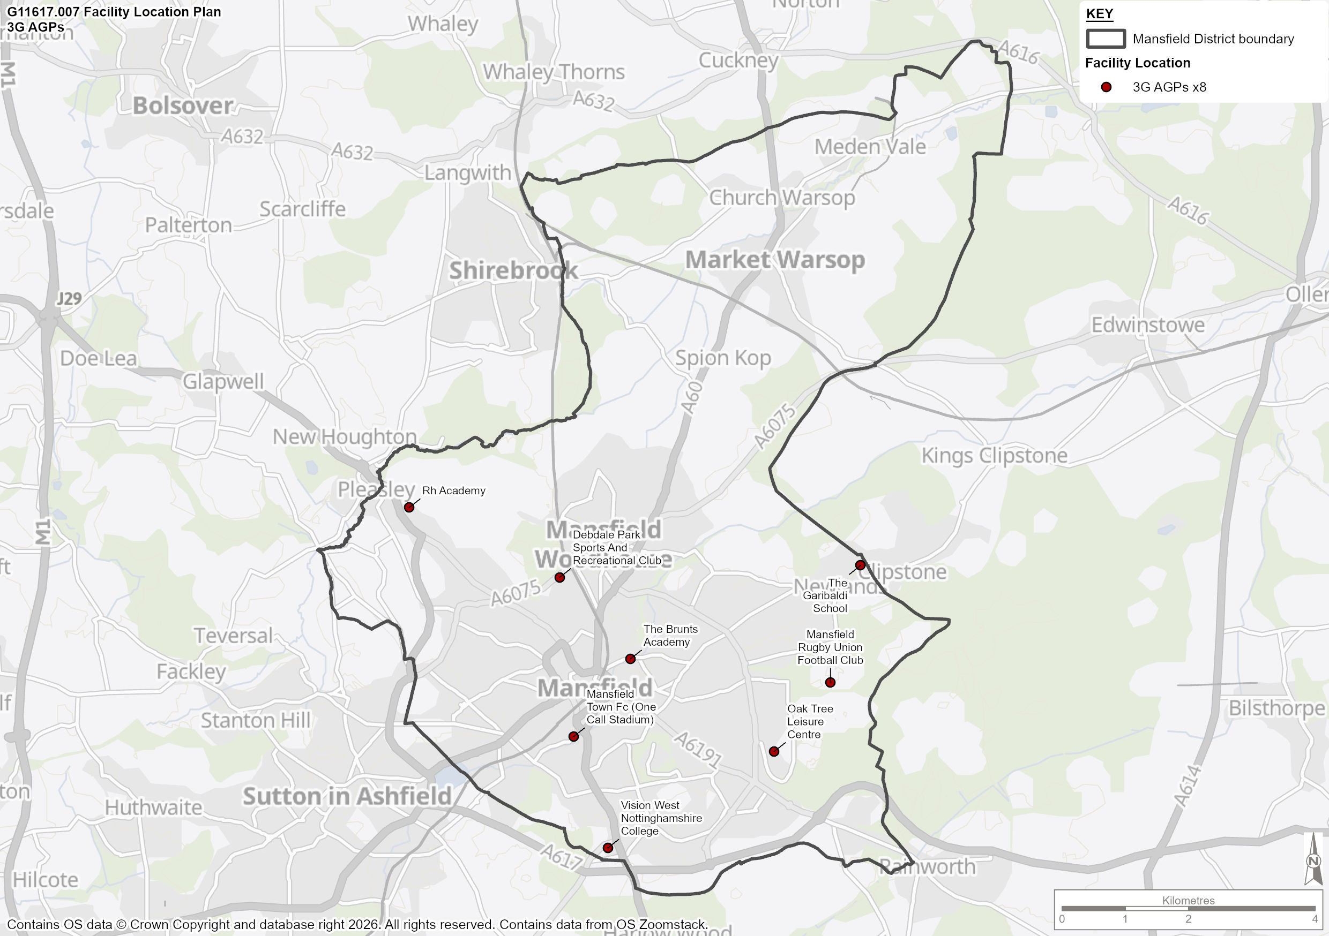

Current Supply and Demand Analysis for Football / 3G AGP

  - The commentary in the previous section has explained the current supply of AGPs in the study area. To understand how this supply caters for the study area, it is necessary to analyse the current demand for 3G AGP pitch use.

  - To provide a more accurate picture of how 3G AGP provision is currently being utilised, Table 27 shows the supply and demand analysis for all provision that is available to the community. This compares the amount of available capacity (in hours) during the peak period with the amount of demand that has been provided by clubs and users during consultation.

  - The Peak period according to the PPS Guidance is identified as Mon-Thurs 5pm to 9pm, Friday 5pm to 7pm; and Saturdays and Sundays 9am to 5pm. Therefore, the total number of hours available mid-week is 18, and there are 16 available during the weekend.

Table 27: Supply and Demand Analysis for all available 3G AGP Provision

Site Name | Pitch Type | Size | Peak Time Capacity | Clubs using the site |  | Total hours
 |  |  |  | Football | Other | Midweek | Saturday | Sunday- | Total
Debdale Park Sports And Recreation Centre | 3G | 11v11 | 34 | Sherwood Colliery FC, G3A FC, Teversal FC, Chesterfield FC Women’s, Reindeer FC, Ashland Rovers, Mansfield Town FC, Rainworth FC, Quarrydale FC. Mansfield Magpies, Beafort United, Adam Somes FC, Woodhouse Colts, Meden Vale FC, Blidworth Welfare, Mansfield Vipers, JW Coaching, Mansfield Town Community Trust, AFC Mansfield, Leisure Leagues | Walking Football, North Notts HC, Queen Elizabeth Academy, Sherwood Wolf Hunt RLFC, Sherwood Colliery Cricket | 18 | 8 | 8 | 34
Debdale Park Sports And Recreation Centre | 3G | 5v5 | 34 | Mini football training – Sherwood Colliery FC, G3A FC, social bookings | Walking Football, tennis | 18 | 8 | 8 | 34
Mansfield Rugby Union Football Club | 3G | 7v7 | 34 | Walking football, casual 5v5 | Mansfield RUFC, fitness classes | 18 | 8 | 8 | 34
Mansfield Town FC (One Call Stadium) | 3G | 5v5 | 34 | Mansfield Town FC Youth, Mansfield Town Community Trust, Leisure Leagues |  | 18 | 8 | 8 | 34
Oak Tree Leisure Centre | 3G | 5v5 | 34 | Walking Football, Casual Football |  | 18 | 3 | 3 | 24
RH Academy | 3G | 11v11 | 34 | Mansfield Town FC, Mansfield Town Community Trust |  | 18 | 8 | 8 | 34
The Brunts Academy | 3G | 11v11 | 34 | Market Warsop FC, Silva FC, G3A FC, Leisure Leagues |  | 18 | 8 | 8 | 34
The Garibaldi School | 3G | 7v7 | 34 | Market Warsop FC |  | 18 | 0 | 0 | 34
Vision West Nottinghamshire College | 3G | 7v7 | 34 | West Nottinghamshire College, Nottinghamshire Powerchair FC, Arnold Eagles FC, Eson FC, Kixx, Ravenhead Reds FC, Market Warsop FC, Bidworth Bengals, Sutton Trinity FC, Mansfield Athletic FC, Forest Town Arena FC, MacClean FC, Casual bookings | Reps 4 Less, Man v Fat | 15 | 0 | 5 | 20
Total |  |  |  |  |  | 159 | 51 | 56 | 282

  - Table 27 suggests that all 3G pitches in Mansfield are currently at capacity during peak hours, other than Oak Tree Leisure Centre and Vision West Nottinghamshire College, which are both small sided 3G pitches. Consultation with clubs, schools and leisure operators indicated that there was no spare capacity to host any more sporting activity on 3G pitches at Debdale Park Sports and Recreation Club, RH Academy or Brunts Academy.

Football - Current Supply and Demand Analysis for use of 11v11 3G AGP

  - As part of their Grassroots Strategy, the Football Association identified the quality of pitch provision as being the number one factor in ensuring an enjoyable playing experience. However, nationally 2 in 3 grass pitches are rated as poor quality and 2,000 new 3G pitches are required, with 96% of local authorities having a deficit in provision. Therefore, the FA aim to ensure that all teams playing competitive football have access to a floodlit 3G AGP to train on at least once a week. To do this, FA calculations show that a 11v11 size 3G AGP (available for community use at peak times) is required for every 38 teams, which will allow the required training and match play slots, as well as providing suitable supply at peak times (weekday evenings and weekends).

  - Table 28 shows the FA recommended pitch sizes for 3G AGPs, as well as outlining the number of teams each size 3G pitch can cater for. As stated earlier, because of extensive usage by a professional club and academy, RH Academy 3G can only cater for 26 teams. The table shows that the current supply can meet the demand of 175 teams, leaving 42 teams without access to 3G provision.

Table 28: Capacity Analysis for AGPs per Pitch Typology

Pitch Typology | Size | Proportion of teams that can use facility | No. of teams that the facility can service | Facilities within Study Area | Capacity (no of teams serviced by 3G) *
11v11 (Including adult and youth) | 91x55m or larger | 100% | 38 | 3 | 102
9v9 | Between 73x46 and 82x50m | 53% | 22 | 0 | 0
7v7 | Between 55x37m and 73x46m | 35% | 15 | 3 | 45
5v5 | Between 37x27m and 55x37m | 17% | 7 | 4 | 28
Total teams |  |  |  |  | 175

  - Using the demand data information from Nottinghamshire FA’s 2025/2026 affiliation data, 217 teams have been identified as playing within Mansfield. Using the FA’s suggested ratio of 1:38, this demonstrates the need for at least 6 11v11 equivalent 3G AGP’s to meet affiliated football club training demand.

  - Throughout this 3G AGP section, the respective total figures have been either rounded up or down to ensure there is adequate 3G provision to meet the existing evidenced demand; the projected future demand/latent demand and align with Nottinghamshire FA and FF local knowledge and priorities.

  - As highlighted earlier, RH Academy does not current meet any community football demand and therefore is discounted from the calculations in Table 29.

Table 29: Current Capacity Analysis for 3G AGPs

Area | Teams | Total number of 11v11 equivalent 3G AGPs required to meet demand | Current number of 11v11 equivalent 3G AGPs | Current balance
Mansfield | 217 | 5.7 | 3.7 | -2

  - Supply data in Table 29 identifies 3.7 existing 11v11 equivalent 3G pitches within Mansfield that are available for community use. When compared to the demand analysis in Table 28, it is evident there is a study area-wide deficit of -2 11v11 equivalent 3G pitches.

  - However, a large proportion of Mansfield 3G provision is made up of small-sided pitches. These are not always appropriate to meet training or match play demand, resulting in a number of teams including Woodhouse Colts, Meden Vale Colts, Manor FC Youth, G3A FC, Market Warsop FC and M&J Ballers highlighting lack of access to appropriate AGP training facilities as a key issue. Market Warsop FC also indicate that they travel outside of the study area to access appropriate artificial provision for training.
  - If only full size 3G AGP pitches were considered, there would be a deficit of -4 (3.7) 11v11 equivalent 3G pitches in Mansfield.

Rugby Union and Rugby League – Current Supply and Demand Analysis for use of 3G AGP.

  - There is only one WR22 compliant 3G pitch in Mansfield, located at Debdale Park Sports and Recreation Club. Although the site is available to the community and utilised extensively by Sherwood Wolf Hunt RLFC for training throughout the winter, there is no identified use by affiliated rugby union teams, and a lack of rugby specific posts limits the capacity of both union and league teams to use the pitch effectively.

  - Although there is a dedicated rugby league pitch on site, Sherwood Wolfhunt RLFC aspire to move all activity, including summer match play, onto the 3G pitch. This would require the installation of rugby posts, for which potential plans are being explored by the site owners.

  - Meden Vale RUFC have access to sports lighting on their grass pitch and Mansfield RUFC have both artificial and grass provision with sports lighting, although this is not WR22 or World Rugby Law 1 compliant. Through consultation, neither club identified any usage of 3G provision, and both highlighted their desire to retain all match play and most training demand on grass pitch provision to minimise pitch hire costs.

Football – 3G AGP Future Supply and Demand Analysis

  - To identify future demand for 3G provision in the Study Area, Team Generation Rates (TGR) have been calculated using the current number of football teams and the current population. This measure allows us to calculate what size of population, will typically cause enough demand to create additional football teams.

  - This Team Generation Rate (TGR) can then be applied to the population projections for the Study Area to confirm how population growth or reduction will affect the number of teams in each of the key age groups. However, latent demand predictions by clubs can also have a major impact. Although these are often aspirational targets set by clubs, the impact of these predictions being realised will be explored in Table 30.

  - The calculations are shown in Table 30 and suggest that as a result of population growth alone, there will be an additional 4 football teams in the study area by 2043, increasing demand for 3G pitches by 0.1 11v11 equivalents. However, if latent demand predictions are considered, there will be a further 30 football teams in Mansfield by 2043, creating demand for an additional 0.8 11v11 equivalent 3G pitch.

  - For football alone, population growth and latent demand predictions will generate a need for 1 new 11v11 equivalent 3G pitch in Mansfield.

Table 30: Future Capacity Analysis for 3G AGPs in Mansfield

Area | Projected No. new teams created by Population Growth (TGR) | Number of new AGPs required to meet future – Population Growth | Projected No. new teams created latent demand | Number of new AGPs required to meet future – Latent Demand | Total number of new AGPs required to meet total future demand
Mansfield | 4 | 0.1 | 30 | 0.8 | 1

  - If this future demand is added to the current deficits, there is likely to be a shortfall of -3 full size equivalent 3G pitches in Mansfield by 2043. If only full size provision is considered, this shortfall rises to -5.

Meeting the Current and Future Demand for 3G AGP Facilities Across Mansfield

  - A planning application has been submitted for the development of an additional 11v11 3G pitch at RH Academy. However, although the applicant comments suggest that local football teams could have access if availability permits, the majority of pitch capacity will be utilised by Mansfield Town FC Academy, Mansfield Town Ladies, Mansfield Town Community Trust and other Mansfield Town grass roots teams.

  - Through consultation, a number of other proposals for 3G development were identified in Mansfield, all of which could cater for community demand and help to reduce the current and future deficits. Table 31 provides an overview of the proposals.

Table 31: Proposed New 3G Pitch Development

Location | Number of Pitches Proposed | Estimated Delivery Date | Comments
Elkesley Road Ground (Meden Vale Colts) | 1 | TBC | Proposal
Queensway Park | 1 | TBC | Proposal
RH Academy | 1 | TBC | Planning Application Submitted
Oak Tree Leisure Centre | 1 | TBC | Proposal
Vision West Nottinghamshire College | 1 | TBC | Proposal
Manor Park | TBC | TBC | Proposal

  - Meden Vale Colts are a 41 team club, operating from Elkesley Road Ground, where there are currently significant shortfalls of provision due to lack of space and poor quality grass pitches.
  - 3G development on site would not only meet demand from the football club, but could also cater for Meden Vale RUFC if necessary, meaning WR22 compliant provision could be considered. However, the rugby club suggested a preference for retaining all training and match play demand on their grass pitch.

  - Development at Queensway Park, could help to meet training demand from a range of clubs due its location, including 2 of the largest clubs in Mansfield; Market Warsop FC (17 teams) and Woodhouse Colts (18 teams). The grass areas behind Oak Tree Leisure Centre could also provide an opportunity to cater for a number of community football clubs.

  - Vision West Nottinghamshire College highlighted their current 3G offer is unable to meet the needs of its students and the wider community due to its size and therefore have aspirations to expand their offer by developing an 11v11 3G AGP.

  - As part of the relocation of the Clipstone Miners Welfare site to Newark and Sherwood, there are proposals for the development of an 11v11 3G AGP alongside grass pitches to meet the needs of Clipstone FC and Clipstone Welfare Youth. The club consists of 19 teams, suggesting that there would be remaining capacity for additional teams from Mansfield to use for training purposes.

  - The impact of these potential developments and others, will be explored in detail as part of the Stage D analysis. However, as the proposed RH Academy is unlikely to cater for substantial levels of affiliated football team training, the development of 3G provision at additional sites will be required to meet the current and future deficits.

  - It must be noted that not all sites in Table 31 will undergo 3G development. These are potential sites that have been identified as possible solutions to help reduce the current and future deficits of 3G provision in Mansfield. Further work with a range of partners including clubs, the Football Foundation, Nottinghamshire FA, the RFU, MDC and others is required to establish the correct locations for investment.

  - The operation of any future 3G AGP development also requires consideration. To ensure pitches can maximise community use, meet the needs of local clubs, be financially sustainable and undergo appropriate maintenance regimes, an effective operational and management structure is required. Experienced community football organisations with a track record of successful delivery may be best suited to deliver high quality outcomes for clubs and the community, as well as meeting NGB and local authority requirements. Whilst both Mansfield Town in the Community and Nottingham Forest in the Community have both expressed interest in the 3G development and operation in the area, the location of any 3G pitch may dictate its ownership and management and the correct model should be explored and identified within the strategy document of this PPOSS.

  - From the current and future supply and demand analysis we can presume the following:

  - There is a current deficit of -2 3G pitches in Mansfield for affiliated football teams, rising to -4 if only full-size pitches are taken into account.
  - To cater for additional future demand through population growth and latent demand, a further 1 11v11 equivalent 3G AGP should be considered, increasing the total deficit to -3 11v11 equivalent 3G AGPs by 2043.
  - If small-sided provision is removed from these calculations due to its inability to cater for a large proportion of the demand, then there will be a deficit of -5 by 2043.

Football Demand for Sand Dressed AGPs

  - The impact of additional 3G development on existing sand-based AGPs also needs to be considered. Increasing the supply of 3G pitches provides increased access for football clubs on their preferred surface. In many cases, this would remove demand from sand-based AGPs, therefore losing a potentially vital source of revenue for sand-based facilities and hockey clubs.

  - Sand-dressed pitches in Mansfield help to meet hockey demand, however whilst not the preferred surface, All Saints Catholic Academy and Manor Sport and Recreation Centre are also used to for community football club training and casual football during the peak evening times. Due to the lack of 3G provision in Mansfield, this is a necessity, but it also helps to ensure that sand-based AGPs are financially sustainable.

  - According to consultation, All Saints Catholic Academy meets 4 hours football training demand Monday – Friday from Market Warsop FC and Woodhouse Colts FC.

  - The sand-based AGP at Manor Sports and Recreation Centre also meets 5 hours of training demand per week from Manor FC.

AGP summary

  - This section summarises the findings from the AGP analysis, which will form the basis of the recommendations and action plan section for Mansfield.

  - Table 32 includes the response to 5 key questions which are identified in the Sport England PPOSS Guidance Checklists.

Table 32: Key PPOSS Findings for AGPs in Mansfield

Key Question | Analysis
What are the main characteristics of the current supply and demand for provision? | There are currently 3 11v11 sized 3G pitches in Mansfield, as well as 4 5v5 and 3 7v7. The 11v11 3G at RH Academy is currently mainly utilised by Mansfield Town FC and its academy programme, with no access to community clubs.  Only the 11v11 pitch at Debdale Sports and Recreation Centre has a WR22 compliant surface, however this is only used by football clubs and a rugby league club and there is no usage by any affiliated rugby union clubs. There is also 1 full size and 2 small sand-based AGPs in the study area, of which Manor Sports and Recreation Centre and All Saints Catholic Academy are used by football clubs for training demand. The sand-based pitch at Meden School is not available to the community. All 3G provision has sports lighting, however investment into this is required at Mansfield RUFC and Brunts Academy.  In consultation responses, a significant number of football clubs highlighted the need for additional artificial, floodlit training facilities.
Is there enough accessible and secured community use provision to meet current demand? | Based on the FA’s 1:38 model and data provided by the RFU, there is a current deficit of -2 11v11 equivalent 3G pitch in the study area. If only full size pitches are considered, then the deficit is -4.  Based on the FA’s 1:38 model, 42 football teams do not have access to 3G provision. Although neither rugby union club has access to 3G provision for match play, both highlighted their desire to retain all activity on existing grass pitches.  Consultation suggests that many clubs face challenges in accessing 3G provision and some find it necessary to travel outside of Mansfield to access appropriate 3G pitches for training demand.  Some clubs rely on utilising sand-dressed AGPs to meet their training demand, due to lack of local 3G pitches. All of these clubs highlighted the desire to use 3G provision instead of sand-dressed.
Is the provision that is accessible of sufficient quality and appropriately maintained? | Of the 9 3G pitches in Mansfield, 6 are rated good quality, whilst RH Academy and Mansfield Town FC One Call Stadium are standard quality, and Mansfield RUFC is poor.  Sand-based AGPs at All Saints Catholic Academy and Meden School are rated as good quality, however the pitch at Manor Sport and Recreation Centre is classed as poor quality and in need of resurfacing works.
What are the main characteristics of the future supply and demand for provision? | Team generation rates informed by population projections suggest that there will be an increase of 4 football teams by 2043, increasing demand for 3G pitches by 0.1 11v11 equivalent 3G pitches. However, if latent demand predictions by football clubs are realised, the deficit will be raised to -3 by 2043. If only full size pitches are considered, the deficit will be -5.  There are a number of proposals for 3G development at RH Academy, Queensway Park, Elkesley Road Ground, Oak Tree Leisure Centre and Vision West Nottinghamshire College. Although most are currently aspirational and require further exploration, they could help to reduce the current and future deficits of football demand.  The proposed 3G development at RH Academy would only meet demand from Mansfield Town FC and its affiliated teams.
Is there enough accessible community use provision to meet future demand? | If all latent demand and population growth is realised, there will be a deficit of -3 11v11 equivalent 3G provision in Mansfield.  Further 3G development is required in Mansfield if the training needs of football clubs are to be met.

Hockey Analysis

Introduction and Strategic Context

  - Hockey in England is governed by England Hockey (EH). In order to understand the overall objectives and priorities of England Hockey (EH), an analysis of key recent strategies and documentation has been undertaken and summarised below.

England Hockey Strategic Direction (2023 - 2028)

  - England Hockey’s strategic plan “Creating a Future for Our Game Together”, outlines the vision for the sport through to 2028. Its mission is to “Work together to make hockey more visible, relevant and accessible to all.” The strategy is built around four core values and five strategic objectives:

- Lead Positive Change.
- Inspirational International Success
- Deliver Visible Impact
- Champion Responsible Leadership
- Foster Meaningful Growth

  - Away from club-based match play and training demand, there are also several initiatives supported by EH that operate across the Country, that where undertaken add to hockey demand at sites. These include:

- Back to Hockey: Back to Hockey sessions are fun, social and informal and are aimed at people who either have not played for a number of years or that are looking to play for the first time. They are generally hosted by clubs, with EH providing guidance on how to deliver the programme.

- Flyerz Hockey: Flyerz is the name widely associated with grassroots disability hockey in Great Britain. There are now more than 50 Flyerz sections across England, Wales, and Scotland, providing inclusive hockey for disabled people

- Hockey Heroes: Hockey Heroes is a six-week hockey programme aimed at beginners (children aged five to eight) that not only focuses on helping children develop some physical hockey skills such as dribbling, passing and goal scoring, but also places as much emphasis on character development including teamwork, communication, perseverance and respect

- Quicksticks: Quicksticks is designed to introduce young people (aged 7-11) to the game of hockey. It is 4-a-side, can be played on any surface, and uses a larger, lighter and safer ball. It is a fun, fast, safe and exciting game that has been designed so that anyone can deliver the game, regardless of previous hockey experience

- Walking Hockey: Increasing in popularity, walking hockey is perfect for players looking for a less physically demanding version of the game but still enjoy showing their skills and being involved in the team and social aspect.

- Protect: To conserve the existing hockey provision. EH currently has over 800 pitches that are used by hockey clubs (club, school, universities). We need to retain the current provision where appropriate to ensure that hockey is maintained across the country.

- Improve: To improve the existing facilities stock (physically and administratively). The current facilities stock is ageing and there needs to be strategic investment into refurbishing the pitches and ancillary facilities. There needs to more support for clubs to obtain better agreements with facilities providers & education around owning an asset.

- Develop: To strategically build new hockey facilities where there is an identified need and ability to deliver and maintain. This might include consolidation hockey provision in a local area where appropriate. Research has identified key areas across the country where there is a lack of suitable Hockey provision and there is a need for additional pitches. There is an identified demand for multi pitches in the right places to consolidate hockey and allow clubs to have all of their provision catered at one site.

  - Competitive league hockey matches, and training must be played on artificial grass pitches (AGPs) that are either sand filled, sand dressed, or water based. Third generation (3G) pitches are not suitable for adult or junior club training. However, where no alternative surface is available, introductory-level hockey may be permitted on 3G pitches.

  - EH’s AGP surface policy details suitability of surface type for varying levels of hockey as shown below.

Table 33: England Hockey Guidelines on Artificial Surface Types Suitable for Hockey

Category | Surface | Playing Level – Essential | Playing Level - Desirable
England Hockey Category 1 | Water surface approved within the FIH Global/National Parameters | International Hockey - Training and matches | Domestic National Premier competition  Higher levels of EH Player Pathway (Performance Centres and upwards)
England Hockey Category 2 | Sand dressed surfaces within the FIH National Parameter | Domestic National Premier competition  Higher levels of player pathway (Academy Centres and Upwards) | All adult and junior League Hockey  Intermediate or advanced School Hockey  EH competitions for clubs and schools
England Hockey Category 3 | Sand filled surfaces within the FIH National Parameter | All adult and junior club training and league Hockey  EH competitions for clubs and schools  Intermediate or advanced schools’ hockey | Lower-level hockey (introductory level)
England Hockey Category 4 | Gen 2 Pitch (sand dressed surface with a modified shock pad) | Education, local authority and leisure centre sites that require multi-sport use  Suitable for community clubs playing up to EHL standards

  - Gen2: In collaboration with the International Tennis Federation (ITF) and England Netball (EN), England Hockey (EH) has supported the development of a multi-sport surface to accommodate lower levels of hockey demand on a pitch that is also suitable for sports such as netball, tennis, and recreational football. This reduces the need for multiple specialised playing surfaces.

  - The Gen2 system is a sand dressed synthetic turf with a compatible shock pad to suit several sports at a community level. The concept is designed for shared-use environments like schools, to maximise available space and enables the provision to be utilised to its full potential.

  - For senior hockey teams, a full-sized pitch for competitive matches must measure at least 91.4 x 55 metres excluding surrounding run off areas which must be a minimum of two metres at the sides & three metres at the ends. England Hockey preference is for four metre side, and five metre end run offs, with a preferred overall area of 101.4 x 63.

  - It is considered that a hockey pitch can accommodate a maximum of four matches on one day (peak time) provided that the pitch has sports lighting. Training is generally midweek for senior activity and requires access to a pitch and sports lighting, whereas many junior teams train on a Sunday as well as during midweek.

Supply

  - Although there are 3 sand-based AGPs in Mansfield. Only 1, at Manor Sport and Recreation Centre, has a full size sand-based pitch that is suitable for competitive hockey. Meden School is not currently available for community use.

  - As part of the PPOSS, each site that is suitable for hockey has been assessed and scored according to England Hockey’s facilities framework contained within the 2013 Sport England Playing Pitch Guidance. Table 34 below provides a summary of the quality assessments for all hockey suitable sites in the Study Area.

Table 34: Quality Overview for Hockey Facilities in Mansfield

Site Name | Postcode | Availability | Security of Use | No. of Pitches | Surface Type | Size | Pitch Dimensions (m) | Age of Surface | Sports Lighting | Pitch Rating
All Saints' Catholic Academy | NG19 6BW | Yes | Unsecure | 1 | Sand Filled | Small | 60 x 40 | 2005 | Yes | Good
Manor Sport And Recreation Centre | NG19 8JE | Yes | Secure | 1 | Sand Dressed | Full | 100 x 60 | 2002 | Yes | Poor
Meden School | NG20 0QN | No | Unsecure | 1 | Sand Dressed | Small | 40 x 33 | 2010 | Yes | Good

  - Table 34 highlights that the only appropriately sized hockey pitch in Mansfield is at Manor Sport and Recreation Centre. However, the pitch is of poor quality, requires resurfacing works and investment in new sports lighting.

  - The site is owned by Mansfield District Council but leased directly to North Notts Hockey Club who use the pitch to meet all of their training and match play demand. The pitch is also used by football teams during the midweek for training.

  - The club also have access to good quality ancillary facilities on site, with changing rooms and showers etc, but use Debdale Sports and Recreation Centre for post-match hospitality.

  - Both small-sided pitches at All Saints Catholic Academy and Meden School are good quality but are not of adequate size to meet formal hockey demand for training or match play.

  - Map 4 shows the distribution of hockey specific AGPs in Mansfield

Map 4: Hockey AGP sites in Mansfield

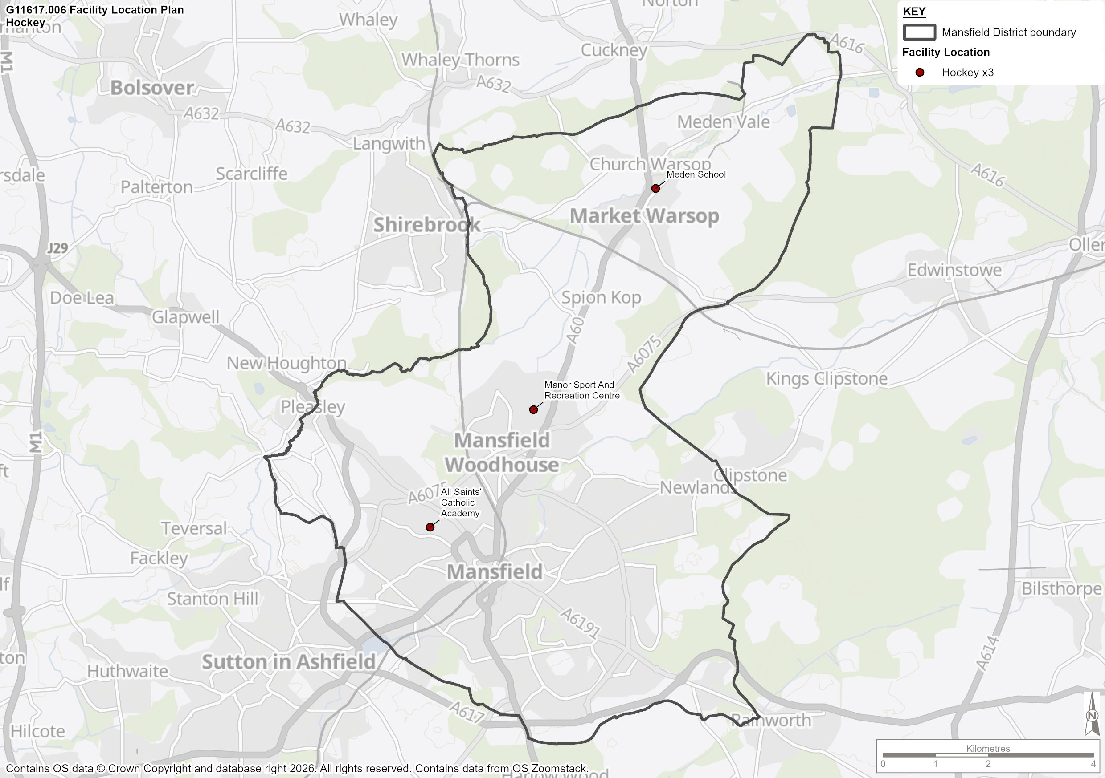

Demand

  - Through consultation with England Hockey, 1 hockey club, North Notts HC, was identified as using AGP facilities within Mansfield. Details for the club are highlighted in Table 35.

Table 35: Mansfield Hockey Demand

Club Name | MDC Facilities Used | Team Numbers
Club Name | MDC Facilities Used | Men | Women | Mixed | Masters Male | Masters Female | Junior Male (membersno.) | Junior Female (membersno.) | Total
North Notts Hockey Club | Manor Sport and Recreation Centre | 4 | 4 | 0 | 0 | 0 | (30) | (38) | 8

Exported Demand

  - Mansfield Hockey Club, Ashfield Aztecs and Mansfield Aztecs (One club with different team names for male, female and junior sections) previously utilised pitch provision at Brunts Academy, before it was resurfaced. The club have since been forced to relocate outside of the study area into Kirkby- in-Ashfield.

  - Consultation with the club suggested that although there were previously aspirations to return to the study area, due to many members travelling from Mansfield, there are no longer any appropriate facilities available.

  - Details for each club are highlighted in Table 36.

Table 36: Exported Hockey Demand

Club Name | Facilities Used | Team Numbers
Club Name | Facilities Used | Men | Women | Mixed | Masters Male | Masters Female | Junior Male (membership no.) | Junior Female (membership no.) | Total Teams
Mansfield Hockey Club | Kingsway Park (Kirkby in Ashfield) | 5 | 0 | 0 | 0 | 0 | 0 | 0 | 5
Ashfield Aztecs | Kingsway Park (Kirkby in Ashfield) | 0 | 4 | 0 | 0 | 0 | 0 | 0 | 4
Mansfield Aztecs | Kingsway Park (Kirkby in Ashfield) | 0 | 0 | 0 | 0 | 0 | 25 | 28 | 0

  - Both clubs were given the opportunity to respond to consultation. Both North Notts Hockey Club and Mansfield HC/Ashfield Aztecs/Mansfield Aztecs provided feedback. A summary of the consultation is provided in Table 37.

Table 37: Hockey Consultation

Club Name | Consultation Summary
North Notts Hockey Club | North Notts Hockey Club currently fields four men’s and four ladies’ teams in England Hockey leagues, with a thriving junior section of 100–120 members that has rebounded after previous challenges with pitch access. The club’s pitch, refurbished in 2001 and leased from the council, is now in poor condition and requires both resurfacing and new floodlighting, for which grants are being sought. Facilities include access to a pavilion with changing rooms and showers, and hospitality is provided at Debdale Sports Club. The club maintains strong links with local cricket clubs and engages eight primary schools, involving around 150 children, though schools do not currently use the pitch. Fixture programming is at capacity, and further expansion would require leasing an additional pitch, likely in Worksop. Plans for growth focus on squad expansion, potentially adding one man’s and one women’s team with morning fixtures, though frost may be a limiting factor. The club is committed to inclusivity, running “Back to Hockey” and disability-friendly sessions, and is well placed to support England Hockey’s aim of increasing state school hockey participation.
Mansfield Hockey Club  Ashfield Aztecs  Mansfield Aztecs | Mansfield Hockey Club comprises three separate clubs—men’s, ladies’, and juniors—with a combined membership of approximately 170–205 across all sections. The club does not have its own facilities in Mansfield and relies on Kingsway Park, which is council-owned and shared with other sports, limiting pitch availability and growth. Occasionally, secondary pitches are used due to scheduling conflicts, but these are often of poor quality and require ongoing maintenance, which the council does not consistently provide. The changing rooms are currently being rebuilt to better meet club needs, although storage may remain an issue, and floodlighting has recently been improved but still has some dark corners. The club has grown in recent years but now faces stagnation, with aspirations to add more teams but no plans to own its own pitch, preferring to rent and use local facilities; social activities are held at a nearby pub, and many members travel from Mansfield to participate.

  - North Notts HC aspire to grow the club, however due to match play capacity issues at their current site, there is no room for further team growth. This would require leasing additional pitch space, which is expensive and of which there is none in the study area. The club would be forced to utilise an additional pitch in Worksop.

  - For this reason, the club are currently focussed on squad expansion, growing their membership and delivering EH initiatives such as back to Hockey and inclusive hockey activities.

  - Table 38 outlines the hourly demand for hockey in Mansfield by club. Figures are collated from EH data, club consultation and AGP operator information.

Table 38: Hockey Team Overview - Mansfield

Club | Weekly AGP Hours Required in Mansfield
Club | Midweek Training | Weekend Match Play/Training | Total
North Notts Hockey Club | 8 | 16 | 24

  - North Notts HC teams train for a total of 8 hours per week during Mon-Fri, due to teams training together at the same time. However, this is not possible for match play and teams utilise the pitch for 8 hours per day Saturday and Sunday, leaving no spare capacity.

  - Junior hockey at the club consists mainly of weekly group training sessions. Whilst there may not be regular junior fixtures like at senior level, the club hold regular juniors’ tournaments and once players reach a suitable age and ability, they may start to participate in training and competitive fixtures with the senior teams.

Pitch Usage

  - It is important to understand that sand-based pitches are also often used for football activity. In these instances, pitch quality deteriorates more quickly, and capacity for hockey clubs is also reduced. However, incorporating demand from other sports, in particular football, ensures the financial sustainability of sand-based AGPs, that otherwise would only meet demand from a small amount of affiliated hockey clubs. Table 39 demonstrates all usage at Manor Sport and Recreation Centre.

  - The Peak period according to the PPS Guidance is identified as Mon-Thurs 5pm to 9pm, Friday 5pm to 7pm; and Saturdays and Sundays 9am to 5pm. Therefore, the total number of hours available mid-week is 18, and there are 16 available during the weekend.

Table 39: Sand Dressed Pitch Usage

Site Name | Pitch Type | Site Usage |  |  | Total hours |  |  |  | Hockey Specific Usage
Site Name | Pitch Type | Football | Hockey | Other | Midweek | Saturday | Sunday | Total | Hockey Specific Usage
Manor Sport and Recreation Centre | Sand Dressed | Manor FC | North Notts Hockey | N/A | 13 | 8 | 8 | 29 | 24

  - Table 39 highlights that there is a demand total demand of 29 hours for community usage on hockey appropriate AGPs in Mansfield. 24 hours of this total demand (83%) is generated through hockey club usage, whilst the remaining 17% is taken up by football club training demand.

Demand Driven by Informal Demand

  - With the success of the England Women’s team at Tokyo 2021, accompanied by significant investment into the grass roots game by England Hockey, there is an aspiration to increase the amount of people playing informal hockey, either as an entry point into the more formal game or simply as a way of providing people with fun ways of keeping active.

  - Among others, England Hockey are looking to promote Back to Hockey, Rush Hockey and Indoor Hockey, all of which are easily accessible programmes that are easy for those who are not experienced hockey players to play and enjoy.

  - It is expected that as these informal forms of the game grow, there will be an increase in the number of participants playing both informal and formal hockey. The scenario testing section of the Stage D assessment will look to calculate the future need for facilities, should this growth be realised.

Supply and Demand Balance

Supply and Demand Balance – Spatial Analysis

  - To calculate the capacity analysis at hockey sites in the Mansfield, Table 40 shows the supply and demand figures for community use hockey facilities in Mansfield. This table contains demand (in hours) from competitive matches as well as training required by clubs and other sporting activity as highlighted in Table 40.

Table 40: Supply and Demand Balance for Hockey in Mansfield

Site name | Supply (Peak Period Hours) |  |  | Demand (Hours: training and matches) |  |  | Balance (hours)
Site name | Week | Sat | Sun | Week | Sat | Sun | Week | Sat | Sun
Manor Sport and Recreation Centre | 18 | 8 | 8 | 13 | 8 | 8 | 5 | 0 | 0

  - Table 40 suggests that there is a limited amount of capacity for hockey activity on sand-based AGPs in Mansfield, and due to the lack of appropriate provision, there is no additional weekend match play capacity.

  - Although there is 5 hours of spare capacity Monday-Friday for additional training sessions, the club are not able to add to team numbers due to lack of match play capacity.

  - Despite aspirations to return to Mansfield, Mansfield Hockey Club (and associated teams) are not able to do so due to lack of appropriate provision in the study area.

  - The development of additional 3G pitches may result in less football demand being met by the sand-based AGP, creating additional capacity for hockey. However, in this case it would only create mid-week capacity, and not the weekend match play capacity the club requires.

  - Investment in hockey facilities is necessary to ensure pitches are of good quality, have appropriate sports lighting and can meet the demands of the club. Although additional hockey pitch development would allow for Mansfield Hockey Club to return to the study area, it would require football usage to ensure its financial viability and would have negative financial implications for their current pitch.

Future Demand

Demand driven by Population Growth

  - In order to calculate the future demand for Hockey in the Study Area, an agreed growth rate has been used in conjunction with the current number of teams across the study area. This measure allows us to calculate the expected number of participants and subsequent number of teams that will be present by the end of the lifetime of the Local Plan Review period (2043).

  - The growth rate is set by England Hockey, based on experience and best practice from across the country. This is believed to be a more accurate projection that than provided by team generation rates (as used for the other sports included within the PPOSS), as it allows for the expected growth driven by national team success, increasing level of junior demand across the sport and the level of informal activity such as pay and play.

  - Table 41 shows the current number of members in each of the age groups and applies a 5% growth rate, to calculate a projected number of members and teams.

  - As consultation identified that most members of Mansfield Hockey Club (and associated teams) are based in Mansfield, membership figures for the exported demand have been included in the figures below.

Table 41: Future Demand Projections for Hockey Teams in Mansfield

Sport and Age Groups | No. of members | 5% growth | Projected number of members
Hockey Senior Men (16-55yrs) | 139 | 7 | 146
Hockey Senior Women (16-55yrs) | 125 | 6 | 131
Hockey Youth Boys (14-16yrs) | 7 | 0 | 7
Hockey Youth Girls (14-16yrs) | 14 | 1 | 15
Hockey Junior Boys (11-13yrs) | 21 | 1 | 22
Hockey Junior Girls (11-13yrs) | 23 | 1 | 24
Hockey Mixed (5-10yrs) | 65 | 3 | 68
Total | 394 | 20 | 414

  - Table 41 illustrates that with the 5% projected growth in participation; it is expected that there will be an additional 11 players over the period of the strategy. To calculate the expected growth in teams that this will generate, a ratio has been calculated based on the existing number of members and teams (1 team to every 17 members). There is expected to be enough demand for 1 additional team over the lifetime of the Local Plan Review period (2043). It must be noted however that these figures include all players from Mansfield Hockey Club (and associated teams), which currently play outside of Mansfield.

  - North Notts HC also suggested through consultation, that if capacity was available, they could increase team numbers by 2 senior teams, creating a total future growth of 3 additional teams by 2043.

  - EH also highlight youth participation growth trends of up to 20%, which could add an additional 19 junior members or 1 team to Mansfield by 2043.

  - However, there is no capacity on hockey pitches in Mansfield to accommodate this growth, so players would be forced to join clubs outside of the study area or North Notts HC will be required to lease additional pitch provision in Worksop.

  - Ensuring the continued security of use for hockey clubs on existing facilities, as well as pitch resurfacing and investment in appropriate sports light installation at Manor Sports and Recreation Centre, are necessary to ensure the North Notts HC can sustain its current operation.

Hockey Summary

  - This section summarises the findings from the hockey analysis, which will form the basis of the recommendation and action plan section for Mansfield.

  - Table 42 includes the response to 5 key questions which are identified in the Sport England PPOSS Guidance Checklists.

Table 42: Key PPOSS Findings for Hockey in Mansfield

Key Question | Analysis
What are the main characteristics of the current supply and demand for provision? | There is 1 full size AGP in Mansfield suitable for Hockey located at Manor Sport and Recreation Centre, with a further 2 small-sided sand-based AGPs at All Saints Catholic Academy and Meden School.  There is 1 hockey club currently operating in Mansfield: North Notts HC. However, Mansfield HC, Ashfield Aztecs and Mansfield Aztecs were displaced due to the resurfacing of Brunts Academy and now operate outside of the study area in Kirkby-in- Ashfield.
Is there enough accessible and secured community use provision to meet current demand? | Although there is spare mid-week capacity at Manor Sport and Recreation Centre, there is a lack of capacity at weekends to meet hockey club match play demand. The club use the pitch for 8 hours on both a Saturday and a Sunday.  Despite the site also being used for 5 hours per week by Manor FC for training purposes, 83% of usage on the sand-based AGP is by North Notts HC.
Is the provision that is accessible of sufficient quality and appropriately maintained? | Manor Sport and Recreation Centre is in very poor condition, with resurfacing works required and investment in new sports lighting necessary to allow North Notts HC to continue to use the site effectively.  Both small-sided pitches are rated as good quality.
What are the main characteristics of the future supply and demand for provision? | Based on membership growth predictions of 5% and latent demand identified by North Notts HC, it is likely that there will be demand for an additional 3 teams over the course of the Local Plan Review period.  Although there is limited predicted growth of hockey, ensuring the long-term security of tenure, as well as pitch resurfacing and investment in appropriate sports light installation at Manor Sports and Recreation Centre, are necessary to ensure the North Notts HC can sustain its current operation.
Is there enough accessible and secured community use provision to meet future demand? | There is a deficit of adequate hockey facilities and future demand driven by population growth and EH participation increases will be unable to be met on the current stock of pitches accessible to the community. If football demand continues to grow, facilities are lost, or Mansfield HC return to the study area, capacity for the growth of hockey clubs will be further restrained.

Rugby Union Analysis

Introduction and Strategic Context

  - The Rugby Football Union (RFU) is the national governing body responsible for grassroots and elite rugby in England, with the season operating from September to May.

RFU Strategic Plan (2026 - 2030)

  - In January 2026, the RFU published the Plan 2030: More than a Game, with the main purpose being to “enrich lives and grown rugby for future generations”. The four focus areas of the strategy include:

- Rugby clubs across England are the lifeblood of our sport. Demands on volunteers have grown and there is a need to respond – make it easier to play and run the game.

- The pioneers of women’s rugby overcame huge hurdles to be heard and acknowledged. Today, the rise of women and girls’ rugby is one of our country’s greatest sporting successes, and it’s only just begun – break new ground as global leaders, on and off the field.

- Engage. Excite. Entertain. Need to ensure that rugby feels fun, inspirational and meaningful for young people. Attracting a new generation into the sport – ensuring rugby is always relevant to young people.

- Keeping players safe is the foundation of everything we do. Players at every level tell us they value the physicality of rugby. Our job is to safeguard that identity for future generations by constantly testing, learning and improving every element of the game – we will leave no stone unturned in pursuit of the safest possible version of the sport we all love.

  - The strategy also identifies 4 ‘Big Goals’.

- Play – More people playing rugby for longer – 50,000 additional registered players.
- Perform – More successful England teams – Consistently winning senior international tournaments.
- Follow – More passionate fans of England rugby – 500,000 additional fans.
- Fund – More investment in rugby - £500 million invested into the core areas of the game that deliver the greatest outcomes for the sport.

  - The objectives and targets of the RFU will be referenced throughout this strategy and utilised to prioritise facility development projects as part of the recommendations and action plan section.

England Rugby Women and Girls Action Plan (2025-2030)

  - Alongside the general strategic plan referenced above, England Rugby has also developed the ‘Every Rose, Our Time’ action plan. The strategy highlights the historical progress that has been achieved and makes four key commitments to the women and girls’ game, to be accomplished by 2030.

  - The aims of the ‘Every Rose’ action plan that are relevant to this PPOSS are:

- Increasing number of female players to 100,000, with 70,000 officially registered to clubs:
  - Grow the number of 6-12 year old girls playing in clubs
  - Grow the number of women and girls experiencing rugby, through T1 Rugby.
  - Expand the reach of rugby to girls in schools, colleges and universities
  - Increase participation through targeted national youth campaigns and partnerships.
  - Make sure under represented and underserved communities are considered as part of all outreach.

- Keep women and girls playing for longer:
  - Initiate research into female health and welfare through purposeful partnerships with both sport and non-sport bodies and apply that learning to the community game
  - Develop more opportunities to play on college and university sites

- Strengthen the club offer for women and girls in local communities:
  - Support clubs and constituent bodies to create a culture where women and girls are respected and supported in all roles.
  - Develop and support female leaders to better reflect local communities

- Keep the women and girls game running effectively:
  - Review and develop the women’s competition management system
  - Review and make recommendations on the mixed gender rugby guidelines in relation to welfare, player development and participation

Supply

Quantity and Quality Assessment

  - For the purpose of this PPOSS, the RFU have one category of rugby pitch, a XV-a-side, which is defined as ‘a marked pitch with posts at both ends’.

  - On sites where PitchPower reports have been undertaken, pitches are assigned a Performance Quality Standard (PQS) grading. These PQS scores grade pitches as Advanced, Good, Basic or Poor. Sites that do not have an up-to-date PitchPower assessment are graded as ‘basic’ based on RFU PPOSS methodology. Each site and pitch were also visited and assessed by SLL using non-technical pitch assessments, which are used to develop a wider understanding of each site, alongside consultation with clubs and the RFU.

  - To align with the PPOSS methodology, ‘advanced’ and ‘good’ pitches are categorised as Good, ‘basic’ pitches are Standard, and ‘poor’ pitches remain Poor. Each grading is then assigned a Match Equivalent Session (MES) carrying capacity based on their PQS. How these align, is shown in Table 43.

Table 43: Rugby Union - Performance Quality Standard

 |  | Advanced and Good PQS | Basic PQS | Poor PQS
Rugby Union | XV-a-side Pitch | 3.3 MES | 2.6 MES | 2 MES

  - Within Mansfield, only Mansfield RUFC have up-to-date PitchPower assessments in place. The remaining sites PQS scores have been informed by non-technical assessments, club consultation and information provided by the RFU. Information on all rugby union pitches in Mansfield is provided in Tables 44 and 45.

  - There are 6 sites with a total of 8 pitches in Mansfield. The ownership of the 6 rugby union sites across the Study Area is shown in Table 44.

Table 44: Ownership of Rugby Union Sites in Mansfield

Sub-category | Ownership | Management
Charity, Trust, Community Organisation | 1 | 0
Education | 2 | 2
Sport Club | 1 | 2

  - As highlighted above, the majority of sites with rugby union provision are owned by education establishments. Of the 2 sites that are home to affiliated rugby union clubs, one is owned by a community organisation and managed by the club, the other is owned and managed by the club.

  - Table 45 provides a breakdown of the rugby sites in Mansfield.

Table 45: Rugby Site Breakdown of Security of Community Use

Site Name | Postcode | Available | Security of Use | Ownership | No. Adult Pitches | Pitch Quality | Floodlit | Ancillary Facilities
Elkesley Road Ground | NG20 9PS | Available | Secure | Community Organisation | 1 | Basic | Yes | Good
Mansfield Rugby Union Football Club | NG18 3EW | Available | Secure | Sports Club | 1 | Basic | Yes | Good
Mansfield Rugby Union Football Club | NG18 3EW | Available | Secure | Sports Club | 1 | Basic | Yes | Good
Mansfield Rugby Union Football Club | NG18 3EW | Available | Secure | Sports Club | 1 | Basic | Yes | Good
Queen Elizabeth’s Academy | NG19 7AP | Unavailable | Unsecure | Academies | 1 | Basic | No | School Changing
The Brunts Academy | NG18 2AT | Available | Unsecure | Academies | 1 | Basic | No | School Changing

  - As per consultation with the RFU, only posted pitches will be taken into consideration for the PPOSS assessment. Clubs may overmark and/or use spare playing field for some age grade rugby activity however as this is both informal and irregular, for the purposes of this assessment all age grade rugby demand is allocated to the defined pitches only.

  - There are 3 sites, with a total of 5 pitches available to the community within Mansfield. These are located at Elkesley Road Ground, Mansfield RUFC and The Brunts Academy. The quality of all available pitches is rated as basic.

  - 33% are located on education sites, however only half of these are available for community use. Although rugby union community demand is currently being provided for on other sites, utilising these pitches in the medium-term may be a good option to develop rugby union clubs within Mansfield. However, this needs to be driven by the relevant parties in order for schools to open their doors to the community.

  - Map 5 shows the geographic location of the rugby pitches across the Study Area.

Map 5: Rugby Pitch Audit in Mansfield

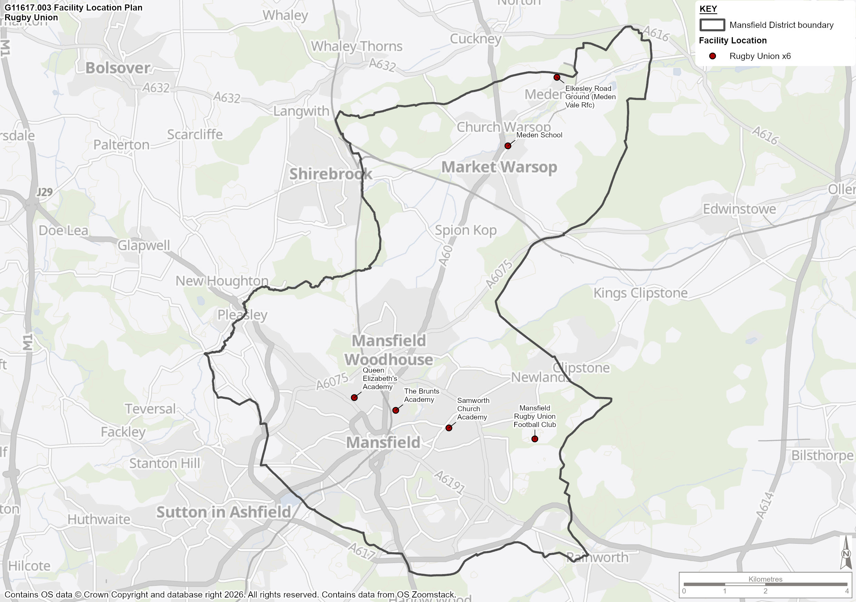

Current Demand

  - Through consultation with the RFU, 2 clubs have been identified in Mansfield. Table 46 provides the team profiles of all community clubs playing in Mansfield.

Table 46: Rugby Union Club Profiles

Club | Adult Male and Female | Age Grade (U13 – U18) | Age Grade Boys (U12) | Age Grade Girls (U12) | Age Grade Mixed (U7-U11) (Max 5 teams) | Total
Mansfield RFC | 5 | 9 | 1 | 1 | 5 | 21
Meden Vale RFC | 1 | 0 | 0 | 0 | 0 | 1
Mansfield Totals | 6 | 9 | 1 | 1 | 5 | 22

  - All rugby union clubs in Mansfield were given the opportunity to be consulted as part of the PPOSS process and both provided responses.

Table 47: Rugby Club Consultation Summary

Club | Site Name | Consultation Summary
Mansfield RFC | Mansfield RFC | Mansfield RUFC owns its site and surrounding land and supports a wide range of sporting and community activities.  Facilities include a clubhouse with a large and small bar, a modern sports hall with a sprung floor, a gym operated by a private company, and four changing rooms (secure but needing adaptation for women and girls), with plans for a dedicated officials’ changing room. There are three floodlit grass pitches (two in reasonable condition with £17,000 annual maintenance, one in very poor condition), and a floodlit 5v5 3G artificial pitch used for rugby training and fitness, though lighting upgrades are required.  Key challenges include poor quality of the third grass pitch, failing floodlights on that pitch and the 3G area, insufficient parking, and the high cost of making grass pitches WR22 compliant, which would be unaffordable and result in the loss of a pitch.  Future aspirations include the Elmsley Heath development, a joint project with the Welbeck Estate and Sherwood Forest Golf Club. This will provide an additional pitch, expanded training areas, and around 100 extra parking spaces, transforming the site into a more accessible community hub.
Meden Vale RFC | Elkesley Road Ground | The site includes one rugby pitch, which is in good condition and very well drained following groundworks. However, it becomes very dry during prolonged dry spells. Rugby provision is stable, with capacity sufficient for one team and no plans for expansion due to limited local demand and catchment size. All junior rugby demand is directed to Mansfield RFC.  The clubhouse, located at the top of the site and funded by Sport England, provides four changing rooms with showers, officials’ rooms, a communal area, and a kitchen. However, it is undersized—particularly for football—and creates operational challenges when both rugby and football have home fixtures.  Additional facilities include training lights on the rugby pitch (not suitable for match play and in need of upgrade), two storage containers for kit, and one container used for refreshments.

Supply and Demand Balance

  - This section of the report brings together the supply of rugby union pitches across the study area and combines it with community use demand data. A supply and demand analysis is then undertaken for all sites that currently meet demand from affiliated rugby union clubs, which is subsequently brought together to provide a view of the current and future position for rugby union across the study area.

  - As highlighted earlier, this assessment will only consider posted senior pitches, so the following analysis will assume demand from all teams is met on senior pitches. For weekend play, senior and age grade U13-18 teams are assigned 1 MES per week, age grade U12 are assigned 0.5 MES and U11 and below assigned 0.25. However, to take into consideration the fact that teams play home and away, these MES are halved.

  - For mid-week training demand, each adult team is assigned 1 MES, U18-U13 teams assigned 0.5 MES and U12s assigned 0.25 MES. U7s – U11s are assumed not participate in training during the week, with all activity taking place at the weekend. Training demand is assumed to occur midweek and can only be placed on floodlit grass pitches or AGPs.

  - If training pitches become overplayed due to training demand, these are then removed from match pitch supply.

  - Table 48 explores the weekly capacity for each site in Mansfield. For clarity the table only includes sites that are used by affiliated rugby union clubs. The impact of securing community use agreements at other sites should be explored at Stage D.

Table 48: Supply and Demand Capacity Balance by Site (All Figures in MES)

Site | Number of Floodlit Pitches | Mid-Week Day/Training (MES) |  |  | Weekend Match Day (MES) |  |  | Total Pitch Balance
Site | Number of Floodlit Pitches | Supply | Demand | Balance | Supply | Demand | Balance | Total Pitch Balance
Mansfield RFC | 3 | 7.8 | 10 | -2.2 | 0 | 8.4 | -8.4 | -10.6
Meden Vale RFC | 1 | 2.6 | 1 | 1.6 | 1.6 | 0.5 | 1.1 | 2.7
 |  |  |  | -0.6 |  |  | -7.3 | -7.9

Site | Number of Pitches | Mid-Week Day/Training (MES) |  |  | Weekend Match Day (MES) |  |  | Total Pitch Balance
Site | Number of Pitches | Supply | Demand | Balance | Supply | Demand | Balance | Total Pitch Balance
Queen Elizabeth Academy | 1 | 2.6 | 1 | 1.6 | 1.6 | 0 | 1.6 | 1.6
The Brunts Academy | 1 | 2.6 | 1 | 1.6 | 1.6 | 0 | 1.6 | 1.6
 |  |  |  | 3.2 |  |  |  | 3.2

  - Table 48 demonstrates that there is currently a deficit of -0.6 MES for training provision in the study area. Whilst Meden Vale RFC have access to adequate training provision, Mansfield RUFC have a deficit of -2.2 MES for mid-week training sessions.. This is largely a result of lack of access to floodlit grass pitches or WR22 compliant floodlit 3G provision.

  - The most significant deficit occurs with weekend match play at Mansfield RFC with a -10.6 MES based on the low supply and continued deficit following the mid-week training demand. This contributes significantly to the overall deficit of -7.9 MES across the whole Mansfield district area, highlighting the under supply of pitches based on the demand for pitch time from the teams.

  - The addition of education sites provides additional supply and demand across the Mansfield district area. Based on RFU methodology 1 MES of demand is allocated to education sites, generating a surplus of midweek training supply of 1.6 MES. This also generates 1.6 MES of supply on weekends, due to no school rugby taking place on weekend. Education sites could provide additional capacity for club sites; however this is dependent on schools permitted community use of pitches during evenings and weekend.

  - Mansfield RUFC’s current artificial pitch is not fit for purpose and has issues with lighting, as does the third pitch which is used for training, adding additional demand to the other grass pitches during the week. The club are not interested in using external 3G pitch facilities due to cost implications. However, there are proposals for the development of land adjacent to the site, from which some land will be utilised by the club for additional pitch space, helping to alleviate some of the training and match play deficit.

  - Meden Vale Rugby Club have sufficient pitch capacity and are satisfied with their current facilities. However, as highlighted in the 3G AGP section, there are proposals for the development of 3G provision at Elkesley Road Ground, which although would be focused on providing for the football team, could meet some training demand from the rugby club also.

Future Demand

  - Future Demand driven by population growth will lead to additional teams within Mansfield.

  - In order to calculate the future demand for rugby in Mansfield, a Team Generation Rate (TGR) has been calculated using the current number of teams and the current population. This measure allows us to calculate what size of population (for various age groups) will typically cause enough demand for a rugby team.

  - This Team Generation Rate can now be applied to the population projections for the Study Area to confirm how population growth or reduction will affect the demand for teams in each of the key age groups.

  - Table 49 shows the TGR calculations for Mansfield.

Table 49: Future Demand Projections for Rugby Teams in Mansfield Based on TGR Data

Age Group | No. of teams | Current Population in age group | Future Population | Current TGR | Population Change | Potential Change in Team no. (Rounded up or down) | Total teams by 2043
Rugby Union Senior (19-45yrs) | 5 | 18,914 | 20,596 | 3,783 | 1,682 | 0 | 5
Rugby Union Senior Women (19-45yrs) | 1 | 19,263 | 20,072 | 19,263 | 809 | 0 | 1
Rugby Union Youth Boys (13-18yrs) | 9 | 4,322 | 4,317 | 480 | -5 | 0 | 9
Rugby Union Youth Girls (12-18yrs) | 1 | 4,834 | 4,716 | 4,834 | -118 | 0 | 1
Rugby Union Mini/Midi Mixed (7-11yrs) | 6 | 6,769 | 6,752 | 1,128 | -17 | 0 | 6

  - Table 49 illustrates that there is unlikely to be any increase in the number of rugby teams across the Mansfield as a result of population growth only.

  - The RFU has recently changed their age bands for girls’ rugby union. Mixed rugby was previously up to under 12s, however individual girls’ rugby now starts at under 12s e.g. year 7 of secondary school. Moving forward, this may increase the demand for girls’ rugby union specifically.

  - While the TGR calculation does not project a growth in female senior or youth age groups, it should be noted that one of the RFU’s key strategic objectives is to increase female participation, with potential investment leading to a growth in demand. Therefore, this should be monitored over the Local Plan period and pitch/facility adaptions may need to be made in the future.

  - It is important to note that this calculation assumes that clubs, the council and the RFU do not improve their marketing or participation schemes over the period and are therefore no more successful than they are now in attracting new players to participate in rugby in in the study area. The latest RFU strategy outlines the NGB’s modernisation plans to build their digital capabilities. This will be undertaken through; modernising systems, allowing England Rugby to become more agile, efficient and resilient; ensuring all elements of the strategy are digitally enabled, allowing analysis of key trends and insights to generate the maximum return on investment for all stakeholders; and ensuring impact is led by clear and purposeful metrics such as inclusion and diversity allowing rugby to reflect all of society.

Future Demand Driven by Latent Demand.

  - Whilst no additional demand has been identified through population growth alone, through club consultation a small number of potential new teams were identified. Table 50 provides an overview of latent demand predictions by affiliated rugby union clubs.

Table 50: Rugby Union Club – Latent Demand Predictions

Club | Adult Male |  | Adult Female | Mixed Ability Disability | Age Grade (U13 – U18) Male | Age Grade (U13 – U18) Female | Age Grade Boys (U12) | Age Grade Girls (U12) | Age Grade Mixed (U7-U11) (Max 5 teams) | Total
Mansfield Rugby Club | 0 |  | 1 | 1 | 0 | 0 | 0 | 0 | 0 | 2
Meden Vale Rugby Club | 0 |  | 0 | 0 | 0 | 0 | 0 | 0 | 0 | 0
Total – Mansfield |  | 0 | 1 | 1 | 0 | 0 | 0 | 0 | 0 | 2

  - 2 additional teams were highlighted by Mansfield RFC, whereas Meden Vale RFC did not identify any additional latent demand. Of the 2 new teams, both are adult. One of the additional teams will provide an inclusive offer for individuals with a disability, something the club are keen to promote and require further support from the community. The other is predicted to be an adult female team.

  - Using the same method for attributing demand as in the Supply and Demand Balance section and Table 50, the predicted growth in teams will create and extra 2 MES of training demand and 1 MES of match play demand across Mansfield.

  - However, as with other sports, latent demand predictions are often not accurate as they are generated through club consultation, meaning they may not actually be realised in the long term.

Current and Future Position

  - Utilising the data from the previous sections, Table 51 shows the current and future position for grass rugby pitches across the study area.

  - The points below provide further explanation on the terms used within the tables:

- Current balance: The supply and demand position for rugby union pitches, when taking into consideration the extent of spare capacity and then deducting the amount of overplay.
- Projected balance: The projected supply and demand analysis for 2043, using the current position and taking into consideration the additional demand from latent demand predictions.

  - As with current capacity projections for mid-week training demand, each adult team is assigned 1 MES, U18-U13 teams assigned 0.5 MES and U12s assigned 0.25 MES. U7s – U11s are assumed to not participate in training during the week, with all activity taking place at the weekend.

  - For weekend play, senior and age grade U13-18 teams are assigned 1 MES per week, age grade U12 are assigned 0.5 MES and U11 and below assigned 0.25. However, to take into consideration the fact that teams play home and away, these MES are halved.

  - Table 51 shows the current and future position for all grass rugby provision in the study area.

Table 51: Current and Future Position for All Community Available Rugby Grass Provision

Pitches | Current Balance |  | Projected Balance
Pitches | Training | Match | Training | Match
Community Club Sites | -0.6 | -7.3 | -2.6 | -8.3
All Supply including Education | 2.6 | -4.1 | 0.6 | -5.1

  - Table 51 highlights that the current Mansfield-wide training deficit of -0.6 MES is likely to increase to -2.6 MES by 2043, focussing on just community club sites, as a result of latent demand predictions. With the addition of education site supply the training deficit decreases to just 0.6 MES. The match play deficit will also worsen, increasing from -7.3 MES to -8.3 MES by the end of the Local Plan Review period, with the inclusion of just community club sites, with the addition of educational site supply, whilst a deficit is likely to remain it will be reduced to -5,1 MES.

  - It is worth noting that the only increase in teams from latent demand was for Mansfield RFC. The club have a deficit of -8.4 MES for match play; this deficit will increase further with the addition of two senior teams to -9.4 MES.

Rugby Union Summary

  - This section summarises the findings from the rugby analysis, which will form the basis of the recommendation and action plan section for Mansfield.

  - Table 52 includes the response to 5 key questions which are identified in the Sport England PPOSS Guidance Checklists.

Table 52: Key PPOSS Findings for Rugby Union in Mansfield

Key Question | Analysis
What are the main characteristics of the current supply and demand for provision? | There are currently 6 rugby union sites in Mansfield, with a total of 6 pitches. 4 sites are available for the community, offering 6 grass pitches.  However currently only 2 sites offer any security of tenure: Mansfield Rugby Club and Meden Vale Rugby Club.  There are 2 clubs in the study area, comprised of 22 teams: 5 senior male, 1 senior female, 9 U13-18 boys, 0 U13-18 girls, 1 U12 boys, 1 U12 girls and 5 U11 mini teams.
Is there enough accessible and secured community use provision to meet current demand? | There are current deficits of training provision across the study area, with a shortfall of -0.6 MES and shortfall in capacity of -7.3 MES in match play. With the addition of education site supply current training balance increases to a surplus of 2.6 MES and training deficit remains but is reduced to -4.1 MES.  The only available spare capacity in training and match play is currently located at Meden Vale RFC and on education sites  In consultation, Mansfield RFC highlighted the need for additional access to grass pitches with sports lighting or improved 3G provision to meet training demand.
Is the provision that is accessible of sufficient quality and appropriately maintained? | The quality of pitches is basic quality based on Pitch Power reports and RFU findings.  Ancillary provision at club sites is mainly good quality, other than the education facilities which only offer school changing facilities.
What are the main characteristics of the future supply and demand for provision? | There is predicted to be no new teams in Mansfield as a result of population growth alone. However, through latent demand predictions by clubs, there is the potential for 2 new teams by 2043, adding 2 MES of training demand and 1 MES of match play demand.  The two new latent demand teams are both from Mansfield RFC.
Is there enough accessible and secured community use provision to meet future demand? | Due to the predicted increase in the future demand for rugby union provision, the deficit of training availability is expected to increase to -2.6 MES by 2043. This increases to a surplus of 6.6 MES with the addition of education sites. The match play shortfall is predicted to increase to -8.3 MES, reducing to a shortfall of -5.1 MES with the inclusion of education sites. Despite the overall spare match play capacity, as the two new teams are located at Mansfield RFC, they will see a further deficit in capacity beyond their current deficit for match play.

- Rugby League Analysis

Introduction and Strategic Context

  - The Rugby Football League (RFL) is the national governing body responsible for grassroots and elite rugby league in England, with the season operating from March to October.

RFL Strategic Report 2022 to 2030

  - The key theme of the RFL’s Strategic Report 2022 to 2030 is “the grassroots underpin everything, including Rugby League’s unique ability to deliver positive social impact in our communities”. This statement is broken down into three different areas of focus:

- Ensure growth of core community projects
  - Sustain – Focus on making the community game more sustainable by greater engagement with the wider community, building stronger communities, and supporting new sources of funding and income.
  - Grow – Create a growth strategy that will involve a targeted approach identifying established RL playing areas where the level of activity can be increased or where geographically it is most appropriate to focus on in terms of new activity.
  - Develop – Deliver enhanced communications, education and delivery programmes for players, coaches, match officials and volunteers. The RFL will help support increasing playing capacity, security of tenure and facilities, underpinned by a new RFL Facilities Strategy.
  - Flexible – Develop flexible, social ways to play the game – including non-contact – and provide customer choice, important retention and transition offers, and support equality.
  - Govern – Exhibit stronger governance and influence competition offers at the grassroots of the game.

- Deliver positive social impact
  - Continue to be a leader in the provision of mental fitness/wellbeing services, health and inclusion, and education.
  - Launch enhanced programmes for education and training, ‘Our League Life’, which will offer education, training and social mobility, supported by hubs linked to leading foundations and community clubs delivering these programmes across communities.
  - Deliver positive social impact including through Rugby League Cares.

- Enhance offer in education.
  - Widen playing offers and educational resources to offer all variations of the sport, including in schools, colleges and universities.
  - Provide a resource to engage and develop young people who may not want to play but may wish to learn to be the next generation of young coaches and match officials and administrators.
  - Ensure a broad and flexible pathway that can contribute to the growth and development of RL across the country.

  - The key aims of the Strategic Report 2020 to 2030 that related to this Playing Pitch Strategy are highlighted below:

- Numbers of coaches delivered annually on our courses to be at least 700 per year
- Deliver match officials courses to 450 people per year and ensure efficient succession ‘coaching’ and planning for full time match officials
- 150,000 annual Rugby League participants
- 1,500 learners a year through the Our League life national hub and 50 Our League life local hubs
- A further £15 million community facilities investment
- 10,000 additional volunteer hours per week delivered by new volunteers

Community Rugby League – Strategy and Vision 2022 to 2030

  - The 2022 RFL community strategy has the following core community goals related to the PPS:

- Deliver culture change to behaviours
- Grow the number of participants and increase retention every year across all forms of the game
- Ensure all players have access to appropriate playing opportunities through improved player engagement and development
- Continue the accelerated growth in the number of woman and girls playing rugby league
- Deliver a more sustainable community game, less reliant on public funding and generating additional funds to invest in growth
- Provide strong governance and first-class administration
- Targeted support for areas and participants that need it the most

  - The measurables related to these community goals are:

- Increase the number of players within community club settings to 60,000, contributing to total number of active participants of 150,000 by 2030
- Increase the number of woman and girls’ participants in core community club setting to 9,000 by 2025
- 75% of community clubs to be accredited with Club Development Plans by 2025
- Increase the percentage of participants from high Indices of Multiple Deprivation (IMD) areas to 50% be 2030

  - The initial programme has set out 3 pillars which provide targets of the tournament’s legacy plan:

- Empowered By: Focusing on engaging with volunteers which are a crucial part of the sport’s grassroots
- Created By: Using government funding to invest in grassroots facilities
- Inspired By: Opening the sport up to sectors of society that have not traditionally participated in the sport.

Supply (Grass)

Quantity Overview

  - There is only one pitch used for rugby league in Mansfield which is detailed in Table 53. Sherwood Wolfhunt RLF are based at the Debdale Park Sports and Recreation Centre site.

Table 53: Breakdown of Sites and Pitches

Site Name | Community Use on Site | Security of Use | Ownership | Number of Pitches | Pitch Sze | Floodlighting
Debdale Park Sports and Recreation Centre | Available | Unsecure | Community Organisation | 1 | Senior | No

  - Map 6 shows the geographic location of rugby league pitches across the Study Area and presents the dispersion pitches across Mansfield.

Map 6: Rugby League Pitch Audit in Mansfield

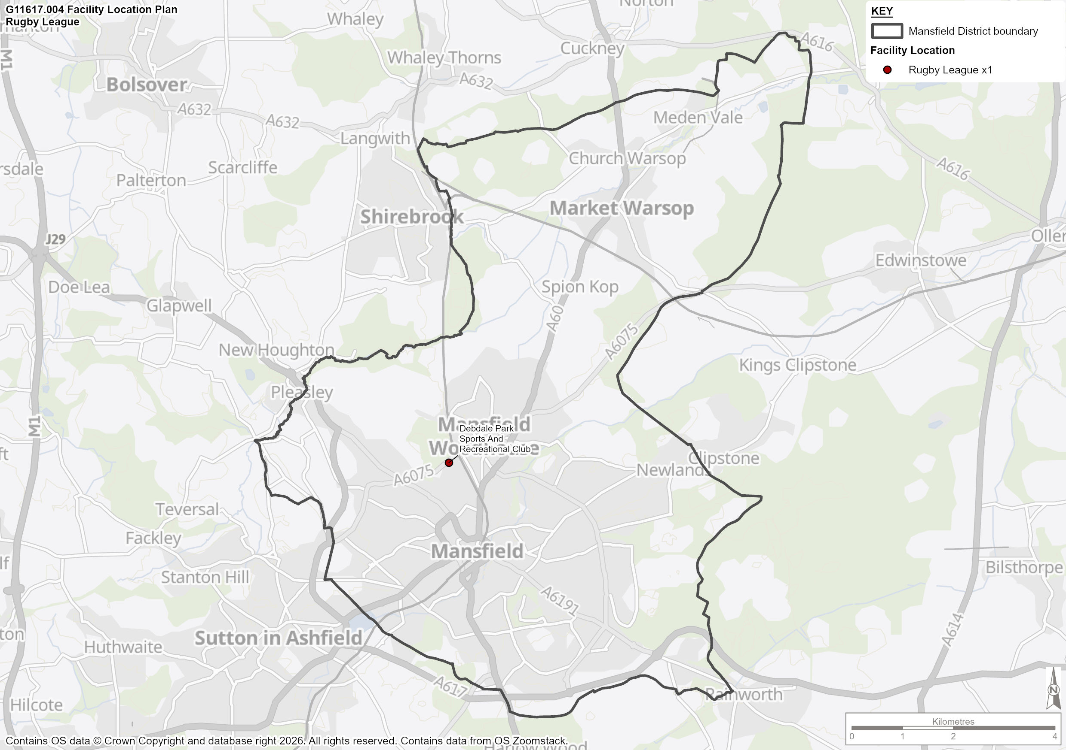

Quality Assessment

  - Strategic Leisure have undertaken a non-technical site assessment of Sherwood Wolfhunt RFLC using RFL and RFU guidelines, to provide a quality score. This score is combined with guidance on the number of Match Equivalent Sessions (MES) a pitch can support to give an overall carrying capacity. How pitch quality affects the carrying capacity is outlined in Table 54.

Table 54: RFL guidance on how quality affects playing capacity

Agreed Pitch Quality Rating | Match Equivalents per Week
Good | 3
Standard | 2
Poor | 1

  - Table 55 shows the overview of non-technical assessments of the pitches at Debdale Park Sports and Recreation Centre. This allows us to understand the capacity of each pitch from a community use perspective, using the capacity calculations in Table 58.

Table 55: Community Sites and Individual Pitch Capacity

Site | Agreed Pitch Rating | Capacity (MES)
Debdale Park Sports and Recreation Centre | Standard | 2

Demand

Current Demand

  - The team breakdown of Sherwood Wolf Hunt RFLC is summarised in Table 56. The club has 3 adult and 2 junior teams.

Table 56: Team Profile of Clubs in Mansfield

Club | Home Ground | Training Venue | Adult | Junior | Mini | Total
Sherwood Wolf Hunt | Debdale Park Sports and Recreation Centre | Debdale Park Sports and Recreation Centre | 3 | 2 | 0 | 5

Supply and Demand Balance

  - Table 57 analyses the capacity of the Debdale Parks Sports and Recreation Centre site against the demand for pitches generated by Sherwood Wolfhunt. Each team is attributed 0.5 MES per week of match play demand to take into account home and away fixtures. However, mini teams have less impact on grass pitches and have therefore been attributed 0.25 MES per week. With regards to training, the club identified that there are 6 sessions per week across all teams.

Table 57: Supply and Demand Balance – Rugby League

Site Name | Carrying Capacity (MES) | Current Demand (MES)
Site Name | Carrying Capacity (MES) | Training | Match | Supply and Demand Balance
Debdale Park Sports and Recreation Centre | 2 | 6 | 2.25 | -6.25

  - The balance in Table 57 suggests that there is a deficit of -6.25 MES per week for rugby league use on the grass pitches.

  - Through club consultation Sherwood Wolfhunt RFU identified that they would like to install rugby posts existing 3G WR22 compliant AGP on site and move all of their demand onto the artificial pitch. Although this would reduce the grass pitch deficit and there is only minimal overlap between football and rugby league seasons, the 3G pitch is already operating at capacity with significant demand from football teams throughout the year.

Future Demand

  - In order to calculate the future demand for rugby league in Mansfield, a Team Generation Rate (TGR) should be calculated using the current number of teams and current population. This measure allows us to calculate the size of population required (for various age groups) to generate enough demand for a rugby league team. This TGR could then be applied to population projections for the Study Area to confirm how population growth or reduction will affect the demand for teams in each of the key age groups.

  - However, because of the low number of teams in the study area, this method is unlikely to predict any team growth. Through consultation with the club, it was established that they do not predict any team growth but rather are focussing on growing numbers in the junior section and retaining existing player numbers to make the existing teams sustainable for the foreseeable future.

Rugby League Summary

  - This section summarises the findings from the rugby league analysis, which will form basis of the recommendation and action plan section for Mansfield.

  - Table 58 includes the response to key questions, which are asked for all PPS studies across the UK, in order to provide a standardised illustration of supply and demand for sports provision.

Table 58: Key PPS Findings for Rugby League in Mansfield

Key Question | Analysis
What are the main characteristics of the current supply and demand for provision? | There is 1 rugby league specific grass pitch in Mansfield, located at Debdale Park Sports and Recreation Centre. The pitch is of standard quality and non-floodlit.  Sherwood Wolfhunt RLFC are the only club in the study area,and currently operate 5 teams of which 3 are adult and 2 are junior.
Is there enough accessible and secured community use provision to meet current demand? | There is currently a deficit of -6.25 MES per week for grass rugby league provision, due the significant demand placed on the Debdale Park Sports and Recreation Centre pitch.  Although the club wish to utilise 3G provision on site more, the pitch is at capacity and securing additional training and match play availability may be a challenge.
Is the provision that is accessible of sufficient quality and appropriately maintained? | The Debdale Park Sports and Recreation Centre grass pitch is of standard quality and well maintained.
What are the main characteristics of the future supply and demand for provision? | The club do not expect to grow the number of teams; however, they are looking to retain players and sustain numbers across all teams. There are no grass pitch development plans and pitch quality improvement would only slightly reduce the shortfall of provision. Therefore, there will remain a deficit of rugby league facilities in Mansfield in 2043.
Is there enough accessible and secured community use provision to meet future demand? | As there are no planned pitch improvements and or additional facility delivery, it is likely that the small deficit of -6.25 MES will remain.

Cricket Analysis

Introduction and Strategic Context

  - To understand the overall objectives and priorities of the England and Wales Cricket Board (ECB), an analysis of key recent strategies and documentation has been undertaken and summarised below.

Inspiring Generations (2025 - 2028)

  - The ECB published an update to its ‘Inspiring Generations’ strategic plan in 2025, with the ambition being to inspire a generation to say that ‘cricket is a game for me’.

  - The ECB’s vision for 2028 is to become the most inclusive team sport, to grow and unite the game and to lead the game through a global transformation.

  - The strategy consists of six priorities:

- Make cricket diverse, inclusive and accessible
- Transform women’s and girls’ cricket
- Connect communities through play
- Inspire through winning England teams
- Support a thriving and sustainable men’s and women’s professional game
- Win the battle for attention

  - It is key that this PPOSS recognises the opportunity made available by Inspiring Generations and provides a framework that allows stakeholders to work together and deliver against the priorities identified above. It is also vital that any facility development for cricket takes the objectives of the strategy into consideration.

Nottinghamshire County Cricket – Facilities Strategy 2023 - 2032

  - The Nottinghamshire Facilities Strategy 2023–2032 sets out a 10-year, evidence-based plan to support the growth and sustainability of recreational and performance cricket across the county. It recognises that while current facilities broadly meet today’s demand, population growth, changing demographics, climate pressures and the rapid expansion of the women and girls’ game will place significant strain on existing provision if action is not taken. The strategy aligns with ECB and Nottinghamshire CCC priorities, focusing on “Places to Play” as a foundation for inclusive participation and long-term growth.

  - The strategy identifies 7 county-wide key strategic priorities designed to safeguard current provision and enable future growth:

- Practice facilities:
- Invest in and unlock access to existing multi-use sites (schools, leisure and community centres).
- Build partnerships with facility owners to improve availability for cricket use.

- Grass square quality:
- Roll out the PitchPower App to better assess and prioritise investment.
- Strengthen and expand pitch marking schemes across leagues.
- Introduce a countywide grounds maintenance support programme.
- Upskill grounds staff and volunteers through targeted training and advice.

- Women & girls’ facilities:
- Undertake a detailed audit of pavilions and off-field facilities.
- Prioritise “Creating Welcoming Environments” within grant funding.
- Share best-practice case studies from successful facility investments.

- Geographic shortfalls:
- Influence local authority Playing Pitch Strategies to reflect cricket shortfalls.
- Gather deeper insight into barriers preventing access to existing sites.

- Funding access:
- Use the Facilities Strategy to guide ECB and external funding decisions.
- Identify and promote alternative funding sources.
- Support clubs to align their development plans with county priorities.

- Climate change response:
- Carry out energy-efficiency and sustainability audits of club facilities.
- Provide guidance on environmentally sustainable operations.
- Prioritise ECB “Tackling Climate Change” funding over the next decade.

- Pathway & performance cricket:
- Identify or develop a dedicated cricket facility for The Blaze and county pathways.
- Invest in additional hybrid pitches to increase match and training capacity.
- Incentivise and support clubs hosting pathway cricket through targeted funding.

All Stars Cricket (2017)

  - Launched in 2017, All Stars Cricket is an ECB initiative that provides children aged five to eight with an introduction to cricket, focusing on parental engagement in supporting the newly trained All Stars Cricket Activators, as well as having a special focus on establishing women’s softball and cricket events.

  - The PPOSS recognises the growth opportunities created by All Stars Cricket. It is key for stakeholders to work together and deliver against the key objectives of ‘more play’, ‘great teams’ and ‘inspired fans.

Dynamos Cricket (2020)

  - Dynamos Cricket adds to the existing All Stars Cricket programme to encourage more boys and girls aged 8 to 11 years old new to the sport to get involved in the game.

  - Dynamos is aimed at complementing junior cricket with a more social offer focused on developing fundamental movement skills within an exciting format that mirrors the Hundred.

Women and Girls’ Cricket

  - The development of female cricket is likely to have an impact on supply and demand in the area. Women’s and girls’ cricket is a national priority, with the aspiration to increase the number of women and girls’ teams, increase the number of softball leagues and increase the number of hard ball teams.

  - Softball cricket is an ECB initiative aimed at women and girls to increase participation in cricket as a sport. The aim of softball cricket sections are enjoyment and participation, without pads, a hardball, a heavy bat and limited rules. Sessions follow a festival format with each session running for a maximum of two and half hours, shorter than traditional formats.

Supply

  - Table 59 presents a summary of the total number of cricket pitches and wickets in Mansfield. Mansfield has a total of 8 cricket pitches, 45 grass wickets and 6 artificial turf wickets.

Table 59: Supply of Cricket Pitches in Mansfield

Area | Number of pitches | Grass Wickets | Artificial Wickets
Mansfield | 8 | 45 | 6

Map 7: Cricket sites in Mansfield

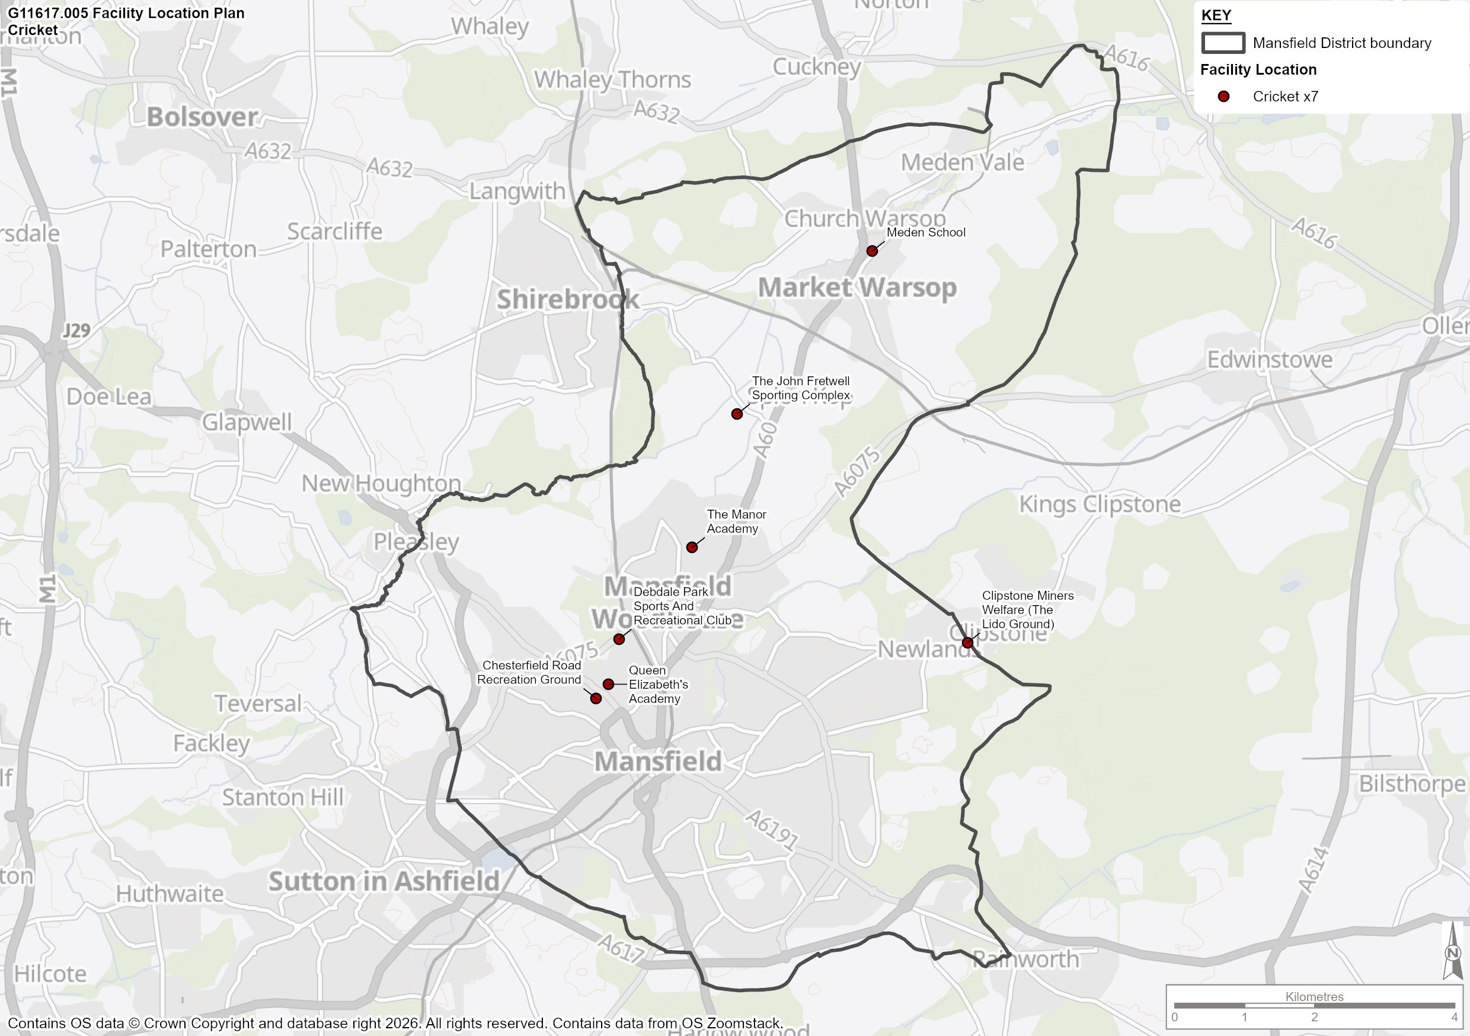

Tenure and Management

  - Table 60 illustrates that there is a variety of ownership and management models for cricket sites in Mansfield. The majority are owned and managed by sports clubs, with the second highest number managed and owned by education facilities.

  - The relatively high proportion of club ownership and management illustrates an autonomy of cricket clubs in Mansfield and suggests a low reliance on the council for cricket facility maintenance and management. Despite cricket pitches being located on education facilities, reliance on them is low as they are not community accessible.

Table 60: Cricket site ownership and management in Mansfield

Type of Ownership | Ownership | Management
Community Organisation / Trust | 0 | 1
Education | 3 | 3
Sports Club | 4 | 3
Local Authority | 1 | 1
Commercial | 0 | 0
Total | 8 | 8

  - There are 3 sites, with 3 artificial pitches, in Mansfield that do not offer any security of tenure for community cricket use. These are Meden School, Queen Elizabeth’s Academy and the Manor Academy. All other remaining sites have secured use.

Quality Assessment

  - Each site was visited and assessed by Strategic Leisure in summer 2025 using a non-technical assessment framework provided by the ECB. Where this was not possible with some school sites, desktop audits and school and club consultations have been used to complete the assessment. The assessment considers the quality of playing surface, the quality of changing rooms and the score of the maintenance regime when compared to ECB recommendations. In addition to the site visits, the club consultation was used to validate the quality ratings. Each site is rated as GOOD (≥80%), STANDARD (between 50% and 80%) or POOR (<50%).

  - The quality of a cricket pitch is essential in determining not only the number of fixtures that can be played throughout a season, but also in ensuring the quality of cricket possible. A poor quality wicket is not conducive to fair competition and may favour the batting or bowling team. With the high amount of footfall each wicket has each game, a poor quality wicket can also be the cause of unnecessary injury, due to uneven ground causing fall hazards or unpredictable bounces. It is therefore important to ensure the high quality of each wicket used for cricket in Mansfield.

  - Table 61 provides a picture of the quality of pitches in Mansfield, based on the quality assessment results.

Table 61: Summary of Cricket Pitch Scoring in Mansfield

Study Area | Pitches
Study Area | Good | Standard | Poor
Mansfield | 4 | 1 | 3

  - Table 61 illustrates that quality of provision in Mansfield is of a generally of a good standard, with 50% of all wickets being of good quality and 38% being poor. Table 62 provides a site-by-site breakdown of cricket provision in Mansfield.

Table 62: Cricket Site Breakdown in Mansfield

Playing Pitch Sites | Club | Postcode | Community use on site | Secured Community use | Ownership | Squares | Grass Wickets | Artificial Wickets | Wicket Quality | Ancillary Facility Quality
Meden School | N/A | NG20 0QN | No | Unsecure | Education | 0 | 0 | 1 | Poor | Poor
Queen Elizabeth's Academy | N/A | NG19 7AP | No | Unsecure | Education | 0 | 0 | 1 | Poor | Poor
The Manor Academy | N/A | NG19 8QA | No | Unsecure | Education | 0 | 0 | 1 | Poor | Poor
Chesterfield Road Recreation Ground | Mansfield CC | NG19 7AS | Yes | Secure | Local Authority | 1 | 14 | 1 | Standard | Poor
Clipstone Miners Welfare (The Lido Ground) | Clipstone CC | NG21 9AB | Yes | Secure | Sports Club | 1 | 9 | 1 | Good | Poor
Debdale Park Sports And Recreation Centre | Sherwood Colliery CC | NG19 7NS | Yes | Secure | Sports Club | 1 | 6 | 1 | Good | Standard
The John Fretwell Sporting Complex | Welbeck CC | NG19 8LL | Yes | Secure | Sports Club | 2 | 8 |  | Good | N/A

  - 69% (31) of all individual grass wickets in the study area are rated as good quality, and the remaining 31% (14) are classed as standard. There are no poor quality grass wickets, although the education sites do not have any grass wickets, which are therefore recorded as poor quality. This highlights the high standard of provision across the MDC area.

  - When considering artificial wickets, 50% are rated as good, 33% as poor and 17% standard.

  - Ancillary provision within the study area is also varied in standard. The three education sites do not offer any ancillary facilities, two of the remaining four sites have excellent facilities, with one being poor and the other standard. The highest quality ancillary facilities are located on a sports club owned and managed facility, with the lowest quality situated on a local authority site.

  - Clipstone CC ancillary facility provision ranked as poor. The club feedback highlighted the Clipstone Miners Welfare Community Trust which Clipstone CC operate within would like them to relocate to a new facility being developed as part of the Clipstone Regeneration project. Phase 2 of the project involves the development of a relocated and enhanced sports pavilion and cricket fields. This would take the club outside of the Mansfield District Council boundary into Newark & Sherwood District Council boundary. The club have explained that they would prefer to improve and develop facilities on their current site, with a move to a new site risking a lowering in the standard and level of cricket below their current standard.

Current Demand

Club and Team Profile

  - To understand how cricket is played across Mansfield and the trends for demand across the game, this section assesses club affiliation data provided by Nottinghamshire Cricket. Welbeck CC data was not provided, and information was instead sourced from Play Cricket.

  - 4 clubs have been identified as playing in Mansfield, consisting of a total of 35 teams. There are 17 teams in junior age categories and 18 senior level teams. Club profiles are provided in Table 63.

Table 63: Cricket Club Profiles

Club | Number of Competitive Teams |  |  |  | Total
Club | Senior Men | Senior Women | Junior Boys | Junior Girls | Total
Clipstone CC | 2 | 1 | 3 | 0 | 6
Mansfield CC | 3 | 0 | 3 | 0 | 6
Welbeck CC | 7 | 2 | 10 | 1 | 20
Sherwood Colliery CC | 3 | 0 | 0 | 0 | 3
Total | 15 | 3 | 16 | 1 | 35

Consultation Overview

  - As part of the PPOSS process, all cricket clubs were given the opportunity to respond to consultation, allowing them to provide their views on facilities, developments, issues and growth plans. Responses cover 3 of the 4 teams. An overview of the consultation is included in Table 64.

Table 64: Cricket Consultation Summary

Club Name | Consultation Summary
Mansfield Cricket Club | The Mansfield CC ground is leased to them from the council, with the club taking responsibility of the maintenance of the grass wickets, where the council manage the outfield groundworks.  The club currently offer three senior teams and three junior sides at U9, U11 and U13, alongside the 18 participants of the All Stars programme. They do not currently have any all-female teams at senior or junior levels but there are females within the U9 and U11 sides. Plans are in place to introduce the 3rd senior side for Saturday cricket, and they would like to offer women’s softball cricket and an U15 junior side.  The club have highlighted the need for improvements to the grounds fencing and benches in the changing rooms, along with the benefit of additional outdoor seating.
Clipstone Cricket Club | The Clipstone CC ground is rented to them through the Clipstone Miners Welfare Trust, with the club responsible for managing the site and maintaining the ground. Accessing the indoor nets in Cuckney, located within neighbouring Bassetlaw district.  The club currently offer three senior teams and three junior teams at U9, U11 and U15, with 12 participants in there All Stars programme and 13 in the Dynamos programme. Offering female softball and hardball activity, for one female team, looking to expand to two next year. The club have aspirations to also offer U13 boys, U12 girls’ teams.  The club are set to be relocated as part of Phase 2 of the Clipstone Regeneration project however the club would prefer to remain at their current location and develop the facilities and ground on the existing site.
Sherwood Colliery Cricket Club | Lease the cricket ground at Debdale Park Sports Club. Currently offer three senior men’s teams and have aspirations to offer U11’s mixed team and introduce women’s softball cricket.  Sherwood Colliery CC have previously secured funding and completed works on the grass wickets and square and are in the process of acquiring funding for new fixed training nets.
Welbeck Cricket Club | No feedback provided – NGB state the club is biggest ground in the county, utilised by Nottinghamshire County Cricket Club (NCCC) as an out-ground site. Good site for a non-professional cricket ground. Located on Warsop Sporting Trust Ground and have an agreement with the trust as their previous ground was utilised for house building. 2 grounds on the site, exported demand to Caunton for 2025 season due to addition of 5ths Men’s team. Have artificial nets on site and indoor. Indoor nets on site utilised for a short period due to competition from private hire of the function room.

Displaced Demand

  - Nearly all demand from cricket clubs in Mansfield is met within the study area. However, there are a number of teams that utilise provision outside of Mansfield.

  - Clipstone CC highlighted that the club travel to Cuckney for winter indoor training.

  - Consultation with the ECB also indicated that Mansfield CC 3 XI play home fixtures at Clumber Park in Worksop, which is a 30 minute drive from Mansfield CC.

  - Welbeck CC 5 XI travel to Caunton Cricket Ground in Newark and Sherwood for home fixtures, which is also approximately 30 minutes outside of Mansfield.

Supply and Demand Balance

  - This section presents the supply and demand balance findings for cricket provision (both for current and future analyses) for the study, split by sub-area.

  - The pitch balance figures i.e., the relationship between supply and demand, have been calculated using the capacity and pitch quality ratings.

  - Table 66 provides a supply and demand analysis for all cricket sites across the study area and provides a greater understanding of the capacity balance of sites across Mansfield.
  - For all supply and demand analysis, the carrying capacity of grass and artificial wickets have been adjusted based on the quality rating of the facilities. Following consultation with the ECB, the following carrying capacity assumptions have been agreed:

- A good quality grass wicket can accommodate 5 matches per season (MPS)
- Standard quality grass wicket can accommodate 4 MPS
- A poor-quality grass wicket has not been assigned any carrying capacity (0 MPS) as it is assumed that the wicket is not safe for formal or informal cricket use
- Good and standard quality non-turf pitches (NTP’s) can accommodate 60 MPS, however a poor quality NTP is not assigned any carrying capacity (0 MPS). In the analysis below, grass wickets are considered alone firstly. If applicable, a total balance includes NTPs included after.

Spare Capacity and Overplay

  - Overplay occurs when a cricket square is played on a greater amount than is recommended by the pitch’s carrying capacity. If a square has 8 individual good quality wickets, then this provides an overall carrying capacity of 40 matches per season for that square. If, however, demand consultation indicates that there are 50 matches being played on that square over the course of a season, then that square (pitch) can be said to be overplayed.

  - ECB guidance suggests that each adult team is presumed to play 10 home games per season, whilst juniors will play 8. These figures have therefore been utilised to calculate the demand for pitch provision. However, where clubs have identified use of NTPs through consultation, this demand has been taken away from grass wickets.

  - There are a number of reasons for a pitch being overplayed, such as lack of alternative provision, poor site management, or poor quality wickets which lower the capacity for cricket to be played on the pitch.

  - Spare capacity is the opposite of overplay and occurs when demand at a site is less than the theoretical carrying capacity over a season. It is important that any overplay of pitches is considered as part of the overall supply and demand analysis for grass wickets, therefore Table 66 identifies overplay or spare capacity at all sites.

  - As there were no junior wickets identified in the study area, the total demand including adult and junior play has been taken into consideration rather than differentiating between the two age categories.

Table 65: Current Position for Cricket in Mansfield

Playing Pitch Sites | Squares | Quality of Provision | Grass Wickets | Grass Supply (MPS) | Grass Demand | Grass Balance (MPS) | NTP Wickets | NTP Supply (MPS) | NTP Demand | NTP Balance (MPS) | Total Balance
Clipstone Cricket Club | 1 | Good | 9 | 45 | 54 | -9 | 1 | 0 | 0 | 0 | -9
Mansfield Cricket Club | 1 | Standard | 14 | 56 | 54 | 2 | 1 | 0 | 0 | 0 | 2
Welbeck Cricket Club | 2 | Good | 16 | 80 | 178 | -98 | 0 | 0 | 0 | 0 | -98
Sherwood Colliery Cricket Club | 1 | Good | 6 | 30 | 30 | 0 | 1 | 60 | 16 | 44 | 44
Meden School | 1 | Poor | 0 | 0 | 0 | 0 | 1 | 0 | 0 | 0 | 0
Queen Elizabeth's Academy | 1 | Poor | 0 | 0 | 0 | 0 | 1 | 0 | 0 | 0 | 0
The Manor Academy | 1 | Poor | 0 | 0 | 0 | 0 | 1 | 0 | 0 | 0 | 0
 |  |  | 45 | 211 | 316 | -105 | 6 | 60 | 16 | 44 | -61

  - Table 65 shows the supply and demand balance of all cricket sites across the Study Area. Where sites have both grass and artificial wickets, the balance is shown separately as well as a total balance. However, the total balance may not reflect any potential overplay on the grass wickets.

  - When considering Mansfield as a whole, there is a deficit of -105 MPS on grass wickets. Although there is a spare capacity at two of the four sites, the Welbeck CC site experiences significant overplay, at -98 MPS. This is due to the large number of teams at the club across both senior and juniors.

  - Welbeck CC based at John Fretwell Sports Ground (-98 MPS) and Clipstone CC (-9MPS) have shortfalls of grass wicket capacity.

  - Welbeck CC does not have a NTP and the NTP at Clipstone CC is of Poor quality and therefore not considered as part of the demand calculations.

  - There are only a small number of artificial wickets in the study area mainly located on education sites, which are not accessible and the NTPs are of poor quality. It must be noted that although useful for training and occasional junior match play, it is often not possible to meet demand, particularly from adults on NTP wickets and clubs aspire to play on grass wickets.

  - Overplay typically leads to clubs either using facilities more intensively than is sustainable or using unsecured nearby facilities for short term usage on an ad hoc basis, to ensure that facilities can be run efficiently and effectively. It is therefore important that future facility planning allows clubs to utilise an adequate quantity of provision to ensure that existing facilities are not subject to overplay.

  - Table 66 highlights where there is potential spare capacity at peak times for cricket activity in Mansfield. Although some sites have spare capacity as they cater for less MPS than the wicket quality allows, due to the number of matches taking place, spare capacity at peak times is reduced.

Table 66: Potential Spare Capacity for Cricket in Mansfield

Playing Pitch Sites | Total Weekly Balance | Potential spare capacity for senior cricket Saturday | Potential spare capacity for senior cricket Sunday | Potential spare capacity for junior cricket midweek
Clipstone Cricket Club | -9 | No | No | No
Mansfield Cricket Club | 2 | No | Yes | Yes
Welbeck Cricket Club | -98 | No | No | No
Sherwood Colliery Cricket Club | 44 | No | Yes | Yes

  - Club consultation and online research have been used to establish match play timings for each club. It is assumed that the unavailable and unsecure sites do not have any available capacity.

  - Based on this research, there is no spare peak time match sessions on Saturdays and only 2 match sessions on Sundays for senior cricket in the study area.

  - Additionally, there are 2 sites that have the potential to offer extra mid-week junior sessions if we consider the use of artificial wickets along with grass wickets. These are Mansfield Cricket Club and Sherwood Colliery Cricket Club.

Site by Site Analysis

  - The site-by-site assessment below includes all cricket site that have been included within the study and provides an overview of grass wicket capacity, as well as summarising the key parts of the PPOSS assessment that have been identified so far within this sport specific section, such as community use status, site security and site ownership.

Table 67: Site by Site Summary for Cricket Provision in Mansfield

Site | Squares | Community Use | Secured Community Use | Ownership | Capacity Analysis (Grass Wickets)
Clipstone Cricket Club | 1 | Yes | Secure | Sports Club | -9
Mansfield Cricket Club | 1 | Yes | Secure | Local Authority | 2
Welbeck Cricket Club | 2 | Yes | Secure | Sports Club | -98
Sherwood Colliery Cricket Club | 1 | Yes | Secure | Sports Club | 0
Meden School | 1 | No | Unsecure | Education | 0
Queen Elizabeth's Academy | 1 | No | Unsecure | Education | 0
The Manor Academy | 1 | No | Unsecure | Education | 0

Future Demand

Demand Driven by Population Growth

  - In order to understand the future demand for cricket in the Study Area, a Team Generation Rate has been calculated using the current number of teams and the current population. This measure allows us to calculate what size of population (for various age groups) will typically cause enough demand for a cricket team.

  - This TGR can now be applied to the population projections for the Study Area to confirm how population growth or reduction will affect the demand for teams in each of the key age groups.

Table 68: Impact of Population Projections on the Need for Cricket Provision in Mansfield (TGRs)

Age group | No. of teams in age group | Current Population (2026) in age group within the area | Future Population (2043) in age group within the area | Current TGR | Population Change in Age Group | Change in Team Numbers in Age Group (numbers rounded up or down)
Cricket Open Age Men’s (18-55yrs) | 15 | 26,392 | 29,912 | 1,759 | 3,838 | 2
Cricket Open Age Women’s (18-55yrs) | 3 | 26,705 | 29,955 | 8,902 | 3,557 | 0
Cricket Junior Boys (7-17yrs) | 16 | 7,828 | 7,753 | 489 | 267 | 1
Cricket Junior Girls (7-17yrs) | 1 | 7,527 | 7,352 | 7,527 | 175 | 0
Total | 35 |  |  |  |  | 3

  - This TGR analysis above predicts that there will be a growth of 3 teams due to population growth across Mansfield. Growth will be within senior men’s teams and one additional junior boys’ team.

  - Additional demand through population growth will add 28 MPS to the study area by 2043.

Future growth driven by latent demand

  - Whilst future demand will be driven by population growth, it is also likely that clubs and operators are successful in converting latent demand into actual demand, therefore increasing the number of people playing cricket. Table 69 highlights the latent demand predictions made by clubs as part of consultation responses.

Table 69: Latent Demand Predictions by Cricket Clubs

Club | Number of Competitive Teams |  |  |  | Total
Club | Senior Men | Senior Women | Junior Boys | Junior Girls | Total
Clipstone CC | 1 | 0 | 3 | 0 | 4
Mansfield CC | 0 | 1 | 1 | 0 | 2
Welbeck CC | - | - | - | - | -
Sherwood Colliery CC | 0 | 1 | 1 | 0 | 2
 | 1 | 2 | 5 | 0 | 8

  - A total of 8 potential additional teams were highlighted by affiliated cricket clubs. Most teams created through latent demand will be junior boys (5), followed by senior women (2) and senior male (1).

  - This growth is predicted to add an additional 70 MPS to grass wickets by 2043.

  - However, it is important to note that the growth from latent demand should be treated with an element of caution, as the source of information is club consultations. In some instances, clubs may not have considered the governance and infrastructure requirements, associated with ongoing club growth. As a result, there may be instances where actual growth does not meet the projections identified during consultation.

Current and Future Position of Grass Pitches

Understanding the Process and Key Terminology

  - The previous section provides an analysis, both over the season and during the period of peak demand, of the balance between supply and demand for each grass and artificial cricket squares across all sites.

  - To provide a clear idea of the current position for cricket provision across each of the sub-areas, Table 70 shows the balance between supply and demand for grass wickets in each sub-area. The information gathered in the earlier stages of the project is used to present the current supply and demand position for each pitch typology. The current position is then used to look at the likely future position by incorporating latent/unmet, and future demand.

  - The points below provide further explanation on the terms used within the tables:

- Site capacity: The amount of capacity from all pitches quantified in Matches Per Season (MPS)

- Current demand: The total amount of demand for cricket sites in the area, expressed in matches per season (MPS)

- Current position: The supply and demand position for grass wickets, when taking into consideration the extent of spare capacity and then deducting the amount of overplay.

- Future position: The capacity position for grass wickets once additional demand that is projected to be realised over the lifetime of the Local Plan Review to 2043, as a result of population growth alone has been added.

- Future position latent demand: The future position once additional demand created by latent demand predictions by clubs has been added to the future position.

- ECB guidance suggests that each adult team is presumed to play 10 home games per season, whilst juniors will play 8. These figures have therefore been utilised to calculate the future demand for pitch provision.

  - The following analysis provides a total supply and demand calculation for grass wickets which includes both adult and junior participation. This has not been separated due to the fact there are no junior grass wickets identified in Mansfield.

Total Wicket Analysis

Table 70: Current and Future Position of Adult Grass Wickets – All Figures in MPS

Analysis Area | Site Capacity | Current Demand | Current Position | Additional Future Demand – Population Growth | Future Position | Additional Future Demand – Latent Demand | Future Position - Latent Demand
Mansfield | 211 | 316 | -105 | 28 | -133 | 70 | -203

  - Table 70 illustrates that there is currently a deficit of -105 MPS for grass wickets across Mansfield. However, this influenced significantly by the high number of teams at Welbeck CC.

  - When future demand created by population growth to 2043 is considered, it is predicted that study area wide deficit will increase to -133 MPS.

  - If latent demand predictions by clubs are also taken into account, then the study area-wide deficit will increase significantly to -203 MPS.

  - When capacity generated by NTPs (non-turf pitches) is taken into consideration an extra 44 MPS is available. However, it is often not possible to meet demand, particularly from adults on NTP wickets. NTPs are not ideal for meeting match play demand and generally clubs wish to play on grass wickets. Meeting future junior demand through use of NTPs could be considered as part of the stage D analysis.

  - The development of additional non-turf pitches (NTPs) is also highlighted as an effective way of catering for youth, women soft ball, girls and disability cricket and assisting with over-capacity issues on grass wickets.

Cricket Summary

  - This section summarises the findings from the cricket analysis, which will form the basis of the recommendation and action plan section for Mansfield.

  - Table 71 includes the response to 5 key questions which are identified in the Sport England PPOSS Guidance Checklists.

Table 71: Key PPOSS Findings for Cricket in Mansfield

Key Question | Analysis
What are the main characteristics of the current supply and demand for provision? | There is a total of 8 pitches in Mansfield, comprising of 45 grass wickets and 6 artificial grass wickets.  There are 3 sites that are unavailable or unsecure in the study area: Meden School, Queen Elizabeth Academy and The Manor Academy.  Most of the facilities owned and managed by sports club, with one local authority owned and managed site.  4 clubs have been identified as playing in Mansfield with a total of 35 teams. There are 17 teams in junior age categories and 18 senior level teams.
Is there enough accessible community use provision to meet current demand? | The analysis shows that, overall, there is a deficit of -105 MPS of accessible community use grass wicket provision in Mansfield.
Is the provision that is accessible of sufficient quality and appropriately maintained? | 69% (31) of all individual grass wickets in the study area are rated as good quality, and the remaining 31% (14) are classed as standard. There are no poor-quality grass wickets, although the education sites do not have any grass wickets, which are therefore recorded as poor quality.  When considering artificial wickets, 50% are rated as good, 33% as poor and 17% standard.
What are the main characteristics of the future supply and demand for provision? | The future demand for cricket is projected to increase across the Study Area, with a total growth of 3 teams and 28 MPS by 2043 due to population growth.  Latent demand predictions by clubs are expected to add 8 teams and 70 MPS of demand to the study area.
Is there enough accessible community use provision to meet future demand? | Taking into account population growth and latent demand, by 2043 the study area-wide deficit is expected to increase to -203 MPS.

- Tennis Analysis

Introduction and Strategic Context

  - The Lawn Tennis Association (LTA) is the organisation responsible for the governance of tennis and padel. The following section provides greater detail of the existing strategies and national facility plans that are currently being delivered by the LTA.

  - Following this, the supply and demand section of this report evaluates the adequacy of facilities for tennis and considers:

- The supply of courts and demand for these;
- The quality of courts in Mansfield; and
- Recommendations moving forward.

  - The LTA govern all tennis activity in Britain, from grassroots participation through to the professional game. Their work is split into three main areas:

- Participation - Making tennis a sport for anyone to play, through increasing participation and access;
  - LTA Youth - increasing opportunities for young people to play and stay in tennis
  - Open Court – successful disability programme allowing all people regardless of disability enjoy the benefits of tennis
  - SERVES - programme that takes tennis right into the heart of new communities across Britain
  - Competition – hosting a range of national, regional and local tennis competitions to support hundreds of thousands of players ever year

- Performance - Becoming one of the most respected nations in the world for player development;
  - Player Pathway - supporting and nurturing the next generation of elite British players with programmes such as our Pro Scholarship Programme
  - National Tennis Centre - equipped with world class courts and facilities, and provides a base for Britain’s top tennis and wheelchair tennis players to train
  - International Competition - increased number of international tournaments we are staging across Britain throughout the year promoting more opportunity for professional British players

- Transformation - Transforming tennis in Britain by working with everyone in the sport
  - Inclusion Strategy - aims to see tennis to lead the way for inclusion and diversity in sport
  - Safeguarding – ensuring the tennis is at the forefront of safeguarding in sport by ensuring that it remains safe for all
  - Parks Tennis – working with government and local authorities to deliver multi-million pound investment for local communities
  - Padel Tennis - exciting new form of tennis that’s easy to play, fun for all ages and abilities and extremely sociable, and will help to engage new audiences

Tennis Opened Up 2024-2026

  - The LTA has recently updated their Tennis Opened Up strategy which outlines the strategic priorities for the future of the sport. The overriding mission statement of the strategy is “to grow tennis by making it welcome, enjoyable and inspiring to everyone.” To help with delivering on this mission statement, three pillars have been identified to provide focus for improvement. These are:

- Welcoming: Making tennis welcoming to all by reaching new audiences through grassroots programmes, investing in high quality facilities with a focus on parks and covered courts, whilst creating a more diverse tennis workforce.

- Enjoyable: Ensure tennis is enjoyable for all by making it easy to play. Investing in resources and teacher training in schools across the country, pioneering new and engaging forms of the sport, and creating a variety of opportunities to book, play and compete whether that be in clubs, parks or other venues.

- Inspiring: Making sure we inspire through tennis – on and off the court. Helping to develop professionals who perform at the highest level, can inspire future generations of players and fans. We can only do this through investment in a high quality and internationally recognised performance programme. We also want to set aspirational standards off the court – making sure tennis is governed and administered to the very highest standards and ensuring we have the financial stability to guarantee the long-term health of the sport.

Pickleball

  - Although the LTA are not the governing body for pickleball, they support their registered venues to offer this type of activity to bring new interest and diversity to venues. Currently around 25% of LTA registered venues offer pickleball where it crosses over with tennis. Pickleball complements tennis and is a great way to engage new and underrepresented communities, however it is advised venues use temporary throw down lines. LTA support for clubs consists of online resources and workforce CPD.

Supply

  - The following tables 72-74 provide a breakdown of tennis courts in Mansfield. Each table represents a different venue type i.e. Clubs, Parks, Education.

  - The quality rating of a site is calculated using the following LTA criteria:

Unplayable:  As described | Poor:  Playing surface poor, slippery playing surface, poor drainage, cracks on the playing surface and surrounding area, court markings hardly visible, no nets or nets damaged, surrounding fencing poor/dangerous. | Below Average:  Court showing clear signs of deterioration  including cracking, loosening of fretting of  the surface indicates the court is in need  of resurfacing. | Average:  Court colour is fading or showing signs of wear. The surface remains largely intact. The court life, prior to needing resurfacing, would be extended for up to 5 years by cleaning and repainting of the existing surface. | Good:  Good playing surface, courts recently been upgraded, resurfaced, nets and fencing in working order | Excellent:  As described

Table 72: Club Sites - Outdoor Tennis Provision by Site

Site Name | Availability | LTA Registration Status | Pay & Play | Security of Community Use | Ownership | Management | Number of Courts | Surface | Floodlit | Site Quality
Mansfield Lawn Tennis Club | Available | Yes | Yes | Secure | Sports Club | Sports Club | 9 | 5x macadam / 4x grass | 3 | Good

Table 73: Parks Sites - Outdoor Tennis Provision by Site

Site Name | Availability | LTA Registration Status | Pay & Play | Security of Community Use | Ownership | Management | Number of Courts | Surface | Floodlit | Site Quality
Carr Bank Park | Available | Yes | Yes | Secure | Local Authority | Local Authority | 4 | Macadam | 0 | Average
Manor Park | Available | Yes | Yes | Secure | Local Authority | Local Authority | 3 | Macadam | 0 | Excellent
Racecourse Park (Mansfield) | Available | Yes | Yes | Secure | Local Authority | Local Authority | 8 | Macadam | 0 | Excellent

Table 74: Education and Other Non-Registered Sites - Outdoor Tennis Provision by Site

Site Name | Availability | LTA Registration Status | Pay & Play | Security of Community Use | Ownership | Management | Number of Courts | Surface | Floodlit | Site Quality
Meden School | Unavailable | No | No | Unsecure | Education | Education | 3 | Macadam | 0 | Poor
Queen Elizabeth's Academy | Unavailable | No | No | Unsecure | Education | Education | 7 | Macadam | 0 | Average
The Manor Academy | Unavailable | No | No | Unsecure | Education | Education | 8 | Macadam | 0 | Poor
Vision West Nottinghamshire College | Unavailable | No | No | Unsecure | Education | Education | 2 | Macadam | 0 | Unplayable
All Saints Catholic School | Unavailable | No | No | Unsecure | Education | Education | 5 | Macadam | 0 | Average
Samworth Church Academy | Unavailable | No | No | Unsecure | Education | Education | 3 | Macadam | 0 | Average
The Brunts Academy | Unavailable | No | No | Unsecure | Education | Education | 5 | Macadam | 0 | Average

  - Provisional findings from the supply-side analysis indicate:

- In total there are 57 tennis courts, across 11 sites in Mansfield.
- Included in the 57 courts, there are 4 grass courts that can only provide seasonal use (6 months per year)
- Of the 11 sites, 4 are LTA registered and 7 are unregistered.
- 24 out of 57 courts are available to public.
- 3 out of 11 sites are rated as excellent or good quality. 5 are classed as average quality and 2 are poor. Vision West Nottinghamshire College is classed as unplayable and cannot offer any capacity for tennis activity.
- There are 3 floodlit courts in Mansfield, accounting for 7% of the total supply. All floodlit courts are located at Mansfield Lawn Tennis Club and are available on a pay and play basis to the community.

  - Although theoretically there are still courts at Vision West Nottinghamshire College, they are in an unplayable condition and are currently used as an additional car park for the college, who have indicated to the LTA that are there no plans to reinstate them as active courts.

  - Non-LTA registered courts are missing an opportunity to open tennis up in their respective locations. Without registration those responsible for the courts are unable to access LTA support and resources. This support aims to help improve the management and operation of courts to ensure they are accessible and meet demand for tennis in Mansfield. Facilities that are not registered to the LTA are likely not managed or utilised effectively. Opportunities are lost to maximise tennis participation as well as wider sport and physical activity benefits to local communities across the area.

Table 75: Outdoor Tennis Ancillary Provision by Site

Site Name | Overmarked? | Ancillary Facilities
Carr Bank Park | No | None
Manor Park | No | None
Mansfield Lawn Tennis Club | No | Good
Meden School | Yes – 3x netball | None
Queen Elizabeth's Academy | Yes – 4x netball | None
Racecourse Park (Mansfield) | No | Basic
The Manor Academy | Yes – 8x netball | None
Vision West Nottinghamshire College | No | None
All Saints Catholic School | Yes | None
Samworth Church Academy | Yes | None
The Brunts Academy | Yes | None

  - Table 76 provides an overview of feedback received from LTA registered venues as part of the tennis consultation process.

Table 76: Tennis Club Consultation

Registered Venue | Venue Type | Consultation Summary
Carr Bank Park | Park | Carr Bank Park comprises of four macadam tennis courts, all of which are rated as being in good condition and are not floodlit. The site currently has 28 annual pass holders and expects this to increase by more than 50 over the next five years, with capacity to accommodate new users. There are no ancillary facilities available on site and no current plans for facility development. The site is leased under a concession fee agreement, with a two-year contract and an optional two-year extension, managed by We Do Tennis and maintained by the local council.
Mansfield Lawn Tennis Club | Club | Mansfield Lawn Tennis Club operates from its primary site, which it owns and manages with a tenure of over 10 years, and all management and maintenance are carried out by volunteers. The club has nine courts in total, including three floodlit courts, five tarmac courts, four grass courts, and no current padel or pickleball courts; court quality is generally standard, although the grass courts are rated poor due to affordability issues, and the courts are due for renewal within the next 24 months. The club has 160 playing members, expects membership to increase by 50 or more over the next five years, and has capacity for new members. Ancillary facilities at the site are of good quality and include changing rooms, a kitchen, toilets, and a bar. Future development plans include installing two padel courts and new floodlighting, both of which are dependent on securing additional funding.
Racecourse Park (Mansfield) | Park | Racecourse Park features eight macadam tennis courts that are all in good condition, with no floodlit, grass, clay, padel, or pickleball courts and no secondary site in use. The club currently has 43 annual pass holders and expects this to increase by 50 or more over the next five years, with capacity to accommodate new users. There are no current facility development plans, and no ancillary facilities. The site is leased, with a 2–3 year tenure, managed by We Do Tennis and maintained by the council, operating under a two-year concession agreement with the option for a further two-year extension.

  - Map 8 shows the geographic location of outdoor tennis courts across the Study Area and presents the dispersion courts across Mansfield.

Map 8: Outdoor Tennis Court Audit in Mansfield

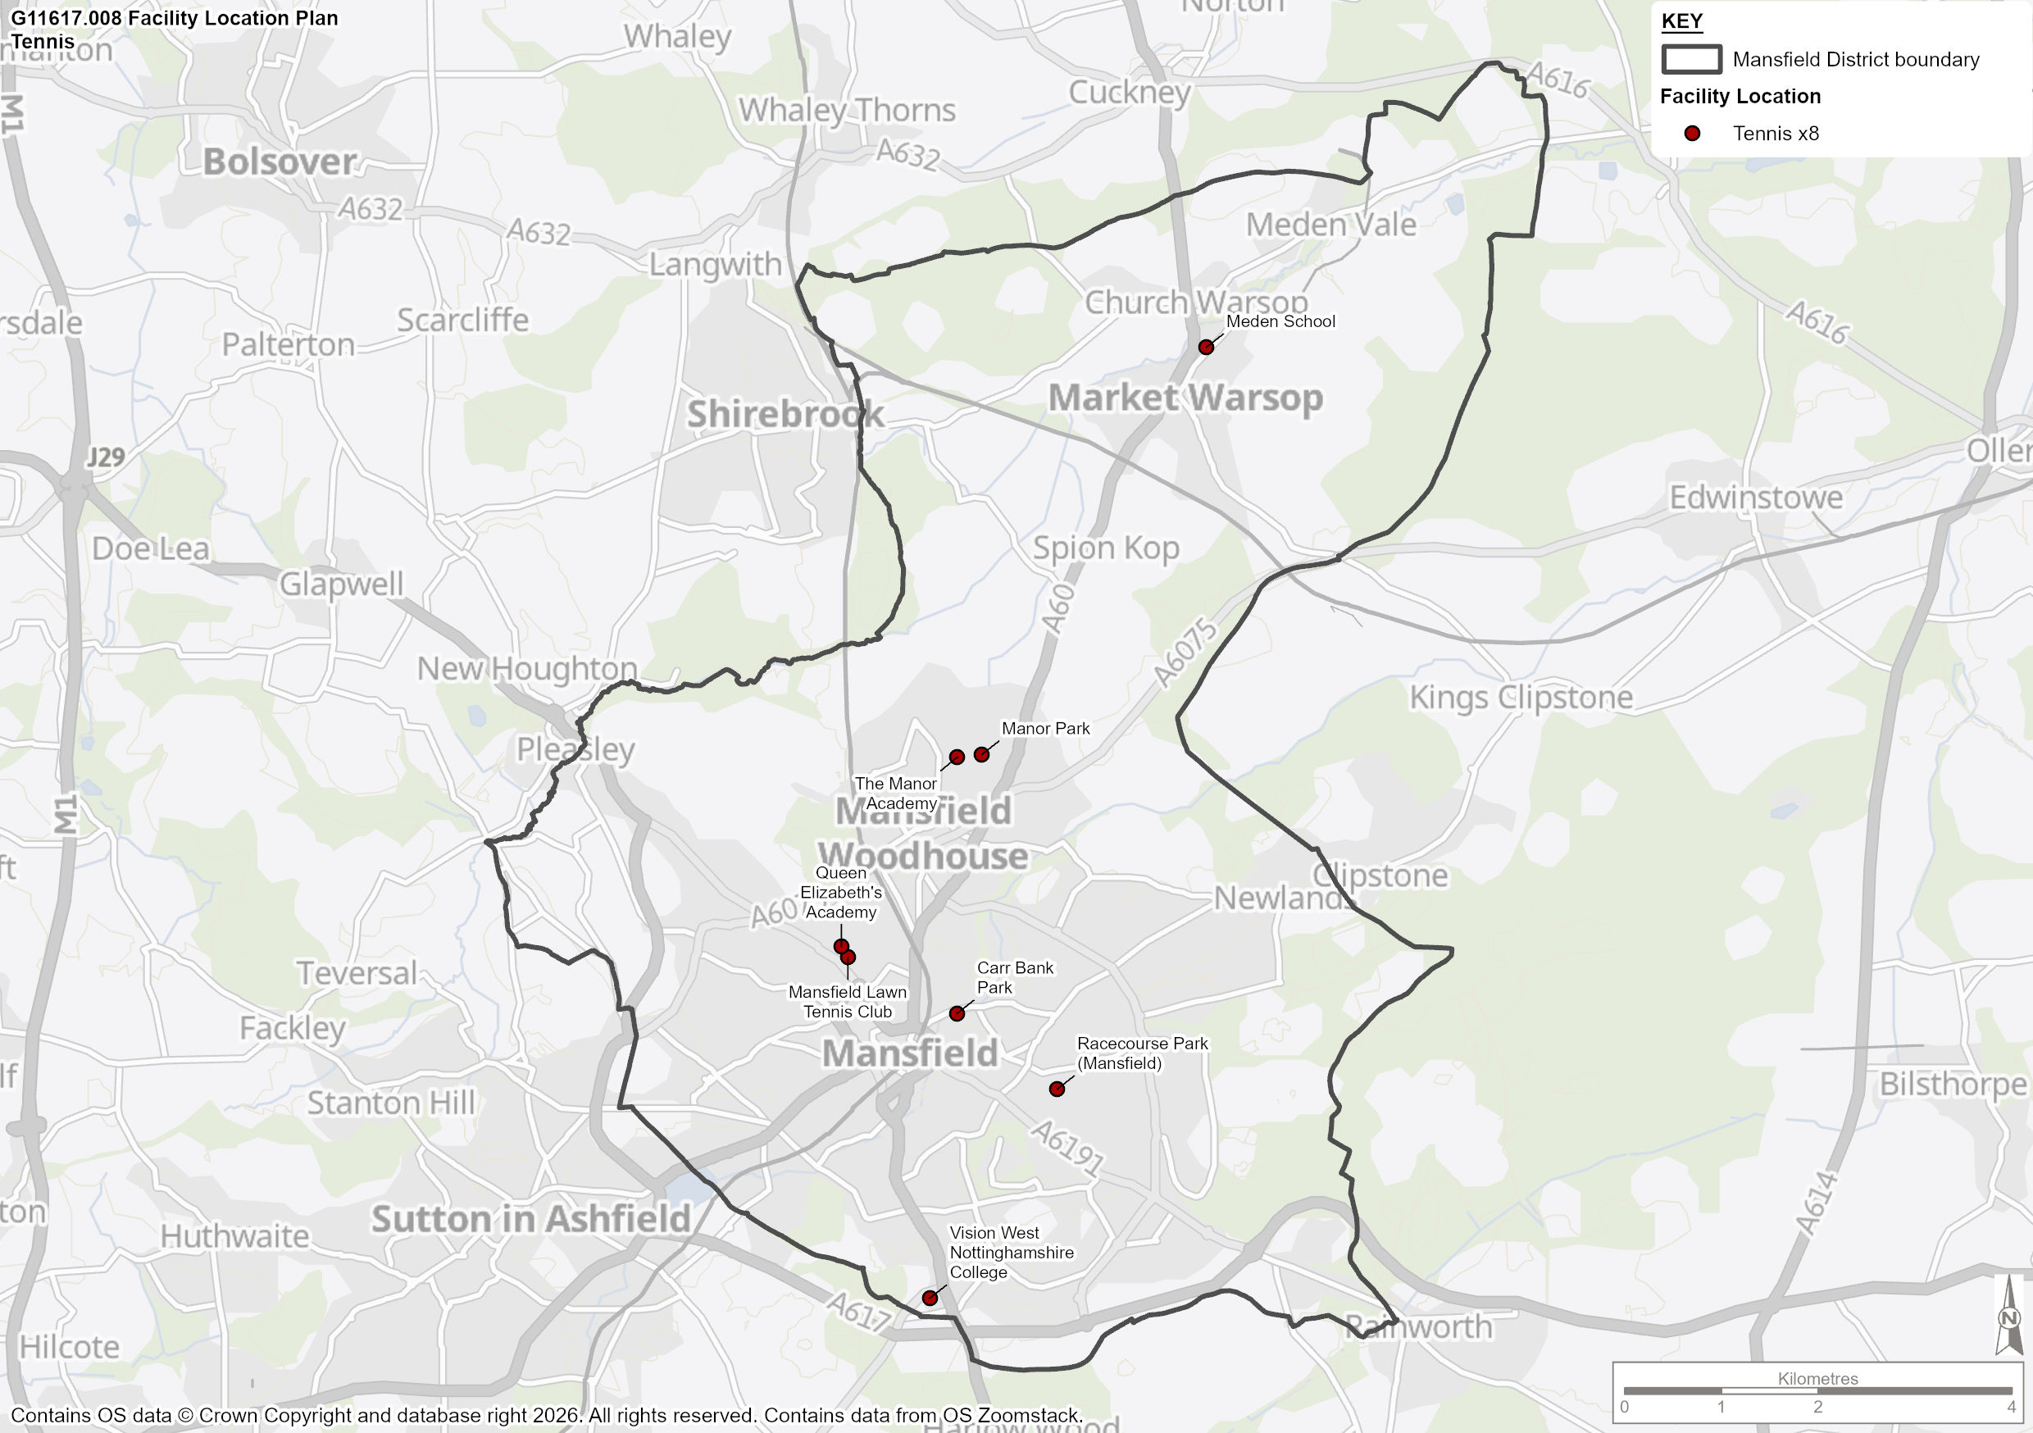

  - This section of the analysis examines the demand for tennis in Mansfield.

Active Lives Survey

  - As per the LTA’s insight as captured at the start of this chapter, demand for tennis is generated by a wide range of participants, from members to more ‘casual’ or ‘recreational’ players, to those trying tennis for the first time. Although Mansfield Lawn Tennis Club is accessible on a pay and play basis, many of the more recreational players are usually defined by a lack of membership to a tennis club and typically access facilities through public park courts and other publicly available facilities, which is reflected in the LTA’s work around participation and transformation.

  - Sport England’s Active Lives Survey represents the most robust dataset regarding participation in sport in England amongst those aged 16 or older. The latest iteration of this data is taken from surveys carried out in November 2023/24. Data was NOT available for Mansfield as a local authority area, so where necessary the data used is from the Nottinghamshire Active Partnership (NAP) area instead. The data shows the following:

- 1.9% of residents aged 16+ in the NAP area reported playing tennis twice within the last 28 days (survey carried out in November 2023).
- The 1.9% ‘twice-monthly’ participation rate for NAP area equal to the national equivalent participation rate.
- 4.9% of residents aged 16+ in the NAP area reported playing tennis at least once in year 23/24, which is 1.3% lower than the national average of 6.2%.
- According to the population figures used throughout this report, there are 93,689 residents in Mansfield aged 16 or over. Although the 1.9% participation rate used in the Active Lives Survey considers the whole of the NAP area, we can assume this is also relevant for Mansfield. This means that when translated into demand, the Active Lives Figures show that 1,780 people play tennis at least twice every 28 days and 4,591 play at least once per year. These figures can be taken forward to analyse the utilisation the court capacity in Mansfield.

Membership Data

  - Consultations undertaken with LTA registered venues in Mansfield have been used to capture membership and other information. The membership figures for each venue are displayed in Table 77. These figures include junior members.

Table 77: Tennis Venue Membership in Mansfield

Site | Current Tennis Membership
Carr Bank Park | 28 (annual pass holders)
Mansfield Lawn Tennis Club | 185
Racecourse Park (Mansfield) | 43 (annual pass holders)
Total | 256

  - Table 77 shows that there is a combined membership of 256 people across 3 sites in Mansfield. As a percentage of residents in Mansfield aged 16+, 0.3% are members of an LTA registered tennis venue. The levels of club membership are significantly lower than the amount of people participating in tennis at least twice per month, when considered as a percentage of the population.

Future Demand

  - Future population figures provided by Mansfield District Council will be used to model future demand for tennis. There will be a predicted 12.6% increase in the population of 16+ year olds across Mansfield by 2043.

  - This means that, should participation and club memberships grow in-line with the population increase there will be around 12.6% more players in the future. This is broken down in further detail in Table 78.

Table 78: Future Demand Estimates

Participant Category | Current | Future Projection
Club/Site Members | 256 | 288
Non-club players (twice every 28 days) | 1,780 | 2004
Non-club players (at least once annually) | 4,591 | 5169

  - Table 78 predicts that there will be an additional 32 tennis club members by 2043. 224 more people will participate in tennis every 28 days and 578 more casual players will be playing at least once annually by 2043. However, this is driven by population growth alone and additional growth is likely to occur through LTA and local tennis organisation initiatives.

Supply and Demand Balance

  - This section of the report will draw together the supply and demand data presented above to show the current and projected capacity balances for tennis in Mansfield.

Club Balance

  - Table 79 summarises the current utilisation of each community club in Mansfield. If a court is floodlit it has a membership capacity of 60, compared with a membership capacity of 40 if non-floodlit. Although these are the figures that will be used to conduct the supply and demand analysis, clubs may be able to operate at a higher capacity. Therefore, they should not be considered to be the absolute threshold.

  - It must also be noted that there are 4 grass courts located at Mansfield Lawn Tennis Club. These courts are only accessible for 6 months per year, and none are floodlit, therefore can only provide a capacity of 20 members per court.

Table 79: Current and Projected Utilisation of Tennis Club Courts in Mansfield

Club | Capacity (membership) | Members | % Utilisation | Projected Members (2043) | Projected % Utilisation
Mansfield Lawn Tennis Club | 340 | 185 | 54% | 208 | 61%

  - Table 79 shows that Mansfield Lawn Tennis Club is currently operating at 54% of its maximum capacity.

  - If growth in membership were to grow in line with population, then the club’s membership would grow by 23 people, increasing court utilisation to 61% by 2043.

Public Parks

  - This section summarises the current supply and demand balance of park courts in Mansfield. Only courts accessible on a free-to-access or pay-and-play basis can be considered as ‘public courts’. The courts below are those that the LTA deem as ‘Park’ sites, however there are a number of other tennis courts that if managed effectively or public access provided, could increase the capacity for tennis in Mansfield.

  - The LTA advises that the capacity of public courts to be 7 hours per day for non-floodlit courts and 12 hours per day for floodlit courts. This equates to 2,555 hours per year on non-floodlit courts and 4,380 hours per year on floodlit courts. However, any grass courts are only available for 6 months of the year, therefore non-floodlit courts are only accessible for 1,278 hours per year.

  - Those sites deemed to be publicly accessible in this fashion are:

- Carr Bank Park
- Manor Park
- Racecourse Park

  - It is estimated that these sites contribute 735 hours per week of playing capacity to meet demand for informal tennis in Mansfield. This equates to 3,150 hours per month (30-day average) or 38,325 hours per year.

  - According to Active Lives data, 1,780 people participate in tennis activity at least twice every 28 days in Mansfield.

  - Assuming an average of 3 people per court per ‘booking / use’ (to account for an even split between singles, doubles and some sessions where 3 people share a court) this equates to 1,187 sessions per month played on public courts. If each match lasts for 1 hour on average this means that public courts are operating at 38% of their total operational capacity.

  - According to data provided by the LTA’s online booking system (Clubspark) with court access technology, the average level of utilisation in venues (UK wide) is 53%. By this barometer Mansfield is operating below the average level in terms of its utilisation of public park courts.

  - If demand for courts increases in line with population, there will be an estimated 1,337 sessions per month on public courts by 2043. This would equate to 42% of existing public park court capacity, meaning that public tennis courts in Mansfield would still be operating 11% lower than the current average utilisation according to the LTA’s benchmarking.

Additional Court Provision

  - There are currently 7 additional sites that, either because of accessibility issues or alternative uses, do not cater for any tennis demand. These sites consist of 33 non-floodlit courts.

  - These additional courts could theoretically provide an additional 6,930 hours of community use per month if the quality of these facilities were improved, managed and programmed effectively. Securing community use agreements and managing effective programming and access at these sites could have a positive impact on increasing the opportunities for people to participate in tennis in Mansfield. This impact could be explored further at Stage D of the PPOSS.

Tennis Summary

  - This section summarises the findings from the tennis analysis, which will form basis of the recommendation and action plan section for Mansfield.

  - Table 80 includes the response to key questions, which are asked for all PPOSS studies across the UK, in order to provide a standardised illustration of supply and demand for sports provision.

Table 80: Key PPOSS Findings for Tennis in Mansfield

Key Question | Analysis
What are the main characteristics of the current supply and demand for provision? | There are 57 courts across 11 sites in the MDC study area, 4 of which are LTA registered.  24 courts are available to the public. However, there are courts on education campuses that do not allow community access meaning there is no tennis activity.  3 of courts are floodlit, accounting for 5% of the total supply, all of which are located at Mansfield Lawn Tennis Club and available to the community.  There is a total of 256 members of clubs in Mansfield, whilst 1,780 people play tennis at least twice every 28 days and 4,591 play at least once per year.
Is there enough accessible and secured community use provision to meet current demand? | Mansfield Lawn Tennis Club is operating at 54% of its maximum capacity, whilst publicly available courts are operating at around 38% of their total operational capacity. This level of utilisation is below the national average according to the LTA data.  Both the club and recreational analysis suggests that there is adequate tennis provision in Mansfield.
Is the provision that is accessible of sufficient quality and appropriately maintained? | 3 out of 11 sites are rated as excellent or good quality, located at Manor Park and Racecourse Park.  5 sites are classed as average quality,  Meden School and Manor Academy are rated as poor.  Vision West Nottinghamshire College is classed as unplayable and are currently used as an additional car park for the college, who have indicated to the LTA that are there no plans to reinstate them as active courts.
What are the main characteristics of the future supply and demand for provision? | If participation continues to grow in line with population the playing population will increase by 12.6%. This means that Mansfield Lawn Tennis Club will be operating at 61% of their maximum capacity.  Demand for public courts will also increase by 150 sessions per month, bringing the utilisation of public courts to 42% by 2043.
Is there enough accessible and secured community use provision to meet future demand? | Mansfield Lawn Tennis Club has enough spare court capacity to meet the predicted growth in demand to 2043.  Although demand for public courts is likely to increase in line with population growth, there is still predicted to be 58% of the total capacity available for community use by 2043.  All indoor and outdoor tennis facilities should be protected and cannot be considered as potential sites for new padel development or any other change of use.

Padel Analysis

  - Padel is rapidly growing in GB with almost 900 courts, the majority of which have been constructed in the last 2 years. Courts are located within existing tennis clubs (member and community offer), local authority venues (parks and leisure centres), standalone padel venues and other sports clubs.

  - Interest in the sport is growing with many sectors expressing an interest in developing courts, including continued growth within the club sector (tennis, rugby, cricket, football, squash); parks and leisure centres, education (secondary and HE) and continued growth delivered by the private sector.

  - Table 81 identifies the current padel facilities in Mansfield

Table 81: Padel Provision by Site

Site Name | Availability | LTA Registration Status | Pay & Play | Security of Community Use | Ownership | Management | Number of Courts | Covered | Floodlit | Site Quality
World Padel Academy | Available | Registered | Yes | Secure | Commercial | Commercial | 4 | Yes | Yes | Excellent

  - World Padel Academy is currently the only site with padel courts in Mansfield, with 4 covered courts. All courts are accessible on a pay and play basis.

  - Map 9 shows the geographic location of padel courts across the study area and presents the dispersion courts across Mansfield.

Map 9: Padel Court Audit in Mansfield

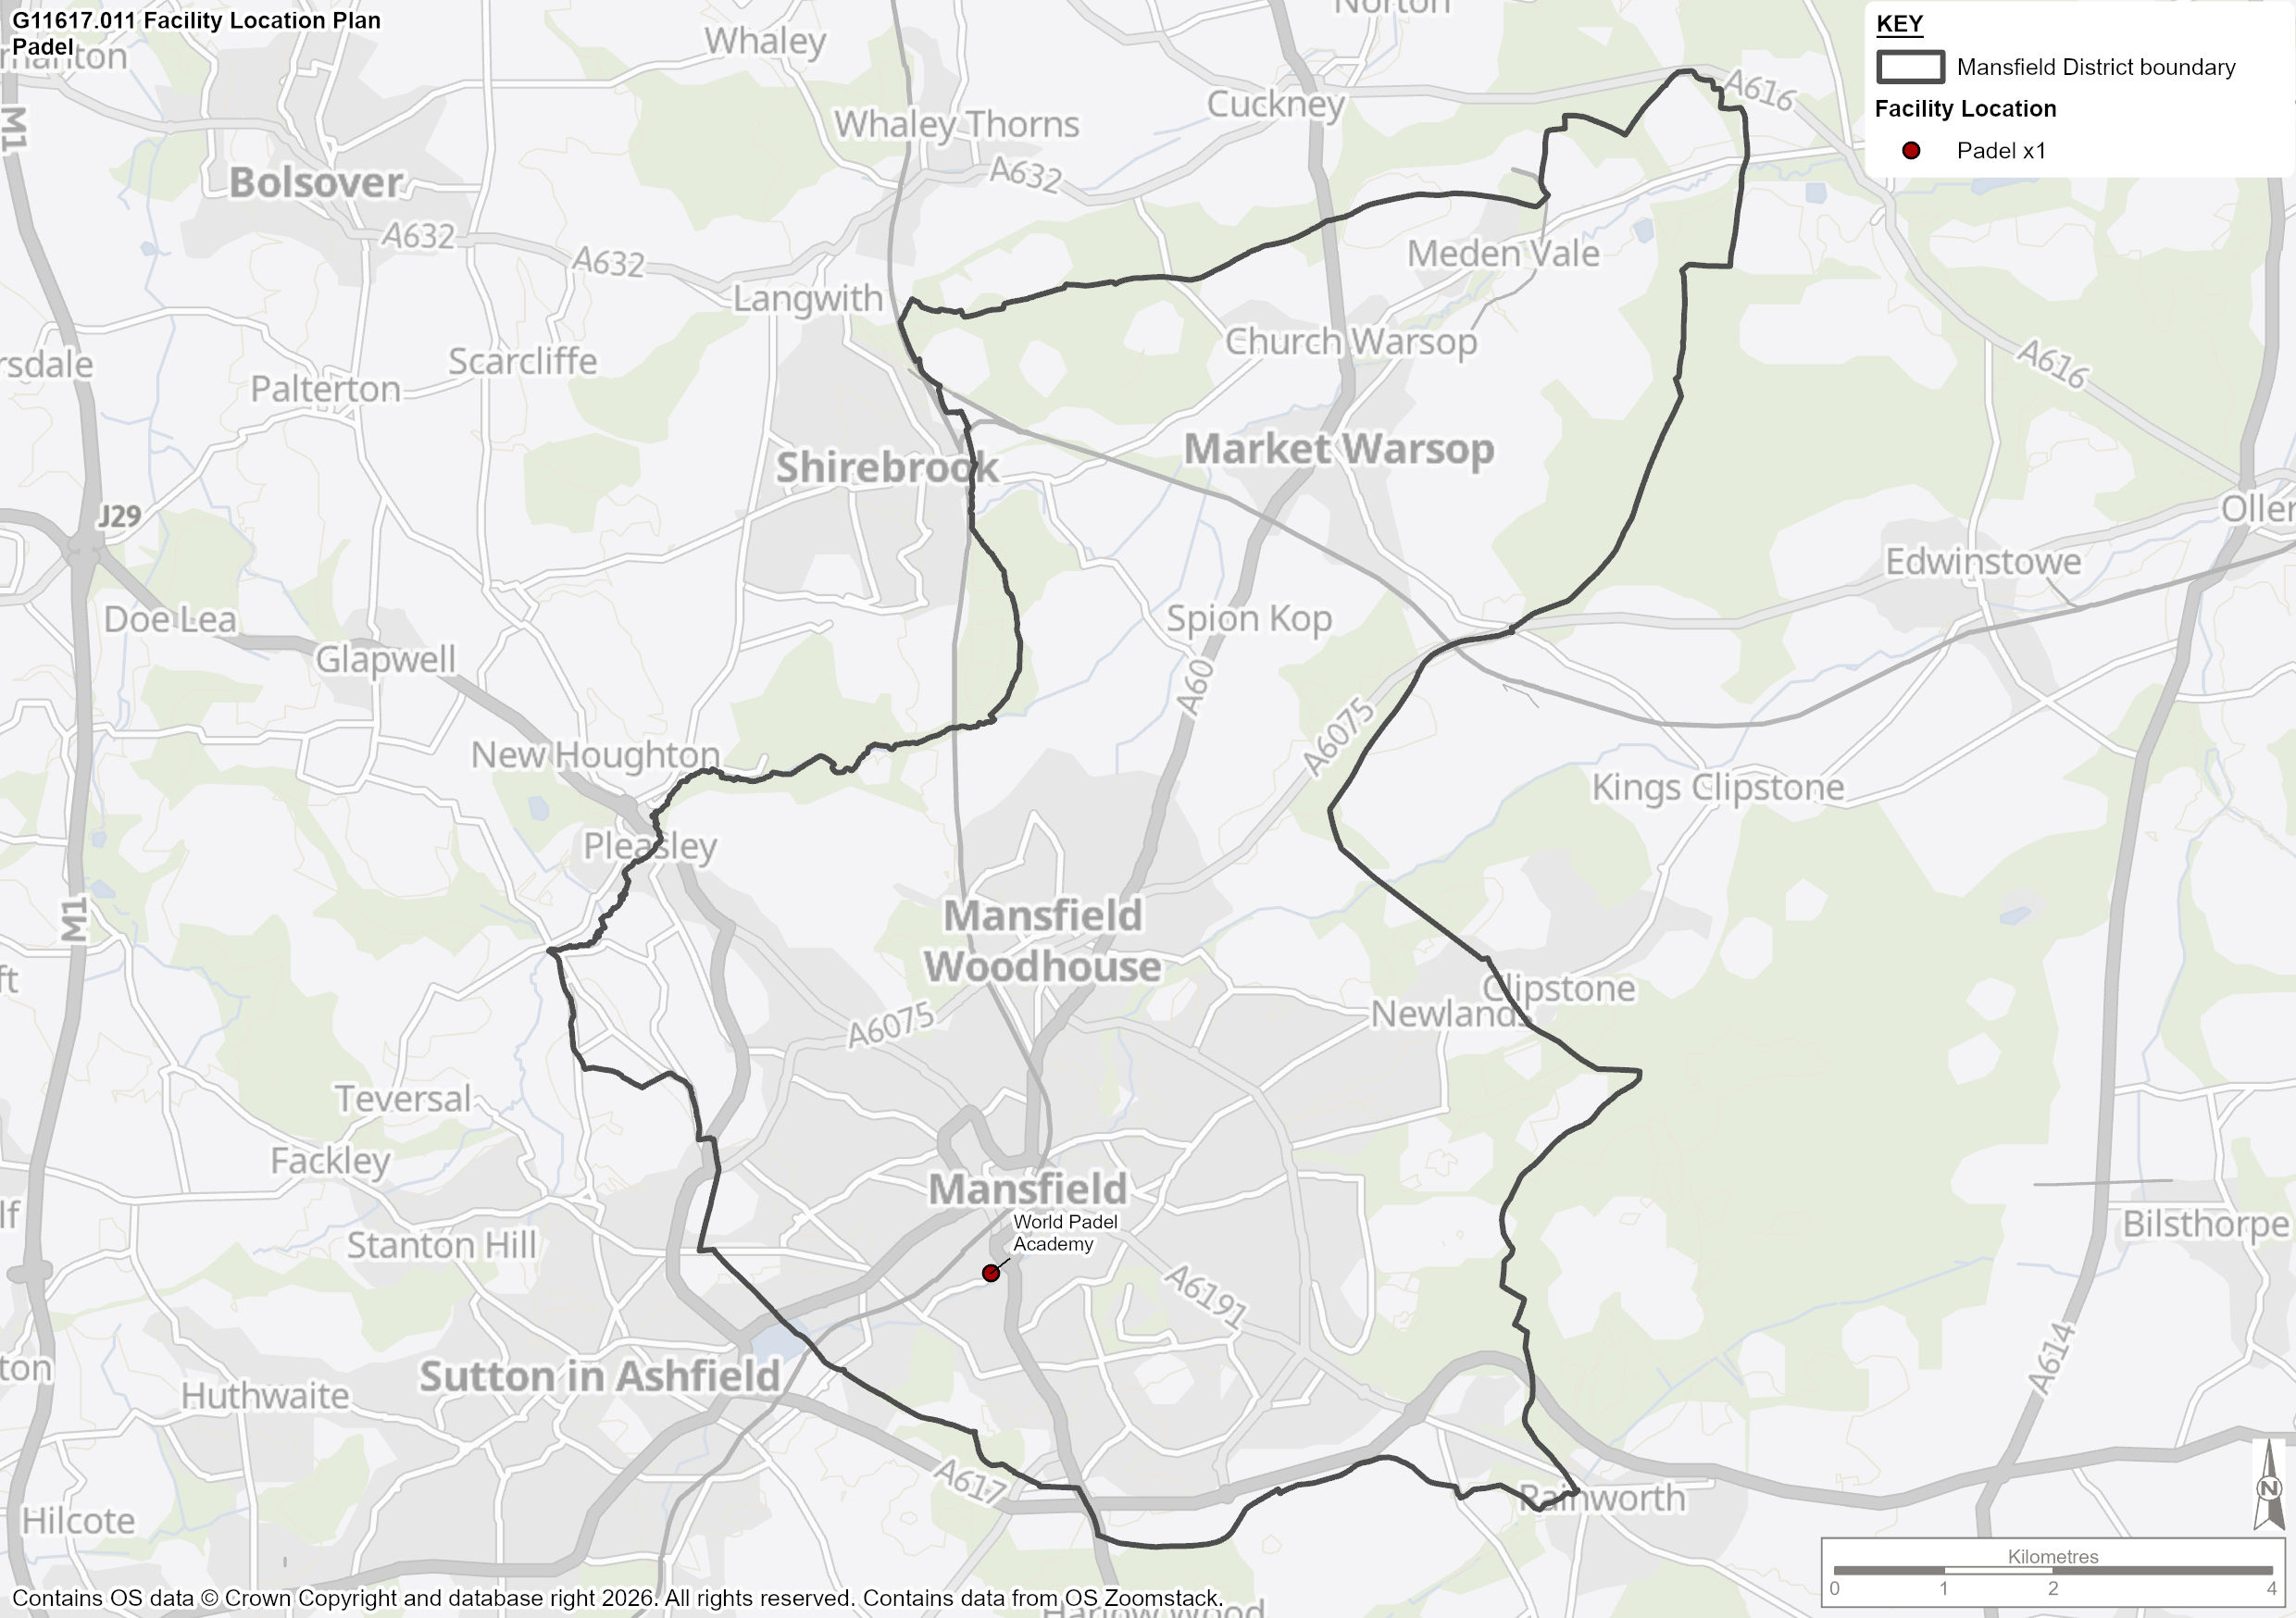

  - The LTA calculate the number of padel courts a local authority area can sustain using the following formula:

- Total population
- Padel demand = 20% of the total population
- Padel penetration = 8% of the estimated demand could convert to actual participants
- 200 players can be accommodated per court

  - Using this formula and the population figures provided in Table 2, it is estimated that Mansfield could currently sustain 9 courts, with potential demand increasing to 10 by 2043. This suggests that the development of an additional 5 courts should be developed in the near future, with demand for an extra 1 by 2043.

  - Although these figures can be used to help support MDC and other local partners in any decision making and investment priorities, the LTA are clear that padel courts should never replace tennis courts, regardless of their condition or current usage. Any development of padel facilities should, where possible, be covered doubles courts, to ensure maximum utilisation and financial sustainability.

  - When planning and developing padel facilities in Mansfield even geographical spread should be considered to minimise clustering of padel courts.

  - The development of further community accessible padel courts may be necessary to ensure equality of access for all.

Padel Summary

  - This section summarises the findings from the padel analysis, which will form basis of the recommendation and action plan section for Mansfield.

  - Table 82 includes the response to key questions, which are asked for all PPOSS studies across the UK, in order to provide a standardised illustration of supply and demand for sports provision.

Table 82: Key PPOSS Findings for Tennis in Mansfield

Key Question | Analysis
What are the main characteristics of the current supply and demand for provision? | There are 4 covered, floodlit courts at World Padel Academy in Mansfield.  Ancillary provision on site consists of social areas, café, toilets and a small shop.
Is there enough accessible and secured community use provision to meet current demand? | Based on LTA calculations, it is estimated that Mansfield could currently sustain 9 courts.
Is the provision that is accessible of sufficient quality and appropriately maintained? | All courts are of excellent quality and clearly well maintained.
What are the main characteristics of the future supply and demand for provision? | Based on future population increases, Mansfield could effectively sustain 10 padel courts by 2043.  There a proposals for the development of a new 12 court indoor padel centre in north west Mansfield.
Is there enough accessible and secured community use provision to meet future demand? | Development of additional padel facilities is necessary to cater for increasing demand. However, new courts should never replace existing indoor or outdoor tennis courts.  IIf the proposed development is realised, then a significant amount of current and future LTA identified demand in Mansfield will be met. However, all facilities will be commercially owned and therefore not accessible to all. The development of further community accessible padel courts may be necessary to ensure equality of access for all.

Netball Analysis

Introduction and Strategic Context

  - This section provides greater detail of the existing strategies that are currently being delivered by England Netball. Following this, the supply and demand section of this report evaluates the adequacy of facilities for netball and considers:

- The supply of courts and demand for these;
- The quality of courts in Mansfield;
- Recommendations moving forward.

  - Netball in England is administered by England Netball, the national governing body for the sport. The current strategy forms the fundamental principles for its strategic planning for the future of sport and business.

England Netball – Adventure Strategy 2021 - 2031

  - England Netball’s Adventure Strategy aims to ‘Lead a movement, on and beyond the court’ and ‘hold an unapologetic focus on women and girls, whilst opening the game for new audiences to belong, flourish and soar’.

  - To achieve this aim, England Netball have identified 6 ‘destinations’ which highlight the aims, goals and purposes for the next 10 years:

- A Game For Life – We will enrich our approach to growing the game, ensuring that netball is a sport for all at every stage of life;

- A World Leading Game – We will set new standards for netball, showcasing inspiring performances by outstanding players in international tournaments and domestic leagues and events;

- A Visible Presence – We will elevate our sport to a new place of prominence, achieving landmark visibility, drawing new audiences to the game, whilst evolving our identity and taking the sport to uncharted territory;

- A Resonant Voice – We will amplify our voice to influence, inform and ignite positive change;

- A Thriving Collective – We will unite our people and partners behind our purpose, nurturing and unlocking potential and achieving common goals;

- An Extraordinary Experience – We will transform the way our sport is consumed, tailoring every touchpoint to provide an exceptional experience at every step of the journey.

Delivery Methods

  - In order to deliver the strategic goals of netball, England Netball has established multiple participation programmes. These programmes are detailed below:

- Traditional 7-a-side: 7 aside is the longstanding format of the game that most girls are introduced to at school. The game is played to a professional level as part of the Netball Super league to regional amateur leagues around the country;

- Back to Netball: A key participation programme for netball, Back to Netball sessions are run nationally with the intention of reintroducing women back into the sport. England Netball report that over 60,000 women have taken part in these sessions since 2010;

- Netball Now: A turn up and play session of netball with an emphasis on low organisation for the player, with no assigned teams or organised leagues. Netball Now is targeted at 16-21year olds and is seen as a partner to the Back to Netball programme;

- I Heart Leagues: Designed to provide a social and gentle introduction into match play. The leagues are designed for players who have participated in the Back to Netball programme or Social Players looking for a weekly, light but competitive game;

- Walking Netball: A slower version of the 7 aside game played only at walking pace. The programme is targeted at older demographics with a key focus on sociability and enjoyment; and

- Bee Netball: Netball specifically designed for 5-11 year olds. Although, not necessarily played on traditional courts, it is one method of driving participation in children which may encourage later participation growth in traditional 7v7 netball.

Supply

  - The following section will detail the supply of outdoor netball facilities in Mansfield. Table 83 shows the outdoor provision of netball courts in Mansfield. There are 6 sites with a total of 24 courts. All courts are located on education sites, and none offer availability of use to the community.

Table 83: Outdoor Netball Facilities in Mansfield

Site | Post code | Ownership | Management Type | Courts | Floodlit | Available to community | Security of Tenure | Overall Rating
Meden School | NG20 0QN | Education | Education | 3 | 0 | Unavailable | Unsecure | Standard
Queen Elizabeth's Academy | NG19 7AP | Education | Education | 4 | 0 | Unavailable | Unsecure | Standard
Samworth Church Academy | NG18 2DY | Education | Education | 3 | 0 | Unavailable | Unsecure | Poor
The Brunts Academy | NG18 2BZ | Education | Education | 4 | 2 | Unavailable | Unsecure | Standard
The Manor Academy | NG19 8QA | Education | Education | 8 | 0 | Unavailable | Unsecure | Standard
Vision West Nottinghamshire College | NG18 5BH | Education | Education | 2 | 0 | Unavailable | Unsecure | Poor

  - Of the 24 outdoor courts, 19 are standard quality macadam courts. 2 courts at Vision West Nottinghamshire College and 3 at Samworth Church Academy are of poor quality. Only 2 of the total outdoor netball court supply in Mansfield are floodlit.

  - Map 10 shows the geographic location of outdoor netball courts across the Study Area and presents the dispersion courts across Mansfield (to be added).

Map 10: Outdoor Netball Court Audit in Mansfield

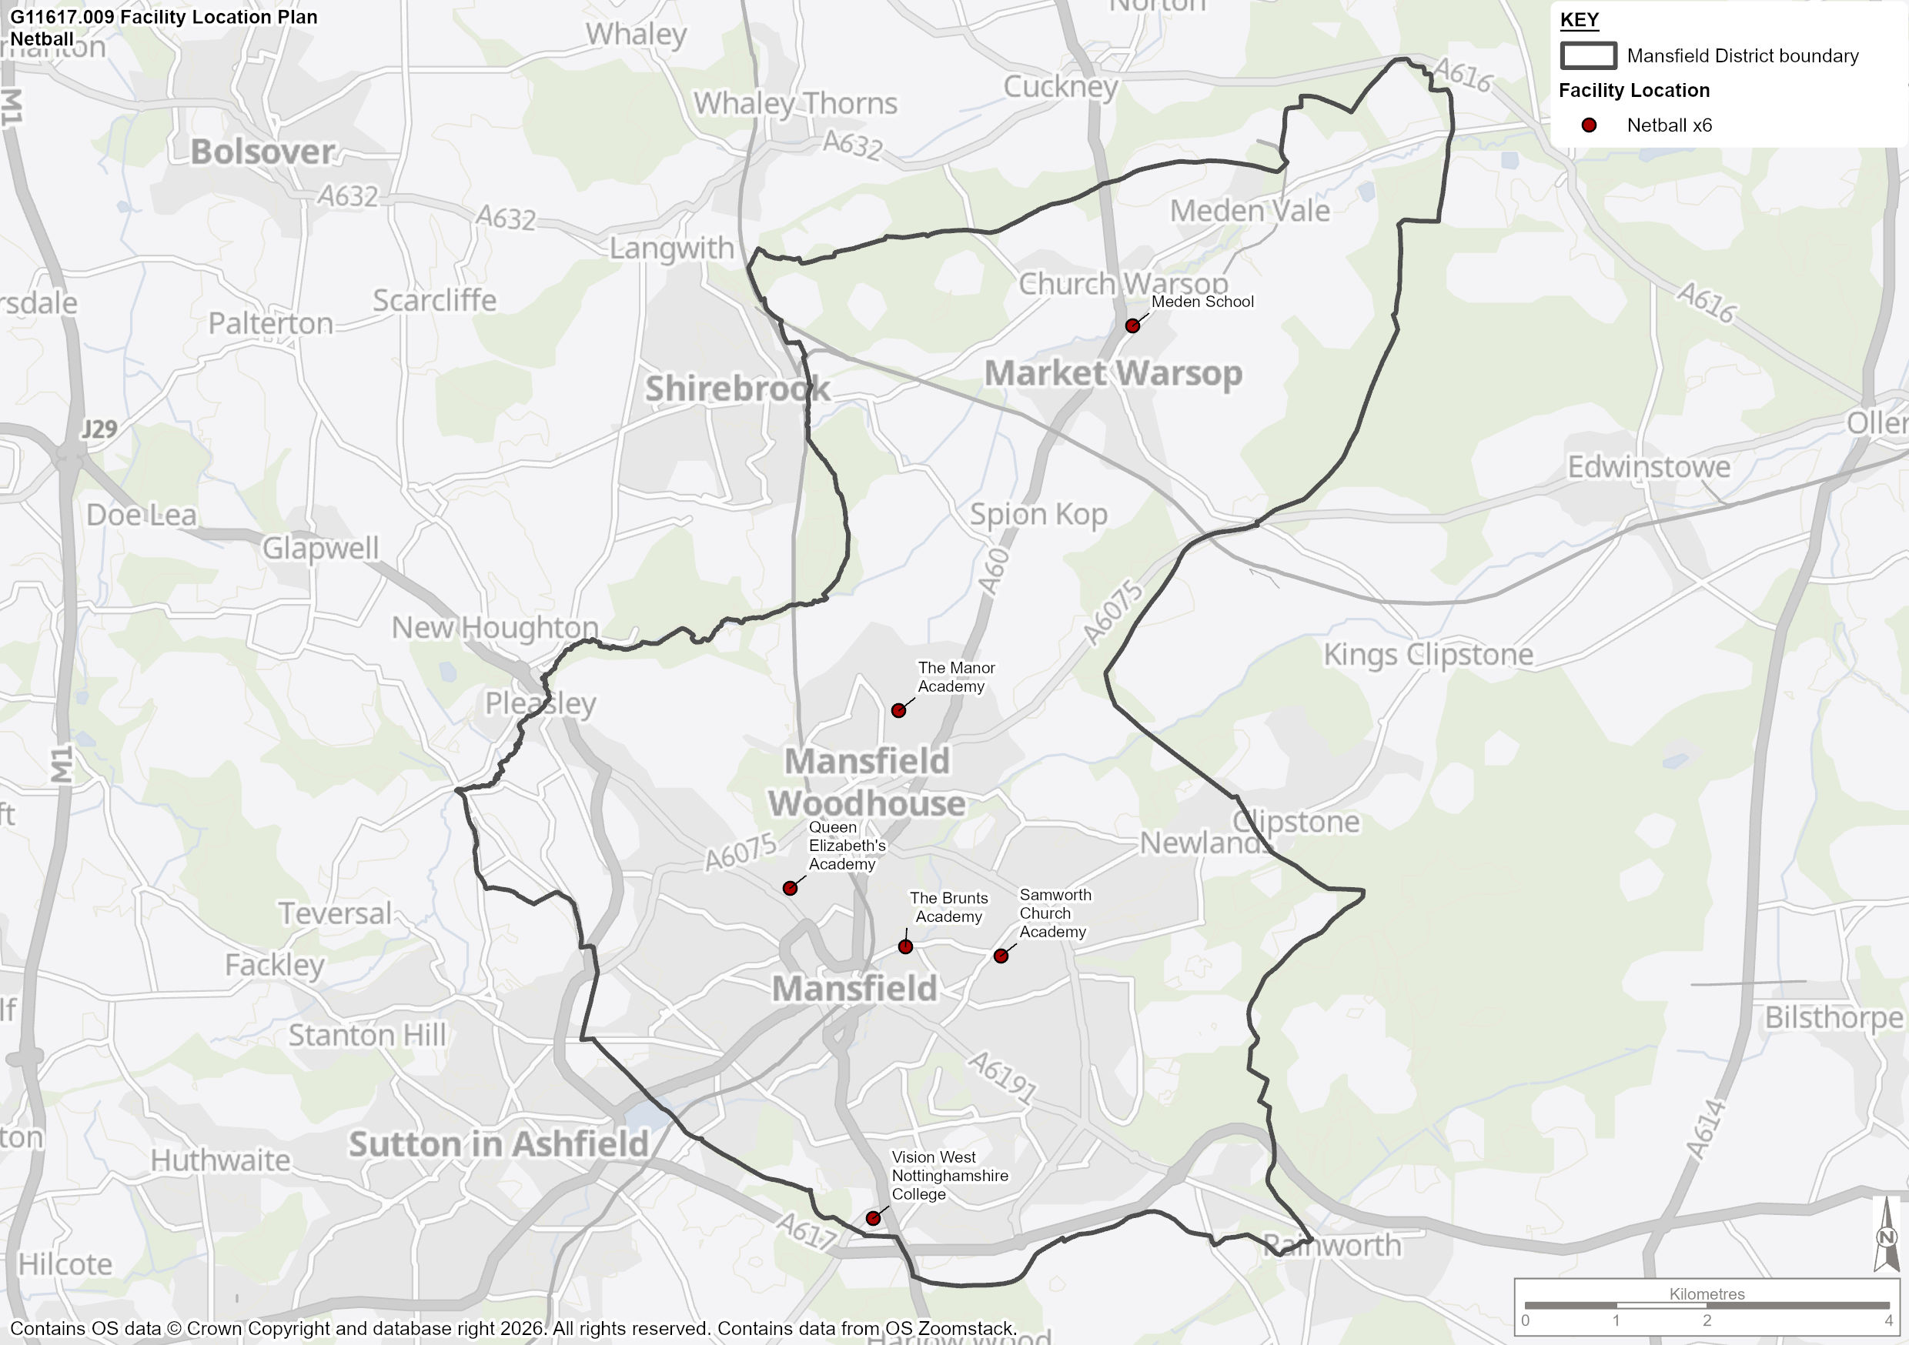

Demand

  - There is currently no outdoor netball activity of any kind in Mansfield, and no England Netball (EN) affiliation within the study area. All current netball demand is met by indoor facilities in Mansfield, with competitive and casual activity only offered by a commercial league, Netball4U.

  - Netball4U began as a method of improving physical activity levels in inactive women, but has now become a thriving commercial netball deliverer, offering year-round netball activity for a range of ability levels. Leagues in the Mansfield area currently attract around 70 teams, alongside training and playing opportunities for approximately 60 young people.

  - However, consultation with the commercial league suggests that the lack of appropriate, safe, floodlit outdoor courts in Mansfield, is causing significant issues in the effective delivery of netball activity.

  - Although the league has previously utilised Samworth Church Academy for outdoor activity in the summer, the courts are now too dangerous to use because of the surface quality and have caused a number of injuries. Netball4U now utilise Ravenshead Leisure Centre in Newark & Sherwood and Titchfield Park in Ashfield for outdoor summer activity.

  - Throughout the winter, the league is forced to utilise indoor provision due to the lack of outdoor floodlit courts. Within the MDC area, the league uses indoor courts at Mansfield RUFC and Vision West Nottinghamshire College, as well as Tibshelf School and Quarrydale School outside of the study area. However, the costs associated with the hiring of indoor facilities are prohibitive and the league require appropriate outdoor court provision, especially during the summer months.

  - Netball4U have previously used outdoor courts at Manor Academy, however these are now unavailable to the community. The league has also used the AGP pitch at Oak Tree Leisure Centre, however due to football demand taking priority, appropriate time slots were challenging to find.

  - According to consultation, the lack of affordable, safe, accessible floodlit netball provision in Mansfield is turning current and potential participants away from the sport. Participation drops significantly through the winter and local schools are unable to host tournaments. Investment in and the delivery of high quality, floodlit outdoor courts is vital for the effective delivery of year-round netball activity in Mansfield.

Future Demand

  - Future demand for outdoor netball is difficult to calculate, as it is often generated by the growth of indoor netball, which is not included as part of this PPOSS. Although indoor sports hall or activity hall provision is the preferred method of netball for many individuals and clubs, it is important to note that the cost of this is often unaffordable for many causing accessibility issues for both new and existing players. Therefore, it is important that the outdoor provision is supported through facility development, floodlight installation and the delivery of initiatives such as walking netball and Back to Netball.

  - However, there is a significant lack of playing opportunities, caused by the aforementioned under supply of appropriate outdoor court provision in Mansfield. Although outdoor courts play a key role in meeting netball demand, un-floodlit and uncovered courts are not suitable for usage much of the year. To mitigate against this and to provide more capacity for netball, the delivery of high quality, floodlit outdoor courts is vital to ensure that netball can be played more effectively, year round, on outdoor courts in Mansfield.

  - Despite the local challenges, demand for netball in Mansfield remains high, and there may be opportunities for interest in the support to further increase, raising participation. Netball experienced significant growth after the ‘Roses’ gold medal at the 2018 Commonwealth Games, and after achieving bronze at the 2019 Netball World Cup in Liverpool, there was an increase of over 160,000 people participating in netball. The upcoming local 2026 Commonwealth Games in Glasgow and the 2027 netball world cup in Australia, provide good opportunities for success for the national team following their professionalisation in 2025, which is hoped to generate further interest in the sport.

  - England Netball programmes and initiatives such as Walking Netball, NetballHer, Bee Netball, Back to Netball and Netball Now are already in high demand nationally and are expected to further increase participation in Netball.

Netball Summary

  - This section summarises the findings from the netball analysis, which will form basis of the recommendation and action plan section for Mansfield.

  - Table 84 includes the response to key questions in order to provide a standardised illustration of supply and demand for sports provision.

Table 84: Key PPOSS Findings for Netball in Mansfield

Key Question | Analysis
What are the main characteristics of the current supply and demand for provision? | Education owned sites provide all outdoor netball courts in Mansfield, however none are currently available to the community.  There is a total of 24 courts in the study area, of which 2 are floodlit.  There is currently no England Netball affiliated activity within Mansfield, and all demand is catered for by a commercial league, Netball4U. The league facilitates activity for approximately 70 senior teams and 60 young people, across a range of indoor and outdoor sites in Mansfield and the surrounding areas.  Indoor courts in Mansfield that are used by the league are located at Mansfield RUFC and Vision West Nottinghamshire College.
Is there enough accessible and secured community use provision to meet current demand? | There is a significant shortfall of good quality, floodlit outdoor courts in Mansfield, significantly impacting the ability of many to engage in the sport without incurring large playing costs and/or travel time.
Is the provision that is accessible of sufficient quality and appropriately maintained? | 19 of the 24 outdoor courts in Mansfield are of standard quality. 3 courts at Samworth Church Academy and 2 at Vision West Nottinghamshire College are of poor quality.  There are no good quality outdoor courts in Mansfield.
What are the main characteristics of the future supply and demand for provision? | Consultation with Netball4U indicates that despite challenges with securing appropriate court provision, that demand for Netball remains high in Mansfield.  However, without the development of floodlighting, securing community use agreements and undertaking court resurfacing, the delivery of high quality netball on outdoor courts in Mansfield will become more of a challenge.
Is there enough accessible and secured community use provision to meet future demand? | There are no appropriate, floodlit outdoor courts currently available to the community in Mansfield. Investment in and the delivery of high quality outdoor netball courts is vital sustainability of netball in the study area.

Bowls Analysis

Introduction and Strategic Context

  - Bowls England is responsible for the governance, administration and promotion of Flat Green Lawn Bowls in England. It was formed in 2008 following the unification of the English Bowling Association and the English Women’s Bowling Association.

  - The following section provides greater detail of the existing strategies that are currently being delivered by Bowls England.

  - Following this, the supply and demand section of this report evaluates the adequacy of facilities for bowls and considers:

- The supply of facilities and demand for these;
- The adequacy of facilities in Mansfield; and
- Recommendations moving forwards.

Strategic Plan – Fit for The Future 2021 - 2026

  - In August 2021 Bowls England launched their new Strategic Plan for the five-year period to 2026, with the aim for reaching 1 million bowls experiences per year. The key priorities to meet this target are:

- Building the brand of bowls – Increasing focus on international and top domestic bowls, and utilising opportunities such as Birmingham 2022 to achieve larger media coverage;
- Ensuring the sport is truly accessible to all – by offering different formats of the game which suit all time constraints, as well as driving more people to clubs in new ways;
- Creating positive playing experiences for everyone – whoever steps on the green, both casual and competitive players, as well as growing our events calendar and introducing a performance pathway;
- Putting volunteers first – as the lifeblood of our sport, by increasing our support for clubs in order to empower them to thrive;
- Leading the sport with purpose – by developing our governance structures, diversifying our revenue streams, and working collaboratively with all the sport’s key stakeholders.

Supply

  - The local authority owns 3 bowls sites in Mansfield, which it is also responsible for the management of 1. All the remaining bowls provision (3 sites) are owned and managed by bowling clubs. This highlights a lack of dependency upon local authority owned and managed sites. A breakdown of ownership and management can be found in Table 85.

Table 85: Ownership and Management of Bowls Sites in Mansfield

Type | Ownership | Management
Local Authority | 3 | 1
Sports Club | 3 | 5
Total | 6 | 6

  - Across the 6 sites, there are 7 greens, 2 of which are good quality, 4 are considered to be standard quality and 1 of poor quality based on the non-technical assessment criteria. It should be noted that for higher level competitive bowls, only good quality greens are considered appropriate.

  - Full details of the sites can be found in Table 86.

Table 86: Bowls Sites in Mansfield

Site | Club Using Site | NGB Affiliated? | Ownership | Management | Security of Availability to Community | Greens | Green Condition | Clubhouse Condition
Clipstone Bowls Club | Clipstone Bowls Club | Yes | Sports Club | Sports Club | Secure | 1 | Good | Good
Yeoman Hill Park | Yeoman Hill Park Bowls Club | Yes | Local Authority | Local Authority | Secure | 1 | Poor | Poor
The John Fretwell Sporting Complex | Titchfield Sookholme | Yes | Sports Club | Sports Club | Secure | 1 | Standard | Good
Mansfield Bowling Club | Mansfield Bowling Club | Yes | Sports Club | Sports Club | Secure | 1 | Good | Good
Manor Sport And Recreation Centre | Brierley Park | Yes | Local Authority | Sports Club | Secure | 2 | Standard | Could not access
Queensway Park | Queensway Park Bowling Club | Yes | Local Authority | Sports Club | Secure | 1 | Standard | Standard

  - Map 11 shows the geographic location of outdoor bowling greens across the Study Area and presents the dispersion greens across Mansfield.

Map 11: Outdoor Bowling Greens Audit in Mansfield

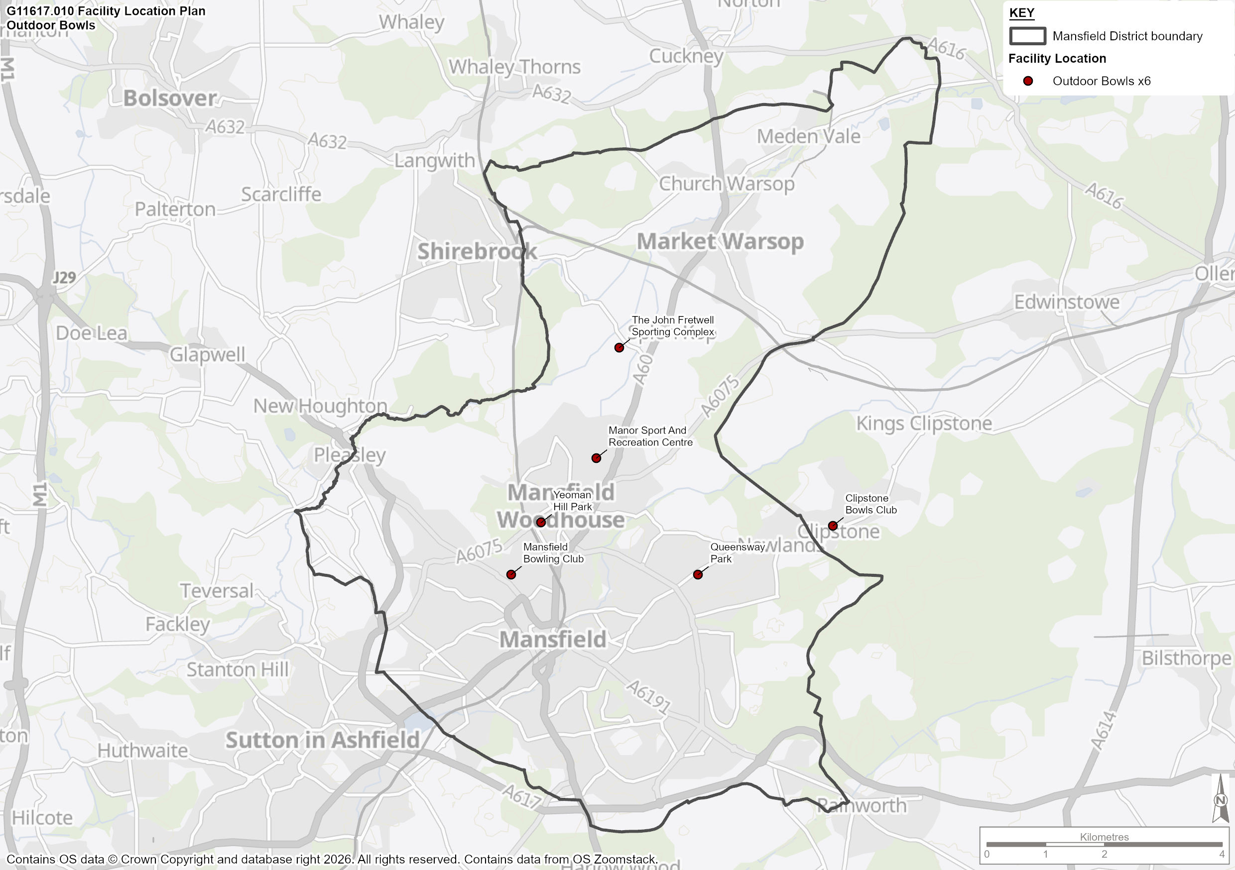

Club and Site Consultation

  - Clubs were contacted by Strategic Leisure with the aim of informing the demand section of the study. Summaries of the information gathered during the Stage B process is provided in Table 87.

Table 87: Club Consultation

Club Name | Consultation Summary
Queensway Park Bowls Club | The Queensway Park Bowls Club utilise the local authority Queensway Park Bowling Green. The club have access to the green alongside, changing room kitchen and toilet facilities, which they rent from Mansfield District Council. The club have 23 members and participate in league and friendly activity as well as training and the Big Bowls weekend. Queensway Park Bowls club report their 6 rink green to be of standard quality.
Yeoman Hill Park Bowls Club | Yeoman Hill Park Bowls club rent their 6 rink green from Mansfield District Council. Alongside the bowling green are changing room, kitchen and toilet facilities, although these are of poor quality. The club stated that the clubhouse is in a poor state and that plans are in place to upgrade it, however there is no funding. Yeoman Hill Park Bowls Club also added that the green is in a poor state and requires and automatic watering system, for its quality to be maintained all year round, along with some further maintenance work.

Demand for Outdoor Bowls Facilities

  - This section summarises the level of demand for bowls in Mansfield. Table 88 shows the demand for bowls in terms of the number of clubs assigned to each site.

Table 88: Club Demand on Each Site

Club Name | NGB Affiliated? | Home Site | Members
Clipstone Bowls Club | Yes | Clipstone Bowls Club | 30
Yeoman Hill Park Bowls Club | Yes | Yeoman Hill Park | 38
Titchfield Sookholme | Yes | The John Fretwell Sporting Complex | 40
Mansfield Bowling Club | Yes | Mansfield Bowling Club | 100
Brierley Park | Yes | Manor Sport And Recreation Centre | 21
Queensway Park Bowling Club | Yes | Queensway Park | 23
 |  | Total | 252
  - Table 89 shows that there are 252 members of bowling clubs in the study area with the largest clubs being Mansfield Bowling Club with 100 members, followed by Titchfield Sookholme with 40 members

  - The Sport England Active Lives Survey results from November 2023-24 show that 1.4% of the population aged 16 or over in the Nottinghamshire Active Partnership area (the smallest area relating to the Mansfield for which there is data available) play bowls at least once per year.

  - The population of residents in Mansfield aged 16 or over is 93,689. If the participation figures for the Nottinghamshire AP region (1.4%) are applied to this population figure, then it can be said that 1,312 people play outdoor bowls at least once per year in Mansfield.

Future Demand

  - Using 1,312 as the number of people playing bowls at least once per year in Mansfield and future projections of the Study Area’s population (105,498 over 16’s by 2043), we can calculate potential future demand for the sport. The future 16+ population is due to grow by 12.6% which, assuming current levels of participation remain constant, equates to an additional demand of 165 people.

  - Due to the fact that during consultation, clubs highlighted that there was capacity for, and they would welcome new members, we can assume that the demand created by population growth can be met by existing bowls provision.

Bowls Summary

  - This section summarises the findings from the bowls analysis, which will form basis of the recommendation and action plan section for Mansfield.

  - Table 89 includes the response to key questions, which are asked for all PPOSS studies across the UK, in order to provide a standardised illustration of supply and demand for sports provision.

Table 89: Key PPOSS Findings for Bowls in Mansfield

Key Question | Analysis
What are the main characteristics of the current supply and demand for provision? | There are currently 6 sites across Mansfield with 7 greens. There are 6 clubs in the MDC area with a total estimated membership of 252 people.
Is there enough accessible and secured community use provision to meet current demand? | All 6 sites in the study are secured for community use, and based on membership figures provided by Bowls England, consultation and Active Lives participation rates, it likely that there is spare capacity for new bowls demand on all greens.
Is the provision that is accessible of sufficient quality and appropriately maintained? | Of the 7 greens, 2 are rated as good quality and 4 are rated as standard and 1 is rated as poor. Maintenance of most greens is of a good standard.
What are the main characteristics of the future supply and demand for provision? | Future population projections indicate a potential additional 165 players by 2043. Any future growth in demand can be satisfied with the current green stock and is likely to have little impact on the supply and demand balance in the study area.
Is there enough accessible and secured community use provision to meet future demand? | The potential increase in demand of 165 participants by 2043 is able to be met by the current green and club supply.

Pétanque Analysis

Introduction and Strategic Context

  - Pétanque England (PE) is responsible for the governance, administration and promotion of Pétanque in England.

  - The following section provides greater detail of the strategic direction and priorities of Pétanque England. Pétanque England’s strategic intent centres on growth, participation, competition, governance and support for clubs/coaching. The organisation’s activities and governance developments suggest a commitment to building a sustainable sport structure that supports players from first-timers through to international competitors, while also striving to modernise and align with good governance standards

Growing Participation

  - Pétanque England’s overarching aim as England’s National Governing Body (NGB) is to grow the sport across all ages and abilities — from complete beginners to competitive players. This includes supporting friendly social play and providing clear development pathways into competitive pétanque:

- Increasing membership numbers and making pétanque accessible to more people;
- Providing opportunities for relaxed social play as well as competitive participation

Supporting Clubs, Regions and Coaching Development

  - A key priority is strengthening the club and regional infrastructure that underpins the sport:

- Encouraging clubs and regions to develop coaching, competition and social play locally
- Supporting coach qualifications and improving coach networks, including higher-level coaching accreditation

Performance and Competitive Pathways

  - Pétanque England places emphasis on competition and performance development:

- Organising and supporting national competitions and selection events for international representation (e.g., national championships and squad selection)
- Building pathways for juniors, Espoir’s (under-23), seniors and veterans to reach higher competition levels.

Governance, Compliance and Sustainability

  - PE has been actively reviewing its governance and organisational structures, an important part of long-term sustainability:

- Aligning governing documents and practices with good governance principles (e.g., Articles of Association, Board structure) and compliance with sports standards
- Encouraging governance reforms that support transparency, accountability and strategic direction.

Enhancing the Member Experience and Engagement

  - Another emphasis is on improving how the organisation interacts with its members:

- Enhancing communication and engagement between the Board, regions, clubs and individual members
- Offering members the chance to influence the sport’s development and direction.

Pathways and Skill Development

  - Making pétanque enjoyable and improving skill levels at all stages are ongoing priorities:

- Implementing structured skill development and recognition programmes (e.g., junior skills pathways, coaching education)
- Supporting initiatives that can retain and progress players over time.

Supply

  - There are currently 2 pétanque sites in Mansfield, as shown in Table 90.

Table 90: Petanque Sites in Mansfield

Site | Club Using Site | Ownership | Management | Security of Availability to Community | Pistes | Condition | Clubhouse Condition
Carr Bank Park | Carr Bank PC | Local Authority | Local Authority | Secure | 16 | Standard | Basic
Titchfield Park | Mansfield PC | Local Authority | Local Authority | Secure | 22 | Standard | Basic

  - The local authority owns and manages both Carr Bank Park and Titchfield Park pétanque sites. Non-technical site assessments and consultation suggest that all pistes are of standard quality and supported by basic, but adequate ancillary provision.

  - Across both sites, there is a total of 38 pistes, 16 of which are at Carr Bank Park and 22 are at Titchfield Park.

  - Map 12 shows the geographic location of outdoor pétanque pistes in Mansfield.

Map 12: Outdoor Pétanque Sites Audit in Mansfield

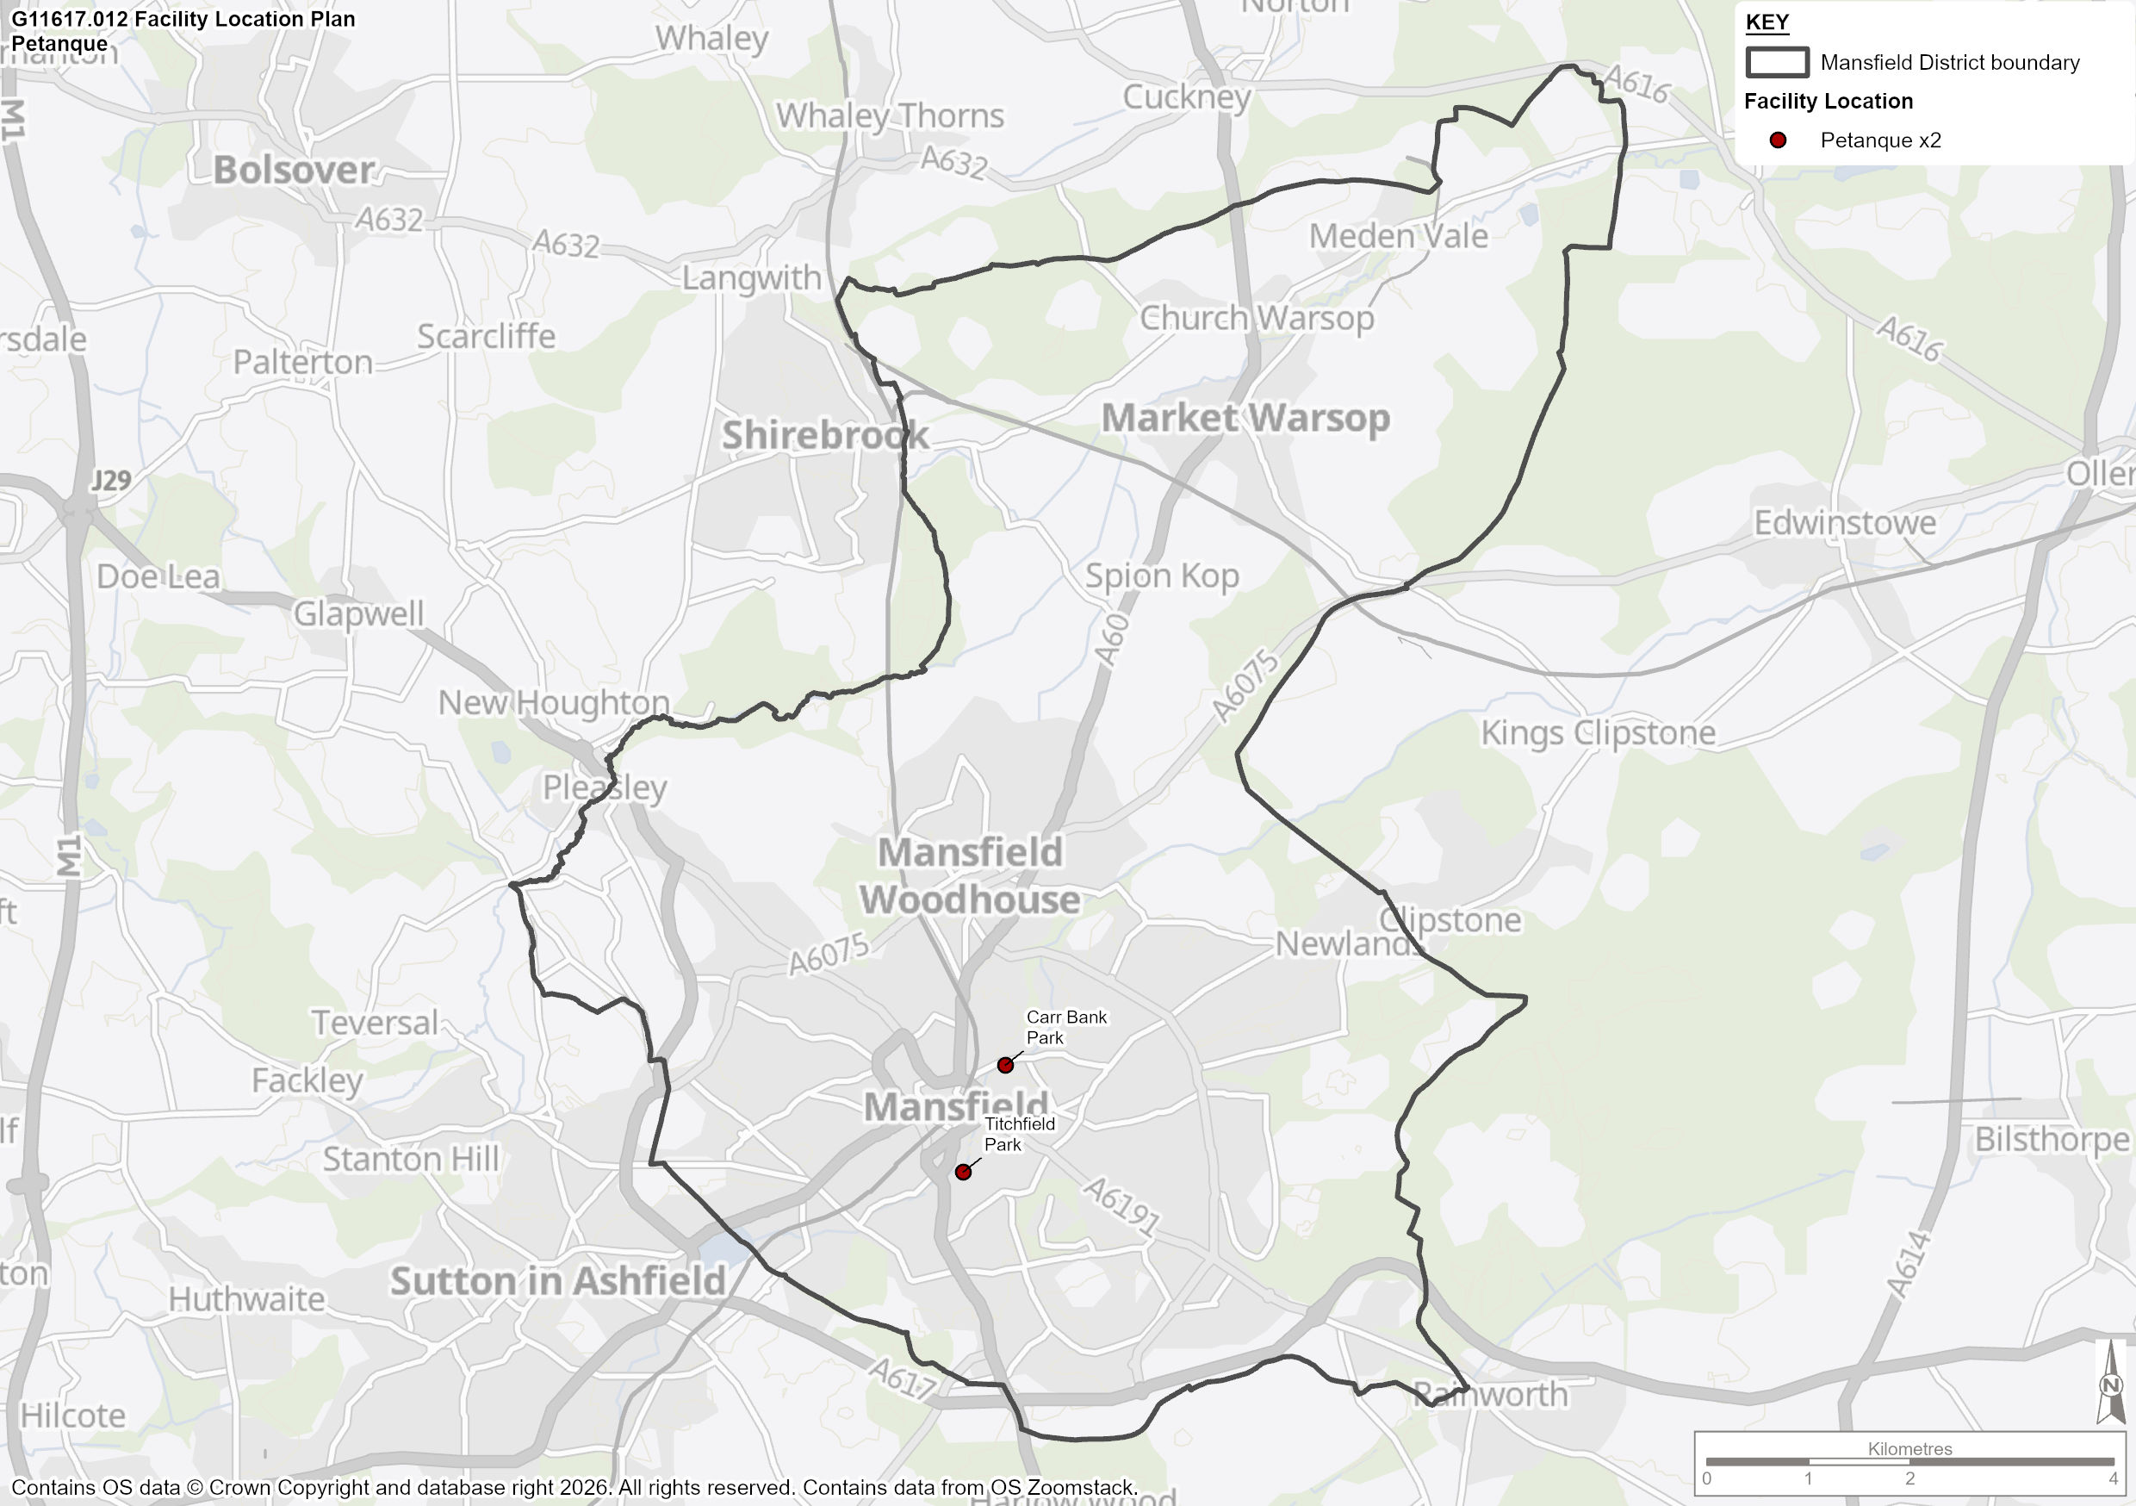

Club Consultation

  - Although both clubs were contacted by SLL only Mansfield PC provided as response. A summary of the information gathered during consultation is provided in Table 91.

Table 91: Club Consultation

Club Name | Consultation Summary
Mansfield PC | Mansfield Pétanque Club has operated successfully for over 15 years and is a well-established, inclusive community sports club with excellent facilities rented from MDC, including a clubhouse with utilities, floodlighting, multiple well-maintained playing areas, and good maintenance support. The club has invested in improvements such as a kitchenette, enhanced gravel, and paving to ensure safety and accessibility. With approximately 120 members of all ages and genders, including players with disabilities, the club offers affordable sport and social connection, plays regularly throughout the week, and hosts local, regional, and national competitions as part of the Mercia region under Pétanque England. It is one of the largest clubs in the region, benefits from nearby amenities, maintains appropriate insurance cover, enjoys strong working relationships with council staff, operates within a fair and manageable rental budget, and is responsibly managed by an elected committee with proper registration, governance, and financial oversight.

Demand for Pétanque Facilities

  - This section summarises the level of demand for bowls in Mansfield. Table 92 shows the demand for bowls in terms of the number of clubs assigned to each site.

Table 92: Club Demand on Each Site

Club Name | Affiliated to Pétanque England | Home Site | Members
Carr Bank PC | Yes | Carr Bank Park | 43
Mansfield PC | Yes | Titchfield Park | 120
 |  |  | 163

  - Table 92 shows that there is a total of 163 members of pétanque clubs in Mansfield. The largest club, with 120 members, is Mansfield Pétanque Club.

  - According to Sport England’s Active Lives Survey, 0.5% of the population aged 16 or over play pétanque at least once per year. Based on a current population of 93,689 people aged 16+, this suggests that 468 individual people engage in pétanque each year.

Future Demand

  - Future population projects indicate that the number of people in Mansfield over the age of 16 is likely to increase by 12.6% by 2043. If participation in pétanque matches this growth, demand for the sport will increase by 60 individuals participating at least once per year. This growth in demand can be met by existing facilities and clubs.

Pétanque Summary

  - This section summarises the findings from the bowls analysis, which will form basis of the recommendation and action plan section for Mansfield.

  - Table 93 includes the response to key questions, which are asked for all PPOSS studies across the UK, in order to provide a standardised illustration of supply and demand for sports provision.

Table 93: Key PPOSS Findings for Pétanque in Mansfield

Key Question | Analysis
What are the main characteristics of the current supply and demand for provision? | There are currently 2 pétanque sites in Mansfield with a total of 38 pistes; 16 at Carr Bank Park and 22 at Titchfield Park.  There are 2 clubs in the study area with a total membership of 163 people. However, based on the Active Lives Survey, it is estimated that 468 individual people engage in pétanque at least once per year in Mansfield.
Is there enough accessible and secured community use provision to meet current demand? | Both pétanque sites offer secure community use, and based on membership figures, consultation and Active Lives participation rates, it likely that there is spare capacity for at both sites.
Is the provision that is accessible of sufficient quality and appropriately maintained? | Based on non-technical site assessments, both sites offer standard quality provision, supported by adequate ancillary provision.
What are the main characteristics of the future supply and demand for provision? | Future population projections indicate a potential 60 additional players by 2043. Any future growth in demand can be satisfied with the current stock and is likely to have little impact on the supply and demand balance in the study area.
Is there enough accessible and secured community use provision to meet future demand? | The potential increase in demand of 60 participants by 2043 is able to be met by the current supply.

Disclaimer

Forecasts and recommendations in any proposal, report or letter are made in good faith and on the basis of the information before the Company at the time. Their achievement must depend, among other things, on effective co-operation of the Client and the Client’s staff. In any consequence, no statement in any proposal, report or letter is to be deemed to be in any circumstances a representation, undertaking, warranty, or contractual condition.

© 2026 Strategic Leisure Limited
All rights reserved

https://www.sportengland.org/guidance-and-support/facilities-and-planning/planning-sport/assessing-needs-and-playing-pitch#playing-pitch-strategy-guidance-36842
https://www.sportengland.org/guidance-and-support/facilities-and-planning/planning-sport/assessing-needs-and-playing-pitch#playing-pitch-strategy-guidance-36842
https://localplans.footballfoundation.org.uk/local-authorities-index/mansfield/mansfield-executive-summary/
https://www.thegma.org.uk/home/
https://www.thefa.com/about-football-association/what-we-do/fa-grasroots-strategy-2024-2028
https://futurefit.englandfootball.com/futurefit/index.html
https://www.englandhockey.co.uk/governance/about-england-hockey/creating-a-future-for-our-game-together
https://rfu.widen.net/s/pxxrjxrvps/rfu-plan-2030-more-than-a-game
https://rfu.widen.net/s/zqnlxwpd8g/women-and-girls-action-plan
Source: RFU affiliation data – 24/25
https://www.rugby-league.com/uploads/docs/RFL%20Strategic%20Report%202021%20Final.pdf
https://www.rugby-league.com/uploads/docs/Community%20Strategy%202021.pdf
https://www.ecb.co.uk/about/what-we-do/strategy
Clipstone Regeneration Phases: https://www.newark-sherwooddc.gov.uk/clipstoneregen/?fbclid=IwY2xjawPoKpRleHRuA2FlbQIxMABicmlkETByaHdTMGFSNGp4N0JuVkMxc3J0YwZhcHBfaWQQMjIyMDM5MTc4ODIwMDg5MgABHgoxsGFmugw6Lh_s55EgT3QtS_AMGwsQ-cycPjSFF6F6ua1638BvF412FRtj_aem_C5UQcmVhm1ZiEg5JZamejw
https://www.lta.org.uk/what-we-do/vision-and-mission/
Pickleball in Britain | Rules, courts & how to play | LTA
https://www.englandnetball.co.uk/our-strategy/
https://www.bowlsengland.com/fit-for-the-future-strategy-2021-2026/

