Mansfield Retail & Leisure Capacity study Update 2026

  - Volume 1: Main Report
Prepared for:
Mansfield District Council
July 2026
lsh.co.uk

This document has been prepared and checked in accordance with the Lambert Smith Hampton Quality Assurance procedures and authorised for release. If not signed off by a Director in the Planning, Regeneration + Infrastructure (PR+I) division at LSH then this document should be treated as a draft, and as being Private and Confidential. It should not be for wider distribution without the sign-off and permission of Lambert Smith Hampton.
This report meets the PDF/UA (Universal Accessibility) standard, which is equivalent to the WCAG 'AA' digital standard.
Prepared by:
Melanie Chan
Nisa Akkok
Callum Clements
Bláthnaid Duffy
Reviewed by:
Bláthnaid Duffy

For and on behalf of Lambert Smith Hampton
Issued: July 2026

Contents
1. INTRODUCTION 4
2. PLANNING POLICY CONTEXT 6
3. ECONOMIC AND MARKET TRENDS 19
4. CENTRE HEALTH CHECK OVERVIEW & SWOT ANALYSIS 28
5. THE STUDY AREA AND TRADING PATTERNS 32
6. RETAIL NEEDS ASSESSMENT 41
7. LEISURE PROVISION AND CAPACITY ASSESSMENT 48
8. TOWN CENTRE POLICY RECOMMENDATIONS 56

INTRODUCTION
- This report has been prepared by Lambert Smith Hampton (‘LSH’) on the instruction of Mansfield District Council (‘the Council’ / ‘DC’). It provides an updated assessment of retail and commercial leisure provision and needs in the Mansfield District Council area and is intended to inform the Mansfield District Council Local Plan Review 2023 – 2043.

Background
- This Study will provide the robust evidence needed to confirm whether the strategic and development management policies set out in the Regulation 18 Mansfield District Local Plan Review particularly in relation to town centre uses across the district’s network of centres are still robust. The new Local Plan will guide growth over the period 2025 to 2043.
- The Study will assess how much additional retail and commercial leisure floorspace is needed over the Local Plan period based on the latest and emerging market trends that influence town centre economies, new evidence on shopping and leisure patterns, and an updated position on how Mansfield District’s key centres are performing.
- This study has been prepared in the context of current and emerging local, regional and national development plan policy guidance, as well as other key material considerations; principally the National Planning Policy Framework (NPPF). Where relevant, the study also draws on advice set out in the National Planning Practice Guidance (PPG). Both the NPPF and PPG place significant weight on the development of positive plan-led visions and strategies to help ensure the vitality and viability of town centres (Town centres or centres are defined by the NPPF (Annex 2).

Report Structure
- For ease of reference this main report (Volume 1) is divided into the following inter-related sections:
- Section 2 reviews the national, regional and local planning policy context.
- Section 3 highlights some of the key trends that are driving the dynamic changes in the retail and leisure sectors at the national and regional level, and how these trends have shaped (and are likely to shape) the urban and retail landscape over the short to long term.
- Section 4 provides a summary assessment of the relative vitality and viability of Mansfield District’s key centres, which are based on the full assessments set out in Volume 2.
- Section 5 summarises the market share analysis of shopping patterns for different types of comparison and convenience goods purchases across a defined catchment area based on Experian Insights data. The Experian transaction data is set out in Volume 3.
- Section 6 details the key assumptions and findings of the strategic retail capacity assessment for new convenience and comparison goods retailing up to 2043 based on LSH’s in-house CREAT^{e} economic model. The quantitative assessment tables are provided in Volume 3.
- Section 7 provides a review of the commercial leisure sector and whether there is potential market demand to support new provision in the district. This section is also informed by the commercial leisure expenditure assessment tables provided in Volume 3
- Section 8 draws on the previous sections and provides a sense check on draft policies for the new Local Plan focusing on policies aimed at maintaining and enhancing the vitality and viability, and competitive positions of its centres over the lifetime of the new plan.
- This Volume 1 document should be read in conjunction with the subsequent volumes:
- Volume 2: Health Check Assessments for Mansfield Town Centre, Mansfield Woodhouse District Centre, and Market Warsop District Centre. An overview is provided of the district’s key local centres and out of centre retail and leisure destinations.
- Volume 3: Quantitative Assessment Tables that inform the retail and leisure needs assessments.

PLANNING POLICY CONTEXT

National Planning Policy and Regulations
- The planning system in England provides a ‘plan-led’ approach to the regulation of land and development and places local plans at the heart of the planning system. Local planning authorities are legally required to prepare plans for their area, and these are expected to provide a positive vision for the future of each area as well as forming the policy basis against which any planning applications for development will be assessed.

National Planning Policy (NPPF)
- The National Planning Policy Framework (NPPF) sets out national Government’s planning policies and how they should be applied, including the requirements for preparing a Local Plan (Section 3). It indicates that the preparation and review of all policies should be underpinned by relevant and up-to-date evidence and take into account relevant market signals (NPPF, para 32).
- The NPPF requires planning policies and decisions to support the role that town centres play at the heart local communities, by taking a positive approach to their growth, management and adaptation (NPPF, para 90) and specifically requires that planning policies:
- define a network and hierarchy of town centres and promote their long-term vitality and viability – by allowing them to grow and diversify in a way that can respond to rapid changes in the retail and leisure industries, allows a suitable mix of uses (including housing) and reflects their distinctive characters;
- define the extent of town centres and primary shopping areas, and make clear the range of uses permitted in such locations, as part of a positive strategy for the future of each centre;
- retain and enhance existing markets and, where appropriate, re-introduce or create new ones;
- allocate a range of suitable sites in town centres to meet the scale and type of development likely to be needed, looking at least ten years ahead. Meeting anticipated needs for retail, leisure, office and other main town centre uses over this period should not be compromised by limited site availability, so town centre boundaries should be kept under review where necessary;
- where suitable and viable town centre sites are not available for main town centre uses, allocate appropriate edge of centre sites that are well connected to the town centre. If sufficient edge of centre sites cannot be identified, policies should explain how identified needs can be met in other accessible locations that are well connected to the town centre; and
- recognise that residential development often plays an important role in ensuring the vitality of centres and encourage residential development on appropriate sites (NPPF, para 90).
- The NPPF also:
- Indicates that local planning authorities can set a local threshold for requiring an impact assessment for retail and leisure planning applications outside of a defined centre (NPPF, para 94);
- Defines main town centre uses as ‘Retail development (including warehouse clubs and factory outlet centres); leisure, entertainment and more intensive sport and recreation uses (including cinemas, restaurants, drive-through restaurants, bars and pubs, nightclubs, casinos, health and fitness centres, indoor bowling centres and bingo halls); offices; and arts, culture and tourism development (including theatres, museums, galleries and concert halls, hotels and conference facilities)’;
- Defines a town centre as the ‘area defined on the local authority’s policies map, including the primary shopping area and areas predominantly occupied by main town centre uses within or adjacent to the primary shopping area. References to town centres or centres apply to city centres, town centres, district centres and local centres but exclude small parades of shops of purely neighbourhood significance. Unless they are identified as centres in the development plan, existing out-of-centre developments, comprising or including main town centre uses, do not constitute town centres’;
- Defines ‘edge of centre’ for retail purposes and other main town centre uses as locations that are well connected to and up to 300m from the primary shopping area of a centre (retail) and within 300m of a town centre boundary for all other main town centre uses, except offices which have a separate definition;
- Defines out of centre as areas that are not in or on the edge of a centre; and
- Defines ‘primary shopping areas’ as the ‘area where retail development is concentrated’.
- The NPPF is supported by additional Planning Policy Guidance, with that relating to town centres set out in the section ‘Town centres and retail’ (https://www.gov.uk/guidance/ensuring-the-vitality-of-town-centres). This also includes summary information on other regulations that affect land uses in town centres, the most important of which are outlined below.

Consultation Draft NPPF
- The 2025 Consultation Draft of the NPPF (DNPPF) and the associated Consultation Document (NPPF CD) provide an indication of the changes that are likely to be made to the NPPF in the coming months. At this stage neither document can be given weight and therefore the current requirements relating to retail and town centre policies are as set out above. However, this may change during the preparation of the Mansfield Local Plan Review.
- The proposed changes to the NPPF are intended to achieve three principal objectives:
- To ensure that national planning policy is accessible and understandable for everyone who uses it;
- To establish a comprehensive suite of national policies on general planning matters which will apply across the country, to avoid these matters being repeated or deviated from in locally produced plans; and
- To make the policy which it contains more ‘rules-based’ and certain, and so more capable of supporting timely and consistent planning (DNPPF, page 10).
- For retail and town centres support for town centres is retained (Section 8), but possible changes include:
- Removal of the reference to such uses under the definition of strategic development (PM1, para 2b). This suggests retail and main town centre uses will be considered primarily at a local level;
- A statement that evidence required for plan-making should use existing data where possible (PM8, para 1) and that once a need has been identified at an early stage of plan preparation, it should not normally require reviewing and updating (PM8, para 3);
- Potential changes to the criteria for finding a plan sound, including a requirement for site allocations to be realistic (PM15, para 1c). The implications of this for sites intended for retail and main town centre uses may need more detailed consideration;
- Retention of the need to define town centre boundaries (Policy S2, paras 1b & 2) but removal of the reference to Primary Shopping Areas;
- Introduction of national decision-making policies for proposals within settlements (Policy S4) and outside of settlements (Policy S5);
- Potential inclusion of local shops in rural areas within the definition of rural business development (Policy E4);
- Extending the policy requirements when developing a hierarchy of centres to include a consideration of areas within them that may be particularly suitable for a greater diversity and/or intensification of use, including through residential development and where infrastructure and public realm improvements are proposed (Policy TC1);
- Specific encouragement to utilise design guides, design codes and masterplans to support town centre visions and the potential use of Article 4 directions to remove a permitted development right where these are justified as a means to support the vitality and viability of particular centres and maintain their character (Policy TC1);
- Removal of the specific reference to markets, because, as noted in the accompanying Consultation document “….their existence is not controlled directly by planning”;
- Introduction of two national decision-making policies that (i) support development in town centres (Policy TC2) and (ii) require new development to demonstrate compliance with the sequential test (Policy TC3). However, the current wording does not require a sequential test for other development proposals;
- Potential requirement to consider disaggregation when applying the sequential test ( Policy TC3, para 3). The impact test is retained (Policy TC4);
- Discouraging single use, low density development and encouraging the re-use of under-utilised retail sites (Policy L1);
- New/amended definitions for:
- Community facilities (meeting places, public houses, places of worship, cultural venues, allotments and facilities for play, sport and informal recreation); and
- Main town centre uses (including banks and professional services); and
- Possible removal of the need to undertake a sequential test is consulted on in the NPPF CD (page 15).

Use Classes Order
- The Town and Country Planning (Use Classes) Order 1987 (as amended) puts uses of land and buildings into various categories known as 'Use Classes' , with the most recent changes made to the Use Classes Order in September 2020.
- Changes of use within a defined Use Class are not considered to be development and as such do not normally require planning permission.
- The 2020 changes were introduced to reflect the diversity of uses found on high streets and in town centres and were intended to provide flexibility for businesses to adapt and diversify to meet changing demands, particularly in the immediate aftermath of the Covid-19 pandemic. It was recognised that town centres now seek to provide a wider range of facilities and services and therefore a new Use Class (Class E) was introduced incorporating the previous Class A uses.
- The single ‘Commercial, business and service’ class (Class E) incorporates:
- Retail Shops (Previously Class A1);
- Financial & Professional services (previously Class A2);
- Restaurants & cafes (previously Class A3);
- Offices (previously Class B1);
- Medical or health services, principally to visiting members of the public, except the use of premises attached to the residence of the consultant or practitioner (previously Class D1);
- Creche, day nursery or day centre (previously Class D1); and
- Gymnasium or areas for indoor sport, recreation or fitness, not involving motor vehicles or firearms, principally to visiting members of the public (previously Class D2).
- Unless a property is subject to a condition limiting the use to a specific type of use within one of the earlier Use Classes, planning permission is no longer required to change from one Class E use to another.
- The main positive benefit of the change is that a wider range of occupiers can now be considered for existing retail units without the owner/occupier needing to obtain planning permission first. This can prove helpful in reducing the length of time units are vacant and has started to attract new uses into centres, such as those relating to health services.
- However, from a local policy perspective the introduction of Class E has meant that policies which sought to retain minimum proportions of retail uses within parts of town centres have become unimplementable, as planning permission is no longer required to change from a retail use to a café, restaurant use etc.
- The changes to the Use Classes Order in 2020 also introduced:
- Class F1 (learning and non-residential institutions), which includes some of the former uses under Class D1 (non-residential institutions), including museums, public libraries, art galleries, schools, and places of worship;
- Class F2 (local community uses) which includes former Class D2 uses (assembly and leisure), such as meeting places/halls, indoor/outdoor swimming baths, skating rinks, and outdoor sport and recreation. A new category of community shop has also been introduced. This is unlikely to be relevant in high street locations but may be in rural locations/outside of the retail hierarchy; and
- An extension to the Sui Generis uses (which fall outside the specified use classes) to include uses previously classified under D2 (assembly and leisure), including cinemas, concert halls, live music venues, bingo and dance halls. The former Use Classes A4 (pubs and drinking establishments) and A5 (hot food takeaways) have also been made Sui Generis uses.

Permitted Development and Changes of Use
- In addition to changes of use within a defined Use Class not being considered to be development and therefore not requiring planning permission, the Government also made changes to Permitted Development Rights (PDR) in August 2021.
- Permitted Development Rights (PDR) are a national grant of planning permission which allows certain building works and changes of use to be carried out without having to make a planning application. Permitted development rights are subject to conditions and limitations to control impacts and to protect local amenity and are set out in the Town and Country Planning (General Permitted Development) (England) Order 2015, as amended.
- Permitted development rights therefore by-pass the local planning authority’s policies contained in its development plan, with the grant of permission only subject to the conditions and limitations set out in legislation.
- Since 2013, central government has gradually expanded the remit of permitted development rights, as a way of speeding up the planning system. In August 2021, permitted development rights were expanded to reflect the introduction of the new Use Classes Order and to encourage residential development. This means that buildings falling within Use Class E (commercial, business and service) have the right to change to residential use (Use Class MA).
- Planning permission is not required for this change of use, but before beginning development under Class MA, the developer must apply to the local planning authority for a determination as to whether the prior approval of the authority will be required, due to:
- The transport impacts of the development, particularly to ensure safe site access;
- Contamination risks in relation to the building;
- Flooding risks in relation to the building;
- Impacts of noise from commercial premises on the intended occupiers of the development;
- The building being located in a conservation area, and the development involving a change of use of the whole or part of the ground floor. The impact on the character or sustainability of the conservation area is then a consideration;
- The provision of adequate natural light in all habitable rooms of the dwelling houses;
- The impact on intended occupiers of the development of the introduction of residential use in an area the authority considers to be important for general or heavy industry, waste management, storage and distribution, or a mix of such uses; and
- The impact on local provision where the development involves the loss of a registered nursery, or health centre.
- The original 2021 changes to PDR rights also required properties for conversion to satisfy a number of key requirements, including having been vacant for a period of at least 3 months and having a floorspace of less than 1,500 sqm. However, these restrictions were removed in March 2024.
- This means that a council’s ability to control the conversion of Class E properties to residential use is limited and significantly the impact on the vitality and viability of the retail core or shopping area is not a consideration.
- The August 2021 changes to the General Permitted Development Order 2015 (GPDO) also introduced a number of other measures that allow specific forms of development to be undertaken under PDR:
- Extensions of existing buildings by increasing their height by one to two storeys; and
- The demolition of unused or derelict office/industrial buildings with redevelopment for residential use (Class ZA).
- The Class ZA PDR is currently limited to:
- Certain previous uses (office, R&D or light industrial);
- Buildings built before 1990;
- Units that have been vacant for at least 6 months; and
- Buildings with a footprint of under 1,000 sqm, with the rebuild restricted to the same footprint.
- The previous government had consulted on a possible extension to these PDRs by removing some or all of the above limitations and the consultation period ended on 9 April 2024. However, there is no indication that the new government are intending to make any immediate changes to PDRs.

Article 4 Directions
- There is little a council can do to prevent a change from a Class E use to Class MA, or redevelopment under Class ZA once a proposal has come forward, but a local planning authority can restrict permitted development rights in an area under an Article 4 Direction, named after Article 4 of the General Permitted Development Order.
- An Article 4 Direction removes permitted development rights over a specifically defined area and requires full planning permission to be obtained. This gives the local planning authority scope to consider other planning matters that are within policies in its development plan, rather than only those issues specified by legislation.
- A local planning authority can issue an Article 4 Direction at any time, although these cannot apply retrospectively. There are two types of Article 4 Direction:
- An immediate direction which removes permitted development rights from the day it is issued, and it can then be confirmed or withdrawn following a consultation; or
- A non-immediate direction which only comes into effect following a 12-month grace period. This is to ensure the council is not subject to potential compensation claims.
- The use of Article 4 Directions is supported by central government subject to it being limited to situations where it is necessary to avoid wholly unacceptable adverse impacts, it being based on robust evidence and applying to the smallest possible geographic area (NPPF, para 54).
- The NPPF acknowledges that a wholly unacceptable impact could include the loss of the essential core of a primary shopping area which would seriously undermine its vitality and viability; but notes that it would be very unlikely to extend to the whole of a town centre.
- The procedures involved in introducing an Article 4 Direction include publicising the Direction locally and informing the Secretary of State by sending a copy of the direction and the notice (including a copy of a map defining the area).
- If it is considered that an Article 4 Direction is inappropriately applied, the Secretary of State can make a direction cancelling or modifying the direction at any time before or after its confirmation.

Adopted Development Plan
- The development plan is defined in Section 38 of the Planning and Compulsory Purchase Act 2004 and includes adopted local plans, neighbourhood plans that have been made and published spatial development plans together with any regional strategy policies that remain in force. Neighbourhood plans that have been approved at referendum are also part of the development plan unless the local planning authority decides that the neighbourhood plan should not be made (NPPF, Annex 2).

Mansfield District Local Plan (2020)
- The Mansfield District Local Plan guides development and informs decision on planning application for the plan period of 2013 to 2033.
- The local plan highlights the vision for the district of Mansfield to continue to transform to a ‘healthier, greener and more vibrant place to live, work and enjoy’.
- The vision for Mansfield Town Centre is to expand on its role as a cultural and leisure destination and to support increased footfall and vibrancy as a place to work, shop and play. Market Warsop’s role as the main town for Warsop Parish is to be strengthened with a diverse range of shopping and associated uses that serves the town and its surrounding communities.
- Policies relating to the district’s network of towns and managing town centre uses place an emphasis on:
- Protecting the retail hierarchy and directing development to centres
- Applying sequential and impact tests to manage out-of-centre growth
- Maintaining a strong retail core while encouraging a broader mix of uses
- Supporting regeneration and long-term resilience of town centres
- This approach reflects national policy objectives and provides a clear basis for managing retail and town centre change across the district.
- Most of the policies set out in the adopted Local Plan are carried forward within the Regulation 18 Local Plan Review which is discussed as follows.

Draft Local Plan: Mansfield District Local Plan Review 2023-2043
- Of relevance to this study is the draft policies contained within the Mansfield District Local Plan Review 2023-2043. The Regulation 18 ‘issues and opportunities’ consultation ended on the 20^{th of} October 2023 and consultation on the draft Local Plan Review took place between 20 May and 17 July 2025. Regulation 19 is anticipated for September 2026.
- The following provides an overview of the relevant retail and town centre policies:

Network & Hierarchy of Town Centres and Local Impact Threshold
- The following section provides an overview of the proposed policies relating to the retail hierarchy and impact thresholds.
- Policy RT1: Main town centre uses supports main town centre uses within the designated town centres provided that they are of a scale and character which reflects the function of the town centre and provided it would not harm the vitality and viability of a town centre. The hierarchy of the town centres is as follows:
- Town centre: Mansfield;
- District Centre: Mansfield Woodhouse, Market Warsop; and
- Local Centre: Clipstone Road West, Fulmar Close, Ladybrook Lane, Newgate Lane/ Redcliffe Road, Nottingham Road and Ratcliffe Gate, Berry Hill (under construction), and Pleasley Hill (which only has outline permission at present).
- The policy supports main town centre uses development proposals outside of town centres provided that the developments meet the day-to-day convenience needs of the immediate area, are an office use proposed within an allocated employment site or following a sequential test.
- An impact test is required for edge of centre and out of centre retail and leisure development (that are not allocated in the Local Plan) over 500 sqm.

Town Centres
- The following provides an overview of the proposed policies that support and enhance the district and local centres.
- Policy RT4: Mansfield town centre improvements support development that strengthens the town’s vitality and environment through objectives including improving Mansfield’s markets, enhancing Old Town Hall and refurbishing key premises such as the Four Seasons Shopping Centre. Development proposals within Mansfield town centre should demonstrate that the proposal helps to achieve the aims of this policy and meets the aims and objectives of the Mansfield Town Centre Masterplan and Mansfield Town Centre Design Code.
- Policy RT5: Accessing Mansfield town centre supports proposals that make relevant improvements to the accessibility of the town centre.
- Policy RT8: District and local centres supports developments that sustain and enhance the range of retail and community provision within district and local centres. An emphasis is placed on supporting retail uses that contribute to the vitality of the centre and quality of the environment.
- Policy RT9: Neighbourhood parades protects neighbourhood parades as areas that provide local day to day needs of the community with a presumption against their loss. The policy supports development of new neighbourhood parades where they do not undermine existing town centres and meet the immediate local need of new residential developments.

Primary Shopping Areas (PSAs)
- The following section provides an overview of the proposed policies relating to the primary shopping area:
- Policy RT3: Mansfield town centre primary shopping area supports town centre uses that diversify and enhance the primary shopping area, with a strong emphasis on retail uses. It sets requirements for primary shopping area proposals where they should maintain an active frontage to the unit. Where a proposal is not retail-based, it should make a positive contribution to broadening the town centre’s daytime and evening economy, including uses that are family‑orientated. Applications for hot‑food takeaways must demonstrate that they would have a positive impact on both the daytime and evening economies of the town centre.

Retail Floorspace Requirements
- The following provides an overview of the proposed policies relating to the distribution of retail floorspace in the district:
- Policy S2: The Spatial Strategy sets out the requirement for at least 10,395 new homes between 2023 and 2043, and that around 90% of these will be allocated within the Mansfield Urban area and 10% within Warsop Parish”.
- The policy sets out the distribution of retail floorspace (to be finalised following a review of retail requirements) across Mansfield Town Centre, and the district centres of Mansfield Woodhouse and Market Warsop for the period 2023–2043. Mansfield town centre is identified as the primary focus for new facilities, including new retail development, restaurants, leisure uses, and other uses that attract significant visitor numbers.

Site Allocations
- The following provides an overview of the proposed policies relating to retail and leisure allocations:
- Policy RT6: Retail and leisure allocations identifies for retail and leisure development. This consist of Belvedere Street (Policy RT6), a 0.5-hectare site that is allocated for 11,500 sqm of main town centre uses.
- Policy RT7: Retail and leisure commitments highlights the sites allocated for retail and/ or leisure uses that have been granted planning permission as of 1 April 2025. The sites included in the policy are as follows:
- Land at Pleasley Hill Farm which allocates 1,000sqm convenience retail floorspace;
- Berry Hill which is allocated for 489sqm convenience retail, 70sqm comparison retail, 289sqm leisure floorspace. Plans are now progressing for as many as eight retail units on this site, with a maximum potential total floorspace of 2,393 sqm;
- Walkden Street, Mansfield which allocates 1,874sm of convenience and comparison retail over 2 units and 65sqm leisure floorspace; and
- MARP Centre Nursery Street, Mansfield which allocated 233sqm convenience retail floorspace. Mansfield District Council indicate that this has now been delivered.
- Policy SUE1: Pleasley Hill Farm allocates the area as a strategic urban extension delivering approximately 925 new homes. The urban extension will deliver a new local centre with retail, leisure and community uses that are appropriate to a local centre as well as a hotel.
- Policy SUE2: Land off Jubilee Way allocates the area as a strategic urban extension that will deliver approximately 800 new homes. Other key facilities include a new neighbourhood parade.
- Policy SUE3: Land at Berry Hill allocates the area as a strategic urban extension which will deliver approximately 1,700 new homes. The urban extension includes a new local centre with retail and leisure and appropriate community uses.

Other relevant policies
- The following section provides an overview of other relevant policies in relation to the wider retail and leisure economy.
- Policy RT10: Hot food takeaways supports new takeaway uses only when they are located outside designated exclusion zones and when they do not cause significant harm to residential amenity.
- Policy RT11: Visitor economy supports visitor facility developments provided that they benefit the local community and visitors and respect/ enhances the natural and built environment of the area. Development should be located within the existing Mansfield urban area boundary, Market Warsop area or village boundaries.

Other material considerations

Neighbourhood Plan Policies
- There are currently no adopted neighbourhood plans in Mansfield District Council.

Supplementary Planning Documents (SPDs)
- Mansfield District Council has 5 adopted Supplementary Planning Documents (SPDs). Although they do not form part of the statutory development plan, these are material considerations in the planning process. The relevant SPDs are as follows:
- Mansfield Town Centre Design Code (2023): The Mansfield Town Centre Design Code establishes clear rules and expectations to guide new town centre developments to ensure that developments accord with the vision set out in the Mansfield Town Centre Masterplan.

Mansfield Town Centre Masterplan (2023)
- The masterplan was adopted in 2023 and sets out the vision and delivery plan that will guide the regeneration of Mansfield town centre over the next 15 years.
- The masterplan sets out the vision of Mansfield town centre as a ‘liveable, vibrant town centre that people are attracted to’. The masterplan identifies 8 principles to deliver this vision:
- A place to live and play;
- A place for innovation and education;
- Valuing Mansfield’s public space;
- Greening Mansfield;
- Celebrate and repair Mansfield’s historic fabric;
- A connected network of destinations and varied characterful routes;
- Uniting the town centre with its neighbourhoods; and
- Providing a welcome worthy of Mansfield.
- The masterplan will guide regeneration, address the shift in economics, define the future identity and physical changes of the town centre, highlight the future role of the centre, attract funding and investment and provide a delivery strategy.

SUMMARY
- The planning system in England is plan-led, with Local Plans forming the primary basis for decision-making and setting out a clear vision for future development. National policy, as set out in the NPPF, places strong emphasis on maintaining and enhancing the vitality and viability of town centres through defined hierarchies, a flexible mix of uses, and the allocation of sites to meet identified needs. It also requires plans to be supported by up-to-date evidence and to respond to changing market conditions.
- Recent and emerging changes to national policy and regulations further reinforce the need for flexibility. Amendments to the Use Classes Order (2020) and the expansion of permitted development rights have reduced local authorities’ control over changes between commercial uses and the conversion of commercial premises to residential. While these measures can help support adaptability and reduce vacancy, they also present challenges in maintaining the retail function and overall balance of centres. Article 4 Directions remain one of the few mechanisms available to manage these impacts where there is clear justification.
- At the local level, the adopted Mansfield District Local Plan (2020) and the emerging Local Plan Review (2023–2043) set out a strategy to strengthen the role of centres, with Mansfield Town Centre identified as the main focus for retail, leisure and investment. Draft policies place emphasis on enhancing vitality, supporting a diverse mix of uses, improving accessibility, and delivering regeneration through site allocations and strategic urban extensions. The Mansfield Town Centre Masterplan and Design Code provide further guidance to support this approach and shape future development.
- Overall, the policy context points to the need for a flexible and proactive approach to planning for retail and leisure, recognising ongoing structural changes in these sectors while supporting town centres as key economic and community assets.

ECONOMIC AND MARKET TRENDS
- This section summarises some of the key economic, consumer and property market trends that have driven the changes in the retail and leisure sectors over the last decade and how town centres can respond to these dynamic trends to remain competitive and enhance their overall vitality and viability in the future.

UK ECONOMIC OUTLOOK
- Over the past six years, the UK economy has endured multiple shocks including the COVID-19 pandemic, high inflation, elevated energy costs, supply chain disruptions, and trade tensions. This has been compounded by the recent crisis in the Middle East that is expected to compound the already fragile state of the economy.
- This is reflected in the forecasts from the Office for Budget Responsibility (OBR) (Economic and Fiscal Outlook – March 2026) where it lowered its forecast for GDP growth for 2026 from 1.4% to 1.1%. This reflects weaker-than-anticipated GDP data at the end of 2025, higher unemployment and subdued business sentiment. OBR forecasts for 2027 and 2028 were raised slightly from 1.5% to 1.6% in each year. However, uncertainty remains high as global geopolitical disruptions and global trade policy remain highly volatile as well as uncertainties relating to UK labour force, GDP and productivity data.
Figure 1: OBR GDP Forecasts (Economic and Fiscal Outlook March 2026)
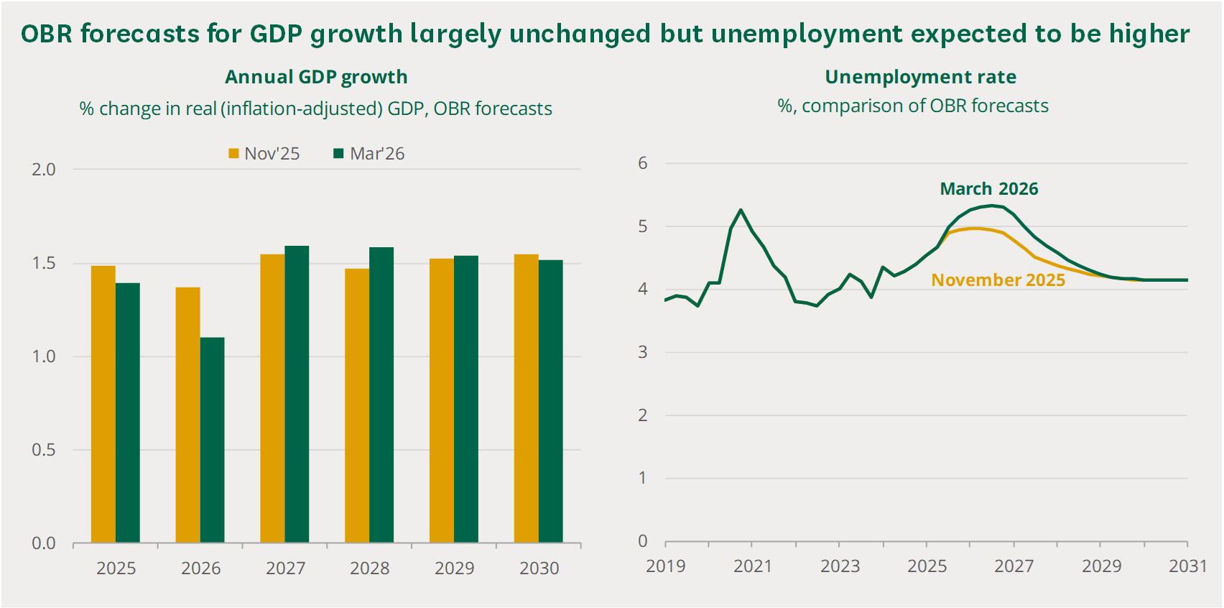
Source: House of Commons Library - 2026 spring forecast
- Annual CPI inflation returned to the Bank of England’s 2% target in mid‑2024 as post‑pandemic supply‑chain pressures eased and energy prices stabilised but rose above target again in 2025 due to renewed global energy and food price increases, higher administered prices and strong wage growth. The OBR’s central forecast anticipates CPI falling to 3.4% in 2025, 2.3% in 2026 and stabilising at 2% from 2027, though ongoing Middle East conflict is expected to place upward pressure on near‑term inflation through higher energy and commodity costs.
- Experian’s latest Retail Planner Briefing Note (RPBN 23, March 2026) projects mild GDP growth in 2026, supported by front‑loaded government spending commitments from the 2025 Autumn Budget. Retail sales are expected to grow modestly, particularly in comparison goods, reflecting improvements in real discretionary incomes.

RETAIL SPENDING
- The latest Experian forecasts from RPBN 23 for retail spending per capita show:
- Convenience goods: The impact of COVID-19 resulted in a significant +7.2% surge in spend per head in 2020 but a contraction of -1.2% in 2021. This followed negative growth of -0.4% between 1998 and 2024. The overall level of negative growth in convenience goods spending has had a significant impact on the grocery sector and on retailer business models. Experian reported a fall in convenience spend in 2023 (-5.1%); 2024 (-2.8%); and 2025 (-1.5%). With no growth projected over the medium term to 2032 and beyond over the longer term to 2041.
- Comparison goods: Experian figures show negative growth to 2025 (-9.4% in 2023, -0.5% in 2024; -0.5% in 2025). The predicted (per capita) growth for 2026 is 1.2%, 1.8% in 2027, which will settle at around +2.5% to 2032 and to +2.6% up to 2041. The longer-term growth forecast is higher than the historic long-term trend (1998-2024) of +2.4% per annum.
- These expenditure growth trends, and forecasts, have informed the updated assessments of retail capacity. Clearly any further dampening of growth rates over the short to medium term due to external shocks such as rising inflation and the cost-of-living crisis will have implications for the viability of existing retail businesses and the demand for new space. Experian’s expenditure and productivity growth only provide forecasts to 2041 and as such, we have assumed the same rate of growth over the period to 2043 for this assessment.

ONLINE SHOPPING
- The growth in non-store retail sales has undoubtedly had the most significant impact on consumer spend and behaviour over the last decade, and on our High Streets and traditional shops. Non-store retailing is commonly referred to as Special Forms of Trading (SFT).
- This comprises all non-store retail sales made via the internet, mail order, stalls and markets, door-to-door and telephone sales. On-line sales by supermarkets, department stores and catalogue companies are also included in the data collected by the Office for National Statistics (ONS).
- ONS figures show that as a percentage of total sales, online retail sales accounted for up to 28.9% of sales in January 2026. The graph also shows the steep increase from 20.2% in January 2020 to 37.8% in January 2021. Overall, the trend suggests that since 2020 online accounts for between a quarter to a third of the amount spent on retail goods. This compares to less than 5% in 2008.
Figure 2: Internet Sales as a Percentage of Total Sales (%) (to January 2026)
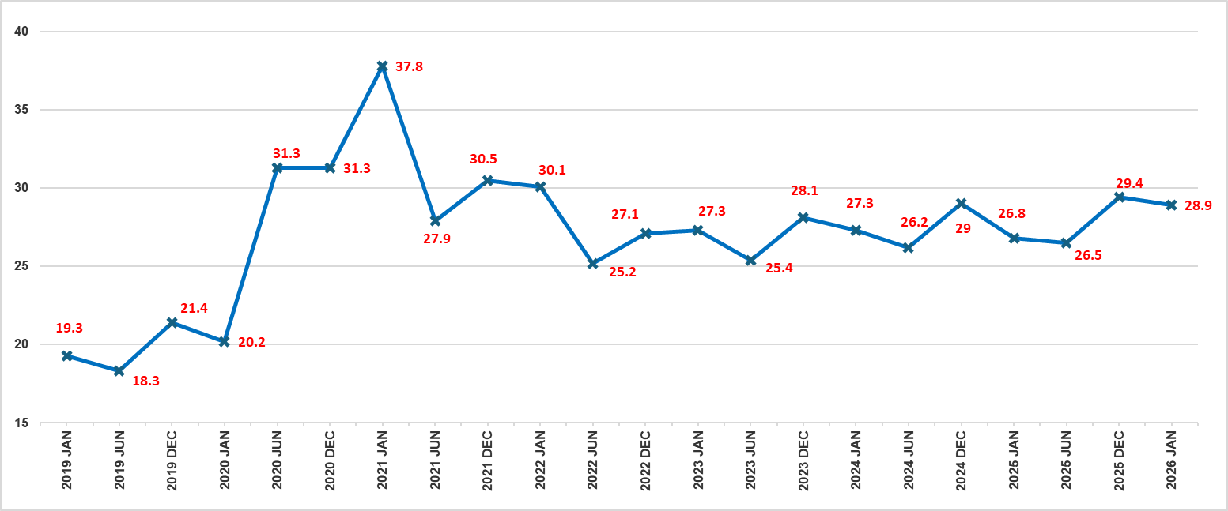
Source: ONS: Retail sales, Great Britain: March 2026
- As the figure below shows, SFT’s share of UK retail sales increased from 5% in 2006 to 30% in 2020, with online channels accounting for nearly one‑third of total spending. Within this, comparison and convenience goods reached market shares of 39.5% and 17% respectively. Experian forecasts that by 2026 total SFT will represent 28.3% of retail sales, rising to 37.8% by 2041, with comparison and convenience goods increasing to 41.8% and 24.9%.
Figure 3: Estimated and Projected Market Shares of Non-Store Retail Sales (SFT), 2007-2041 (Not Adjusted)
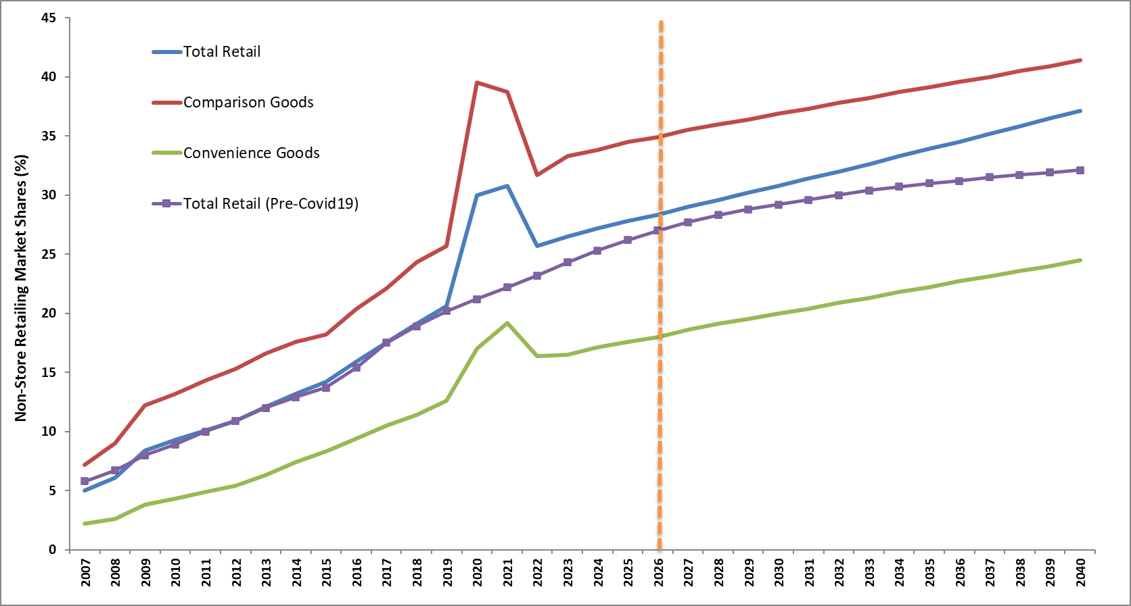
Source: Experian Retail Planner Briefing Note 23 (March 2026)
- This growth reflects advances in digital platforms, faster fulfilment, improved connectivity, and the expansion of flexible payment and price‑tracking tools. However, physical stores still play a significant role, supporting around 25% of comparison and 70% of convenience SFT sales. Accounting for this, adjusted SFT shares for capacity forecasting are lower, at 18% in 2026, 19.8% in 2030, and 24.9% in 2041.
- Overall, these trends highlight the need for town centres to remain competitive by building on their strengths and offering a diverse mix of retail, services, leisure and hospitality to attract consumers.

RETAILER BUSINESS MODELS AND REQUIREMENTS
- Challenging economic conditions and sustained growth in online sales have permanently reshaped consumer shopping behaviour. Retailers have faced supply‑chain pressures, inflation, economic uncertainty and wider geopolitical factors, creating significant difficulties for traditional high‑street operators. National multiples are therefore continually reassessing their strategies, formats and operational models to respond to rapid sectoral change.
- The emerging “new normal” is characterised by hybrid, technology‑enabled retailing. Key trends include seamless ‘phygital’ shopping across physical and digital channels; increased use of AI for customer support and personalised recommendations; greater reliance on social‑media sentiment analysis and social‑commerce platforms; and the growing importance of click‑and‑collect and BOPIS models. Retailers are also testing new store formats and responding to rising consumer interest in repair, reuse and circular‑economy initiatives, particularly among younger demographics.
- Persistent inflation and the cost‑of‑living crisis continue to constrain discretionary spending, intensifying margin pressures from labour costs and business rates. These dynamics are evident in the grocery sector, where major operators have shifted towards online fulfilment and smaller convenience formats, resulting in a marked decline in large‑store development. At the same time, discount operators such as Aldi and Lidl have expanded rapidly, with Aldi now entering the top five by market share.
Figure 4: UK Grocery Market Share
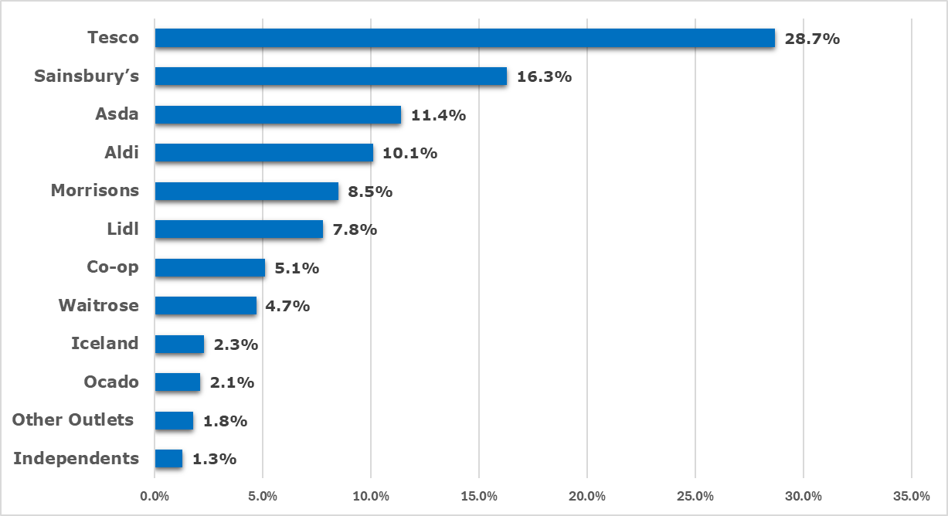
Source: Kantar (January 2026)
- The non-food retail sector has also experienced a significant impact from the rise of online shopping over the last decade, which has impacted on business models and store viability. Many well-known retailers have either closed or have significantly reduced their store portfolios. Contributing factors included reduced financial support post-COVID-19, rising operational costs, and the shift towards online shopping.
- The latest industry research shows that over 971 closed stores in 2023 due to businesses entering administration, with almost 21,000 jobs lost. This compared with 5,200 store closures in 2020, and over 109,000 job losses. At the end of 2025, there were 3,380 store closures with almost 32,600 job losses. These numbers included shop closure numbers for major chains such as Claire’s Accessories, LK Bennett and The Original Factory Shop during this period.
Figure 5: Major Retail Failures (2007 – 2025)
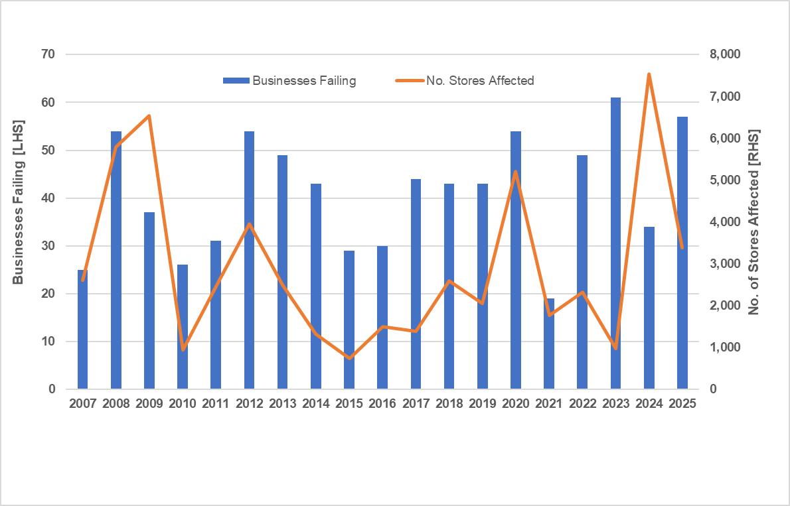
Source: Centre for Retail Research (January 2026)
- National retailers with large high‑street portfolios are finding it increasingly difficult to maintain market share and profitability, as trading costs remain significantly higher than for online and out‑of‑centre operators. This imbalance continues to contribute to widespread store closures.
- While some retailers are better positioned to adapt to online growth and shifting consumer behaviour, many are struggling to absorb rising costs and transition to more technology‑driven business models. Although digital tools can help small and medium‑sized enterprises expand their reach and better understand consumer trends, disparities in cost, capability and digital literacy mean the competitive landscape remains uneven.

RISING OCCUPANCY COSTS
- ‘Bricks and mortar’ retailers continue to face above‑inflation increases in occupancy costs; including rents, business rates, utilities and staffing, which are outpacing sales growth and eroding profitability, leading to further store closures. The competitive imbalance between high‑street, online and out‑of‑centre retailing persists, requiring operators to increase efficiencies and productivity within existing floorspace to remain viable.
- Retail planning assessments typically apply year‑on‑year sales density growth allowances to ensure existing and new floorspace remains viable. However, there is limited evidence on long‑term changes in retailer turnover and profitability. The latest Retail Planner Briefing Note (RPBN 23, March 2026) provides updated forecasts of annual floorspace productivity growth to 2041 under two scenarios: a ‘constant floorspace’ scenario, assuming limited new development and greater efficiency of existing stock, and a ‘changing floorspace’ scenario, reflecting the impact of new retail development on average sales performance.
Table 1: Floorspace Productivity Growth Rates (year-on-year growth %)
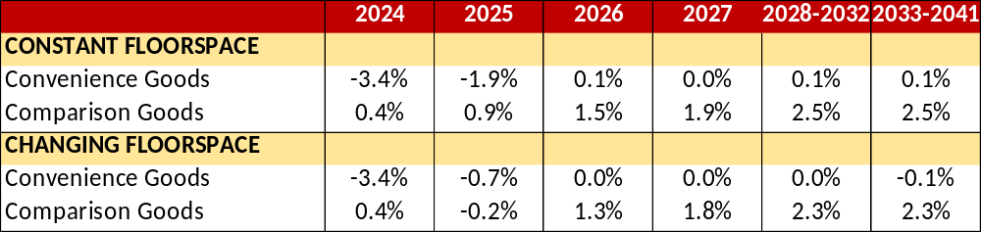
Source: Experian Retail Planner Briefing Note 23 (March 2026); Figures 3a/3b and 4a/4b
- Experian notes that sales‑density growth has been highly volatile in recent years due to pandemic‑related closures and subsequent inflationary pressures. A rebound is expected in 2026, driven mainly by comparison goods and improving consumer affordability. However, rising costs and tight margins are expected to shape medium‑ and long‑term floorspace efficiencies, with outcomes varying significantly between local areas.
- Budgetary pressures mean retailers will need to extract greater efficiency from existing floorspace through redevelopment or repurposing, adoption of new technologies, stronger marketing and integrated omni‑channel strategies. These adjustments are occurring against a backdrop of weak demand for retail property, high vacancy levels and a substantial decline in new retail‑led development.
- Given these conditions, higher constant‑floorspace productivity growth rates are preferred for retail planning assessments, as they better reflect national trends and the need for retailers to enhance sales performance to remain viable. Demand for retail space has fallen sharply since 2007, contributing to declining property values and rents, with the sector continuing to underperform relative to other property markets.
Figure 6: Property: Average Rental Growth (2006-2025) (%)
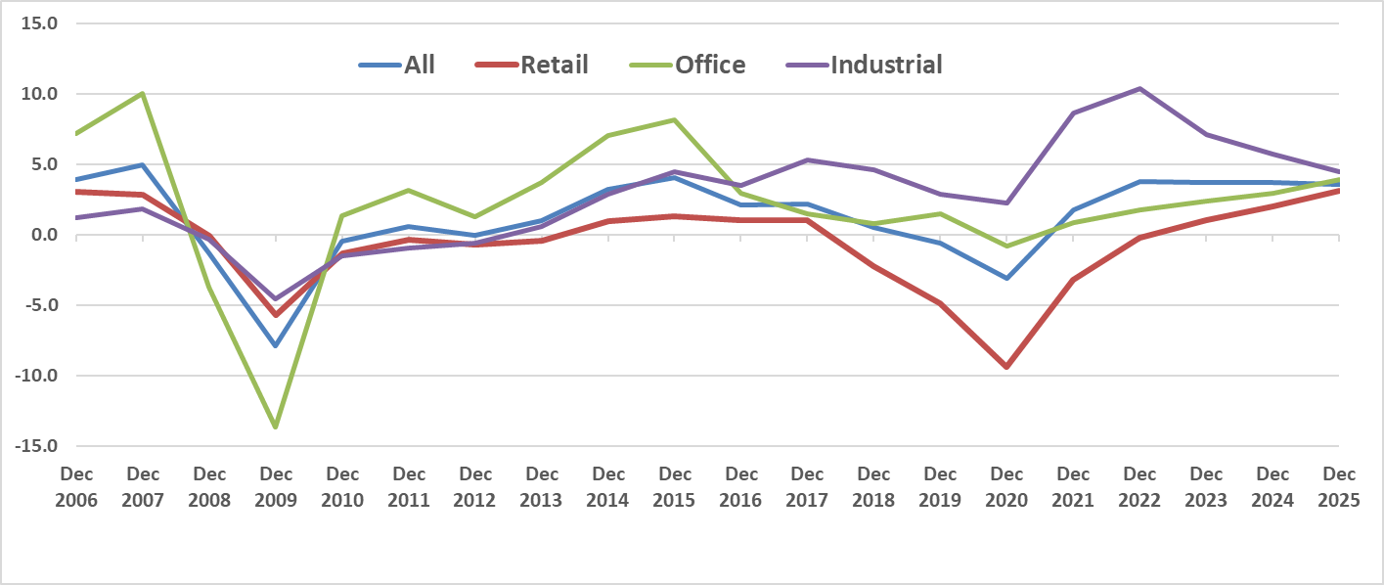
Source: MSCI UK Quarterly Property Index (March 2026)
- Retail sector pressures have contributed to a sustained fall in retail rental values. Major national retailers now hold a stronger negotiating position, using lease events to reduce costs and increase operational flexibility. Over the past 18 months, many have sought provisions such as:
- Turnover‑linked rents rather than traditional market‑value rents.
- Capped market‑rent reviews to limit future increases.
- Shorter leases with frequent break options.
- Capped service‑charge increases.
- Pandemic‑related rent‑cessation clauses.
- Across the UK, many centres now have either an oversupply of retail floorspace or stock that no longer meets modern retailer requirements for larger, more flexible formats. Research by LSH and REVO (Shaping Tomorrow’s Places, 2025) highlights business rates, excess floorspace and the growth of online retail as key structural challenges affecting centre viability.
- This oversupply, combined with limited market demand, continues to undermine the viability of existing stores and shopping centres, making it increasingly difficult for landlords, investors and operators to justify further capital investment.

OUT-OF-CENTRE RETAILING
- Development and take‑up of food and non‑food out‑of‑centre space has slowed in recent years, mirroring trends in high streets and town centres. Major grocery operators have largely withdrawn from large superstore formats to focus on online growth and smaller convenience outlets, with the exception of discounters Aldi and Lidl, who continue to seek new edge‑ and out‑of‑centre sites.
- Despite reduced activity, out‑of‑centre locations retain strong competitive advantages, including modern large‑format units, ease of access, lower occupancy costs, extensive free parking and suitability for last‑mile logistics. These factors continue to attract retailers revising their business models—for example, Marks & Spencer replacing some traditional high‑street stores with out‑of‑centre Simply Food formats.
- According to the IPF Consensus Forecasts (March 2026), rental growth in 2026 is projected at 1.8% for shopping centres, 2.3% for retail warehouses and 3% for standard retail.

VACANCY RATES
- At the end of 2025, the national average vacancy rate for retail stood at c.13.5% (a decrease from 14% in 2023). The current rate is still higher than the pre-pandemic (Q4 2019) level of 12.1%, so the sector has yet to fully recover.
- Over the past five years, retail parks and shopping centres have shown an overall decline in vacancy rates, while high streets have experienced an increase. From a vacancy high of 19.4% in the second quarter of 2021, shopping centres dropped to c.16.5% at the end of 2025.
- The LSH/Revo survey has consistently identified there is too much retail floorspace in the UK. As a result, centres and locations are competing to attract limited occupier interest. There is also competition to secure public and private sector investment to help deliver critical redevelopment and regeneration projects.

USE CLASSES ORDER & PERMITTED DEVELOPMENT RIGHTS
- Government planning reforms since 2020 have increased flexibility in town centres, particularly through the introduction of the broad Class E and new community‑focused use classes, while moving several former A and D uses to sui generis. These changes enable a wider range of uses without planning permission and support the reuse of vacant buildings.
- However, town centre boundaries and primary shopping areas remain important for policy, and traditional distinctions, such as between convenience and comparison retail that still aid interpretation. While frontage policies are less enforceable due to Class E flexibility, planning controls remain relevant for certain sui generis uses, including takeaways and betting shops.
- Town centres are expected to evolve towards a more diverse mix of uses, with less reliance on retail and greater emphasis on placemaking, services, and residential development, particularly on upper floors. Permitted development rights introduced since 2020 further support this shift, allowing additional residential storeys and conversion from Class E to housing, subject to prior approval on matters such as design, amenity and safety.

SUMMARY
- Traditional town centres and shopping centres continue to face significant structural challenges, including surplus retail floorspace, elevated vacancy levels, rising occupancy costs and increased competition from online and out-of-centre retailing. These pressures are affecting the ability of centres to retain occupiers, fill vacant units and attract investment, underlining the need for a flexible and evidence-led approach to planning for retail and leisure uses.
- Economic pressures, changing retail and leisure spending patterns, the growth of online sales and rising operating costs continue to affect the resilience of town centres and shopping destinations. These trends are particularly relevant to Mansfield District, where the study seeks to understand how centres can remain competitive, retain expenditure, support appropriate investment and adapt to changing operator and consumer requirements over the plan period.
- National planning reforms over the past 6 years and emerging local policy provide greater flexibility for centres to adapt to changing market conditions, including through a broader mix of town centre uses and, where appropriate, residential development. This flexibility can help support the reuse of vacant or underperforming floorspace, but it also reinforces the need for clear local policy to manage change in a way that protects the role, function and vitality of defined centres.
- In this context, the evidence points to the need for centres to become more adaptable and less reliant on traditional retail floorspace alone. Future policy should therefore support the managed diversification of centres, including appropriate retail, leisure, service, community and complementary uses, while continuing to direct main town centre uses to the district’s defined centres and safeguard their long-term vitality and viability.

CENTRE HEALTH CHECK OVERVIEW & SWOT ANALYSIS
- Planning policy at all levels seeks to maintain and enhance the vitality and viability of town centres and therefore understanding the current health of a centre is an important element of any evidence-based Retail Study.
- Health check assessments for Mansfield District Centre’s town centre, two district centre and six local centres are provided in Volume 2 of this study. The assessments provide a qualitative overview of the current vitality and viability of the centres informed by information on some of the KPIs set out in the PPG. Details of the KPIs, other information used to inform our assessments and data sources used are detailed in the report (Volume 2) and the key findings in terms of our overall conclusions and the strengths, weaknesses, opportunities and threats for each of the town centre and district centres is set out below.

MANSFIELD TOWN CENTRE
- The Strengths, Weaknesses, Opportunities and Threats (SWOT) for Mansfield Town Centre can be summarised as follows:

Strengths
- Strong independent retail offer which creates a unique visitor destination.
- Strong presence of high street banks.
- Good presence of a range of national multiples.
- Strong heritage and historic character, with a good blend of both old and new architecture, which is contributing to a pleasing environmental quality overall.
- Good parking provision, including the presence of EV charging.
- Mansfield market acts as a key attractor and footfall driver, especially during special market events e.g. Christmas markets and artisan markets.
- Good accessibility and public transport connections (bus and train).
- Strong wayfinding and easy navigation through the presence of maps around the centre.
- Strong provision of greenery, street furniture and statues which create visual interest.
- Good evening and night time economy.
- Increase in footfall figures between 2021 and 2025.

Weaknesses
- Vacancy rate higher than the UK average.
- Underrepresentation of convenience retail floorspace which is lower than the UK average.
- Weak food and beverage offer with a weak provision of cafes, fast food & takeaways and restaurants that are lower than the UK average.
- Prime retail rents have significantly decreased in recent years.
- Unable to maintain strong growth in evening footfall seen in 2022.

Opportunities
- Capitalise on interest for representation from retailers.
- Creative use of vacant units through pop-ups, community hubs, co-working spaces etc.
- Broader mix of uses within the centre to address vacant units – e.g., residential (White Hart redevelopment being a good example of this).
- Regeneration / redevelopment of large vacant units (the former Beales department store and the former BHS store) which are both in progress.

Threats
- The growth in online shopping and its impact on brick-and-mortar retail outlets.
- High business operating costs.
- The potential loss of further high street brands leading to further vacancies.
- We conclude that Mansfield continues to be a vital and viable centre, acting as a retail and leisure hub for the region. Whilst the centre has a good presence of national multiples that allow it to draw visitors from beyond its immediate catchment, there is also a strong sense of distinctiveness as a result of its strong range of independent operators alongside its unique history and character.
- Opportunities for Mansfield to evolve and strengthen include better usage of vacant space (either through temporary uses or a greater mix of uses). This is already underway with the planned redevelopment of the former BHS store into a food hall destination as well as the ongoing redevelopment of the former Beales department store into a community hub. Both are expected to boost the vibrancy and offer of the centre, helping Mansfield to transition away from an era where comparison retail dominated town centres like Mansfield, to a future where a greater mix of uses are present. Redevelopments such as White Hart will also boost the residential population of the centre, thus increasing the immediate catchment’s total expenditure and footfall activity within the centre.

MANSFIELD WOODHOUSE DISTRICT CENTRE
- The Strengths, Weaknesses, Opportunities and Threats (SWOT) for Mansfield Woodhouse District Centre can be summarised as follows:

Strengths
- Strong presence of independent retailers which creates a distinct sense of character.
- Good public transport connections, with the presence of bus stops within the centre
- Well maintained and clean streets
- Distinct historical building facades which strengthen the centre’s environmental quality
- Strong convenience retail anchor within the centre (Morrisons superstore)
- General increase in total footfall levels between 2021 and 2025.

Weaknesses
- Absence of cycle parking.
- High and rising vacancy rate.
- Narrow pedestrian routes towards Station Street.
- Diminished environmental quality towards the western boundary of the centre on Station Street.

Opportunities
- Creative use of vacant units through pop-ups, community hubs, co-working spaces etc.
- To diversify the food & beverage operator types as they are currently dominated by fast-food and takeaways.

Threats
- High business operating costs could lead to further vacant units.
- Rise in vacant units negatively impacting on the environmental quality and damaging the appeal and attraction to the centre as well as negatively impacting on operator’s perceptions and willingness to invest.
- We therefore conclude that Mansfield Woodhouse is a vital and viable centre, which continues to meet the day-to-day needs of its immediate catchment and serves a functional role. The draw of the centre is led by the Morrisons supermarket store, which is supported and complemented by a range of other uses and operators.
- Challenges to the centre include the rise in vacancy levels, posing a risk to its long-term vitality and a potential diminishing of its environmental quality.

MARKET WARSOP DISTRICT CENTRE
- The Strengths, Weaknesses, Opportunities and Threats (SWOT) for Market Warsop District Centre can be summarised as follows:

Strengths
- Strong history, character and charm with the presence of listed buildings.
- Good accessibility and public transport connections.
- Well maintained streets and attractive shop frontages.
- Good provision of street furniture and greenery.
- Good representation of convenience retail and retail service units.
- Good overall environmental quality.
- Declining rate of recorded crimes.
- Proportion of vacant floorspace is significantly lower than the UK average.
- General increase in footfall levels over the past 5 years.

Weaknesses
- Limited evening and night time offer – particular lack of restaurants.
- Particularly high representation of fast food and takeaways.
- Underrepresentation of financial and business services.

Opportunities
- Improvements to accessibility through the resurfacing areas of uneven paving on High Street.
- Creative use of the vacant space in the form of pop-ups, community hubs and co-working spaces.

Threats
- High business operating costs which could lead to a rise in vacancies.
- Concentration of fast food and takeaways could lead to ‘dead frontages’ and reduced vibrancy during the day time.
- We therefore conclude that Market Warsop is a vital and viable centre, which continues to serve the day-to-day needs of its immediate catchment. The centre’s historic architecture creates a distinct environmental quality.
- The centre does however lack when it comes to its food and beverage offer, with no provision of bars & wine bars or restaurants and a disproportionately high number of fast-food and takeaway units (which risks creating inactive frontages during daytime hours and, in turn, diminishes the overall vibrancy and street-level activity of the area).

THE STUDY AREA AND TRADING PATTERNS

EXPERIAN INSIGHTS DATA
- To provide the necessary information on expenditure patterns in the adopted Study Area, data has been obtained from Experian Insights.
- Experian Insights uses actual transaction data from 4 million customers across the UK. This information can be used to identify how much money is spent in specified locations and the origin of that spend (i.e. customer home location), using different levels of geography and against typical retail and leisure categories. This allows a detailed understanding of actual customer behaviour.

STUDY AREA
- The Study Area is shown on the map provided at Appendix 1, Volume 3, and comprises four zones, including:
Zone 1 | Mansfield District administrative area and settlements within.
Zone 2 | Urban areas of Sutton-in-Ashfield and Kirkby-in-Ashfield and surrounding rural areas in Ashfield District.
Zone 3 | Rural settlements to the east of Mansfield District and within Newark & Sherwood District.
Zone 4 | Shirebrook urban area and rural settlements to the north and northwest of Mansfield District, which fall within Bolsover District.
- The Study Area is used to inform the level of expenditure retained by settlements across the defined area. For Mansfield District (Zone 1), this includes Mansfield Town Centre, Mansfield Woodhouse, Market Warsop, and the district’s local centres. Transaction data for the district’s out of Centre retail and leisure facilities are also identified, such as the various retail parks that surrounding Mansfield Town Centre Park, and out of centre retail and food & beverage (F&B) clusters. All other transactions that comprise remaining parts of the district are aggregated and classified under ‘Elsewhere Zone 1’.
- To better understand expenditure outflows from the Study Area, transaction-based expenditure from the Study Area to the key competing centres are identified and assessed, such as competing towns in neighbouring authorities (Worksop, Hucknall, etc.) and regional shopping destinations (e.g. Sheffield, Meadowhall Shopping Centre, Nottingham, etc).
- The market share of online convenience goods expenditure is also identified for the study area and zones within.
- Inflows of expenditure to Mansfield District from beyond the Study Area is also provided. This expenditure is referred to throughout the report as “expenditure inflow” or “expenditure uplift”.

EXPENDITURE CATEGORIES
- Given the purpose of this study is to determine the capacity/need for additional retail floorspace and other town centre uses/ facilities, and to examine commercial leisure trends, the expenditure data provided by Experian Insights relates to the following expenditure categories:
Table 2: Experian Insights Retail and Leisure Food & Beverage Categories
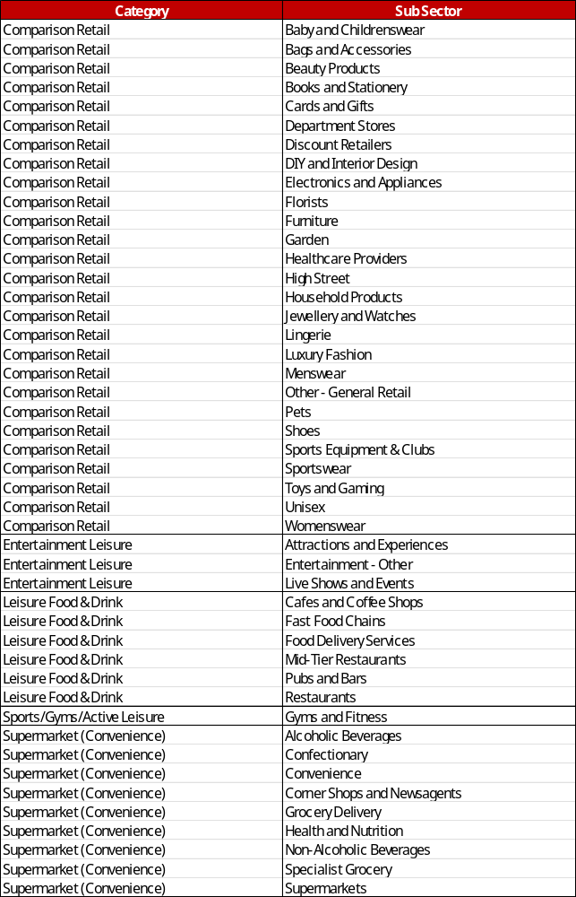

- Experian Insights transaction data estimated for a 12-month period ending 31st December 2025. As such, the data provides a good baseline for understanding how residents and visitors spend money on retail goods and leisure activities, taking account of variances that typically occur over a given year (e.g. seasonal activity).
- The base data is provided in Appendix 2 (Volume 3) as follows:
- Table 1: Supermarket Spend
- Table 2: Comparison Spend
- Table 3: Leisure Food & Drink Spend
- Table 4: Entertainment Spend
- The remainder of this section presents the market share analysis for convenience goods expenditure.

RETAIL SPEND PATTERNS
- The data supplied by Experian Insights on retail spend is presented in Tables 1-3 of Appendix 2, Volume 3.
- Population data Zone 1 (Mansfield District) has been obtained from the Council and is informed by the Council’s population projections as provided by Justin Gardner Consulting (JGC). The population for Zones 2 to 3, along with the retail expenditure data for all study zones has been obtained from Experian Location Analyst. The population and expenditure forecasts are set out in Tables 1 to 5 of Appendix 3, Volume 3. These calculations are applied to the transactional data to estimate the distribution of convenience and comparison expenditure across the identified centres within and outside of the Study Area. The results are presented in percentage and monetary terms for the base and forecast years in Tables 1-8 of Appendix 4 and Appendix 5 (Volume 3) for convenience and comparison, respectively.
- The resulting tables provide useful information on spending patterns within Mansfield District for convenience and comparison retail spend and within the individual centres. Key findings are discussed as follows:

Convenience Goods Market Shares
- Supermarket expenditure represents transactions made at foodstores, supermarkets, and convenience stores, and includes national multiples and independent operators. This form of expenditure is also referred to as convenience retail expenditure.
- The market share analysis of Experian Insights data on convenience retail spend is set out in Tables 1-8 of Appendix 4 (Volume 3) and are summarised in the table below and follow on paragraphs. The allocation of expenditure is represented as percentage of total expenditure for the zone or the total Study Area, which is referred to as ‘market share’ or ‘market shares’. The percentage baseline convenience spend market shares for 2025 are presented in Table 1 of Appendix 4 (Volume 3).
- The distribution of spend on convenience retail (as evidenced by Experian Insight’s data on supermarket spend) would normally be expected to reflect proximity to home and the degree of available convenience retail facilities. This is generally the case for Mansfield District with the overall retention rate for Zone 1 being 69.7%. This reflects a reasonably healthy retention rate, with leakage split broadly evenly between expenditure diverted to competing centres outside of the district and online. What is noted is that there is no specific competing location that is drawing trade from Mansfield District. Instead, expenditure leakage to locations outside of the district is widely spread.
- The online convenience shopping market share for Mansfield District (Zone 1) compares with the study area average (15%) and is lower than the national average identified by Experian in 2025 (17.6%).
- We note the following results for market share for the Mansfield’s main centres and other retail locations in the district:
- Mansfield Town Centre – attracts just 1% of Study Area expenditure, which will be influenced by a limited convenience retail offer in the centre. Convenience expenditure in the district (Zone 1) is directed to the Asda adjoining Fulmar Close, foodstores at Jubilee Way South, and the Sainsbury’s and Aldi off Nottingham Road.
- Mansfield Woodhouse District Centre – the town centre’s convenience retail market share is performing stronger than Mansfield town centre – capturing 5% of district expenditure. That will be due to the in centre Morrisons. The town centre also has a number of traditional convenience retail providers such as a bakery and butchers.
- Market Warsop District Centre – market share for the town centre is low for convenience and reflects the limited convenience retail offer available in the centre, which is mainly served by two Co-op stores and a third Co-op store located in the northern edge of the town. The stores are likely to primarily serve a top-up shopping function, although the Co-op store on Mansfield Road is the largest of the three stores and is likely to support some main food shopping.
- Smaller Centres – convenience retail market shares are limited across the districts smaller centres including the local centres and neighbourhood parades. The results reflect the limited scale of convenience offer which were available is aim at serving day to day convenience needs.
- Edge and Out of centre foodstores - the district’s out of centre foodstores together capture over half of Zone 1 convenience goods expenditure and over a third of total study area convenience goods expenditure. The following provides an overview of key stores/ locations:
- Asda, Old Mill Lane – for the purpose of the assessment the store is included within the defined boundary for Fulmar Close local centre, however it represents the only convenience outlet within the defined area. At 9.3%, the store generates the second highest market share of Zone 1 resident expenditure of all identified locations in the district. The store also draws expenditure from Zones 3 (6.8% of zonal expenditure) and Zone 4 (3.5%). The store’s market share of total study area expenditure is 5.7%.
- Tesco Extra, Jubilee Way South – attracts the highest market share of all stores or centres identified in the district. The store retains a tenth of Zone 1 convenience goods expenditure, increasing to 14% from Zone 4 which is likely due to the foodstores’ position on the western edge of the district. The store’s market share for total study area convenience goods expenditure is 7.1%.
- Tesco Extra, Chesterfield Road – the store is located edge of centre to Mansfield Town Centre and is well connected to the town. The store attracts a Zone 1 market share of 9% and is also popular with residents from Zone 4 (8.7%). The store’s overall study area market share of 5.8% compares to the Asda store.
- Foodstores at Nottingham Road/ Talbot Street – includes the Sainsbury’s and Aldi stores, which together generate a Zone 1 market share of 9.8%. The store also draw trade from Zones 2 and 3, and to a lesser extent from Zone 4.
- Morrisons, Sutton Road – attracts a Zone 1 market share of 3.7% although the store attracts a higher market share from Zone 2 at 5.2%. This will reflect the store’s position on the southern edge of district’s boundary and the close proximity to communities in and around Sutton-in-Ashfield.
- Aldi and Lidl stores, Leeming Lane – the two stores attract a combined Zone 1 market share of 6.4%, with a similar market share of Zone 2 expenditure. The overall study area market share is 3.9%.
- Elsewhere in the district – attracts an 8.8% market share of Zone 1 expenditure and includes all local and standalone stores in the district that are outside of the settlement boundaries for the defined centres and the out of centre retail locations defined for this analysis.
- Generally, the analysis shows that the presence of main foodstores is driving market share retention across the district with convenience retail serving a limited role for the district’s town centres. The evidence shows that the district’s out of centre foodstores dominate the convenience retail market for Mansfield.

Comparison Goods Market Shares
- The findings of the comparison retail spend analysis are set out in Tables 1-8 in Appendix 5 (Volume 3). The percentage baseline comparison goods market shares for 2025 are presented in Table 1 of Appendix 5 (Volume 3).
- Comparison spend retained within Mansfield District is low with retailers retaining only 28% of expenditure generated by residents in the district (Zone 1). However, the low rate of retention is explained by strong competition with nearby major shopping destinations and online offer, which we discuss later.
- We note the following results for market share for centres and other retail location in the district:
- Mansfield Town Centre – comparison retail market share is 7% of total district expenditure. This is a relatively low market share but not a surprising one and reflects competition with out of centre retail in the district (St Peter’s Retail Park, Portland Retail Park, Baum Lane, etc) which have a greater combined market share. The town centre attracts the highest proportion of study area expenditure of all destinations identified in the district. The town is drawing over 4% of comparison goods expenditure from Zones 3 and 4.
- Mansfield Woodhouse and Market Warsop - limited transaction data was identified for the two district centres which reflects the limited role of comparison retail in both centres.
- Smaller Centres – similarly to the district centres, limited or no transaction data was identified for the districts local centres and neighbourhood parades. Again, the results reflect the lack of comparison retail offer, which is expected for small centres.
- Out of centre – the district’s retail parks and standalone comparison retail providers retain 12.6% of Zone 1 comparison goods expenditure, and 9.9% of total study area comparison goods expenditure. Specific out of centre retail locations of note include:
- St Peters Retail Park – attracts a Zone 1 market share of 3.9%, with a relatively even market share across Zones 2 to 4.
- Portland Retail Park – attracts a similar Zone 1 market share to Portland Retail Park at 3.5%, with a similar market share from Zone 4 (3.4%)
- Baum Lane & Nottingham Road Retail Park – includes B&M Homestore and Garden Centre, Halfords, Topps Tiles, and Currys, which combined attract a Zone 1 market share of 4.1% and total study area market share of 3.2%.
- Elsewhere in Zone 1 (Mansfield District) – 6.5% of Zone 1 expenditure and 4.7% of Study Area expenditure is retained by comparison retailers located across the rest of the district. This will include standalone retailers located in smaller centres and trade parks.
- Turning to expenditure leakage to competing centres, approximately 28.1% of Study Area expenditure is lost to centres outside of Mansfield District, which is directly comparable to the district’s market share retention rate. Sutton-in-Ashfield is the principle competing location attracting 3.7% of Zone 1 expenditure. The remaining expenditure spent outside the district is spread across a variety of identified locations such as East Midlands Designer Outlet Village (1.9%), Meadowhall Shopping Centre (1.9%), and Nottingham central (1.6%). Over 12% of Zone 1 expenditure is spent at other locations in the UK.
- Online sales account for an even higher rate of leakage than to competing centres, with online retailers capturing around 44% of total Zone 1 comparison goods expenditure, which is broadly comparable across the other study zones. The online market share is approximately six percentage points higher than the 2025 UK average indicated by Experian.
- Typically, sales on clothing and footwear account for the highest proportion of comparison retail spend and therefore the range of offer in a centre will influence retention levels of overall comparison spend. For Mansfield Town Centre, whilst the town has a number of key fashion anchors (e.g. Primark) the scale and range of offer is limited but is broadly comparable to smaller sub-regional centres. As a result, it is unsurprising that the centre is losing spend to online and higher order competing centres and shopping destinations where there is a bigger range of offer and brands.

INFLOW’ FROM OUTSIDE THE DISTRICT
- The Experian Insights data identifies transactional spend on centres in Mansfield District (Zone 1) made by UK visitors that reside outside of Zone 1. This includes expenditure from Zones 2 to 4 that is captured by retailers in Mansfield as well as inflow of expenditure from UK residents that reside outside of the study area (Zones 1 to 4). From this we can estimate the percentage uplift on Mansfield District’s retained resident spend. Expenditure inflow is estimated for the base year (2025) alongside the baseline market shares for convenience goods (Table 3, Appendix 4, Volume 3) and comparison goods (Table 2, Appendix 5, Volume 3).
- The percentage uplift from expenditure inflow identified for centres in Mansfield District are summarised below:
Table 3: Study Area Retail Expenditure & Inflow from Outside Mansfield District in 2025 (£m)
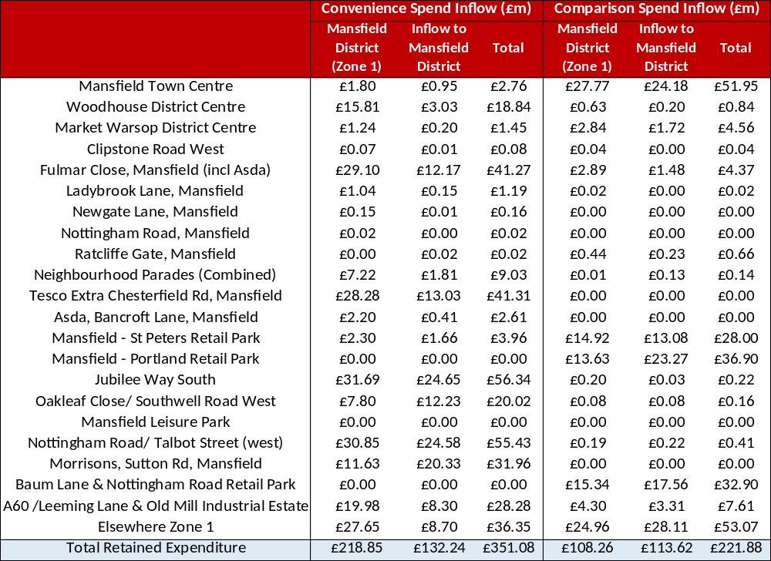
Notes: Inflow to Mansfield includes expenditure from Zones 2 to 4, which are areas outside of the district and expenditure inflow from beyond the study area.
- The following provides an overview of key findings summarised in the table above:
- Mansfield Town Centre - The majority of the town centre’s convenience and comparison goods turnover (retained expenditure) is supported by district residents. Overall, inflow of expenditure from beyond the district accounts for 46% of the town’s total retail turnover and represents an 85% uplift on retained district expenditure. Inflow is largely supported by residents living beyond the study area (i.e. beyond Zones 1 to 4). The value for inflow (£m) and percentage uplift is higher for comparison retail expenditure than for convenience, which correlates with the town’s bias towards comparison retail provision and the absence of anchor foodstores.
- Mansfield Woodhouse District Centre – inflow from beyond the district accounts for 16% of the town’s total turnover, of which 56% is generated from residents of the rest of the study area (Zones 2 to 4 combined). The town’s inflow is more reliant on comparison goods expenditure which accounts for 24% of total comparison goods expenditure, representing a 35% uplift on retained district expenditure.
- Market Warsop – at 32%, inflow accounts for a higher proportion of total retained retail expenditure compared to Mansfield Woodhouse, which is likely to reflect the centre’s more peripheral location within the district. A comparably high proportion of total retail expenditure inflow is generated from residents in the rest of the study area (56% from Zones 2 to 4 combined), with comparison goods turnover accounting for a higher proportion of inflow (38% of total retail expenditure inflow).
- Smaller centres – including the district’s local centre and neighbourhood parades have varying rates of expenditure inflow, with the uplift in turnover associated with expenditure inflow from beyond the district being generally much lower than for the larger centres. This is to be expected given the scale of retail offer.
- Edge and Out of Centre Retail Parks - are key drivers of expenditure inflow into the district. For example, 60% of the retail turnover generated by Portland Retail Park is from residents living outside of the district, of which almost 80% is from beyond the study area (Zones 1 to 4). Inflow equates to a 171% uplift on retained district expenditure, which is likely due to a lack of comparable retail offer in other parts of the study area and in rural locations beyond. Similarly, the majority of total retail expenditure generated by retailers in the area that comprises Baum Lane and Nottingham Road Retail Park is from residents living beyond the district, and particularly beyond the study area.
- Out of Centre Foodstores – the majority of the out of centre foodstores identified generate a high proportion of their turnover from beyond the district. For example, over two thirds of the turnover for Morrisons on Sutton Road is generated from residents living beyond the district, of which almost three quarters is from residents living beyond the study area. Foodstores around Oakleaf Close and Southwell Road East also generate a high proportion of turnover from residents living beyond the district (61%), with the majority of this inflow originating from beyond the study area.
- The uplift associated with ‘Elsewhere in Zone 1’ includes expenditure inflow to the district’s rural centres and standalone stores located outside of the designated centres. Notably, inflow accounts for a higher proportion of total retail turnover, which is likely to relate to passing trade.
- The results show the importance of visitor expenditure in supporting centre market shares, particularly for comparison retail businesses. For Mansfield Town Centre, uplift is likely to be driven by visitors/tourists, and residential communities beyond the district boundary that are within a reasonable drive-time catchment (e.g. notably communities in Zone 2/ Sutton-in-Ashfield).

SUMMARY
- The analysis of trading patterns using Experian Insights data shows clear differences between convenience and comparison goods market performance in Mansfield District.
- Convenience goods (food and everyday retail) demonstrate relatively strong local retention. Around 69.7% of expenditure generated within the district (Zone 1) is retained locally, indicating that most residents meet their day-to-day shopping needs within the area. Leakage of spend is modest and dispersed, with no single competing centre dominating, and online shopping (c.15%) broadly in line with wider averages. However, the analysis highlights that out-of-centre foodstores dominate the convenience market, capturing over half of district expenditure. Large supermarkets such as Tesco Extra, Asda, and Sainsbury’s are the primary drivers of retention, while town centres play only a limited role due to a relatively weak convenience offer. Smaller centres mainly serve top-up needs, reflecting their limited scale and provision.
- By contrast, comparison goods (non-food retail) show much weaker performance. Only 28% of comparison expenditure is retained within the district, reflecting strong competition from both higher-order centres and online retail. Online shopping alone captures around 44% of comparison spend, significantly above the national average, highlighting the structural challenges facing physical retail. Within the district, Mansfield Town Centre accounts for just 7% of comparison expenditure, with retail parks and out-of-centre locations performing more strongly overall. Smaller centres have minimal influence in this sector due to the limited range and scale of their offer.
- A significant proportion of comparison expenditure also leaks to competing destinations, including nearby centres such as Sutton-in-Ashfield and major regional shopping locations (e.g. Meadowhall and Nottingham), further reinforcing the district’s limited role in higher-order retail.
- Overall, the findings indicate a two-speed retail market: strong localised retention for convenience goods driven by large foodstores, alongside significant leakage and structural weakness in comparison retail, influenced by competition from both online platforms and larger regional centres.

RETAIL NEEDS ASSESSMENT
- Having used the Experian Insights transaction data to inform our understanding of shopping spending across the Study Area, the next stage is to undertake the economic retail capacity (‘need’) assessment for new retail (convenience and comparison goods) floorspace in Mansfield District.
- Aligned with the NPPF and PPG the capacity forecasts take account of the lifetime of the plan starting from 2025 (base year) up to 2043. Whilst the study will assess outputs up to 2043 any findings beyond 2035 should be treated with caution on the basis that forecasts become less reliable after a 10-year period.

THE CREAT^{e} MODEL
- The assessment utilises the CREAT^{e} economic model which has been specifically designed, developed and tested by the LSH team over more than 25 years to assess the capacity for and impact of new retail (convenience and comparison goods) floorspace development. The evidence-based model has helped to inform and guide plan-making and decision-taking at the local, sub-regional and regional level. In brief, the CREAT^{e} (Excel-based) model adopts a transparent ‘step-by-step’ approach in which all the key assumptions and forecasts can be easily tested.
- The Experian Insights data provides the basis for the retail capacity assessment which uses the CREAT^{e} model to forecast actual capacity for convenience and comparison goods.
- At the outset it has been assumed for the purpose of the capacity assessment that the local retail market in Mansfield District is in ‘equilibrium’ at the base year. In other words, all existing centres/stores are broadly assumed to be trading in line with expected average (‘benchmark’) turnover levels. This is a reasonable approach in this case as it reflects the impact of the economic downturn and the significant growth in online sales on the trading levels and performance of retailers and stores across the UK.
- The main challenge and focus for Mansfield’s centres over the short/medium term will revolve around their response to a multitude of economic factors. They include: their response to evolving market trends, embedded spending habits from the COVID19 pandemic and the cost-of-living crisis, rising business costs, and the effect of geopolitical unrest (e.g. impact of physical war and trade war escalations on supply chains). These factors will influence the ability for the district’s centres to retain existing occupiers and to redevelop/repurpose vacant retail floorspace to attract new businesses and uses.
- In simple terms, any residual expenditure available to support new retail floorspace over the forecast period will be generated by the difference between the forecast growth in ‘current’ (survey-derived) turnover levels and the growth in ‘benchmark’ turnovers based on applying robust year-on-year ‘productivity’ (‘turnover efficiency’) growth rates to all existing and new retail floorspace.
- It is important to restate that medium to long term forecasts should be treated with caution, as they will be influenced by the dynamic changes in economic, demographic and market trends. As described previously (see Section 2), the NPPF (paragraph 90a) states that local planning authorities should meet the need for retail and town centre uses “looking at least ten years ahead”. The Planning Practice Guidance also states that given the uncertainty in forecasting long-term retail trends and consumer behaviour, assessments “may need to focus on a limited period (such as the next five years) but will also need to take the lifetime of the plan into account and be regularly reviewed”. Therefore, whilst this study assesses retail capacity up to 2043, greater weight should be placed by the local planning authority on forecasts over the next five (to 2030) to ten-year period (to 2035).
- The updated capacity forecasts set out in this section provide the Council with a broad indication of the (quantitative) need for new retail (comparison and convenience goods) floorspace in Mansfield District and its main centres, particularly Mansfield Town Centre. In turn, this will inform whether there is a need to identify and allocate sites to meet any forecast need, in accordance with the advice set out in the NPPF (paragraph 86).
- The key steps in the retail capacity assessment, and the main assumptions and forecasts underpinning the CREAT^{e} Model are described below.

BASE YEAR POPULATION AND PROJECTIONS
- The 2025 (‘base year’) population estimates and projections over the study period (to 2043) for Zone 1 (Mansfield District) are informed by projections generated from the Council’s population projections provided by JGC to inform the Local Plan Review which calculates the future population based on housing targets (standard methodology). Population estimates and projections for Zones 2 to 4 are based on projections from the Office of National Statistics’ 2022-based Sub National Population Projections (released in June 2025).
- The calculations on population projections are set out in Table 1, Appendix 3 (Volume 3) and show that the total Study Area population is forecast to increase by over +24,393 persons (+10.2%) over the 18-year study period from 238,524 in 2025 to 262,917 in 2043.
- It should be noted that areas to the north of Zone 2, which falls within Ashfield Borough, include draft allocations in the emerging Ashfield Local Plan 2020-2038 major housing growth. For example, a number of sites which combined would support approximately 1,000 homes are located around Skegby which borders Mansfield District. Retail parks and standalone stores in the south western fringe of Mansfield District are likely to benefit from the future population of these housing sites, as will Mansfield Town Centre. This potential additional spend is not accounted for within the retail capacity model, but should be identified as part of any future update of the study

EXPENDITURE PER CAPITA LEVELS AND FORECASTS
- The baseline expenditure per capita (‘per person’) figures and forecasts are presented in Table 2 (Appendix 3, Volume 3) for convenience goods and Table 5 (Appendix 3, Volume 3) for comparison goods. The baseline (2025) average expenditure per capita figures have been derived from our in-house Experian Location Analyst GIS (please note all expenditure and turnover figures are expressed in 2024 prices which reflect the estimate year for this data).
- The growth in the expenditure per capita figures by zone is informed by the forecasts published in the latest Experian Retail Planner Briefing Note 23 (RPBN23); released in March 2026. As described in the main report, Experian forecast more limited year-on-year growth in retail expenditure than previous forecasts due to the impact of long-term economic and market trends, which have been further accelerated by the impact of the pandemic.

SPECIAL FORMS OF TRADING & OTHER ADJUSTMENTS
- Special Forms of Trading (SFT) is deducted from the forecast retail (convenience and comparison) expenditure levels over the forecast period to reflect that proportion of retail spend that is not available to physical shops. The Experian Insights transactions data identifies online transactions rather than the wider category of SFT. However, as online accounts for a significant proportion of SFT transactions we can assume that a similar pattern in SFT market share growth will apply to online market share.
- The base rate for 2025 is informed by the proportions of spend recorded by the Experian Insights data which relates to transaction data across 2025.
- This has then been adjusted to reflect the fact that a proportion of online convenience and comparison retail sales are sourced from traditional (‘physical’) stores rather than from dedicated (‘dot com’) warehouses. Experian assume 25% of SFT’s market share for comparison goods and 70% for convenience goods are sales sourced from “physical” stores.
- The baseline SFT market share identified in RPBN23 is 5.3% for convenience goods and 25.8% for comparison goods in 2025. These are forecast to increase to 7.5% and 31.4% respectively by the end of the study period (2041).
- The expected growth in online sales/SFT is then applied to the forecast expenditure per head for future years, in line with the RPBN23 figures. As highlighted before, Experian’s projections go to 2041. Therefore, it is assumed for the purpose of this study that the annual growth rates for 2042 and 2043 will be comparable to 2041.
- The available spend per head has also been adjusted to reflect that not all convenience spend is spent in foodstores or comparison purchases made in non-food stores.

TOTAL AVAILABLE EXPENDITURE
- Tables 3 and 5 (Appendix 3, Volume 3) forecast the growth in total available convenience goods and comparison goods retail expenditure across the Study Area up to 2043 (excluding SFT).
- The tables for the ten-year period from 2025 to 2035 show that available convenience goods expenditure will increase by +1.9% (+£11.9m) while available comparison goods expenditure will increase by +24.4% (+£132.7m).
- Over the 18-year period to 2043, available convenience goods expenditure will increase by +3.6% (+£22.6m) and available comparison goods expenditure will increase by +52.1% (+£282.7m).

CENTRE TURNOVER ANALYSIS
- The next stage in the capacity assessment involves allocating the 2025 transaction-based market shares (Table 1 Appendices 4 and 5, Volume 3) to the baseline (2025) convenience and comparison expenditure (£ million) for the Study Area. From this information the expected turnover of centres in the Study Area and the monetary value of Study Area expenditure diverted to competing centres can be identified.
- The base year (2025) monetary/turnover market shares for convenience and comparison retail are set out in Table 1a of Appendix 4 and Appendix 5 (Volume 2), respectively, which are based on expenditure allocated from the Study Area and expenditure inflow from beyond the Study Area. These tables present market shares including online market share.
- For the retail capacity assessment, and in line with accepted approaches, the turnover analysis has been adjusted for both convenience goods and comparison goods to exclude online market share. The adjusted turnover market shares for the base year (2025) is set out in Table 2a in Appendices 4 and 5 (Volume 3) and used to inform the adjusted percentage market shares in Table 3a in Appendices 4 and 5. The adjusted market shares for the forecast years (2030, 2035, 2040, and 2043) in Tables 4 to 8 (Volume 3) and summarised in Table 9 in Appendices 4 and 5 (Volume 3).
- The forecast turnovers are based on constant market shares, i.e. assuming no change in where people currently shop. This ‘constant market share approach’ is standard practice for strategic retail capacity assessments. This approach does not take account of the potential impact that new retail investment and development (both within and outside Mansfield District) and variances in visitor numbers, which can influence existing shopping patterns, market shares and turnover performance over time.

FLOORSPACE PRODUCTIVITY
- A key input to the retail capacity assessment is the application of a year-on-year floorspace ‘productivity’ growth rate to all existing and new retail floorspace. As described in Section 3, existing retailers will need to achieve higher annual ‘productivity’ growth rates to cover their increasing costs (including, for example, rising rents, business rates and wages) and to remain profitable and viable over the short, medium and long term. This is particularly the case as the competition from online retailing increases; a trend that has been significantly accelerated by the impact of the pandemic.
- Experian provides forecasts for productivity growth rates in the form of expected changes to retail sales densities (Figures 3 and 4), with two scenarios tested, assuming (i) constant floorspace and (ii) changing floorspace. For the purposes of this assessment, we have used the ‘constant’ floorspace assumptions.

RETAIL CAPACITY ASSESSMENT
- Our assessment of both convenience and comparison retail capacity is provided in Table 9, Appendix 4 (Volume 3) for convenience retail and Tables 9 to 11, Appendix 5 (Volume 3) for comparison retail.
- The assessment is based on the assumption that retail market shares for Mansfield District and at centre level (as a proportion of total Study Area expenditure and the associated percentage uplift) remain constant. In other words, capacity forecasts do not allow for potential changes to shopping patterns from those currently being seen.
- Capacity forecasts are provided for the Mansfield District area as a whole.
- We have assessed a base capacity for Mansfield District, which considers capacity from a no-development scenario (excluding any turnover of pipeline development of new retail floorspace, where none had been identified), which is set out in Table 9 of Appendix 4 (Volume 3) for convenience goods and Appendix 5 (Volume 3) for comparison goods.
- The capacity results at District level identify no capacity/need for new convenience and comparison goods floorspace over entire study period (Table 9, Appendix 4, Volume 3).
- The absence of capacity for convenience goods floorspace reflects:
- a lower rate of growth in retail expenditure per capita with negative growth for convenience goods expenditure in particular.
- higher rates of productivity/efficiency growth for existing retail floorspace which accounts for retailers seeking to improve the efficiency of their sales space to counter pressures from rising operational and supply costs.
- Increasing market share of online sales.
- Table 10 and Table 11 in Appendices 4 and 5 (Volume 3) test capacity further by accounting for future turnover generated from committed retail schemes in the district, which have yet to be built out. Based on the constant market share approach the revised capacity findings in Table 11 (Appendices 4 and 5, Volume 3) demonstrate that capacity will move further into negative figures. However, in reality, schemes such as the redevelopment of the Rosemary Centre may improve the market share for the district by drawing new expenditure from beyond the district. Furthermore, the planned development of a new local centre for Berry Hill will largely be supported by expenditure generated from the surrounding Sustainable Urban Extension, as well as passing trade.

MARKET DEMAND
- In terms of market demand for new retail operators, a review of requirements has identified 11 site requirements in the district within the 24 months to May 2026, which are listed out in the table below.
Table 4: Retailer Requirements
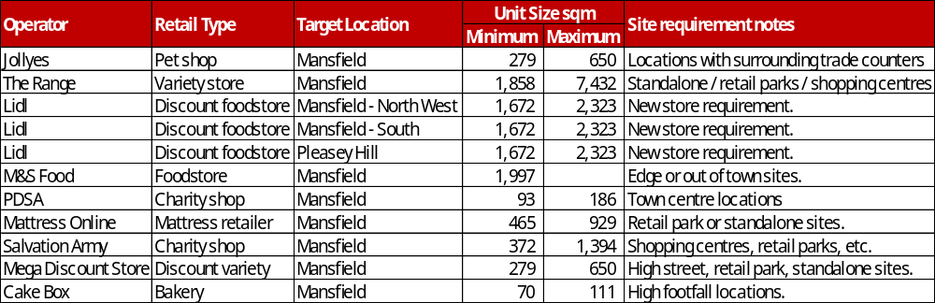
- Of note, there is strong market demand from the foodstore market with Lidl publishing three site requirements for new stores. This includes a site requirement for Pleasley Hill, which will benefit from a significant increase in new homes associated with the Sustainable Urban Extension. The standard site and store requirements for Lidl include sites of at least 0.6 hectares to support a store size of 2,184 sqm (GIA) and 100+ parking spaces.
- Of note, M&S is seeking a site to accommodate a M&S Foodhall format. The Range is another key retailer of note with a recorded site requirement.
- While there is a reasonably strong interest from the retail market for sites these requirements are largely seeking edge or out of centre sites. There is in fact limited interest from the retailer market for sites in the town centres, beyond charity shop brands. There are likely to be requirements from operators that have not been recorded, where brands may be seeking sites on a confidential basis. However, it is more likely that there will be requirements from independents as and when available units come forward in the centres.

SUMMARY
- The NPPF (paragraph 86d) is clear that local planning authorities should plan to meet the need for new retail and town centre uses by “looking at least ten years ahead”. The PPG also states that given the uncertainty in forecasting long-term retail trends and consumer behaviour, assessments “…may need to focus on a limited period (such as the next five years) but will also need to take the lifetime of the plan into account and be regularly reviewed”. Notwithstanding this, to help inform the Council’s longer-term plan-making and strategies we have assessed the potential capacity for new retail floorspace over a ten-year period to 2035 and to 2043.
- It can be concluded from the quantitative retail assessment findings is that there is no need to identify new sites to accommodate new retail floorspace in the district over the study period. However, the likelihood is that the longer-term capacity findings for Mansfield will change within that period. It is for this reason that evidence on retail spending habits should be updated every five years.
- However, where market demand presents an opportunity to improve the retail offer in Mansfield District’s centres, particularly for Mansfield Town Centre, then this should not be discounted on the basis that there is no identified quantitative need. Where demand for new retail floorspace should arise over the plan period, then this should be directed to the district’s existing centres in accordance with the “town centre first” (sequential) approach detailed in national and local plan policy and guidance.

LEISURE PROVISION AND CAPACITY ASSESSMENT
- This section analyses forecast commercial leisure expenditure over the study period, focusing on key sectors that are most likely to support opportunities to promote investment in Mansfield’s centres.
- Forecasting the need for new leisure uses is more difficult than for retailing, as the sector is highly complex and dynamic. The demand for existing and new leisure uses and facilities is particularly sensitive to changes in economic, demographic, lifestyle and fashion trends and those in the business are often unable to look more than a few months ahead.

LEISURE EXPENDITURE OVERVIEW
- Expenditure on leisure items and activities is an important element of a household budget, and it is estimated that in 2024, UK households spent in excess of £259 billion on such items including:
- Recreational and sporting services – i.e. services provided by sports stadia, racecourses, rinks, golf courses, pools, courts, bowling alleys, gyms, fairs, parks, dancing and skating;
- Cultural services – i.e. cinemas, theatres, concerts, circuses, TV rental, satellite subscription, video hire, hire of musicians, clowns, performers, photographers, film processing;
- Restaurants, cafes etc (F&B) – i.e. catering services, meals, alcohol, snacks and drinks sold by restaurants, pubs, cafes etc;
- Accommodation services – i.e. accommodation in hotels, motels, inns, “bed and breakfast” establishments, caravan sites, youth hostels, boarding schools, universities and other educational establishment accommodation; and
- Hairdressing salons & personal grooming – i.e. hairdressers, barbers, beauty shops and salons, men’s personal grooming centres, massage parlours, saunas, tanning centres.
- The table below sets out average expenditure per capita for residents within the Study Area - Zones 1 to 4.
Table 5: Expenditure per Capita on Leisure Services (2024)
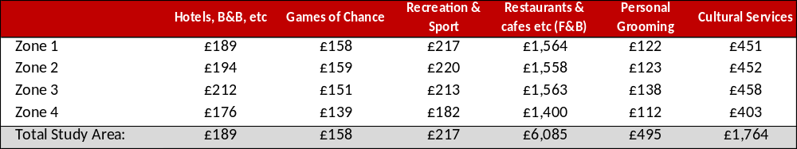
Source: Table 2, Appendix 6, Volume 3
- The table above shows that average spend on leisure services is dominated by F&B, which includes restaurants, cafés and bars. F&B accounts for approximately 68% of all average spend per capita on leisure services in the Study Area and 58% within the district area (Zone 1).
- From a planning perspective this clearly shows the potential importance of spending on F&B for centres, given much of that spend will, or has the potential to be spent in defined centres at all levels of the retail hierarchy. Cultural spend will be important for the larger centres, at the top of the hierarchy, whilst hairdressing and personal grooming services may generate less expenditure per head but are more likely to be spent locally.
- Spend generated by the residents of Mansfield on accommodation services is not likely to be spent within the authority area but spend from visitors staying in Mansfield or elsewhere whilst visiting the region, will be vital to supporting the hospitality market. Mansfield Town Centre is likely to experience spikes in demand for accommodation and hospitality during the football game fixtures at One-Call Stadium (home of Mansfield Town Football Club), particularly relating to visiting team supporters who choose to stay overnight locally. The stadium has capacity for approximately 9,000 spectators, which is likely to support hospitality both from home supporters and visitors. Spend on recreational & sporting activities is likely to be less important for town centres as is spend on games of chance – the former due to the scale on expenditure on activities that will not be located in town centres and the latter due to the significance of online spend.

LEISURE EXPENDITURE FORECASTS
- The base year expenditure per capita levels for leisure have been projected forward to 2043 using the latest Experian’s forecast annual growth rates. The expenditure per head projections is then applied to the updated population projections for each study zone to identify the total available expenditure on leisure and recreation goods and services.
- The table below shows the most recent leisure spend projections by Experian Business Strategies (EBS) as set out in Retail Planner Briefing Note 23 (RPBN23); published in March 2026.
Table 6: Actual & Forecast Growth in UK Leisure Spend (% per annum)
 |  |  | 2025 | 2026 | 2027 | 2028-32 | 2033-41
Annual Leisure expenditure growth (%) |  |  | 0.7% | 0.8% | 0.6% | 1.1% | 1.0%
Source: Retail Planner Briefing Note 23 (March 2026)
- In summary, leisure spend nationally is expected to increase by on average 0.84% per annum between 2025 and 2041. This represents an improvement over time, with the period 1998 to 2024 having experienced a lower rate of growth of 0.2% per annum. This takes account of a sharp drop in 2020 during the height of the COVID19 pandemic and subsequent spike in 2021 as leisure venues reopened. However, it should be noted that these quoted rates of expenditure are for total leisure expenditure. Expenditure for different types of leisure will experience different rates of growth during this period, with varying degrees of spend being made online.

LEISURE FOOD & DRINK SPEND
- Spending on food and drink encompasses a range of activities from purchasing takeaways for consumption in the home to dining out. As a result, any individual is likely to spend money in a large number of outlets, including some when on holiday or away from home. This is reflected in the market share transaction data (Table 1, Appendix 7, Volume 3) which shows 30% of all Mansfield spend being made in more distant parts of the UK, in addition to spend online. We discuss the F&B market shares later on.
- Using population and expenditure per capita data on F&B (Table 4, Appendix 6, Volume 3) it is estimated that approximately £185.7m is generated by Mansfield District residents in 2025; increasing to £376.8m for the Study Area. F&B expenditure is forecast to potentially increase by +£31.2m (+16.8%) for the district by 2035 and by +£61.1m (+16.2%) for the Study Area.
- It would also be expected that a significant proportion of residents’ spend will be made outside of the study area (currently 56.6%) reflecting the increased propensity for such spending when on holiday or visits. However, certain centres will continue to benefit from spend by visitors to the area.
- What this is likely to mean for Mansfield District overall is that the area will see an increased spend on F&B during the next 10 years and beyond to 2043, but that the spend will not equate to the £53.1m increase that is forecast, nor will it necessarily generate a corresponding requirement for new floorspace.
- It is however likely that those centres with a strong F&B offer, whether this is aimed at residents and/or visitors, are likely to see the greatest demand from new occupiers. It is also likely that the demand for cafes and takeaways to serve local communities will continue.
- The nature of the spend also means that much of the spend is likely to be made outside of defined centres, as possible destinations include pubs, many of which are free-standing. Destinations will also include cafes and takeaways in small parades of shops and cafes and restaurants linked to transport termini etc.
- This is reflected in the transaction data for Mansfield District with ‘Elsewhere’ locations in Zone 1 attracting significant proportions of spend (e.g. 13.9%).
- Mansfield District retains 19.8% of total F&B expenditure for the study area, increasing to 30.7% for Zone 1.
- Mansfield Town Centre retains a very low proportion of Zone 1 spend and draws expenditure visitors from surrounding zones, albeit very limited. The following compares the town centre’s expenditure retention across the four study zones:
- Zone 1 (Mansfield District) – 5.5%
- Zone 2 (Sutton-in-Ashfield) – 2.0%
- Zone 3 (Shirebrook/ South East Bolsover) – 2.4%
- Zone 4 (Rainworth/ Ravenshead) – 2.8%
- Overall, the town captures 3.7% of total F&B spend based on transaction market shares. The market shares for Mansfield Town Centre reflects the scale of F&B offer identified in the health check assessment (Volume 2). The F&B provision within Mansfield Town Centre is characterised by a strong mix of value-oriented established national brands such as Costa Coffee and McDonald’s, complemented with a good range of independent brands contributing to the town centres unique historic character. There is a good mix of bars, cafes and fast-food offer etc, however there are fewer restaurants then expected, indicating a relatively low slow-dining evening economy, and rather more convenience led offer.
- Other centres in the district attracting a higher proportion of spend of zonal and total Study Area spend include:
Table 7: Out of Centre F&B Operators
 | F&B Operators | Zone 1 Market Share | Total Study Area Market Share
Oakleaf Close / Southwell Road West | McDonalds, Greggs, Dunkin, Costa Coffee, Burger King, Golden Eagle | 1.7% | 1.4%
Mansfield Leisure Park | McDonalds, KFC, Nando’s, Costa Coffee, Bella Italia, Serenity | 1.8% | 1.3%
Nottingham Road / Talbot Street (west) | Il Rosso, OPA Greek Mansfield, Peri Peri Sizzler, Fellas Fish and Kebab, Talbot Inn | 1.1% | 0.7%
- Oakleaf Close / Southwell Road West is characterised by a concentration of large-format retail and drive-through operators with major national brands, primarily serving passing trade due to their roadside positioning and demand generated by the surrounding business parks.
- Mansfield Leisure Park functions as a purpose-led leisure destination, anchored by a range of national operators. It captures a proportion of F&B expenditure within the study area; however, its overall market share remains relatively limited, reflecting the number of operators present.
- In close proximity, over the road, the nearby Nottingham Road / Talbot Street (west) location is characterised by a concentration of independent local operators, providing a complementary independent operator offer, attracting a modest share of expenditure, which is lower in surrounding zones (Zone 1 - 1.1%, Zone 2 and 3 – 0.4%, and Zone 3 - 0.2%) reflecting a more localised role.
- It should be noted that the market shares exclude online transactions which will include takeaway/delivery orders from restaurants and takeaways via third party delivery platforms (e.g. Deliveroo, Just Eat, Uber Eats, etc). The market share turnover will be higher to some degree for some are all centres in the district.
- Online spend from Zone 1 is dominated by Just Eat, Uber Eats, McDonalds, Deliveroo and Domino’s Pizza, making up 60% of spend. Another 20% are from smaller non-national operators.
- It would be expected that an increasing proportion of spend is likely to go online, given the current study area online market share of 23.6% reflects the popularity of delivery services. Existing businesses will also be expected to take some of the additional spend to improve their productivity performance and retain/improve their profitability in the face of rising operational costs.
- If online spending is excluded from the market share analysis for F&B then the percentage for retained expenditure increases to 25.9% for the study area, this increases to 40.6% for Zone 1. This assumes that all online transactions are linked to F&B outlets within the study area, but in reality, a proportion will be generated by F&B outlets outside.
- With the above caveats in mind, the market shares should be treated as indicative, but it can be assumed that retained F&B expenditure for the district (Zone 1) will range somewhere between 30.7% and 40.6%.

LEISURE ENTERTAINMENT/ CULTURAL SERVICES
- Available spend on Cultural Services generated by residents in Mansfield District is expected to increase by approximately £9.2m between 2025 and 2035 and an indicative £17.2m over the entire study period to 2043 (Table 6, Appendix 6, Volume 3). However, much of this spend is expected to go to existing theatres, cinemas and music venues, given the high costs involved in providing such services and the lack of expected investment in new facilities.
- The Experian data on entertainment spend is of more limited assistance in understanding the use of leisure facilities within Mansfield, as nearly two-thirds of recorded spend is now made online, (67.1% across Mansfield (Zone 1), 66% for total study area), (Table 1, Appendix 8, Volume 3). A large proportion of entertainment expenditure is transacted through online purchases, reflecting the way most cinema, theatre and live music tickets are now sold. For Zone 1, Ticketmaster, Odeon Cinemas and ATG Entertainment made 14% of online spend.
- Mansfield District has a relatively modest leisure and entertainment offer, comprising one cinema, one theatre, and a small number of other activity-based operators. Overall provision is limited, and this is reflected in local spending patterns.
- Zone 1 residents are likely to go to:
- Mansfield Town Centre (2.3%) – reflecting provision such as Mansfield Superbowl (bowling alley) and Mansfield Palace Theatre.
- Mansfield Leisure Park (1.4%) – reflecting provision such as Odeon, Club 3000 Bingo.
- A60 /Leeming Lane & Old Mill Industrial Estate (1.0%) – reflecting provision such as I Fun Trampoline & Soft Play.
- Outside Study Area to Nottingham Central (1.1%).
- Surrounding Zones (Zone 2-4) exhibit a similar pattern, demonstrating some retention in Zone 1.
- Zone 2 residents spend most in Kirby-in-Ashfield (2.0%), Mansfield Town Centre (1.4%), Nottingham Central (1.4%) and Mansfield Leisure Park (1.1%).
- Zone 3 residents spend most in Mansfield Town Centre (1.5%), A60 /Leeming Lane & Old Mill Industrial Estate (1.6%), Mansfield Leisure Park (1.0%) and Nottingham Central (1.3%).
- Zone 4 residents spend most in Mansfield Town Centre (1.2%) and Mansfield Leisure Park (1.0%).
- Forecasting the need for new leisure uses is more difficult than for retailing, as the sector is highly complex and dynamic. The demand for existing and new leisure uses and facilities is particularly sensitive to changes in economic, demographic, lifestyle and fashion trends and those in the business are often unable to look more than a few months ahead.
- From a planning policy perspective therefore the key to meeting future, as yet unknown needs, will be the development of policies that can accommodate the changing needs of the sector and can operate in the real world. This includes recognising that for many leisure uses the level for entering a new market will be relatively high and, unlike retail outlets where store size can vary significantly, incremental development is unlikely if only small increases in market growth are identified. For instance, a new cinema or bowling alley will need a certain number of screens or alleys to be commercially viable.
- The overall effect of the likely continued leakage of resident spend on entertainment and limited catchment will be that any new investment in facilities within Mansfield over the next 10-15 years will be limited. Specialist provision may be seen in the largest centres such as Mansfield Town Centre or Mansfield Leisure Park, which has support sufficient capacity to attract new investment, however instead, national multiple operators are more likely to look to investment opportunities in Nottingham and Sheffield.

RECREATION & SPORT
- The anticipated spend on recreation & sport generated by Mansfield District’s residents (Zone 1) is also likely to be limited, with an increase of just £3.3m forecast over the 10-year period 2025 and 2035 and just over £7.6m in the period to 2043 (Table 10, Appendix 6, Volume 3) in the Mansfield. Within the total study area as a whole, this is expected to be around £6.4m between 2025 and 2035, rising to £15.2 in the period to 2043.
- The transaction data obtained for sports, gyms and active leisure is limited for the study area. Therefore, the results set out in Tables 1 and 2 of Appendix 9 (Volume 3) should only be treated as indicative. With this in mind, the results for the total study area show that a small proportion of expenditure is directed to Nottingham Road / Talbot Street (west) (0.9%) and Baum Lane & Nottingham Road Retail Park (1.2%). This level of spend is notably limited, with minimal inflow from surrounding zones (Table 1, Appendix 9, Volume 3). There is a relatively high proportion of expenditure recorded under Elsewhere Zone 1 from Zone 1 (15.9%) and Zone 3 (13.7%), which is likely to reflect spending at out-of-centre and standalone leisure and retail destinations within Mansfield District.
- Whilst this represents just a small proportion of total spend on recreational and sporting services, this exemplifies the types of leisure most likely to be suitable for Mansfield town centre or out of centre locations.
- This suggests that any demand for new space is likely to be aimed at smaller local markets and come from smaller or independent operators. As such support for the change of use of appropriate buildings is more likely to be the appropriate way to meet any emerging need rather than the allocation of new sites for development.

COMMERCIAL LEISURE MARKET DEMAND
- A review of leisure operator requirements over the 24 months to May 2026 has identified 8 site requirements in the district, which are listed out in the table below.
Table 8: Leisure Operator Requirements
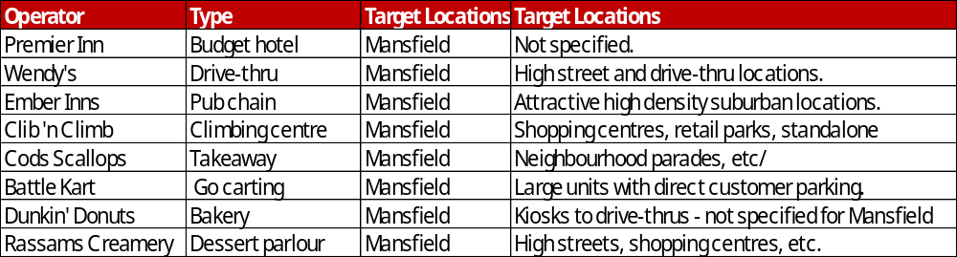
- The listed site requirements cover a broad range of leisure types and operators ranging from market demand from the hotel budget sector (Premier Inn) to drive-thru operators (Wendy’s and Dunkin’ Donuts) to a dessert parlour operator (Rassams Creamery) and active leisure operators (Battle Kart and Clip ‘n Climb).
- As with the overview of retailer requirements, not all of the site requirements are for town centre locations with a number of requirements being specific to out of centre locations that can serve particular site requirements (e.g. dedicated car parking, large site areas/ units, etc). The challenge is to encourage operators that have more flexible site requirements to take space within Mansfield Town Centre to help strengthen the town’s commercial offer. Opportunities such as those for a new hotel and the reuse of large vacant units for active leisure are uses that would help diversity the town’s offer and also support other businesses.
- Although several leisure requirements relate to edge- or out-of-centre locations, some operators may have more flexible requirements that could potentially be accommodated within Mansfield Town Centre. Opportunities such as a new hotel or the reuse of large vacant units for active leisure could help diversify the town centre offer and support linked trips to other businesses, subject to site suitability, viability and policy considerations.

SUMMARY
- Leisure expenditure forms a substantial component of household spending, with UK households spending over £259 billion in 2024 across a range of sectors including food and drink (F&B), cultural services, recreation, accommodation and personal care. Within the Study Area, F&B clearly dominates, accounting for around 68% of total leisure spend. This underlines its importance in supporting the vitality and viability of centres, particularly where there is a strong and varied hospitality offer.
- Forecasts point to modest but steady growth in leisure expenditure, averaging 0.84% per annum to 2041. While this marks an improvement on historic trends, overall growth remains limited and varies by sector. Although F&B expenditure is expected to increase significantly in absolute terms, this is unlikely to translate directly into a requirement for new town centre floorspace. This reflects high levels of expenditure leakage, the strength of out-of-centre provision, and the continued growth of online spending.
- Mansfield currently captures a relatively limited proportion of leisure expenditure, particularly within the town centre, which secures only a small share of both F&B and entertainment spend. Competing destinations, especially out-of-centre locations and online platforms, play a significant role in diverting expenditure. The town centre offer is relatively limited in range, with a concentration of lower value operators, which restricts its ability to broaden its appeal and increase dwell time.
- In other leisure sectors, including cultural, entertainment and recreational uses, forecast growth is expected to be modest, with much of the additional expenditure likely to be absorbed by existing provision. High levels of online activity, particularly in the entertainment sector, further reduce the need for new physical floorspace. As a result, major new leisure developments are unlikely, with investment more typically focused on larger regional centres or established leisure destinations.
- Overall, future growth in leisure in Mansfield is likely to be gradual and selective. Centres with a strong F&B base and complementary leisure uses are likely to perform best. In this context, planning policy should prioritise flexibility, allowing for changes in format and encouraging smaller-scale, locally driven uses, rather than relying on large-scale new development.

TOWN CENTRE POLICY RECOMMENDATIONS
- This final section provides interim advice and recommendations to help Mansfield District Council effectively plan and manage the vitality and viability of network of its centres over the lifetime of the plan through appropriate town centre policies. The policies would form part of the emerging new Local Plan.
- The advice focuses on the next five-to-ten-year period (up to 2035) in accordance with the advice set out in the National Planning Policy Framework (NPPF) and the Planning Practice Guidance (PPG). The NPPF states that planning policies and decisions should support the role that town centres play “…at the heart of local communities” and should promote the long term vitality and viability of centres, “…by allowing them to grow and diversify in a way that can respond to rapid changes in the retail and leisure industries, allows a suitable mix of uses (including housing) and reflects their distinctive characters” (paragraph 90a).
- Our policy and strategy advice is based on assessments of the quantitative and qualitative need for new retail (comparison and convenience goods) floorspace (Section 6), and commercial leisure uses over the forecast period (Section 7). These assessments have been informed by a comprehensive review and update of the dynamic economic and market trends that are impacting on the retail and leisure sectors, new evidence on retail and leisure habits of residents and visitors, and a SWOT analysis of Mansfield’s three main centres.
- It is against this background that we provide the Council with recommendations on town centre policies to help inform plan-making and decision-making over the next 5-10 years, and over the lifetime of the plan up to 2043.
- The following key policy themes are considered:
- Spatial development of retail and leisure uses
- Centre hierarchy
- Town centre first approach and the sequential test
- Retail and leisure impact thresholds
- Centre boundary definitions
- To inform our advice, LSH has considered existing policy, which was reviewed in Section 2 and whether these policies need to be amended to reflect the findings of this Study. In addition, our advice takes account of initial draft policies produced by the Council in preparation of the Regulation 19 Local Plan document.

Appropriateness of Regulation 18 Local Plan Policies for Town Centres
- Consideration is now given to the draft policies within the Regulation 18 Mansfield Local Plan and whether the findings of this 2026 Study still support policies relevant to supporting the borough’s centres and the development of town centre uses. The policies are reviewed in Section 2. The following provides recommendations on whether these policies are still appropriate in light of the new evidence.

Policy S2: The Spatial Strategy
- The findings of the quantitative retail capacity assessment do not identify any need for new retail floorspace for the district over the lifetime of the plan. This is based on need at district level and assumes that transaction-based retail market shares remain constant over the same period. While the population of the district will increase over the plan period, this does not necessarily correlate with additional expenditure to support new retail floorspace. The retail capacity model must account for growth in online market shares and inflationary pressures on retailers, which, along with subdued rates of expenditure growth, reduce the level of residual expenditure available to support new retail floorspace.
- However, the quantitative findings should not prevent the Council’s aspirations to invest in new retail provision in the district, particularly in Mansfield Town Centre and the two district centres. New investment has the potential to improve centre market share (retained expenditure), which may draw trade from out of centre facilities and competing locations beyond the district. The latter would have the added benefit of improving the district’s overall retail turnover.
- Overall, we consider that the principal aim of Policy S2 remains relevant and appropriate and that Mansfield town centre is the primary focus for new facilities, including new retail development, restaurants, leisure uses, and other uses that attract significant visitor numbers.

Policy RT1: Main town centre uses
- Sets out the hierarchy of centres for the district and guidance on how to manage proposals for new retail and leisure development in locations outside of the designated centres.
- The findings of the market share analysis for retail and leisure expenditure broadly reflects the hierarchy of centres in terms of retained expenditure, which is supported by the scale of retail and service offer identified in the health check assessments and centre audits.
- It is considered that the hierarchy of centres remains relevant and the provisions for local centre at designations at Berry Hill and Pleasley Hill are still appropriate.
- The provisions for the sequential test remain sound and should follow the centre hierarchy as set out in the policy.
- The application of an impact threshold(s) to ensure the robust assessment of impact on retail and leisure proposals that are not located within a defined centre is now commonplace for local authorities across England.
- Given the many challenges facing existing retail and leisure businesses and therefore town centre vitality and viability, we consider that the proposed 500 sqm gross local impact threshold for retail and leisure proposals that are not located within a defined centre (PSA for retail proposals) should be revised to 350 sqm gross. This floor area aligns with the Sunday hours threshold, which is based on a 280 sqm net trading area of a store.

Policy RT2: Mansfield town centre vision and strategy
- The findings of the study also validate the need for policies that support improvements to Mansfield Town Centre which in turn will help to attract investment from the commercial market. The Mansfield Town Centre Masterplan (2023) which is supported in Policy RT2 focuses on diversifying the town centre, enhancing its environment, and celebrating its character to create a more attractive and vibrant place to live, work, and visit which are reviewed in Section 2.
- The market share analysis shows that the town’s retail and leisure economy relies on the comparison retail market. However, given that the retail sector is vulnerable, particularly in terms of competition from online, there is a greater impetus to broaden the town’s commercial offer and appeal. Improving key town centre assets and promoting the delivery of the Mansfield Town Centre Masterplan can help to achieve this.
- Other policies that help to promote Mansfield include Policy RT4: Mansfield town centre improvements and Policy RT5: Accessing Mansfield town centre will have an important role in supporting the outcomes of the masterplan and improving the town’s customer experience. In turn this should help to improve footfall and encourage investment from commercial operators.

Policy RT3: Mansfield town centre primary shopping area
- The Regulation 18 Local Plan policy map is set out below, which shows the relationship between the proposed town centre boundary and the primary shopping area for Mansfield Town Centre. The designations are largely unchanged from the boundaries defined in the adopted Local Plan policy map.
Figure 8: Regulation 18 Policy Map - Town Centre Boundary and Primary Shopping Area for Mansfield Town Centre
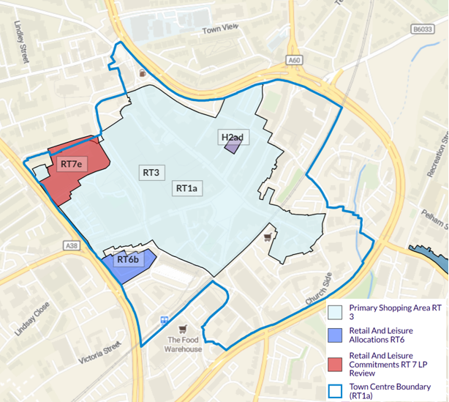
- The town centre boundary largely encompasses the commercial areas of the town centre to the west of the railway line, with the area of the town centre to the east of the railway line mainly comprising secondary and tertiary commercial areas, heritage sites, and non-commercial land uses. This is broadly reflected in the distribution of commercial uses identified in the Experian Goad survey of outlets in December 2025 (see figure below).
Figure 9: Distribution of Occupied Retail and Service Outlets and Vacant Retail Outlets in Mansfield Town Centre
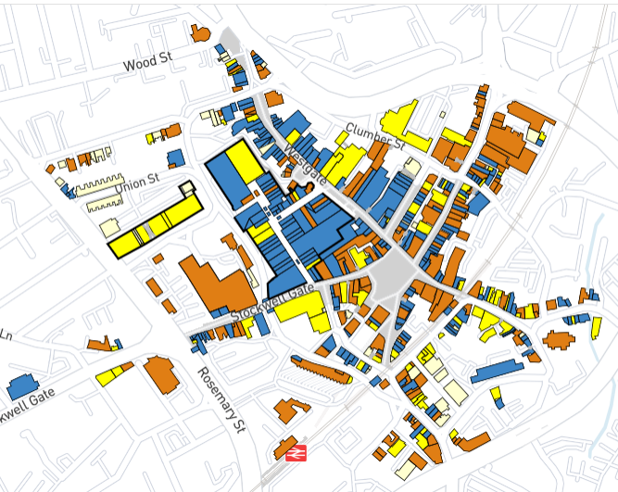
Source: Experian Goad Survey (December 2025)
- Given that the current boundary primarily comprises existing and occupied commercial uses we do not consider it is necessary to amend the defined town centre boundary. It is noted that St Peter’s Retail Park is located immediately beyond the boundary of the defined town centre boundary. While this site represents an asset for Mansfield in terms of supporting major retailers, it still represents a competing commercial asset to the town’s primary shopping area. The site should remain outside of the town centre boundary.
- Within the PSA, core commercial activity is focused around Westgate and the Four Seasons Shopping Centre. There is a question as to whether the secondary retail and service frontages on Church Street that are east of the railway line should be included in the PSA, particularly given the persistence of vacancies along the southern frontage of this street. Consideration was given to whether the area of the current and proposed PSA between Stockwell Gate and Union Street should be included given the Council’s aspirations to bring forward residential uses as part of the Mansfield Town Centre Masterplan (as shown in the figure below). However, we note that the Rosemary Centre which forms part of this area in question is under redevelopment and will include commercial ground floor uses (including a foodstore). The delivery of a new foodstore in the town centre is a key investment and will help to strengthen the retail profile of the town. Therefore, the Rosemary Centre redevelopment site should be retained within the PSA. The remaining part of the area in question includes the Walkden Street multi-storey car park which closed in 2025 due to a partial collapse of the building street and requires demolition. However, this site includes ground floor units that front onto Stockwell Gate. A retail frontage faces opposite which supports a mix of retail and service uses. This area appears to support a more secondary commercial function and is physically separated from the rest of the PSA by the nature of Quaker Way. The section of Stockwell Gate immediately east of Quaker Way is the Mansfield Connect scheme. This scheme will mainly support civic uses with no retail and commercial town centre uses at ground floor. Therefore, the retail frontage along Stockwell Gate will be further fragmented. Therefore, we consider that while the Rosemary Centre redevelopment site could be retained within the PSA, the area of the current PSA that runs south to and including Stockwell Gate and bounded to the east by Quaker Way should be excluded.
Figure 10: Mansfield Town Centre Masterplan Land Use Plan
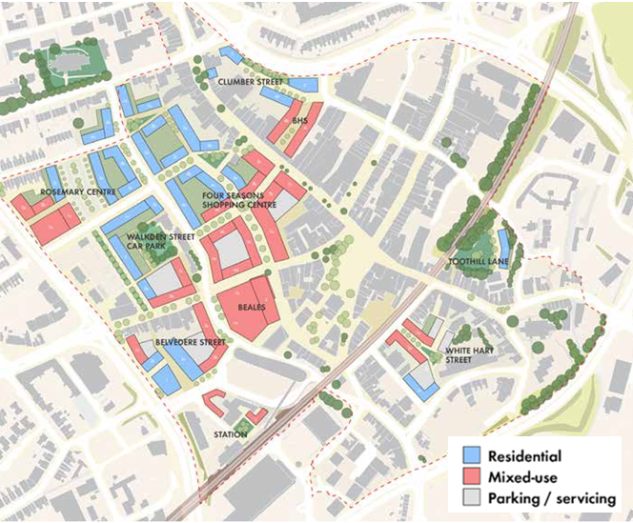
- For Mansfield’s two district centres, the Regulation 18 Local Plan Policy Map defines the district centre boundary Mansfield Woodhouse and Market Warsop, as shown in the figure overleaf.
- It is noted that a PSA is not identified for either centre. However, given the size of these centres and the broad distribution and mix of retail and service uses it is considered unnecessary to create separate areas for district centre boundary and PSA. However, the Council may wish to provide more guidance within Policy RT1 that states that the definition of what is edge and out of centre will apply against the defined district centre boundaries as these will differ where PSAs are identified. For example, what is edge and out of centre for applying the sequential test to retail proposals is based on the PSA boundaries while the town centre boundary applies to other main town centre uses (Annex 2: Glossary, NPPF).
Figure 11: Regulation 18 Policy Map - Town Centre Boundary for Mansfield Woodhouse District Centre
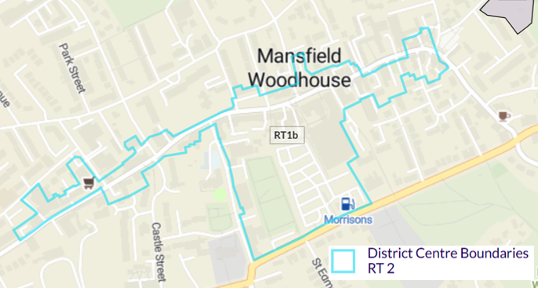
Figure 12: Regulation 18 Policy Map - Town Centre Boundary for Market Warsop District Centre
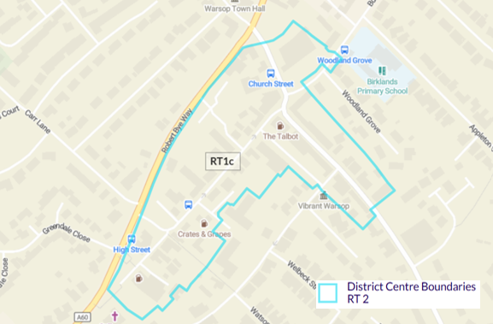

Policy RT6: Retail and leisure allocations
- The policy comprises the Belvedere Street site allocation and promotes the development of the site for main town centre and complementary uses, along with related servicing and car parking facilities. The site is well located in relation to other town centre investment projects, including the redevelopment of the former Beale’s Department Store and the Rosemary Centre development, and continues to represent a major regeneration opportunity to strengthen the town’s commercial offer. While the study identifies no forecast quantitative need for new retail floorspace over the study period, this should not preclude the site from continuing to be allocated for appropriate town centre uses, where this would support the objectives of the Mansfield Town Centre Masterplan and improve the town’s overall vitality, viability and expenditure retention. However, it is unclear from the available evidence what the previous basis was for identifying up to 11,500 sqm of floorspace in the adopted policy. We therefore recommend that the allocation is retained, but that the floorspace figure is reviewed and, if necessary, expressed more flexibly to reflect the range, scale and mix of town centre uses that could realistically come forward on the site over the plan period.

Policy RT7: Retail and leisure commitments
- The policy sets out extant retail and leisure commitments in the district, which includes the consents for local centre provision within the Berry Hill and Pleasley Hill SUEs. The supporting text to this policy includes Tables 7.8 and 7.9, which are intended to present the retail capacity findings of this study.

District Centres, Local Centres and Neighbourhood Parades
- Guidance on how commercial and community uses should be supported are set out in Policy RT8: District and local centres and Policy RT9: Neighbourhood parades.
- For the district centres, the policy supports their sustainable growth and while the capacity assessment identifies no need for new retail floorspace in the district, this should not prevent opportunities coming forward to support new retail and leisure uses in the defined centres. The same applies to local centres and neighbourhood parades where the proposals for retail and leisure uses are of an appropriate scale to the size and function of the centre.
- For Market Warsop in particular, as the district’s second largest centre, current town centre convenience provision is limited to a small Co-op store on High Street. A second larger Co-op store (Central Co-op) is located edge of centre; immediately south of the defined centre boundary, with a third located out of centre to the north of the centre. Central Co-op measures approximately 400 sqm gross and while the store is expected to support some main food shopping given the absence of any larger foodstores in the area, it’s principal function will be to serve top-up shopping needs. The emerging Local Plan includes a number of housing allocation sites in the Market Warsop area that will support demand for convenience retail on top of existing expenditure that is likely to be spent at larger stores in other locations in the district. Therefore, there is a potential case to support a foodstore to serve current and future residents of the Market Warsop catchment area and surrounding rural communities. This would improve access to main food shopping and reduce the need for catchment residents to travel the distance to foodstores in Mansfield’s urban area.
- However, careful consideration is needed on the scale and location of any potential new foodstore in Market Warsop. While the provision of a new foodstore could reduce the need to travel away from the settlement, a new foodstore should be limited to serving the local catchment rather than becoming a destination for a much wider catchment. A new foodstore should be prioritised within the centre to ensure that linked trips are supported and to negate the likely trade diversion from existing convenience stores and other businesses. Where proposals are located outside of the defined town centre, they should be subject to the sequential and impact tests. It will be essential that any foodstore proposals that are not located in the centre can demonstrate that they will not have a significant adverse impact on the vitality and viability of Market Warsop. Impact assessments should be based on up-to-date evidence

Site Allocations
- Proposed site allocations related to retail and leisure uses are considered against the retail capacity and leisure needs assessment findings.
Allocation Policy | Guidance on town centre uses
Policy SUE1: Pleasley Hill Farm | Identifies new local centre with retail, leisure and community uses that are appropriate to a local centre as well as a hotel.  Comment: no change.
Policy SUE2: Land off Jubilee Way | Allocated to deliver approximately 800 new homes. Other key facilities include a new neighbourhood parade.  Comment: While no change recommended, the ability to deliver commercial uses within a new neighbourhood parade are likely to be limited from a resident capacity and market demand perspective.
Policy SUE3: Land at Berry Hill | Allocated for 1,700 new homes and a new local centre with retail and leisure and appropriate community uses.  Comment: no change. The scale of new housing will support localised need for new convenience retail and associated commercial uses.

---End---

