WELCOME TO OUR ANNUAL COMPLAINTS AND SERVICE IMPROVEMENT REPORT
Here at Mansfield District Council, we take feedback we get from our tenants very seriously so we can understand how to improve our services and drive change.
We believe in being transparent and being held to account by our tenants, which is why we embrace initiatives like the annual complaint’s performance and service improvement report.
Councillor Craig Whitby – Poertfolio Holder for Corporate and Finance (MRC)
ENGAGEMENT WITH CUSTOMERS
Engagement with our involved tenants is important to us. Our Tenant Scrutiny Panel receives regular complaints reports and has recently undertaken a review of the way in which we handle and learn from our complaints.
On concluding the review, the panel made several recommendations for improvement, which included:
- The production of an easy to read version of our complaints policy and procedure.
- Carry out survey’s of tenants that have made a complaint to find out about their experience during the complaint handling process
All recommendations made by the Tenant Scrutiny Panel were accepted by the Housing Executive Group and have now been fully implemented.

WHAT IS THE ANNUAL COMPLAINTS AND SERVICE IMPROVEMENT REPORT?
The Annual Complaints and Service Improvement Report
is an annual regulatory report that requires social housing landlords to report the number of complaints
they’ve received that year, the lessons they’ve learned,
and the results of their self-assessment against the
Housing Ombudsman’s Complaints Handling Code.

The results will then feed into the Housing Ombudsman’s
Annual Complaints Review, providing a comprehensive
overview of the sector’s performance, and promote key
learnings with the broader sector.

Reports on our complaint handling performance is also presented to our Corporate Leadership Team (CLT) and the Housing Executive Group on a quarterly basis allowing them to thoroughly review our performance and ensure corrective action is being undertaken to improve any areas of poor performance.

The annual complaints’ performance and service improvement report is also presented to Cabinet to provide them with the assurance that we are complying with the Housing Ombudsman’s Complaint Handling Code and using the feedback to identify any lessons learnt as part of the process.

ANNUAL SELF ASSESSMENT – HOUSING OMBUDSMAN COMPLAINT HANDLING CODE
The Housing Ombudsman carried out a review of our Policy in June 2025 as part of their duty to monitor compliance with the Complaint Handling Code. As a result of that review they put forward a series of recommendations which we responded to by amending our policy to reflect the recommendations including:
- Defined a complaint in line with the Housing Ombudsman’s definition
- Dealing with all complaints within a clear two stage process
- Giving residents the choice to make a compliant
- Further details provided in our acknowledgement of stage1 and stage 2 complaints
- Agreeing suitable intervals for regular updates on progress on extended timescales
- Clear timescales for acknowledging complaints that are escalated to stage 2

TENANT SURVEY RESULTS
Our tenants’ opinion of our complaints handling service is of the utmost importance to us. As a result, we ask our tenants to complete a survey after a complaint is logged and closed to help us gain a better understanding how the complaint was managed, our strengths and areas of improvement.

Overall:
- 19% were satisfied with the the way in which their complaint was dealt with
- 31% stated that it was easy to make a complaint
- 43% were satisfied with the time it took to deal with the complaint
- 48% felt that they were kept informed of progress with their complaint
- 42% stated that their complaint was fully addressed
In addition to this routine survey, we also worked with Housemark, the leading data and insight company for the UK housing sector, to collect data for the Tenant Satisfaction Measures (TSM’s) which provides a comprehensive set of performance measures including satisfaction with our complaint handling.
From this feedback, we have established that our Customers Satisfaction rate with our approach to complaints handling for the period 2024/25 is 33.3% (up from 24.6% in 2023/24. We acknowledge that this statistic is lower than we hoped and are making conscious efforts to improve on this score.

PERFORMANCE 2024/25
Number of Stage 1 complaints received – 260 compared to 174 in 2023/24
Number of stage 2 Complaints received – 20 compared to 32 in 2023/24
Proportion of stage one complaints responded to within the Housing Ombudsman’s Complaint Handling Code timescale – 70.77% compared to 50.65% in 2023/24
Proportion of stage two complaints responded to within the Housing Ombudsman’s Complaint Handling Code timescale – 85% compared to 80.77% in 2023/24
Stage one complaints relative to the size of the landlord – 41.25 which increased from 36.51 in the previous year (2023/24). The median benchmark figure for our peer group is 39.7
Stage two complaints relative to the size of the landlord – 3.17 which is a decrease from 4.11 in the previous year (2023/24). The median benchmark figure for our peer group is 5.3
41 cases were not included as 36 were initial requests for service / not previously reported and 5 were duplicate cases.
Whilst response rates to stage 1 complaints have improved significantly in the last two quarters of 2024/25, we have identified additional resources within the repairs service to help deal with complaints handling to improve response rates further

HOUSING OMBUDSMAN DETERMINATIONS
If a tenant is unhappy with the way we have dealt with their complaint, they can refer their complaint to the Housing Ombudsman. Each year the Housing Ombudsman produces a performance report about us as a landlord.
During 2023/24 the Housing Ombudsman made 4 determinations. It is important to note that each defined complaint must have its own determination. It therefore follows that in a case involving two (or more) defined complaints, there will be 2 (or more) different findings.
Of the four determinations the HO made 11 findings,
- 6 were classed as maladministration – a failure which has adversely affected the resident.
- 3 were classed as service failure - a minor failing where action is still needed to put things right
- 2 were found to have no maladministration
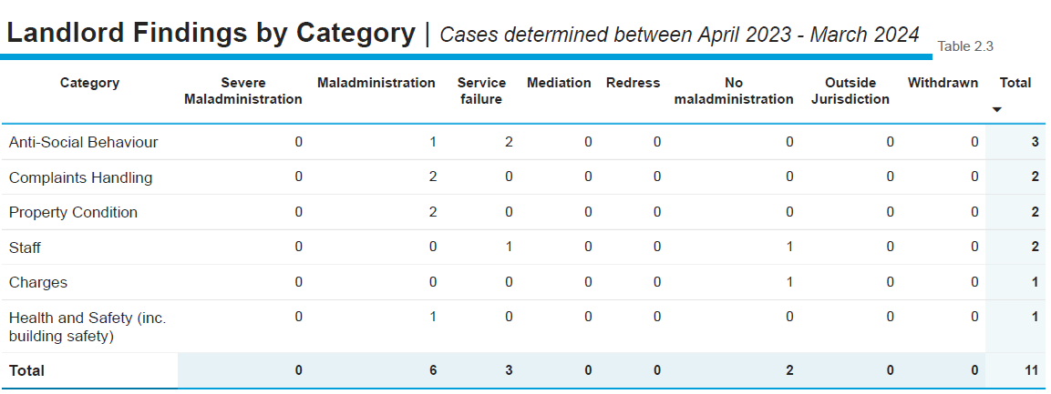

The following table provides a summary of our performance
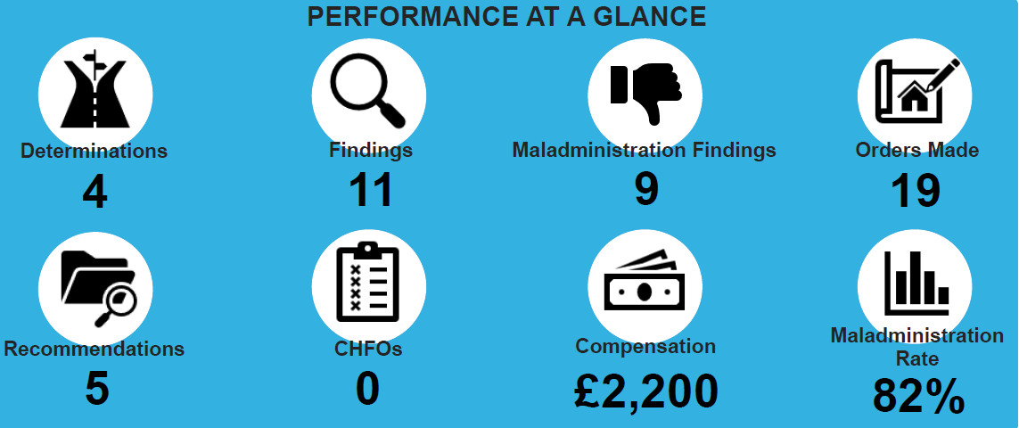
The HO made 19 orders which MDC had to carryout including:
- 9 orders to pay compensation
- 3 orders to carry out repairs
- 3 orders to provide an apology
- 4 orders to undertake staff training
All orders were complied with within 3 months of being made
LEARNING FROM COMPLAINTS
As a result of the orders, we have made the following improvements:
- We launched a revised ASB policy in 2024 and a revised ASB procedure in February 2025, which included undertaking risk assessments and written action plans and regular case audits and further staff training.
- Provided further staff training on our complaints policy and procedure.
- Set up a Complex Cases team that takes a whole house approach when dealing with complex repairs complaints to ensure no other issues are missed
- Regular quality assurance checks undertaken on complaint responses to ensure they meet the requirements of the Housing Ombudsman Compliant Handling Code and that they address all issues raised within the initial complaint.
- Introduced a Discretionary Compensation Policy where officers are able to offer compensation in line with the Housing Ombudsman compensation scheme
As a result of the changes we have seen a reduction in the number of stage 1 complaints being escalated to Stage 2 in 2024/25 compared to 2023/24
KEY AREAS FOR IMPROVEMENT
Thematic analysis has been undertaken on all complaints received during 2024/25 identifying the following areas that we need to focus on going forward:
Repairs Service – areas for concern

- Delayed or incomplete repairs resulting in tenant concerns over safety and security
- Poor communication and lack of updates leading to tenant frustration
- Contractor work quality and lack of oversight resulting in poor customer satisfaction
- Staff conduct leaving tenants feeling disrespected and unheard
As a result of this analysis we are:

- undertaking a root and branch review of our responsive repairs service to improve systems, processes, tenant communication, repair timescales and staff attitudes
Lettings and Tenancy Services- areas for concern
- Noise Nuisance – lack of resolution leading to tenant frustration
- ASB case management & procedural issues – lack of transparency and communication leading to tenant dissatisfaction
- Property condition / environmental concerns – lack of timely response to issues leading to tenant frustration with living conditions
As a result of the analysis we are:
- Implementing a stricter noise complaint resolution process.
- Educating tenants on noise reduction policies.
- Developing a more transparent ASB complaints process with clear updates
- Training staff on complaint handling to improve responsiveness.
- Ensuring proper ASB documentation / case management to prevent unresolved cases.
- Strengthening enforcement of maintenance policies.
- Increasing estate inspections and taking follow up actions

