Project Highlight Report

Project Title: | Destination Mansfield
Reporting To: | Place Board
Reporting Period: | January 2025

Project RAG Status: |  | Red |  |  | Amber |  |  | Green | x

Headlines
February Status Report on Destination Mansfield Brand

Launch Timeline Update
We have decided to postpone the launch of Destination Mansfield by six weeks. The original launch date of February 15, 2025, has been rescheduled to April 3, 2025. We are now scheduled to launch at this year’s Gaia event. This adjustment ensures that all critical brand assets are finalized and ready to support the launch.

Light Night Preview
Although we have pushed back the launch by six weeks, we will preview the brand at our Light Night event from February 15-17, 2025. Attendees will see the brand displayed on large screens throughout the event. Our strategy is to generate anticipation and excitement leading up to the official launch at Gaia on April 3, 2025.

Key Assets in Development
The successful launch of Destination Mansfield depends on having essential assets, such as the website and brand storybook, ready. These materials are critical in directing interested audiences to official resources for deeper engagement with the brand. While they will not be completed by the original February launch date, production remains on track for April completion.

Focus Areas During the Extended Timeline
The additional time allows us to refine and solidify the strategic framework for the brand, including:
- Implementing brand positioning and strategy
- Refining the campaign messaging framework
- Finalizing production outputs, including print materials, digital assets, and multimedia content

Collaboration with Linney
We are working closely with Linney to ensure all deliverables are completed ahead of the new April launch date. Linney and Ciara have demonstrated strong support for the brand’s development, recalibrating strategies to integrate new elements effectively. They’re willing to provide us with all the deliverables we’ve asked for. We are awaiting final confirmation on our requests for a storybook, copywriter, and expanded strategic outputs.

Web Development
We are targeting a website launch date of April 1, 2025. In parallel with the brand strategy work, we have begun developing the website. Currently, we have a foundational build for the Homepage, Our Story, and Enjoy pages.

While full website completion may extend beyond April 1, we are prioritizing the essential pages needed for launch and will integrate additional sections in future phases if needed.
Our next web development meeting is scheduled for February 3, 2025, where we will review new builds for the Live, Investment, and Become an Ambassador pages.

Brand Guidelines
Our brand guidelines are already well-developed, with the latest version receiving strong positive feedback. However, we are now working on a more strategically robust iteration. The next version is expected to be delivered in the coming weeks once the current revisions have been implemented. Given the evolving nature of our strategic and copywriting efforts, we believe an iterative approach is the best way to ensure the guidelines remain dynamic and aligned with our broader objectives.
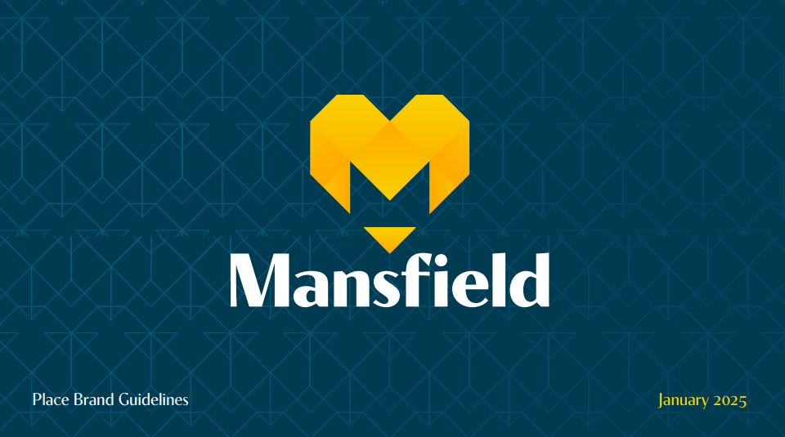

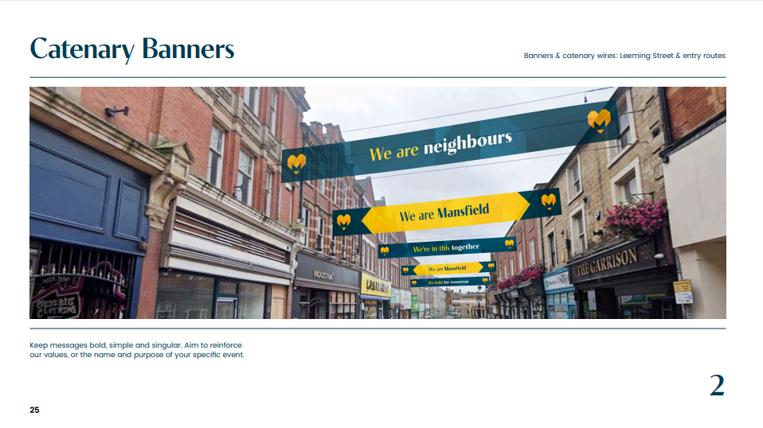
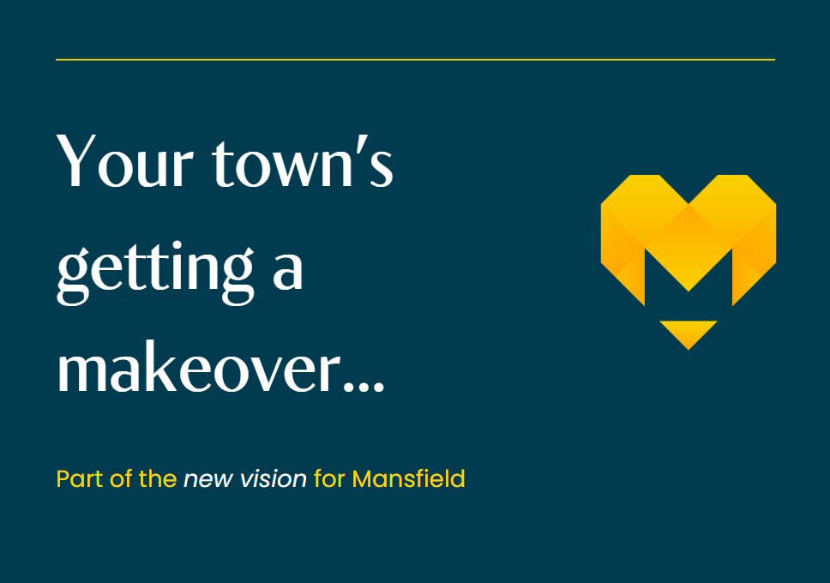

Further brand development

A branding strategy session is planned for 3 February to determine
- Brand Story
- Mission Statement
- Vision Statement
- Slogan
- Tone of Voice
- Positioning strategy
Student collaboration
We have had positive discussions with West Nottinghamshire College about launching a collaborative program that will enable students to co-develop place brand strategy campaigns.
We have engaged with key figures within the college and have requested a proposal outlining how we can co-produce high-quality, sustainable campaigns. We are now moving into the next phase of program implementation, with campaign work expected to begin in April.
The college has extensive experience with tested methodologies and is confident in its ability to help us deliver impactful work. We anticipate receiving their proposal by Friday, March 7, 2025.

Tasks, Milestones, Outcomes of the project | Completion dates and notes
Procurement of supplier
Project commences | February 2023
Stakeholder engagement on Place Strategy | May 2023
Completion of Place Strategy | September 2023
Event Programme commences | September 2024
Brand consultants appointed | March 2024
Stakeholder engagement on Branding Strategy | July 2024
Completion of Branding Concepts | September 2024
Brand approved | September 2024
Brand adoption and campaign content development activity commences | October 2024
Web development | October 2024 to January 2025  January 2025 to March 2025
Marketing officer commences | 27 November
Brand roll out commences  Brand preview | January 2025  February 2025
Event – Light Night | 15 – 18 February 2025
Ambassadors campaign and resident campaign | From February 2025  March 2025
Event – Giai | April 2025
Investment campaign | From April 2025
Student welcome and young person campaign | August 2025
Welcome to Mansfield Signage | March 2025
Event Party on the Market | June 2025
Event Mansfield Carnival | June 2025
Event Mansfield 10k | September 2025
Event Fire Garden | October 2025

Risks and Issues
Despite some minor setbacks, we are making significant progress. With multiple ongoing initiatives, we are confident that the brand is being developed in the most effective way possible. Our task is to continue building and iterating to ensure a successful launch.

Recommendations and Requests for Decisions or Support
- Board members to nominate a person to be their Destination Mansfield Ambassadors
- Board members to consider how they can adopt the branding and signpost to the Destination Mansfield website

