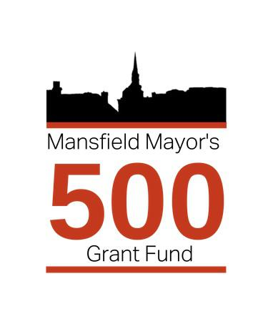
Mayor’s 500 Fund Application Form 2025

Name and address of applicant

Purpose of Application

Amount of requested

If the proposal is to receive any other funding or joint funding with other organisations please give full details below, include funding bodies/members name, amount and whether the funding has been confirmed or not.

Any additional information in support of the application

Proposed total project cost: £
Please provide the following information to enable payment to be made if approved:
Exact Amount: £
Full name of Payee:
Telephone number of Payee
Full address of Payee:

Bank name
Bank Account: Sort Code: Account No:
Please return form to:
Democratic Services, Civic Centre, Chesterfield Road South, Mansfield, Notts, NG19 7BH
01623 463048
e-mail: mayor@mansfield.gov.uk

