TENANT ENGAGEMENT FRAMEWORK
2024 / 25

CONTENTS
- Introduction
- Purpose and scope of the framework
- Regulation
- Charter for Social Housing Tenants
- National tenant Engagement Standards
- Vision and ambitions for tenant engagement
- Tenant engagement principles
- Ways to get involved
- Governance and accountability
- Review

- INTRODUCTION
This framework seeks to strengthen our approach to tenant engagement. It focuses on our priorities for the future and sets out how we will become a truly customer focused organisation. One that actively listens to its tenants, learns from the feedback we receive and involves them in designing, testing and scrutinising the services we provide.

Only by doing this, will we be able to continually improve, offer value for money and transform the services we provide to ensure they meet the changing needs and aspirations of our tenants.

Whilst reference is made throughout this framework to tenant engagement, it also relevant to Mansfield District Council’s (MDC) leaseholders.

- PURPOSE AND SCOPE OF THE FRAMEWORK

The Tenant Engagement Framework:
Sets out the council’s overall approach to tenant engagement, ensuring we meet our regulatory requirements and the National Tenant Engagement Standards
Defines our vision and ambitions for tenant engagement
Sets out the framework for delivering tenant engagement activities and the resources that supports those activities
Sets out how we will measure the success of those activities in achieving our vision and ambition

- REGULATION
MDC’s Landlord Services are regulated by the Regulator for Social Housing (RSH) using the regulatory framework below

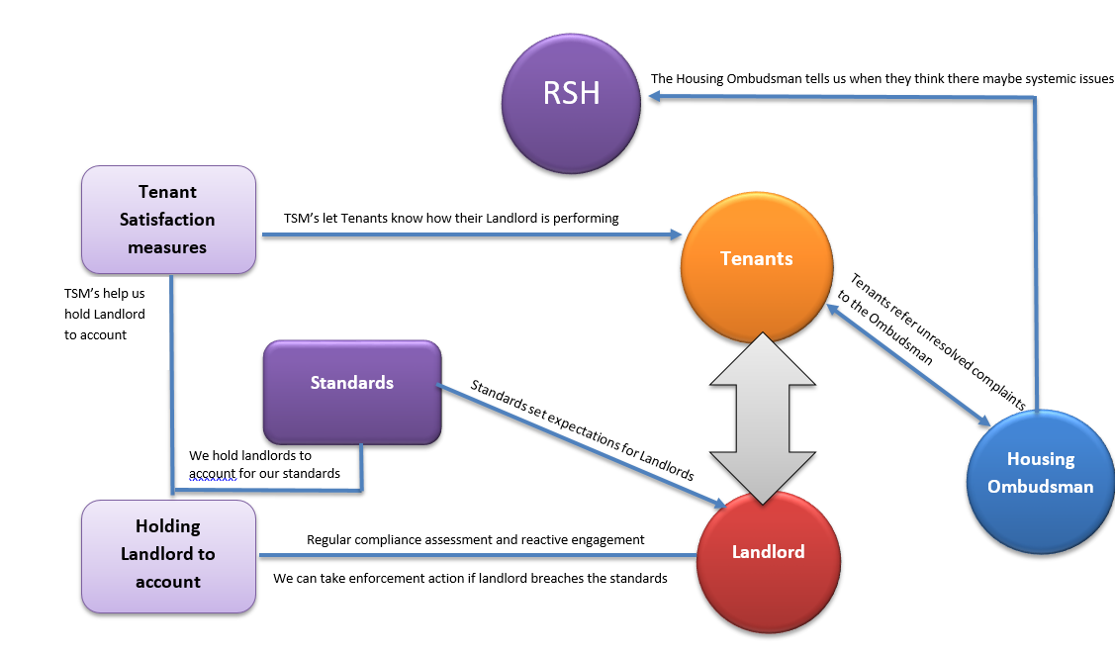
The regulatory framework for Local Authorities is based on compliance with the four consumer standards including:

The Safety and Quality Standard – requires landlords to provide safe and good quality homes and landlord services to tenants.

The Transparency, Influence and Accountability Standard – requires landlords to be open with tenants and treat them with fairness and respect so that tenants can access services, raise complaints when necessary, influence decision making and hold their landlord to account.

The Neighbourhood and Community Standard – requires landlords to engage with other relevant parties so that tenants can live in safe and well-maintained neighbourhoods and feel safe in their homes.

The Tenancy Standard – sets requirements for the fair allocation and letting of homes and for how those tenancies are managed and ended by landlords

Co-Regulation
The consumer standards are at the heart of what the SHR calls co-regulation - meaning councillors are responsible for ensuring our landlord services are managed effectively and comply with all regulatory requirements, in partnership with tenants. The Council must also support tenants to shape and scrutinise service delivery and to be held accountable where standards are not being met.

RSH Co-regulatory approach
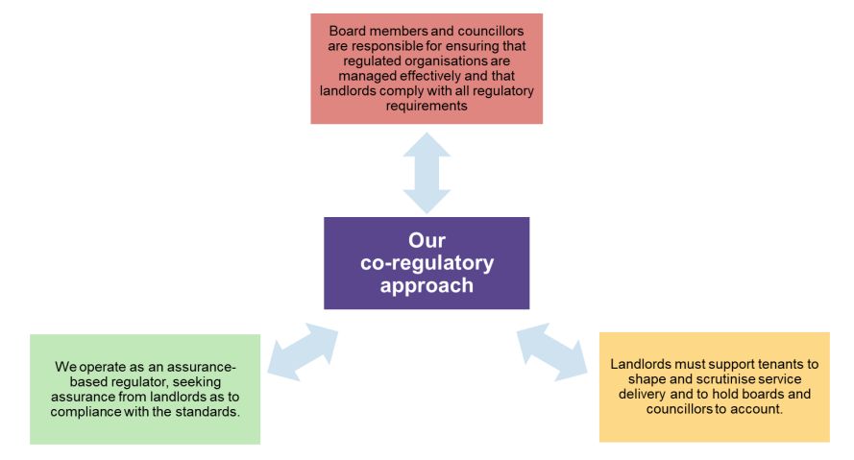

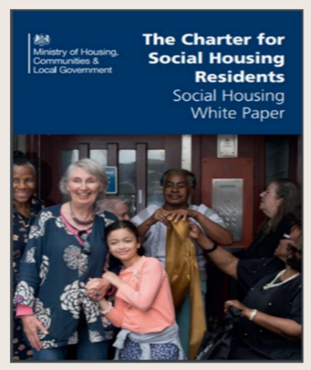
- The Charter for Social Housing Tenants

The 2020 Social Housing White Paper ‘The Charter for Social Housing Tenants’ was produced building on the lessons learnt from the Grenfell Tower fire. The importance of having the resident voice at the heart of service design and effective resident involvement is a theme that runs throughout. This includes:

• ‘Engaged tenants’ should be a key part of any landlord’s governance and scrutiny arrangements

• Tenants who do not want to attend formal meetings or join a formal group need to have ways to feedback to their landlord to ensure their voices are heard and their needs are identified

• Engagement opportunities are tailored to tenants’ needs and interests encouraging and supporting greater involvement

• The Charter also enforces that information should be published and available to tenants on how their landlord is performing in key areas of service delivery.

• It also reshapes the role of the regulator placing a stronger role in regulation particularly in relation to the consumer standards, this includes a new periodic inspection programme for registered providers

- National Tenant Engagement Standard
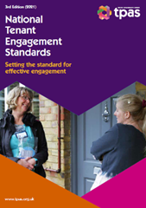
To ensure the effectiveness of our approach to tenant engagement we will work towards the National Tenant Engagement Standards that go beyond the regulatory requirements and set out clear actions that MDC needs to take to continuously improve the way tenants are involved in shaping and improving services.
The standards cover seven key activities which are considered essential to demonstrating a positive approach to co-regulation and good practice.

The key activities covered by the standards include:
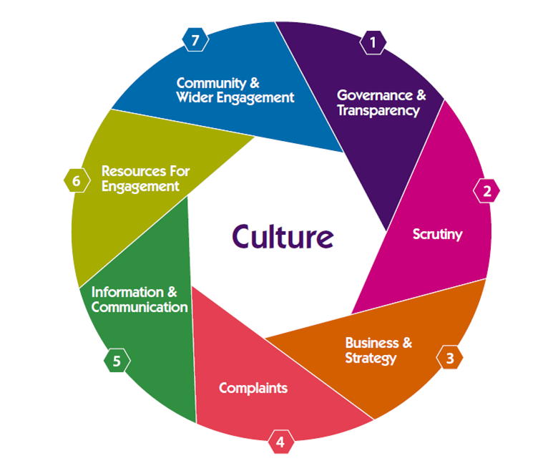

- VISION AND AMBITIONS FOR TENANT ENAGEMENT

Vision
Every tenant has a voice, feels listened to and is able to directly influence the way services are designed and delivered

Ambitions and priorities
Ambition 1 - To strengthen tenant engagement and empowerment.
- We will improve the culture and practice of involving our tenants across the housing service
- We will embed a co-production approach into improving our services to meaningfully involve and empower tenants and our communities.
- We will identify the barriers that prevent tenants from taking part in engagement activity and create new opportunities that encourage and empower more tenants to get involved
- We will achieve more diversity in tenant engagement to better reflect our community.
- We will promote the benefits of tenant involvement and demonstrate where tenants have made a difference.

Ambition 2 - To improve communication, interaction and opportunities to
provide feedback
- We will find out what matters the most to tenants and the best ways to communicate on these things.
- We will review the ways we communicate and use more channels with a greater reach to share information with tenants.
- We will strengthen digital solutions to improve access to information and to increase engagement using technology.

Ambition 3 - To enable effective scrutiny
- We will report against new national tenant satisfaction measures to make our performance as a landlord more visible to our tenants.
- We will review the accessibility and availability of information for tenants to scrutinise our performance and hold us to account.
- We will develop and support a tenant-led scrutiny process to challenge our housing service and recommend improvements.
- We will offer support and training to tenants who want to engage with us, helping them to build their knowledge and skills

- TENANT ENGAGEMENT PRINCIPLES
When designing and delivering tenant engagement activities we will adhere to the following principles:

Trust respect and honesty – treating our tenants with respect, being open and honest and transparent in our decision making

Inclusive – ensuring every tenant has a voice and feels listened too

Asset based – recognising and valuing our tenant’s strengths, skills and lived experience

Accountable – invite scrutiny and challenge from tenants on the decisions we make about their homes and services

Supportive – ensuring tenants have the resources, skills and support they need to become involved

Co- production – ensuring services are designed collaboratively with tenants to ensure their needs are met

Valuing Involvement – celebrating achievements and inspire tenants to make a difference

Finding our silence -. We will actively seek out those unheard voices to understand their needs and perspectives.

- WAYS TO GET INVOLVED
Not everyone wants to, can, or has the need to get involved in the same way. We have therefore designed our engagement framework to provide a flexible range of options for tenants to get involved at all levels based on their interests, preferred engagement activity and communication channel. It seeks to ensure that all tenant engagement activity is designed to ensure the tenant voice is integrated in service planning, monitoring and improvement.

All our engagement activities will be underpinned by an understanding of our tenant profile so that we can ensure that the different segments of our tenant base views are represented

The framework is based on the following engagement levels:

ENGAGE – Your Voice

Information
Information supports all kinds of engagement and we will ensure our tenants receive clear, accessible and timely information on the issues that matter to them.

As a minimum, MDC will ensure it meets the RSH required outcome and specific expectations set out in the Regulators Consumer Standards – Information about landlord services

The required outcome states that:

“Registered providers must communicate with tenants and provide information so tenants can use landlord services, understand what to expect from their landlord and hold their landlord to account”.

Information will be made readily available via:

- MDC’s dedicated Housing webpages
- Regular electronic bulletins / updates
(Channel and frequency of all communications to be determined following wider consultation)

Consultation and feedback
MDC is committed to listening to what our tenants have to say and
using the feedback we receive to design and improve the services we provide.

We will take a pro-active approach to gathering feedback through a variety of channels including:

- A programme of transactional surveys
- Online polls
- Annual tenant perception survey
- User research
- Attending community hubs – drop in events at community spaces throughout the district
- Community conversations – where tenants are invited on a quarterly basis to work with us on a pre-set question or theme

Tenants also have the opportunity to provide feedback via:

- Corporate Complaints procedure
- Dedicated email address / website form – feedback@mansfield.gov.uk
- Voice of the Customer through Employees - VOiCE – direct feedback made to council officers

All feedback received will be recorded, analysed to identify any trends and used as insight to improve the way in which we design and deliver our services

We will clearly communicate how tenant feedback is being used in decision-making and provide updates on the implementation of suggested changes via our ‘You said, We did’ webpage
INVOLVE – Your Choice

Tenants can also choose to work directly with the housing service to co-produce and co design services to ensure they meet their needs and expectations through participating in specific:
- Workshops
- Focus groups / Pop up groups
- Improvement groups – i.e. virtual policy review group,

They can also apply to sit on:

- The Tenant Scrutiny Panel - an independent team of tenants who work closely with Mansfield District Council to review the housing service and its policies and performance. It plays a key part in ensuring all tenants receive an excellent, value for money service

Tenants can also get involved in improving their neighbourhoods by:

- Taking part in regular estate walkabouts with council officers / elected members
- Becoming a community champion, acting as an advocate for community-based issues
- Become a Block Buddy, monitoring communal services and reporting block issues
- Setting up independent organisations to represent tenant / leaseholder interests in the communities where they live or special interest groups

INVEST – Supporting you

We will work closely with tenants that choose to become directly involved by offering a range of support to help them carry out their work including, but not exclusively limited to:

- Funding
- Training
- Networking opportunities
- Supporting tenants with additional support / diverse needs (see our reasonable Adjustment Policy for further details)
- Support for tenants wanting to exercise their right to manage

Tenant Right to Manage
Since 1994, tenants of local authority housing have had the legal right to manage their housing services. By creating a Tenant Management Organisation (TMO) and following specific regulations, these tenants can take over tasks like repairs, caretaking, and rent collection from their landlord.

TMOs are well-established models that give the community more control and can lead to better service quality, more cost-effective management, and higher tenant satisfaction. The members of these organisations are unpaid volunteers dedicated to improving the quality of life in their communities by taking on these responsibilities.

The Right to Manage regulations outline a clear process for tenants who want to form a TMO and take over local services. They also ensure that service delivery and financial management are safeguarded for the tenants, the local authority, local taxpayers, and the Government.

MDC will provide support and guidance to any tenants wanting to exercise their right to manage via the setting up of a Tenant Management Organisation (TMO) For more information on setting up a TMO see MDC’s website – Right to Manage
- GOVERNANCE AND ACCOUNTABILITY

Whilst tenant engagement activity is the responsibility of all staff employed to deliver the housing service, the development and delivery of this framework will form an integral part of the co-regulatory structure of MDC as follows:

- HOW WE WILL MEASURE SUCCESS
MDC will use the following measures to ensure the delivery of the tenant engagement framework and associated activities are effective including:

- Profile of engaged tenants
- Tenant Satisfaction Measures (TSM’s)
- Case Studies
- Landlord inspection by the Regulator
- Benchmarking

- REVIEW
Due to the limited initial input by tenants this framework and supporting action plan will be reviewed on an annual basis following further consultation and direct input from tenants.

Tenant Engagement Improvement Plan
Ambition 1: To strengthen tenant engagement and empowerment.
Activity | Lead | Timescale
Formally adopt the Tenant Engagement Framework | Assistant Director of Housing | 30/09/2024
Undertake training with all relevant stakeholders on the delivery of the Tenant Engagement Framework | Performance and Insight Manager | 31/10/2024
Develop and adopt a Co-production Framework and Toolkit | Performance and Insight Manager | 30/11/2024
Provide training on undertaking co-production activities | Tenant Engagement Officer / Performance and Insight Manager | 28/02/2025
Survey tenants to identify any barriers to getting involved and develop action plan to address those barriers | Tenant Engagement Officer | 30/07/2025
Undertake a survey of all tenants to gauge their satisfaction with the current opportunities for involvement and gather feedback on other opportunities for involvement | Tenant Engagement Officer | 30/07/2025
Use tenant profiling information to create customer segments and target under represented groups | Tenant Engagement Officer / Performance and Insight Manager | 30/07/2025
Undertake a mapping exercise to create a directory of all special interest groups especially those representing the protected characteristics | Tenant Engagement Officer | 31/10/2024
Promote the benefits and outcomes of tenant engagement activities through all communication channels | Tenant Engagement Officer | Ongoing
Establish a tenant engagement budget to support all tenant engagement activities | Performance and Insight Manager | 31/10/2024
Undertake a self assessment against TPAS Tenant Engagement Standards | Performance and Insight Manager | 31/10/2025

Ambition 2: To improve communication, interaction and opportunities to provide feedback
Activity | Lead | Timescale
Review Tenant Engagement Web pages | Tenant Engagement Officer / Performance and Insight Manager | 31/10/2024
Survey tenants on their preferred methods of communication and use the feedback to plan and target communications | Tenant Engagement Officer | 30/07/2025
Investigate the potential for expanding communication channels i.e. podcasts / you-tube | Tenant Engagement Officer | 31/03/2025
Develop and deliver a programme of transactional surveys | Tenant Engagement Officer | 31/03/2025
Support the service review roadmap with user research to gather feedback on the customer journey to inform future improvements / transformation | Tenant Engagement Officer | Ongoing
Introduce ways in which we can gather and record the voice of the customer | Tenant Engagement Officer | 31/10/2024
Undertake an annual tenant perception survey to identify the key drivers for improving tenant satisfaction | Tenant Engagement Officer / Performance and Insight Manager | 31/12/2024 - annually
Co produce an action plan with staff and tenants following the finalisation of the tenant perception survey | Performance and Insight Manager / Service Insights | 31/03/2025
Develop a programme of Community conversations across the district with agreed schedule of themes / pre set questions | Tenant Engagement Officer / Service Managers | 30/11/2024 - ongoing
Develop and publish an annual Communication Plan in consultation with Service Managers | Tenant Engagement officer / Service Managers | 31/10/2024 – then annually

Ambition 3: To enable effective scrutiny
Activity | Lead | Timescale
Publish the results annually of the TSM measures on the website and in other communication channels | Performance and Insight manager | 31/01/2025 - annually
Further refine and broaden KPI’s to strengthen the evidence of how the consumer standards are being met and to demonstrate the impact | Performance and Insight Manager | 31/09/2024
Review Housing performance web page and publish the wider suite of KPI’s including trends and benchmarking where available | Performance and Insight manager | 31/10/2024
Undertake a recruitment campaign to increase the number of active tenants involved on the tenant Scrutiny panel | Tenant Engagement Officer | 31/12/2024 - ongoing
Publicise the role of the Tenant Scrutiny Panel and communicate the outcomes of the work undertaken by the panel to the wider tenant population | Tenant Engagement Officer | Ongoing
Develop a training programme for Tenant Scrutiny Panel members | Tenant Engagement Officer | 31/12/2024
Gather feedback from active Tenant Scrutiny Panel members to evaluate the levels of support and training and knowledge and skills development | Tenant Engagement officer | 28/02/2025

