ML30 Oxclose Wooded Hill
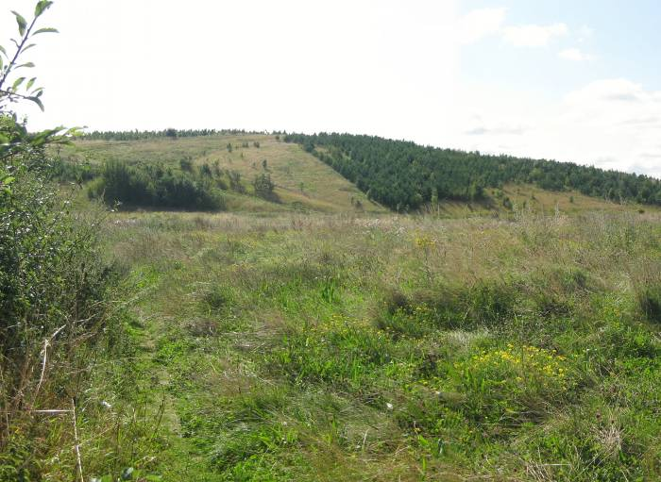  ML30A | CONTEXT  Regional Character Area: Limestone Farmlands  LDU Reference: 244  Landscape Policy Zone (LPZ) Reference: ML30  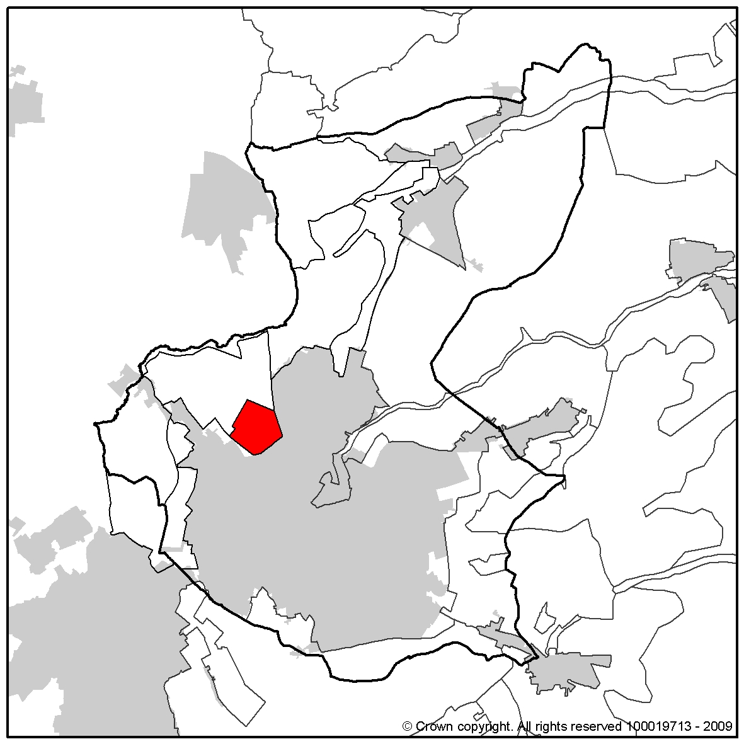
CHARACTERISTIC FEATURES
Landform and Hydrology
- A prominent man-made landform from coal mining at the former Sherwood Colliery
- A restored landscape comprising raised woodland covered mound with engineered even sides, used for informal recreation
- There are two large ponds in a bowl at the foot of the hill on the north side with associated wetland grassland and reeds around their margins
Landuse
- Land cover is a mixture of woodland, neutral grassland, wetland and water bodies creating a range of habitats and recreational opportunities
- A post and wire fence marks the boundary between the hill and the arable fields to the west
Landscape Features
- Planted woodland is set out in irregular shaped blocks of varying ages. Semi-mature woodland is to the north and east with newer woodland planted to the south and west. More mature woodland tends to be present on the lower ground
- A planting mixture of broad-leaf and blocks of conifer trees with rough grassland and meadow along the edges
- A linear strip of woodland to the north screens residential properties along Northfield Avenue
- The woodland is interspersed with footpaths and larger areas of unimproved neutral grassland
Built Form
- Debdale Hall (a country house dating from 1730) lies to the south of the mound set within mature parkland and woodland. Woodland provides a strong sense of enclosure along Debdale Lane
- The urban fringe of Mansfield Woodhouse is to the east although generally well screened by woodland vegetation
- Glimpses of residential rooftops are visible through the trees along the fringes of the LPZ on lower ground
Views
- Views are channelled and enclosed along the footpaths by the maturing woodland, although from high ground extensive views are possible across the landscape. On clear days views of Hardwick Hall are possible
- To the west views over arable fields are restricted by the rising landform to the east over the built form to higher ground in the distance, where a mining shaft at Upper Pleasley is prominent
- Woodland will increase the sense of enclosure and limit and channel views as it matures
- The mound is prominent in views from surrounding LPZs
Other Features
- The railway forms the eastern boundary of the area, although this is not prominent due to its wooded fringes
- Industrial development around the perimeter of the hill to the east at the entrance to the footpath network is screened by woodland planting
- Surfaced public footpaths create a series of interlocking routes around the hill through the woodland and rough grassland

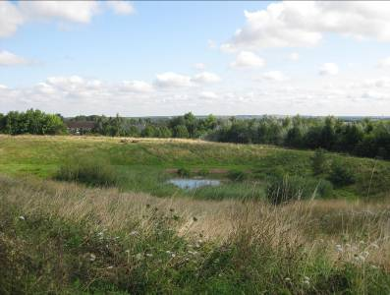
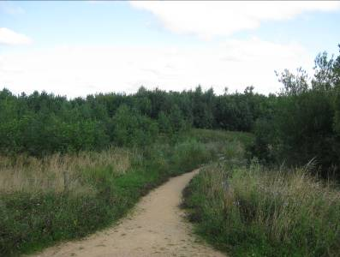
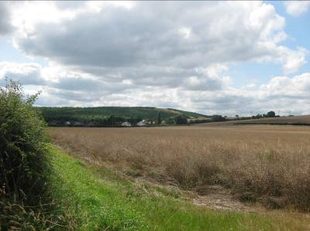

ML030B
ML030C
ML030D

LANDSCAPE ANALYSIS
Condition
This is a restored landscape characterised by a prominent mound, engineered from mining residue. The area is now associated with recreation as a community forest. It is a mosaic of rough grassland, neutral grassland and wild flowers with substantial blocks of woodland, man-made ponds and a network of public footpaths.  Medium regular shaped agricultural fields are situated around the foot of the mound and larger field pattern leads out in the adjacent character area. The field pattern is no longer evident in the LPZ.  Woodlands on the mound consist of blocks in varying shapes and sizes, with broadleaf and conifer species. The woodland varies in age with young establishing woodland across much of the mound. Mature woodland is found at the base of the slopes close to Mansfield Woodhouse Station and around Debdale Hall.  The landscape condition is considered to be GOOD. This is a designed landscape, restored and assigned for recreational purposes. There is evidence of well managed woodlands and grasslands for recreation and nature conservation. The features of this landscape are prominent within the area and adjacent character areas. |  | 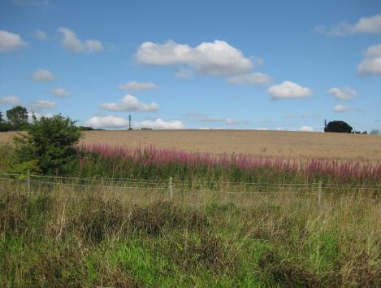  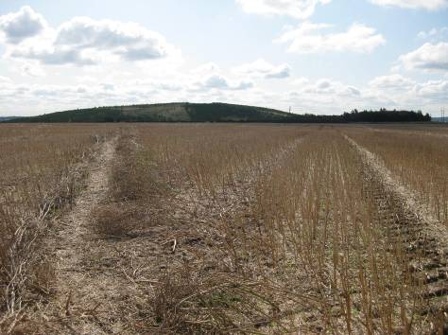  ML030E  ML030D
Landscape Strength
The spoil mound is a distinctive landscape feature which is visible over large areas, particularly from the north. Views from the mound are channelled along the footpaths by woodland on lower ground, with more expansive views possible from higher ground across the landscape to other woodlands and to Hardwick Hall .  This LPZ has a MODERATE strength of character. The area is a distinctive modern landscape, designed for recreational use. The landscape provides a sense of place and is a prominent feature within the surrounding the area, similar to the surrounding restored landscapes. The interspersed woodland in the grassland on the mound will mature and provide a strong woodland influence on the LPZ. |  | 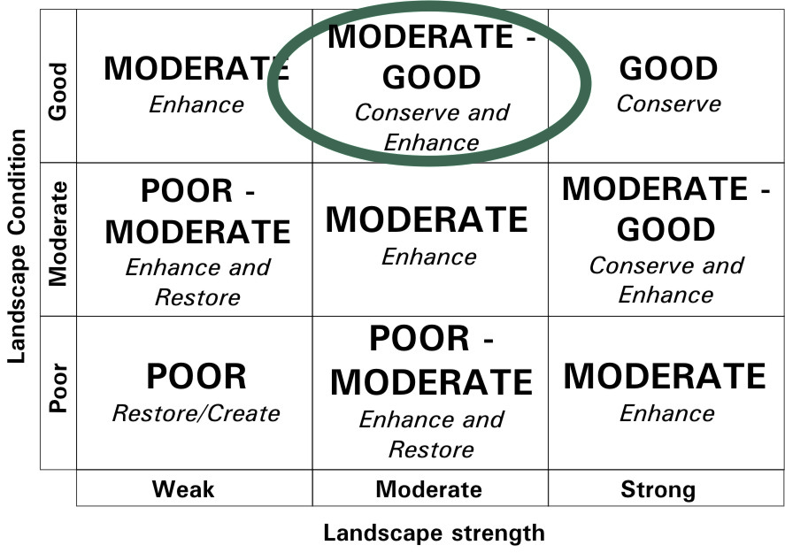  The overall landscape strategy is CONSERVE AND ENHANCE
LANDSCAPE ACTIONS
Landscape features
- Enhance the establishing woodland blocks by managing the woodland to ensure a strong wooded landscape character
- Conserve and enhance the balance between woodland, neutral grassland, wetlands and ponds
- Conserve and enhance the biodiversity of the new planting by ensuring a mix of species and diverse edge mixes
- Enhance new woodland with management through selective thinning of trees and groups to ensure a natural characteristic to the woodland and to soften the strong grid character currently present
- Conserve and enhance the rough grassland and neutral grassland through management to retain their character and diversity and seek opportunities to extend these areas
- Enhance areas of wetland meadow and reeds around ponds through appropriate management
- Conserve the enclosed wooded character in lower slopes
- Conserve and enhance the channelled views on lower slopes through management of existing vegetation
- Conserve and enhance expansive views from high ground through maintaining and managing wooded vegetation to retain views

Built form
- Conserve and enhance the wooded boundaries which screen and filter views of urban fringe and the railway track
- Conserve and enhance the mature wooded parkland setting at Debdale Hall

Other development/ structures in the landscape
- Conserve the character of industry set within woodland and therefore not visible within the landscape
- Conserve the informal character of footpaths through the landscape

