ML27 Pleasleyhill Upland Plateau Farmland
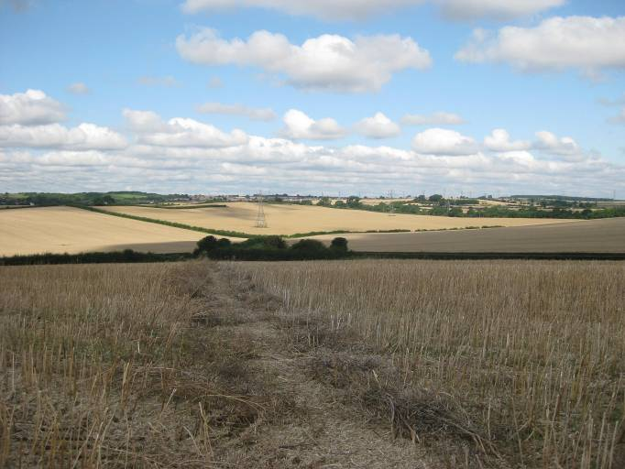  ML027A | CONTEXT  Regional Character Area: Limestone Farmlands  LDU Reference: 244  Landscape Policy Zone (LPZ) Reference: ML27  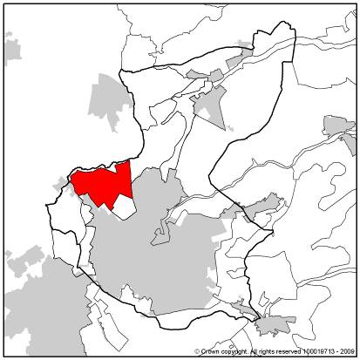
CHARACTERISTIC FEATURES
Landform and Hydrology
- A gently undulating upland plateau which gradually become steeper to the west at Redmanthwaite and Pleasleyhill and the River Meden Valley to the north
- The northern boundary is formed by the sloping valley of the River Meden
- Field ponds are present within a quarry and close to a farmstead, vegetation and landform reduces their prominence within the landscape
Landuse
- A simple pattern of fields comprising farmland with few occasional farms and little woodland
- Land use is completely set to arable farming; fields are uniform and geometric in shape, becoming smaller and irregular towards the urban fringe. Older field patterns are present on the northern boundary of the LPZ
- Field boundaries are all formed by hedgerows which are in variable condition. Some are intact and some are fragmented. The majority are uniform in height, although some have been left to become taller closer to the urban fringe. There are very few hedgerow trees and where present these are prominent features
Landscape Features
- Wooded restored collieries and woodland along the disused railway and River Meden Valley in the adjacent LPZ, provide a wooded contrast to the open landscape in the LPZ
- Mature individual trees in the gardens of properties along the urban edge and smaller pockets around the occasional farm buildings, soften the built form on the fringes of the area
- Calcareous grassland is concentrated along a disused railway in the northern part of this LPZ
- A definitive urban edge is prominent along the eastern boundary, set in low ground. Farmland rises beyond the settlement
Built Form
- An individual farm property is located on the south east slope, although it is not visible from the top of the plateau due to the sloping landform and mature trees around its boundaries
- Modern red brick, semi detached properties of Radmanthwaite are visible, as a linear belt of development
- The prominent roofs of an industrial development are visible to the south, consisting of large grey metal cladded units with little screening vegetation
Views
- Views to the south are limited by the restored mound of Oxclose Wood Hill
- From higher ground views to the east are expansive and over a long distance. A prominent mining shaft at Pleasley is visible
Other Features
- The only road is Common Lane a narrow rural lane bordered by low hedgerows. Busier A and B roads are found around the perimeter of the LPZ. Public Rights of Way (PROWs) are frequent and are discernable as a line through arable crops. One is a narrow route between a tall mature hedgerow
- A quarry lies on the edge the LPZ, it has wooded boundaries which limit its influence within the wider landscape
- A prominent overhead line runs across arable fields through the eastern side of the plateau
- The disused railway now a long distance trail ‘The Meden Trail’ is a prominent wooded feature along the northern boundary of the LPZ
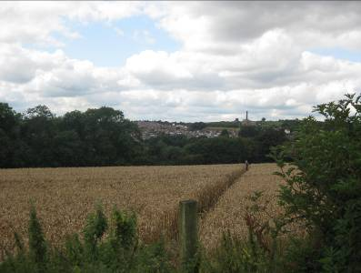
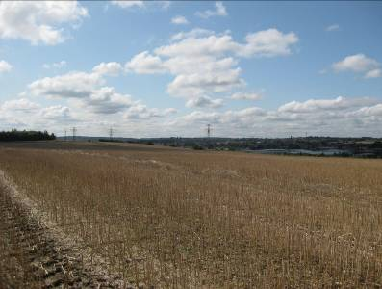
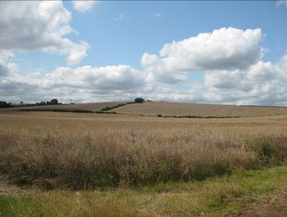

ML027B
ML027C
ML027D

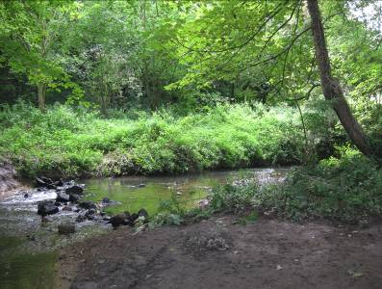
LANDSCAPE ANALYSIS
Landscape Condition
This area is characterised by a simple pattern of large scale uniform arable fields, on a broad plateau, which slopes down to the west where it meets the urban fringe of Rathmantwaite and Pleasleyhill. There are few features other than farmland. The area has a vast open exposed character due to few vertical features such as woodland and hedgerows. Land use is predominantly arable farming with a large geometric modern field pattern across the higher ground, becoming smaller and more irregular as the landform slopes to the north where they are recognised as older patterns reflecting open systems and to the west.  Woodland is sparse and only becomes evident in small clumps as the landform slopes towards the river valley in the adjacent LPZ. Individual mature trees within the private gardens along the urban edge give a linear wooded appearance and soften the appearance of built form. A young woodland plantation is present on the man-made Oxclose Wood Hill (former Sherwood Colliery) in the adjacent LPZ. Field boundary hedgerows are in variable condition and in some areas have been allowed to grow taller; this leads to the appearance of linear strips of vegetation, although when set against the vast scale of the fields these are not prominent. There are very few hedgerow trees although, as with any vertical element in this landscape, where present are prominent  The landscape condition is considered to be MODERATE. The land is well managed although some boundaries have been allowed to mature and become tall and others are fragmented. Features are intact, although parts of one PROW have become overgrown and inaccessible. | 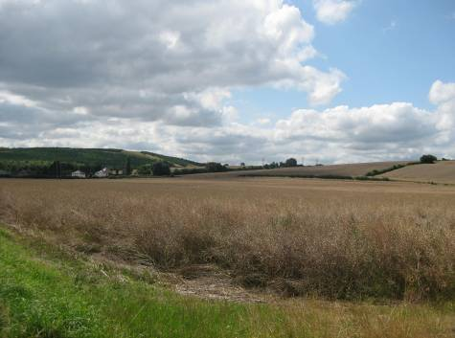  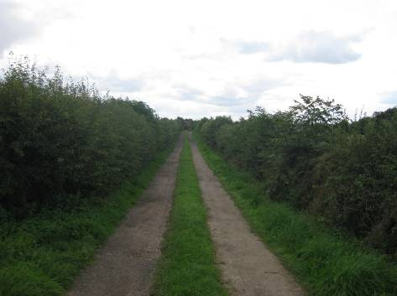  ML027E  ML027F
Landscape Strength
Views are expansive from higher ground across the LPZ; modern urban fringe is visible where the landform slopes and the land rises again beyond. To the south the view is restricted by the man made land form at Oxclose Wood Hill. There are more expansive views to the west where landform and infrequent wooded hedgerows limit views to the east and the tops of higher land often become visible.  This LPZ has a MODERATE character. The field pattern is simple and uniform, and consistent across the area with the urban influences situated on the fringes and have a limited effect. There are few features within the landscape which reduces its distinctiveness and sense of place. | 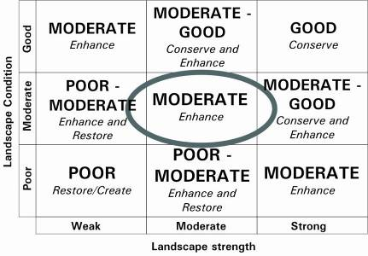  The overall landscape strategy is ENHANCE
LANDSCAPE ACTIONS
Landscape features
- Conserve older patterns of field enclosure along the northern edge of the LPZ such as those reflecting open systems
- Enhance the hedgerows through management
- Enhance diversity through planting hedgerow trees, especially along the western slope to create a transition to the urban fringe whilst maintaining an open character
- Enhance the rural character by planting woodland along the urban edge and to the perimeter of farmsteads and industrial development
- Enhance and conserve the simple agricultural pattern of the landscape
- Enhance the open character and gently rolling plateau landform through carefully siting any woodland or built development to maintain the scale and enclosure in the landscape
- Conserve, enhance and where possible extend areas of calcareous and neutral grassland and seek opportunities to establish native lowland wildflower grassland along field margins
- Conserve and enhance field ponds and their associated wetland vegetation
Built form
- Ensure any further urban development uses appropriate materials retaining the uniform roofline with views of rising farmland beyond
- Ensure the use of local stone similar to Mansfield White for any individual properties or extension developments and within modern settlements red bricks with darker grey or orange pantile roofs. Some buildings are Listed Buildings and thus any planned work requires consent.
Other development/structures in the landscape
- Enhance the PROW into the area by clearing vegetation along overgrown narrow routes
- Conserve and enhance small tracks and lanes through maintaining their narrow character and hedgerow boundaries
- Carefully consider the sitting of any vertical infrastructure to minimise its intrusion into this LPZ

