ML29 River Meden Limestone Valley
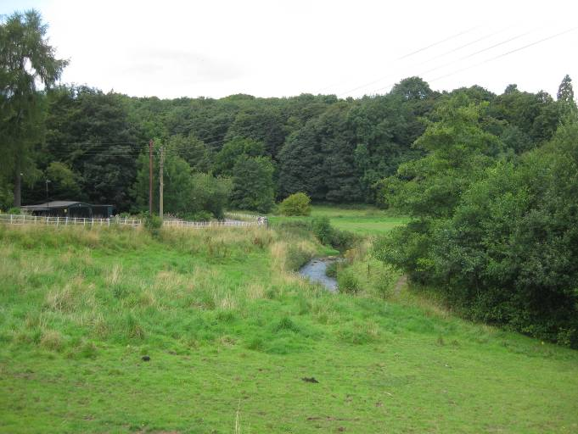 | CONTEXT  ML29A  Regional Character Area: Limestone Farmlands  LDU Reference: 218  Landscape Policy Zone (LPZ) Reference: ML23  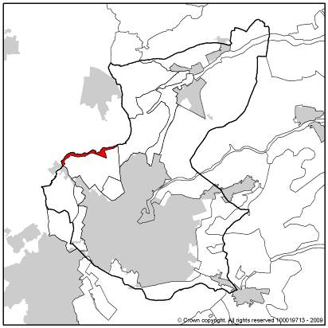
CHARACTERISTIC FEATURES
Landform and Hydrology
- A narrow river valley with steep valley sides formed during last ice age where melting water cut through rock to create a distinctive ‘U’ shape
- Vertical limestone rock faces are common distinctive features along the northern banks of the river
- Meandering water course through the base of the valley although often not visible as it flows through mature woodland
Landuse
- Rural remote character with little built form; woodland reduces the scale and visibility of built form within the area. Majority of the area is designated as the Pleasley Park and Vale Conservation Area
- Land use is a mixture of pasture and horse grazing, wet meadow, mature woodland, housing and historic mill complex (now offices)
- Fields are of irregular shape although tend to be narrow and linear following the river, reflecting the nature of the valley
- Field boundaries are mostly formed by estate fencing and, in places, dry stone walls along roads, woodland and some post and wire fencing although traditionally the area would have been unenclosed grazing land
Landscape Features
- Linear belts of mature often ancient woodland are key features, concentrated along the river banks and on the steeper sloping ground
- Where vertical rock faces are present woodland ‘overhangs’ the rocks and is established at the base. Rock faces tend to be only locally visible as they are surrounded by mature woodland
- Small-leaved lime trees are a feature along this limestone ridge
- Scattered mature hedgerows, regenerating scrub and riparian trees are frequent throughout the area
- Linear belt of woodland demarcates the route of the ‘Meden Trail’ a former railway now used as a long distance trail
- Pocket of parkland close to properties at the base of the valley; more distantly the land is set to arable farming with mature isolated horse chestnut tree, oak and beech present within the fields
- Pockets of conifer planting along the former railway line and close to private properties
- Frequent pockets of unimproved calcareous grasslands along the valley slopes are features
- Areas of ground flora within woodland although in places particularly along waterside edges, species are being replaced by more aggressive species such as nettles and thistles
Built Form
- Very limited built form including small terraces of vernacular buildings constructed of local buff stone which is a mix of limestone and Mansfield White with Mansfield Red used for detailing around windows and cornerstones. Other built form includes individual vernacular buildings and a small church, St Chads (Grade II listed building) nestled close to the river
- Pleasley is a small settlement in the centre of the LPZ which has a mix of housing styles including Top and Lower Meadow Cottages and is within a narrow river valley with housing on the rising slopes
Views
- Enclosed character with views channelled along the base of the valley
- Prominent vantage points include views between trees along the Meden Trail
Other Features
- Roads are generally small narrow single tracks bordered by estate fencing or stone walls and enclosed by mature woodland
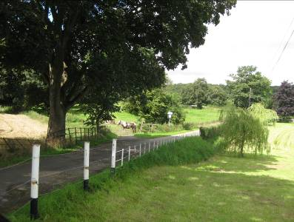
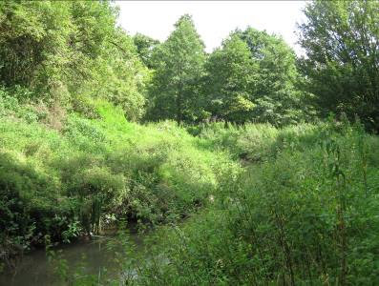
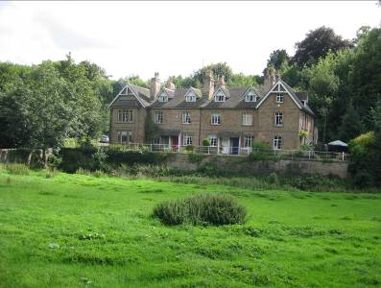

ML029B
ML029C
ML029D

LANDSCAPE ANALYSIS
Condition
This area is consistent with the character area: Limestone Gorges within the Derbyshire Landscape Character Assessment. It is a narrow river valley characterised by steep vertical limestone rock faces with overhanging woodland, meandering River Meden, mature woodland and pasture and wet meadows along the river banks.  Land use is mostly pasture and meadows. In places where the land is higher and therefore less waterlogged arable farming is present. The area includes land which would previously have been unenclosed grazing meadow and is some of the oldest forms of field pattern present within Nottinghamshire.  Woodland is one of the key features of this area. It tends to be long linear mature belts following the watercourse, disused railway and on the valley sides. Most woodland is an ash, oak and birch woodland type. Pockets of mature hawthorn and scrub are present within some fields and in patches along the river. Parkland trees include horse chestnut, oak and beech. Willow is common along the watercourse.  The landscape condition is considered to be MODERATE. In many places the land is well managed with boundaries along roads being intact and in good condition. Within some fields and woodland the management is less intensive with scrub and ruderal species within meadow areas. |  | 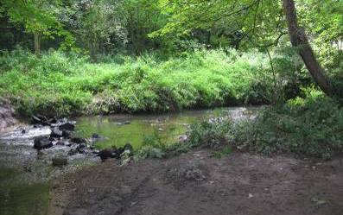  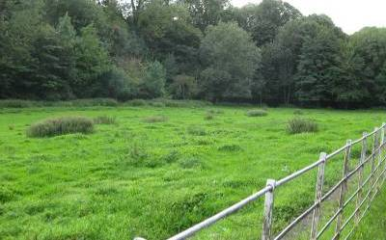  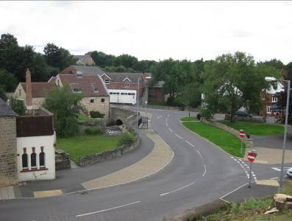  ML029E  ML029F  ML029G
Landscape Strength
This landscape has a strong visual containment created through a combination of the narrow river valley and mature woodland. Views are channelled along the river but are generally only across an individual field. All views contain woodland which forms the horizon. Built development does not punctuate this horizon.  This LPZ has a STRONG character. The meandering course of the River Meden surrounded by mature woodland, vertical rock faces, wet meadows and pasture and limited built form creates a peaceful and remote character. It has a strong sense of place which contrasts strongly with the arable landscapes surrounding it although weakens slightly where land is subdivided for horse paddocks |  | 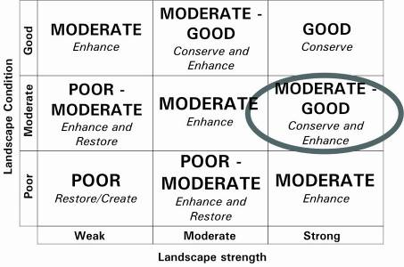  The overall landscape strategy is CONSERVE AND ENHANCE
LANDSCAPE ACTIONS
Landscape features
- Conserve areas of ancient woodland and ensure a programme of maintenance to maintain their floral understory diversity and interest
- Conserve and enhance the balance between woodland, pasture and wetland meadows
- Ensure any new planting is small, long and linear in character and retains pockets of wetland meadow and pasture
- Conserve and enhance the visual unity of the area through maintaining scattered riparian trees, natural regeneration and wildflower meadows along the river, trees within farmland and the connection between the built form and the surrounding landscape
- Conserve the meandering character of the River Meden
- Conserve the character of rock faces surrounded by scattered trees and ‘overhanging’ woodland. However ensure vegetation is managed to retain the visual relationship with the landscape and buildings in Pleasley Vale
- Conserve the presence of small-leaved lime trees on the limestone ridge
- Conserve and enhance areas of wetland meadow through appropriate management
- Conserve areas of pasture along the river banks
- Conserve the enclosed wooded character of the landscape
- Conserve and enhance the channelled views through the area through management of existing vegetation
- Conserve and enhance pockets of parkland through planting of trees along roads and within fields and use of estate fencing
- Enhance horse grazing paddocks through hedgerow planting or estate fencing and dry stone walling instead of post and wire fencing
- Conserve areas of lowland calcareous grassland and seek opportunities to extend and interlink these areas throughout the LPZ
Built form
- Conserve the sparsely developed character of the landscape with clusters of distinctive buildings or individual properties
- Ensure the use of local stone such as Mansfield White and Limestone in building and boundary wall construction using Mansfield Red stone as contrasting detail around windows, doors and as cornerstones
- Conserve the distinctive character of buildings and ensure any alterations are not detrimental to the design and character of the buildings
- Conserve the character and integrity of Pleasley Park and Vale Conservation Area (See Appraisal for more details.)
Other development/ structures in the landscape
- Conserve the small narrow character of roads through the LPZ bordered by estate fencing or stone walls
- Conserve the wooded character of the Meden Trail (along the disused railway). However ensure a programme of management to retain viewing points across the valley from the trail

