ML28 Penniment Lane Urban Fringe Farmlands
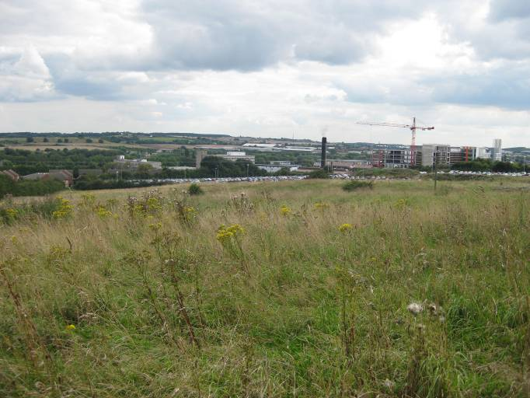  ML028A | CONTEXT  Regional Character Area: Limestone Farmlands  LDU Reference: 244  Landscape Policy Zone (LPZ) Reference: ML28  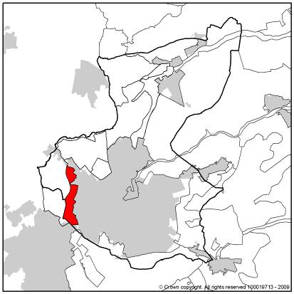
CHARACTERISTIC FEATURES
Landform and hydrology
- A flat strip of land which is bordered on the east side by urban development
- A small pond is present close to the urban fringe surrounded by grassland and trees
Landuse
- A semi-rural character with farms and woodlands, influenced by the urban fringe which is always visible
- Land use is mostly pasture farming, with some arable in the centre and pockets of informal and formal recreation land
- Fields immediately adjacent to the urban edge have, in some cases, been changed into amenity and recreation open spaces for the local residents, although some fields have been left to become scrubby through lack of use and some are now used by local residents for informal recreation
- Land to the south provides open land which maintains a semi-rural separation between Sutton in Ashfield and Mansfield
- A regular field pattern of medium scale arable fields of geometric shape; pasture fields are smaller particularly to the north and south where the field enclosure pattern is older
- Fields are bounded by fragmented hedgerows with scattered hedgerow trees in variable conditions. Hedgerows are generally well maintained, although closer to the urban fringe have either been left to become mature or are low or absent
Landscape Features
- Hedgerow trees where present give a linear character and provide a limited amount of screening to the urban edge
- Woodland blocks are sparse throughout the area and generally concentrated in informal open space and small linear strip close to Romsey Place
- Tree groups are generally clustered along the urban fringe
- Areas of neutral grassland present both within the southern and northern parts of this LPZ
Built Form
- The urban edge of Mansfield consists of modern residential properties, in red brick with red roofs. It is almost always visible as a uniform, well defined edge
Views
- Views are contained by the urban fringe, although longer views are possible to the west across arable farmland
- Views from the south west corner are over a long distance as the landforms falls to the newly built hospital and industrial development on lower ground nestled in woodland. Farmland rises further beyond over industrial development
Other Features
- An A road travels across the south east corner the area, connecting the A38 to the A617 and forming the west boundary beyond which the landscape becomes more rural and open

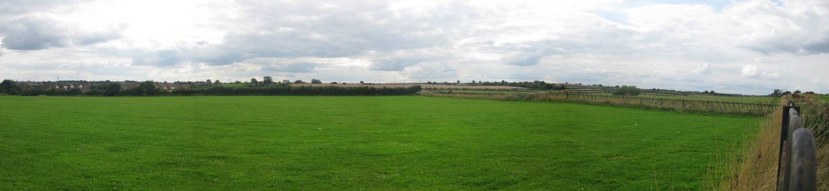

ML028B

LANDSCAPE ANALYSIS
Condition
A flat and gently undulating landscape with a strong urban fringe influence. Characterised by mainly pasture and some arable farming, with very little woodland, and infrequent hedgerow trees. The LPZ is on flat land surrounded by urban development to the south and east  Field pattern is mostly regular, medium scale arable to small pasture fields, rough grassland and amenity. Most are of modern origin although older patterns are present to the north and south.  Woodland across the area is very limited, to a single linear belt and scattered trees in open space. Fields are bounded by hedgerows and although these are fragmented in parts, in places they are closely clipped with few hedgerow trees and in other places left to mature and contain clusters of mature trees increasing the sense of enclosure. Amenity recreation spaces are present close to the urban fringe and include sports pitches, children’s play equipment and informal grassland and woodland areas. Some fields are under used and have become scrubby and in places overgrown.  The landscape condition is considered to be MODERATE. Whilst in places the area is well maintained, such as the amenity areas close the urban edge, the hedgerows across the wider area, have become fragmented or become overgrown. Some fields close to the urban edge have been left unused and allowed to become scrubby, with overgrown mature edges. Field pattern is still evident but being eroded where hedgerows are in decline. | 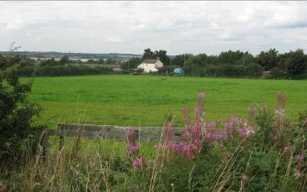  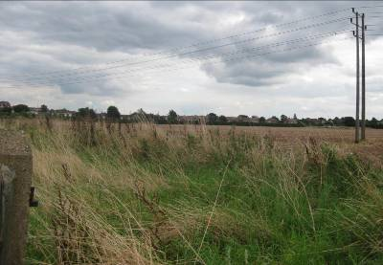  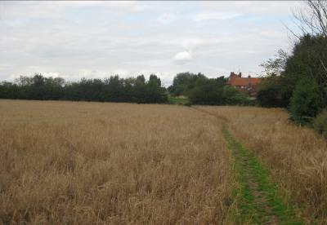  ML028E  ML028C  ML028D
Landscape Strength
Views are contained by urban development which is always present in views and exerts a strong influence on the landscape. Views to the west include open arable farmland with few buildings; longer views are possible in the south of the area across the new hospital to farmland beyond.  This LPZ has a MODERATE to WEAK character. The distribution of features is variable due to the lack of woodland and mix land uses within the area. Built form exerts a strong influence which reduces its rural character and fragments and disrupts it in places particularly where boundary vegetation is limited and fields are under used. It has limited distinctive characteristics and a weak sense of place. | 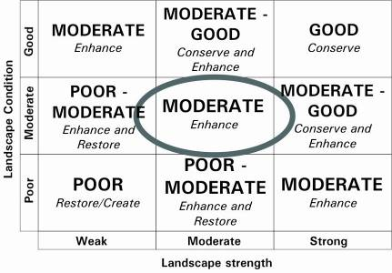  The overall landscape strategy is ENHANCE and RESTORE
LANDSCAPE ACTIONS
Landscape features
- Enhance and restore the field pattern, particularly older patterns of enclosure by restoring and maintaining the existing fragmented hedgerows, to reinforce field pattern
- Enhance the balance of woodland cover by introducing new trees, especially to settlement fringes to reduce its frequency of prominence in the landscape
- Enhance the smaller pastoral fields close to settlement through non-invasive management to retain and enhance their character
- Enhance the open character of the amenity playing fields and informal character with a balance of trees and wildflower grassland
- Conserve and enhance areas of neutral grassland and seek opportunities to extend these areas
- Enhance the fringes of the open spaces by introducing new planting species including trees, shrubs and meadow grassland to integrate with adjacent farmland
- Restore hedgerow trees into the landscape particularly along the A6075 and fringes of the LPZ
- Enhance ponds and their associated wetland vegetation
Built form
- Ensure that built development remains sensitively screened from view by linear woodland planting and clusters of trees to ensure it does not become more prominent in the surrounding landscape particularly in views from the west
- Ensure that any new developments are consistent keeping with the surrounding existing developments, where building materials, styles and sizes are concerned
Other development/ structures in the landscape
- Retain and enhance the open, undeveloped character of land particularly to the south where it is important for retaining separation between settlements

