ML25 Sookholme Limestone Farmlands
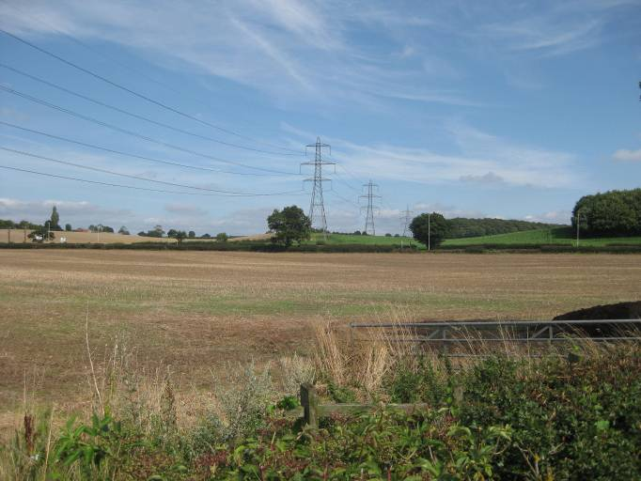  ML025A | CONTEXT  Regional Character Area: Limestone Farmlands  LDU Reference: 348  Landscape Policy Zone (LPZ) Reference: ML25  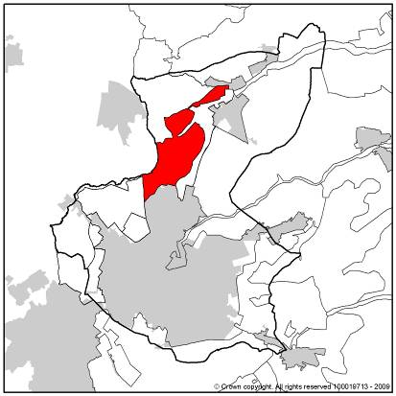
CHARACTERISTIC FEATURES
Landform and Hydrology
- A flat landscape which appears set within a wide bowl with man-made hills and natural landform rising along the fringes of the Landscape Policy Zone (LPZ)
- Prominent wooded hills surround the LPZ; plantation on them is young but as it matures will provide a sense of wooded enclosure
- The River Meden flows through the landscape and is demarcated by a thin scattering of riparian trees and shrubs although often fields extend to the river banks
Landuse
- Rural character interspersed with frequent farmsteads and large village fringes
- Free-draining limestone soils enable a wide variety of crops to be supported on the land therefore most land is set to arable farming
- There is a small amount of pasture present on the fringes of Spion Kop and horse grazing to the west of Littlewood Lane where the field size becomes smaller. Horse grazing fields are sub-divided by post and rail fencing. This in combination with small stables and barns and individual trees and scrub, has an influence on the generally well managed rural character of the area
- Field pattern is generally large and irregular with fields following the line of the river and roads through the area
- Fields are bounded by hedgerows in variable condition. Hedgerow trees are evenly spaced throughout the area although more frequent close to farmsteads and villages
Landscape Features
- Woodland comprises small copses and coverts mostly concentrated around Park Hall and Nettleworth Manor where it tends to be present as small geometric blocks or long linear belts and has a parkland character. Ancient Woodland present at Hind Car Wood and Ox Pasture Wood
- A perceived woodland cover is created through the combination of riparian trees, mature hedgerows, frequent hedgerow trees and woodland blocks
- The approach to Park Hall is distinctive with a walled garden and wooded lane, the hall is set within woodland
- Large area of calcareous/neutral grassland around Warsop Vale, designated as Hills and Holes SSSI
Built Form
- Villages and urban fringes are visible within the landscape often set on low ground with hills rising beyond
- There is often limited vegetation along village fringes where linear rows of housing are visible dispersed slightly by individual or clumps of trees
- Church Warsop village fringe is characterised by an older core of Mansfield White buildings with orange pantile roofs; more modern development on the western fringes is characterised by red brick and white render and red or brown tile roofs. This is a designated Conservation Area
Views
- St Peter and St Paul Parish Church is prominent on the skyline of Church Warsop
- Long views are possible across much of the area to the surrounding wooded hills; localised enclosure is created within fields closest to woodland where views are limited to being across one or two fields
Other Features
- Overhead line is a prominent feature through the central part of the LPZ

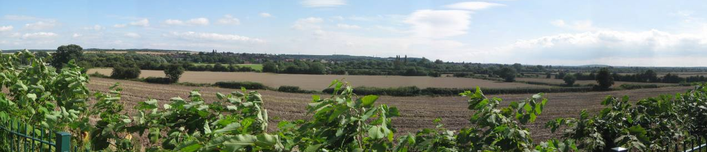

ML025B

LANDSCAPE ANALYSIS
Condition
The area is characterised by arable farmland, small linear and geometric woodlands, parkland at Nettleworth Manor and frequent farmsteads and village fringes. The LPZ is on flat land surrounded by wooded hills creating the illusion of being set within a wide ‘bowl’.  Field pattern is formed by mostly irregular shaped medium to large sized fields of modern origin. The fields around Park Hall and Nettleworth Manor are slightly smaller and have a slightly higher sense of enclosure whereas those close to Church Warsop and south of Sookholme are larger and more open and expansive in character. Some field patterns of older origin are dispersed throughout the LPZ.  Woodland is sparse within this LPZ and tends to be present as small geometric plantation such as Hind Carr, Quarry Plantation and Garden Plantation. Other woodland is long and linear in shape such as The Shrubbery, Hop Yard and Ox Pasture Wood. The most mature woodland is ancient woodland. A perceived woodland cover is created through the combination of mature hedgerows, frequent hedgerow trees (a mix of ash and oak) and woodland. Other vegetation of importance to the character are meadows including an extensive area of calcareous grassland, Hills and Holes SSSI, formed on former limestone quarries  The landscape condition is considered to be MODERATE. Whilst most features are generally well maintained and intact, there is evidence of hedgerow fragmentation in places and expansion of farmland up to the edges of the River Meden. Where horse grazing occurs the use of post and rail fencing and small stables and scrub reduce the appearance and condition of the landscape. |  | 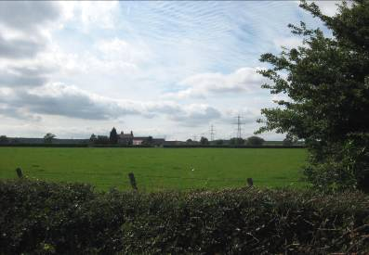  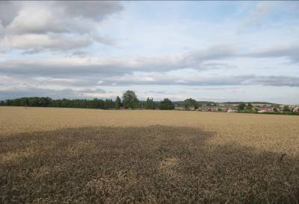  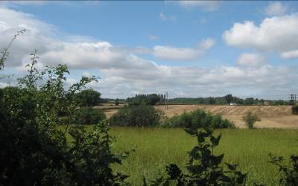  ML025C  ML025D  ML025E
Landscape Strength
Views are generally open across the landscape and comprise linear woodland and frequent farmsteads often surrounded by clumps of trees with wooded hills surrounding the LPZ. Towards the south of the LPZ where woodland is more frequent views are slightly more enclosed and in places only across one or two fields; wooded hills are still visible beyond.  This LPZ has a MODERATE/GOOD character. The simple pattern of arable fields and woodland is consistent across the character area. The frequent influence of urban fringes dilutes the generally rural character present The landscape becomes slightly more distinctive where woodland is present and around Nettleworth Manor where there are parkland influences. |  | 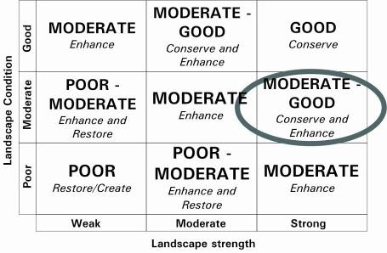  The overall landscape strategy is CONSERVE and ENHANCE
LANDSCAPE ACTIONS
Landscape features
- Conserve areas of older field patterns such as semi-regular and regular geometric patterns and patterns reflecting open systems
- Conserve areas of calcareous and neutral grassland and seek opportunities to extend and enhance these areas
- Enhance hedgerows through management and replanting
- Enhance the cover of hedgerow trees through new planting, particularly close to village fringes to soften their appearance
- Enhance the coverage of small linear woodlands particularly close to village fringes and farmsteads
- Conserve open views across the landscape through careful siting of any woodland and management of existing vegetation
- Conserve and enhance rural character through reducing the prominence of urban fringes
- Enhance the riparian character of the River Meden through retaining any wetland meadow, reedbeds or grassland banks as a buffer adjacent to arable farming and planting of new riparian trees and shrubs
- Ensure where fields are fenced to maintain stock or horses it is used behind a native hedgerow
- Conserve and enhance woodland areas through ensuring appropriate management
- Conserve and enhance the parkland character around Park Hall and Nettleworth Manor
Built form
- Conserve the prominence of St Peter and St Pauls church in the skyline of Church Warsop
- Enhance the built form distinctiveness of settlements through the use of material similar to Mansfield White stone and orange pantile roofs in any new development
- Conserve the distinctive character and integrity of Church Warsop Conservation Area
- Maintain the uniform roofline of villages with wooded hills rising beyond
Other development/structures in the landscape
- Conserve and enhance roadside hedgerows through management and replanting and concentrating new hedgerow trees along roads

