ML26 Warsop Vale Wooded Farmland
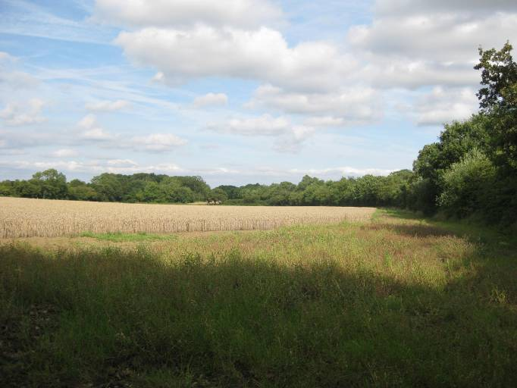  ML026A | CONTEXT  Regional Character Area: Limestone Farmlands  LDU Reference: 347  Landscape Policy Zone (LPZ) Reference: ML26  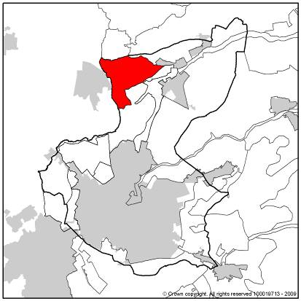
CHARACTERISTIC FEATURES
Landform and Hydrology
- A flat to gently undulating landscape which slopes down from a highpoint around Warsop Cottage Farm to a low point at Church Warsop
- Man-made landforms at the former Warsop Colliery and former Shirebrook Colliery are distinctive and have a localised influence on the landscape
- Small stream present to the north of the former Shirebrook Colliery
- Ponds and small lakes are common within restored land and set within woodland or surrounded by wetland vegetation
Landuse
- Rural character of woodland and farmland although urban influences increase to the south around Warsop Vale
- Land use is a mixture of woodland with arable and pasture farmland between. The land is mostly pasture although arable is present to the west
- Informal amenity space comprising wetland, new mixed species broadleaved woodland and wildflower meadows and grassland. Calcareous and neutral grassland is present along the edges of the disused railway
- A regular field pattern which is mostly of modern origin although older patterns of enclosure are present adjacent to woodland where fields become smaller
- Field boundaries are almost all formed by hedgerows which are often mixed species although hawthorn is dominant
- There is a small pocket of fields enclosed by dry stone walling in the eastern part of the character area. It is one of the few areas of this in the district and relates to the more common form of enclosure within Derbyshire to the north
Landscape Features
- Hedgerow trees are infrequent within hedgerows and tends to be individual trees or groups of two or three
- Woodland is a key feature within this landscape with large interconnecting blocks forming much of the land cover. Mature woodland is a prominent feature including Lord Stubbin’s Wood, Parson’s Wood and Warsop Wood which are all Ancient Woodland
- The extensive woodland which covers the former colliery sites will, once mature, contribute to the woodland character and provide a strong sense of enclosure within the landscape
- In places such as New Plantation, wet woodland is establishing on waterlogged ground
- The woodland along the disused and active railways form prominent linear wooded features
- Farms often have clusters of mature trees around their boundaries, in places Lombardy Poplar is used whose form and shape contrasts with the surrounding naturalistic woodland character
Built Form
- Settlement is sparse within the LPZ comprising isolated farms such as Warsop Cottage Farm and William Wood Farm. These include a large residence and a cluster of farm buildings and animal sheds. The buildings are constructed from local stone such as Mansfield White with Mansfield Red used for detailing around windows
- The edge of Warsop Vale comprising rows of former mining terraces is locally visible in the landscape although woodland along fringes reduces the extent and scale of visibility. Shirebrook is screened from the landscape by woodland along the railway line
Views
- Views throughout the area are generally limited to being over one field with woodland always present often forming the horizon
- Longer distance views are possible from the highest ground on restored mounds although the scale and extent of these is likely to change and reduce as woodland vegetation matures. No roads are present through this LPZ although small tracks cross the central part of the area and are present through recreational land

Other Features
- A small sewage works lies on the edge of the LPZ; woodland screens it from view

LANDSCAPE ANALYSIS
Condition
The area is characterised by farmland interspersed between woodland and prominent man made landform planted with young woodland and grassland. Built form and roads are infrequent within the landscape.  Field pattern is generally of modern origin with medium-sized geometric fields mostly bordered by hedgerows although in places by dry stone walls. Pockets of older enclosure are notable by their smaller size. Hedgerow trees are infrequent within hedgerows. Hedgerows are generally intact and a mix of heights, some appear as wooded belts whilst others are closely clipped.  Large tracts of ancient woodland are prominent features within the landscape at Lord Stubbin’s Wood, Parson’s Wood and Warsop Wood. Other young woodland plantation on former colliery sites is extensive and links into the existing woodland. Woodland is a mixture of ash, oak and birch with a wider range in newer plantation.  The landscape condition is considered to be MODERATE. Features are generally well-maintained although in places close to Warsop Vale areas of former hardstanding and field boundary fragmentation give an untidy appearance and have an influence on landscape condition. |  | 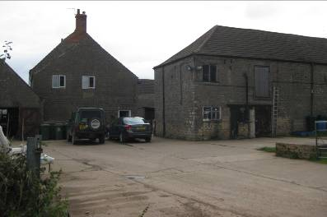  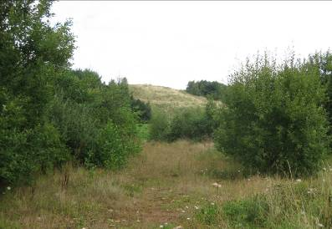  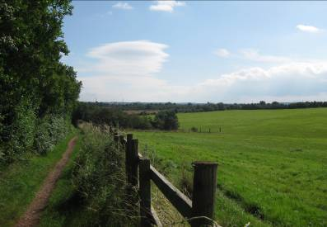  ML026B  ML026C  ML026D
Landscape Strength
Views are generally restricted by woodland and only over short distances often across a single field and bounded by woodland. Views are enclosed within woodland and across much of the recreational space on former collieries although more open expansive views are possible from highest ground. Wooded skylines are common.  This LPZ has a STRONG character. The balanced woodland and farmland are key features which give the landscape a sense of place. The newly restored woodland planting and landform partially links into this landscape however as planting matures the character within the landscape will be strengthened and reinforced. |  | 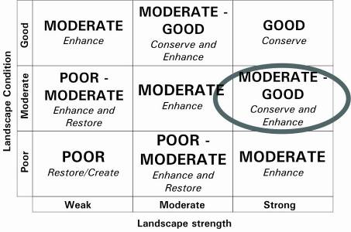  The overall landscape strategy is CONSERVE and ENHANCE
LANDSCAPE ACTIONS
Landscape features
- Conserve and enhance the interlocking character of woodland through planting new hedgerows and linear woodland belts to link recreational areas with the wider farmland
- Conserve and enhance woodland through management to ensure its longevity
- Enhance farm tracks particularly close to Warsop Vale through reinstating hardstanding concrete areas to narrow routes with grass verges
- Conserve and enhance the rural character through small scale tree planting along the fringes of Warsop Vale
- Conserve the older field patterns of enclosure where they occur
- Enhance field boundaries through management and replanting of hedgerows or repair of dry stone walls where they become damaged
- Conserve and enhance the strong woodland character within the landscape through maintaining and where opportunities exist, extending existing woodland and planting new woodland using oak, ash and birch mixes
- Conserve and enhance calcareous and neutral grasslands to extend the areas of wildflower meadows particularly around the former colliery sites, along grass verges, disused railway and along field margins
- Conserve the balance of arable and pasture farming
- Enhance hedgerow tree cover within the landscape through new tree planting particularly along roads on the fringe of the area and tracks within the area
- Conserve and enhance ponds and streams and associated wetland vegetation
Built form
- Conserve the character of isolated farmsteads with clusters of trees around the boundaries.
- Ensure extensions or new development use locally appropriate materials such as local Mansfield White Stone and within settlements red brick with darker grey or orange pantile roofs
- Conserve and enhance the contained character of Warsop Vale through ensuring any built development does not make the settlement more prominent within the landscape
Other development/structures in the landscape
- Conserve the linear wooded character of the disused and active railways through the landscape
- Conserve the rural and informal character of lanes and tracks through the landscape

