ML23 Skegby Plateau
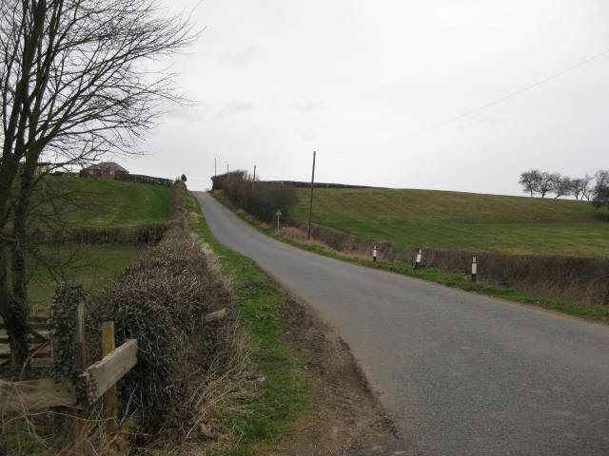  ML023A | CONTEXT  Regional Character Area: Limestone Farmlands  LDU Reference: 244  Landscape Policy Zone (LPZ) Reference: ML23  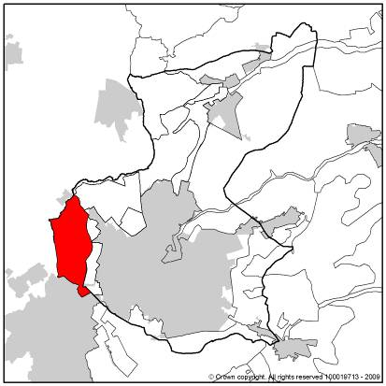
CHARACTERISTIC FEATURES
Landform
- An area of farmland on land rising to a broad plateau from Ashfield into Mansfield
- Land falls sharply at the western edge where the character area adjoins the River Meden valley and at the northern edge close to Pleasley
Land use
- An area of predominantly rural character but influenced by urban elements visible at the edge of Skegby, Sutton in Ashfield and Pleasley
- Land use is primarily arable farming with some pasture and woodland on the fringes of Pleasley and Skegby
- On plateau areas, fields are large; hedges are typically trimmed and low between fields and adjacent roads
- Field pattern varies throughout the area. It is mostly of modern origin and modified pattern but there are some older, open field patterns at the western edge and south of Pleasley
- Fields are medium to large in size, regular and geometric in shape. Fields are smaller in the western and northern parts where the pattern of enclosure is older
- There are localised variations where there is equestrian land use. Grazing paddocks tend to be smaller, enclosed by timber fences; and regular and geometric in shape
- Fields are typically bounded by low thorn hedges which are generally intact
Landscape Features
- Hedges line roadsides and are sometimes raised with narrow or no verges creating ‘sunken’ lanes
- Woodland is not a strong characteristic of the landscape and there are few hedgerow trees. Cotton Plantation is the only significant woodland in the LPZ. Other woodland is linear in form along the River Meden
- Tree groups are generally restricted to areas close to urban fringes and farms and along the River Meden in the northern part of this LPZ
- Calcareous and neutral grasslands are concentrated around Moorhaigh
Built Development
- Built development is limited within the area, restricted to a small group of dwellings at the south eastern edge and scattered farms
- Infrequent individual farms within the character area are on high ground
- Low hedges allow unrestricted views over open fields and towards urban fringes
Views
- Views are sometimes restricted by gently rising landform, some views from lower ground are more enclosed by steeper slopes
- The northern fringes of Skegby and southern fringes of Pleasley and glimpsed views of the urban edges of Radmanthwaite which adjoin the LPZ have a localised urbanising influence in adjacent parts of the LPZ
- The roofline of neighbouring settlements is typically below the height of mature trees and is not a prominent feature in views
- Oxclose Woods on a restored colliery mound outside this LPZ is visible on the skyline from northern parts of this LPZ
Other Features
- Overhead lines are prominent on high ground and in large open fields
- Rural public footpaths cross the area through open fields on high ground and are evident as breaks within fields of crops
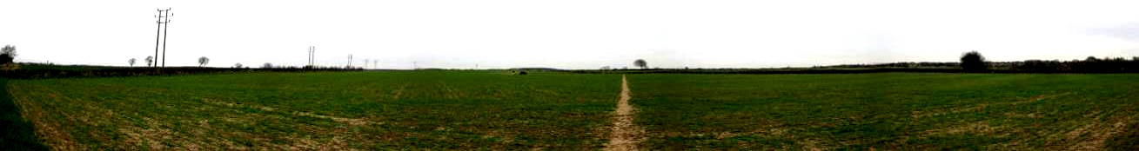

ML023B

LANDSCAPE ANALYSIS
Condition
A rural area on raised ground between Skegby and Pleasley. There are large arable fields on high relatively flat or gently sloping land bounded by hedges. Overhead electricity lines are prominent on the skyline of the raised plateau and open fields.  Land use is predominantly arable farming. Fields are mostly medium to large in size with the majority of arable land being laid out in a modified field pattern. Pasture land around settlement fringes is smaller, medium sized fields although they are also regular in size and shape. Areas of older enclosure such as semi-regular field patterns and those reflecting open systems are present to the north of Skegby and south of Pleasley.  Cotton Plantation is the only woodland within the LPZ. Tree cover is generally limited to the urban fringes and adjacent residential properties and farms. Linear belts are present along the River Meden. There are few hedgerow trees and infrequent copses or areas of scrub at the base of slopes and around settlements. Intact hedgerows are present across much of the area although fragmentation is occurring in some places. Pockets of neutral and calcareous grassland are present around Moorhaigh.  The area has a sense of openness because of the elevated position, sparse development and lack of tree cover.  The landscape condition is GOOD. The arrangement of this agricultural landscape is simple and regular. Features are intact and consistent throughout the character area. Hedgerows and field pattern are managed largely for arable farming although there is some localised variation in field boundary type where there is equestrian use. | 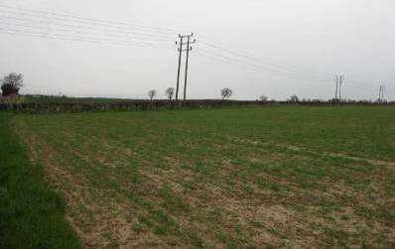  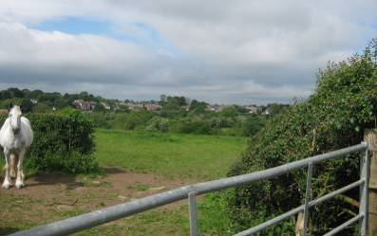  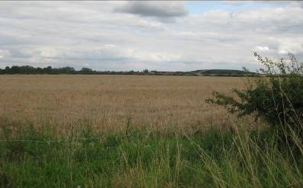  ML023C  ML023D  ML023E
Landscape Strength
This LPZ is a plateau adjacent the River Meden valley LPZ. The nature of views from within the area is varied. Views are unrestricted across large open fields from higher points although in places sloping and rounded landform restricts long distance views. Views are enclosed where land is more steeply sloping at the edges of the LPZ. Views into the River Meden valley are possible from the western and northern edge of the LPZ.  The character strength of the area is STRONG. The area has a small number of characteristic features such as plateau landform, field size and shape, trimmed hedges and limited tree cover. These are consistent throughout the area which reinforce the strength of landscape character. | 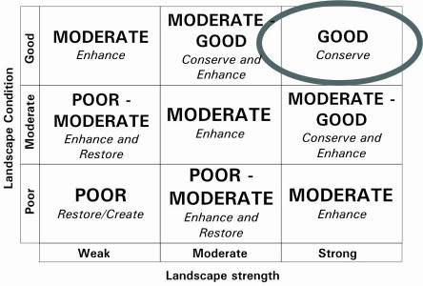  The overall landscape strategy is CONSERVE.
LANDSCAPE ACTIONS
Landscape features
- Conserve the simple and regular field pattern of the rural agricultural landscape
- Conserve the older patterns of enclosure such as those reflecting open systems and semi-regular field patterns
- Conserve field boundary hedges and encourage restoration of any fragmented sections
- Enhance and create wildlife corridors to link with existing hedgerows and also increase numbers of hedgerow trees whilst maintaining an open character
- Conserve the distinctive gentle rolling landform and openness of the raised plateau through careful siting of woodland planting and built form
- Conserve and enhance tree cover at the edge of settlements, individual farms or dwellings
- Conserve areas of pasture close to village fringes
- Conserve and enhance areas of calcareous and neutral grassland
Built form
- Conserve the open countryside character. Built form is not prominent in this landscape and any new developments should be restricted to existing settlements as far as possible. Development generally should avoid adverse effects on open countryside and particularly sloping edges of the plateau
- Conserve the existing settlement pattern where rooflines are typically below the crest of hills and ridgelines
- Enhance views of settlement edges and increase tree cover in these areas to minimise effects of development on the landscape
Other development/ structures in the landscape
- Conserve the narrow and enclosed character of rural lanes and conserve road- side hedges
- Conserve long views from high points by ensuring the viewpoints remain open

