Sherwood Landscape Policy Zone 29: Meden Vale and Church Warsop

Policy: Conserve

The area is located south of Worksop, immediately between the Poulter valley, at the north, and the Meden valley at the south. The A60 runs north-south through the west and the B6034 runs north-south through the east; these roads are connected by the A616 which bisects the Landscape Policy Zone (LPZ) south-east to north-west. The village of Budby lies to the south-east, Cuckney and Norton are located towards the north-west. Church Warsop and Meden Vale lie at the south-western boundary.

Generally the landform is rounded and gently undulating, rising to a ridgeline north of Church Warsop before descending sharply in both the north and south towards the Rivers Poulter and Meden respectively. There are localised steep sections around the spoil heap [north-west of Meden Vale] where land has been worked, this has been restored to grassland. Views are mostly medium distance towards wooded skylines. Views of Welbeck Park are gained from the north and of built settlement from the south. Internal wooded areas create some enclosed views within the core of the LPZ.

The LPZ comprises mainly arable fields on the lower ground, woodland is evident at the ridgeline. The fringe of Welbeck Estate features in the east along with a corner of Clumber Park Estate [Carburton] in the far north-east. Remnants of historic features include avenues, clumps of trees and lodges. Broad Lane, a historic lane which possibly separated the two estates, runs east-west and is now part of the Robin Hood Way. Recreational activity is fairly low key in the area; horse riding, walking and cycling. Plantations are generally mixed and coniferous. Stone vernacular farmhouses, estate lodges and walls are characteristic of the area, however both Church Warsop and Meden Vale have a non-vernacular urbanising influence.
Sherwood Landscape Policy Zone 29 - Meden Vale and Church Warsop
PHOTOGRAPH | CONTEXT
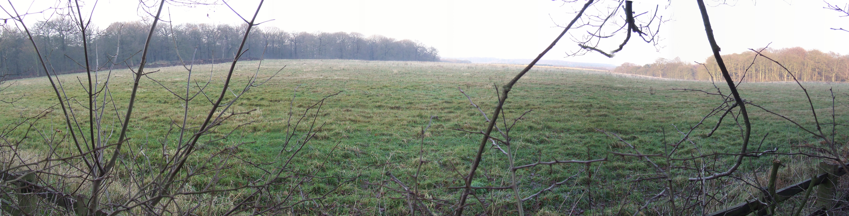 | Landscape Policy Zone: S LPZ 29  Land Cover Parcel[s]: S36, S69
 | Condition
 | Good | REINFORCE |  | CONSERVE & REINFORCE | CONSERVE
 | Moderate | CREATE & REINFORCE |  | CONSERVE & CREATE | CONSERVE & RESTORE
 | Poor | CREATE |  | RESTORE & CREATE | RESTORE
CHARACTERISTIC FEATURES  - Medium scale arable farmland.  - Intensive pig farming and a small amount of rough grazing.  - Lady Margaret Hall, part of the Welbeck Estate.  - Stone and red brick built farmhouses and dwellings.  - Coniferous and deciduous woodland blocks. |  | Low |  | Moderate | High
 |  |  |  | Sensitivity
LANDSCAPE ANALYSIS | SUMMARY OF ANALYSIS
Condition | Condition |  | Good
The landscape condition is good. There is a coherent pattern of elements and few detracting features within the Landscape Policy Zone (LPZ). Detractors include low voltage power lines, agricultural sheds, the A616, and spoil heaps and the mineral railway associated with Welbeck Colliery. The latter is currently being restored to openspace and employment built development. Overall this leads to a visually unified area.  Land use is mainly medium scale arable farming with some rough grazing. A pig farm is located close to Meden Vale. Buildings tend to be of stone or red brick construction, though stone is more dominant. Lady Margaret Hall [stone built], part of the Welbeck Estate, lies within the LPZ. The urban estates of Meden Vale and Church Warsop are apparent and of modern non-vernacular style. The overall cultural integrity is considered variable.  The historic field pattern has declined due to mineral workings and the need to create larger arable fields, these are bounded by hawthorn hedgerows which are well trimmed although gappy in places. No hedgerow trees are apparent. The LPZ has moderate tree cover and combines mature woodland blocks with more recently planted areas of both deciduous and coniferous species. There is some heathland along field and woodland boundaries, acid grassland occurs along road verges and beneath woodland. There are at least 5 SINCs and also areas of ancient woodland (Minster Wood) within the LPZ. The ecological integrity has been assessed as moderate which gives a coherent habitat for wildlife/functional integrity. A visually unified area and coherent functional integrity gives a good landscape condition overall. | Pattern of Elements: |  | Coherent
 | Detracting Features: |  | Few
 | Visual Unity: |  | Unified
 | Ecological Integrity: |  | Moderate
 | Cultural Integrity: |  | Variable
 | Functional Integrity: |  | Coherent
Sensitivity | Sensitivity |  | High
Features which give the area local distinctiveness are characteristic of the Sherwood region and the continuity/time depth is historic [post 1600] giving a moderate sense of place.  Visibility is high due to the open views to wooded higher ground beyond the boundary of the Landscape Policy Zone and the dominant undulating landform. A moderate sense of place with high visibility results in high landscape sensitivity overall. | Distinctiveness: |  | Characteristic
 | Continuity: |  | Historic
 | Sense of Place: |  | Moderate
 | Landform: |  | Dominant
 | Extent of Tree Cover |  | Intermittent
 | Visibility: |  | High
LANDSCAPE ACTIONS
Conserve
Landscape Features
- Conserve woodland blocks and reinforce as necessary.
- Seek opportunities to restore arable land to pasture.
- Conserve historic field pattern, restoring and reinforcing poor hedgerow boundaries where necessary.
- Seek opportunities to create areas of heathland where appropriate.

Built Features
- Conserve the rural character of the landscape by concentrating new development around the existing settlements of Meden Vale and Church Warsop. Create small scale woodland/tree planting to soften new development, preferably in advance of development.
- Conserve and respect the local vernacular of stone/ red brick construction in any new development.
- Conserve and respect the historic character and setting of Lady Margaret Hall and surroundings.
- Contain new development within historic field boundaries.

