Sherwood Landscape Policy Zone 25 - Birklands Wooded Estatelands
PHOTOGRAPH  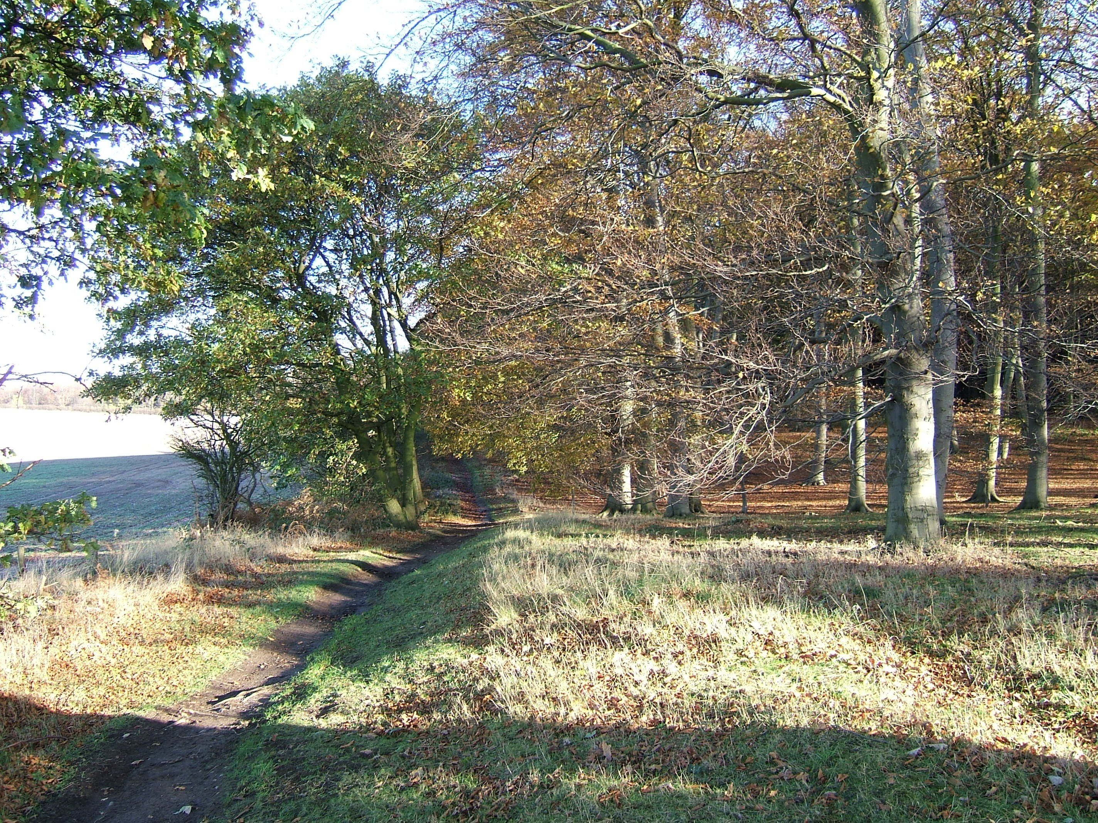 | CONTEXT  NCC Landscape Type: Wooded Estatelands  Landscape Policy Zone: S LPZ 25  Land Cover Parcel: S23, S24, S25
 | Condition
 | Good | REINFORCE |  | CONSERVE & REINFORCE | CONSERVE
 | Moderate | CREATE & REINFORCE |  | CONSERVE & CREATE | CONSERVE & RESTORE
 | Poor | CREATE |  | RESTORE & CREATE | RESTORE
 |  | Low |  | Moderate  Sensitivity | High
CHARACTERISTIC VISUAL FEATURES

- Undulating topography
- Frequent views of wooded skylines
- Geometric pattern of medium to large-scale arable fields
- Trimmed hawthorn hedges
- Large coniferous plantations
- Scrubby semi-natural woodland and heaths with ancient-stag headed Oaks
- Strong heathy character (heather, bracken, gorse and broom species)
LANDSCAPE ANALYSIS | SUMMARY OF ANALYSIS
Landscape Condition | Condition |  | Good
The Landscape Condition is defined as good.  This large area has a generally coherent pattern of elements with some detracting features. Thoresby Colliery and its associated spoil heaps are located to the east of the area. The busy A6075 cuts from east to west across the centre of the area linking Mansfield to Edwinstowe. Other land uses include a lorry park at Bradmer Hill, a sewage works as well as numerous masts and pylons. Tourist attractions such as Sherwood Forest Farm Park also tend to detract from the landscape unity of the area. Overall the visual unity is coherent.  There are several SINCs within the area, including Birklands and Bilhaugh (i & ii), Clipstone Drive, Edwinstowe, New Lodge Plantation, Hanger Hill Drive Wood, Bradmer Hill Cutting and Warsop Sand Quarry. Birklaugh West Ollerton Corner and Birklands and Bilhaugh are SSSI’s, and the latter is also designated as a SAC (Special Area for Conservation). Sherwood Forest is a National Nature Reserve.  This area has a number of large coniferous and broadleaved woodlands set within an intensively farmed arable landscape. Sherwood Forest Ancient Woodland located to the north of Edwinstowe contains remnants of historic oak and birch woodland. The open canopy forest contains extensive mosaics of grass, bracken and heather heathland. The ecological integrity is strong within this area.  Roadsides and arable land are enclosed by generally well maintained, trimmed hawthorn hedgerows with some oak and ash trees. The woodland, hedgerows and heathland provide a strong network of wildlife corridors and there is moderate tree coverage with a diverse age structure. There has been recent planting at the Thoresby Colliery and Blakeley Lane, whereas the semi-natural woodland areas are over-mature and in decline. Overall the cultural integrity is variable giving a strong functional integrity. | Pattern of Elements: |  | Coherent
 | Detracting Features: |  | Some
 | Visual Unity: |  | Coherent
 | Ecological Integrity: |  | Strong
 | Cultural Integrity: |  | Variable
 | Functional Integrity: |  | Strong
Landscape Sensitivity | Sensitivity |  | Moderate
Features which give the area local distinctiveness are characteristic of the Sherwood region and the continuity is historic although ancient in parts which gives a moderate sense of place.  A number of trees and woodland are shown on the Sanderson Plan of 1835. The field pattern is mainly intact, to the west the field pattern has been lost to modern arable farming practices and coniferous plantations and to the far east by Thoresby Colliery and associated development. Tree cover varies throughout the area with blocks of woodland particularly to the east and more open areas of arable fields to the west. Overall the extent of tree cover is intermittent.  The views within the area are varied and are either contained by close belts of woodland or by plantations at a greater distance. A moderate sense of place combined with moderate visibility gives a moderate landscape sensitivity overall. | Distinctiveness: |  | Characteristic
 | Continuity: |  | Historic
 | Sense of Place: |  | Moderate
 | Landform: |  | Apparent
 | Extent of Tree Cover |  | Intermittent
 | Visibility: |  | Moderate

ACTIONS - Conserve and Reinforce
Landscape Features

- Conserve and reinforce the ecological diversity and distinctive character of heathland and semi-natural woodland habitats.
- Conserve and reinforce existing hedgerows and seek opportunities to restore the historic field pattern with new hedgerow planting with some hedgerow trees, where appropriate.
- Restore areas of arable land to semi-natural oak woodland and heathland.
- Conserve all existing heathland sites.
- Reinforce the existing level of tree cover and use oak and birch along woodland edges and rides.

Built Features

- Conserve the historic character and setting of village settlements. New development should respect the scale, design and materials used traditionally.
- Conserve the integrity and remote rural character of the landscape by concentrating new development around existing settlements of Market Worksop and Mansfield Woodhouse.
- Promote sensitive design and siting of new agricultural buildings.
- Promote measures for reinforcing the traditional character of farm buildings using vernacular building styles.

