Sherwood Landscape Policy Zone 28 - River Meden Between Meden Vale and Church Warsop

Policy: Conserve

The area stretches from Lound Hall in the east to Church Warsop in the west along the Meden and Maun valleys. It almost bisects the Sherwood character region south of Clumber and Thoresby Estates and north of Sherwood Forest Country Park. Thoresby Lake falls within the Landscape Policy Zone (LPZ) in the west.

Both the River Meden and Thoresby Lake have gently sloping sides, further east the flat valley floor is evident between the Meden and Maun valleys.

Views tend to be medium distance either towards surrounding higher ground or woodland and plantation blocks which occur frequently adjacent to the river corridors. Some views are limited by residential development at Meden Vale and by the reclaimed slopes of the former Welbeck Colliery.

Essentially the LPZ comprises small areas of pasture, flood meadow and arable alongside the watercourses. Part of the historic landscape of Thoresby Park encroaches into the area from the north; mature parkland trees stand close to the Lake and deer graze to the waters edge. Most field boundaries are post and wire fencing, though a few gappy hawthorn hedgerows are also present. Small areas of settlement are contained within the area; Lound Hall Training Centre, Haughton Hall Farm and Haughton are located close to the River Maun while the small villages of Perlethorpe and Budby are located close to the River Meden along with Gleadthorpe Grange further west.

SH 28: River Meden Between Meden Vale and Church Warsop
PHOTOGRAPH | CONTEXT
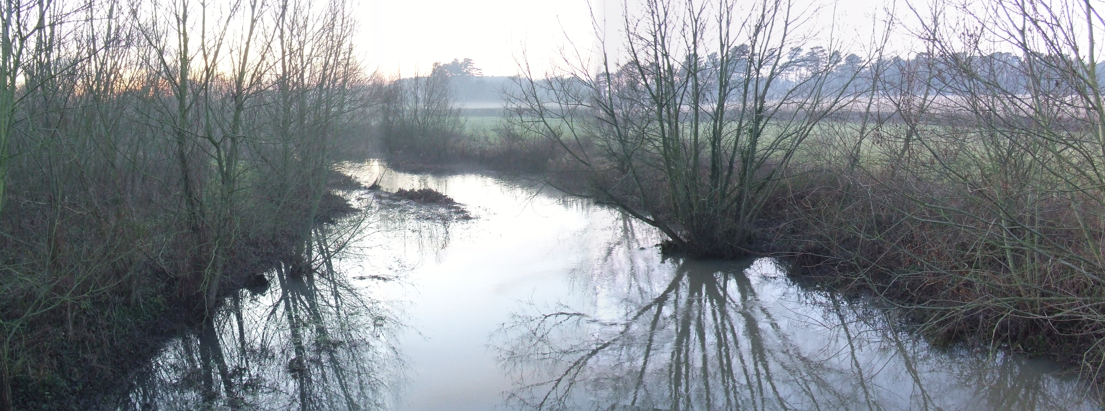 | Landscape Policy Zone (LPZ): S LPZ 28  Land Cover Parcel[s]: S29, S30, S31
 | Condition
 | Good | REINFORCE |  | CONSERVE & REINFORCE | CONSERVE
 | Moderate | CREATE & REINFORCE |  | CONSERVE & CREATE | CONSERVE & RESTORE
 | Poor | CREATE |  | RESTORE & CREATE | RESTORE
CHARACTERISTIC FEATURES  - River Meden, River Maun, Thoresby Lake.  - Linear sections of flood meadow.  - Deciduous woodland belts aligning the river corridor.  - Mix of oak and poplar with heathland understorey. |  | Low |  | Moderate | High
 |  |  |  | Sensitivity
LANDSCAPE ANALYSIS | SUMMARY OF ANALYSIS
Condition | Condition |  | Very Good
The landscape condition is very good. The Landscape Policy Zone (LPZ) contains a coherent pattern of elements with few detracting features including the urban areas of Meden Vale, Church Warsop and Market Warsop, Welbeck Colliery. Although busy roads, the A616 and A614 are minor detractions running perpendicular to the valley. Overall the landscape is visually unified.  The River Meden dominates the Policy Zone, subsequently the area is not intensively used. There are relatively few buildings or structures within the area, farm buildings are mainly red brick with slate or pantile roofs. Urban areas at nearby settlements Meden Vale, Church Warsop and Market Warsop are more modern in style. The historic field pattern is still evident in part though several hedgerows have been replaced by post and wire fencing. The overall cultural integrity is considered good.  Linear sections of flood meadow follow the watercourse, some is used for pastoral farming and some amenity grassland occurs near to settlement. Generally there is good vegetation connectivity along the valley between deciduous woodland belts and hedgerow field boundaries adjacent to the LPZ. Tree coverage is moderate and of diverse age structure, oak and poplar are the dominant species and occur with heathland understorey in less wooded areas. A significant strip of riparian vegetation follows the River Meden comprising mature willow, poplar with understorey. One SINC, a woodland block, is contained within the LPZ along with one Local Nature Reserves (LNR): The Bottoms LNR [riparian habitats along the River Meden]. The ecological integrity is defined as strong which gives a very strong habitat for wildlife/functional integrity. A visually unified area combined with a very strong functional integrity gives a very good landscape condition. | Pattern of Elements: |  | Coherent
 | Detracting Features: |  | Few
 | Visual Unity: |  | Unified
 | Ecological Integrity: |  | Strong
 | Cultural Integrity: |  | Good
 | Functional Integrity: |  | Very Strong
Sensitivity | Sensitivity |  | Moderate
Features which give the area local distinctiveness are characteristic of the Sherwood region and the continuity/time depth is historic [post 1600] giving a moderate sense of place.  The presence of the River Meden prevents intrusive land use or development. Dense woodland along the majority of the valley helps to further protect the river as a habitat, although the tree cover is noticeably sparse between Meden Vale and Budby, where arable and pastoral land is farmed right up to the water’s edge.  Moderate visibility is afforded due to the wooded enclosure of the Landscape Policy Zone. The landform is considered dominant. A moderate sense of place combined with moderate visibility gives moderate landscape sensitivity overall. | Distinctiveness: |  | Characteristic
 | Continuity: |  | Historic
 | Sense of Place: |  | Moderate
 | Landform: |  | Dominant
 | Extent of Tree Cover |  | Enclosed
 | Visibility: |  | Moderate
LANDSCAPE ACTIONS
Conserve
Landscape Features
- Conserve the character, pattern, ecological diversity and biodiversity of the River Meden corridor and surrounding flood meadow, seek to enhance as appropriate.
- Conserve the structure of existing woodland and flood meadow and seek to enhance and reinforce as necessary to encourage greater habitat diversity as appropriate.

Built Features
- Conserve the rural character of the landscape by respecting the scale and setting of existing settlements.
- New development should take account of the distinctive ecological elements within the Landscape Policy Zone.

