Sherwood Landscape Policy Zone 18 - Blidworth and Rainworth Wooded Estatelands
PHOTOGRAPH | CONTEXT
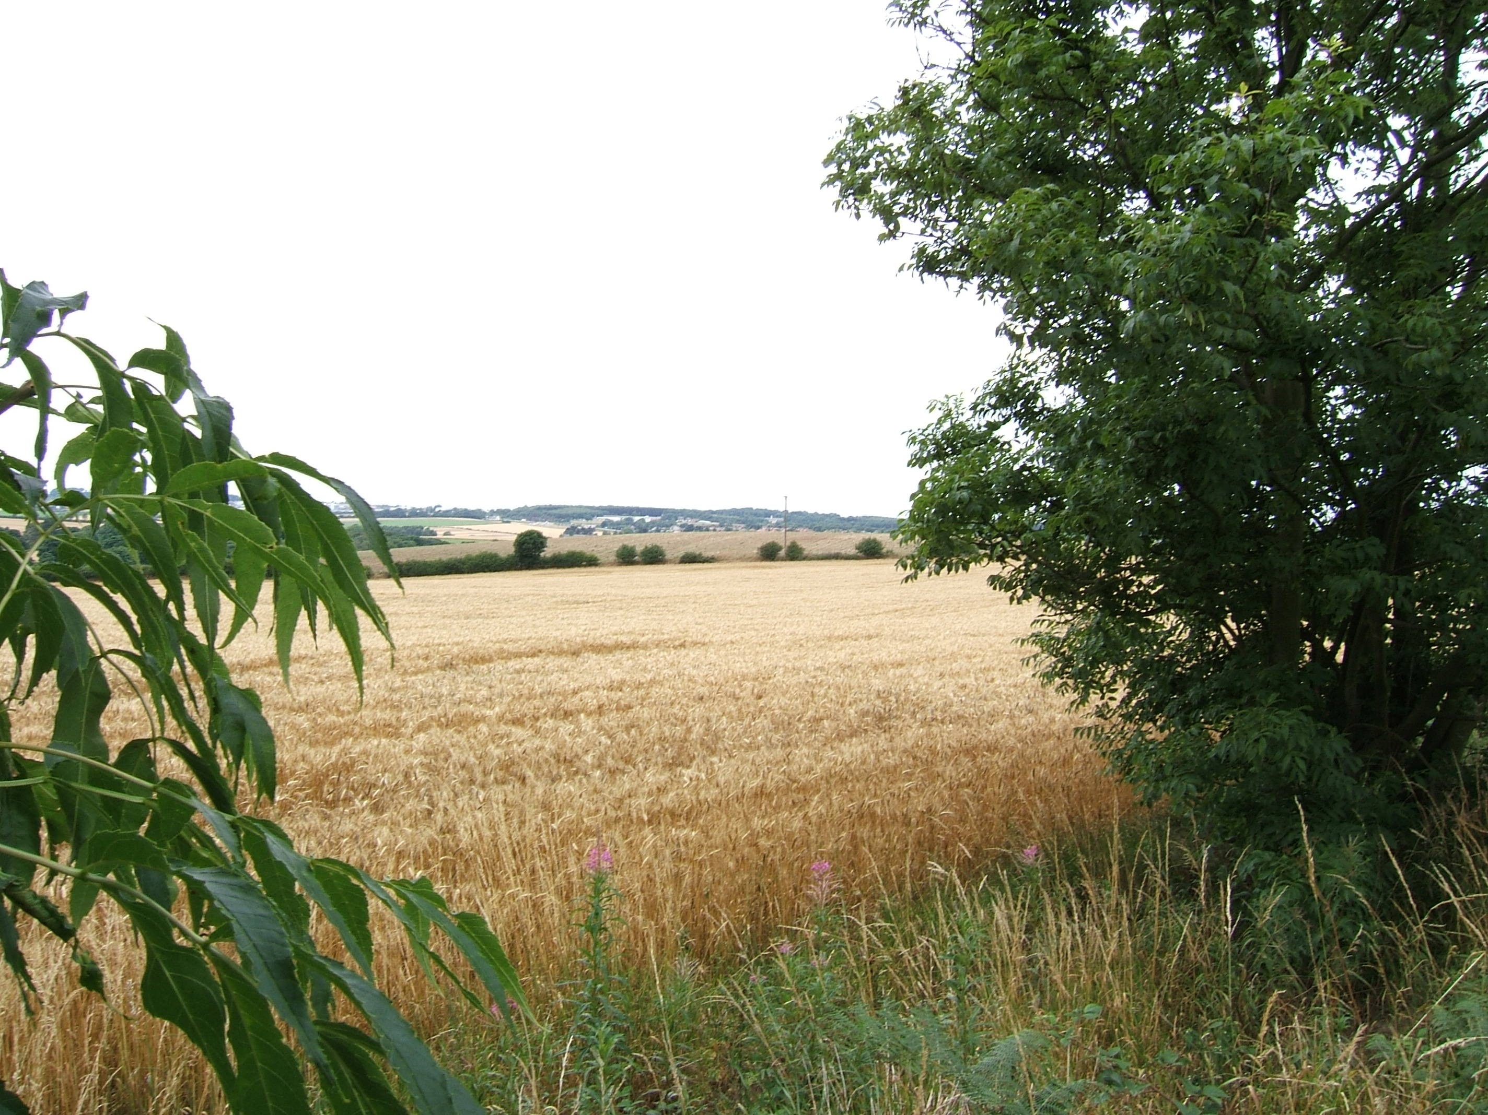 | NCC Landscape Type: Wooded Estatelands  Landscape Policy Zone: S LPZ 18  Landscape Character Parcel: S1, S2, S11
 | Condition
 | Good | REINFORCE |  | CONSERVE & REINFORCE | CONSERVE
 | Moderate | CREATE & REINFORCE |  | CONSERVE & CREATE | CONSERVE & RESTORE
 | Poor | CREATE |  | RESORE & CREATE | RESTORE
 |  | Low |  | Moderate  Sensitivity | High
CHARACTERISTIC VISUAL FEATURES

- Gently undulating topography
- Coniferous forestry plantations with deciduous margins to road edges
- Small deciduous woodlands dominated by Oak.
- Intensive arable farming in large to medium geometric fields
- Poor internal field boundaries, but stronger road edge boundaries with mature trees
- Rainworth Bypass (A617) crosses the north of the area, A614 runs north to south
- Isolated farms
- Heathland character, apparent to road verges. Heathland species present within woodlands and along disused mineral railway lines.
- Evidence of former coal mining, restored spoil heaps at Blidworth and Calverton
- Settlements of Bildworth and Rainworth

LANDSCAPE ANALYSIS | SUMMARY OF ANALYSIS
Landscape Condition | Condition |  | Moderate
The Landscape Condition is defined as Moderate  The area has a coherent pattern of elements: mainly large geometric arable fields and blocks of coniferous plantation woodland. There are some detracting features these include: busy roads including the A614, the A617 Rainworth Bypass and the built edge of urban areas of Rainworth and Blidworth. Overall this gives a visually coherent area. There are a number of SINCs and heathland sites in the area. Overall this is a moderate habitat for wildlife although connectivity is reduced by poor hedgerows in places and busy roads. Cultural integrity is variable in that the land use pattern is of the Sanderson’s Plan of 1835 has been lost due to forestry planting and coal mining activities; where it does exists, many hedgerows have been removed. Fragments of deciduous woodlands that were present during the Sanderson’s Plan (1835) remain, as well as isolated vernacular farm buildings.  A visually coherent area with a coherent functional integrity gives a moderate landscape condition | Pattern of Elements: |  | Coherent
 | Detracting Features: |  | Some
 | Visual Unity: |  | Coherent
 | Ecological Integrity: |  | Moderate
 | Cultural Integrity: |  | Variable
 | Functional Integrity: |  | Coherent
Landscape Sensitivity | Sensitivity |  | Moderate
The Landscape Sensitivity is defined as Moderate  The components of the landscape are characteristic of the regional Sherwood Landscape Character Area. The time depth is historic (post 1600) giving a moderate sense of place overall. There is evidence of the pre-enclosure heathland character in the presence of heathland species to road edges and within woodlands.  The undulating landform is apparent with intermittent areas of woodland giving a moderate visibility of features in and out of the LPZ to the north, although the higher proportion of woodland in the south creates a more enclosed area. There are dominant views of the urban edges of Bildworth and Rainworth.  A moderate sense of place and a moderate visibility leads to a moderate landscape sensitivity overall. | Distinctiveness: |  | Characteristic
 | Continuity: |  | Historic
 | Sense of Place: |  | Moderate
 | Landform: |  | Apparent
 | Extent of Tree Cover |  | Intermittent
 | Visibility: |  | Moderate
ACTIONS – Conserve and Create
Landscape Features
- Conserve the ecological diversity of small deciduous woodlands throughout the area
- Conserve and Reinforce field boundary and road hedgerows where these have become degraded or lost
- Create opportunities for restoring areas of heathland where appropriate
- Create small deciduous woodlands where appropriate

Built Features
- Conserve the integrity and rural character of the landscape by concentrating new developments around the existing urban fringe of Blidworth and Rainworth
- Create small scale woodland/tree planting to soften new development, preferably in advance of development
- Conserve the existing field pattern by locating new small scale development within the existing field boundaries
- Promote measures for reinforcing the traditional character of farm buildings using vernacular building styles.
- Promote sensitive design and sitting of agricultural buildings

