Sherwood Landscape Policy Zone 50 - Strawberry Hill Heath Wooded Estatelands
PHOTOGRAPH | CONTEXT
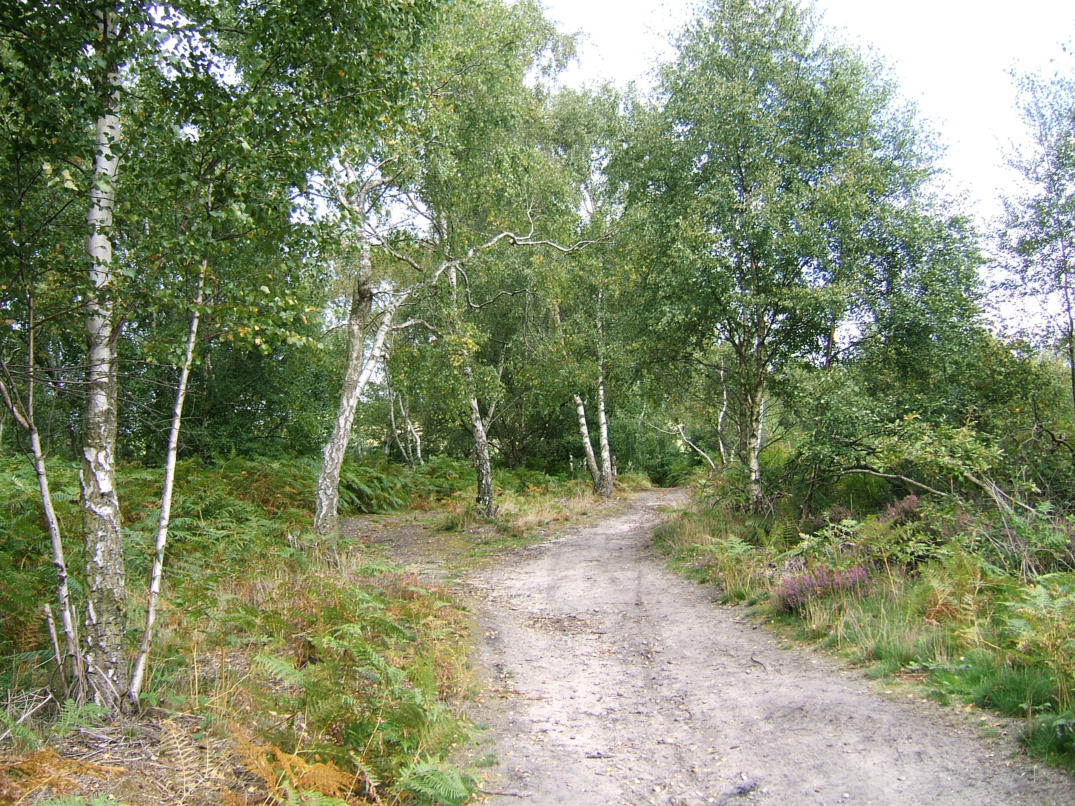 | NCC Landscape Type: Wooded Estatelands  Landscape Policy Zone: S LPZ 50  Land Cover Parcels: SH20 and SH21  Condition
 | Good | REINFORCE |  | CONSERVE & REINFORCE | CONSERVE
 | Moderate | CREATE & REINFORCE |  | CONSERVE & CREATE | CONSERVE & RESTORE
 | Poor | CREATE |  | RESTORE & CREATE | RESTORE
CHARACTERISTIC VISUAL FEATURES  - Oak and Birch Woodland  - Strawberry Hill Heaths SSSI is a dominant feature in the landscape  - Heathland vegetation includes Heather, Bracken, Broom and acidic grassland  - Sandy paths up to Strawberry Hill Heaths SSSI, show some signs of erosion  - Open views to adjacent quarry site to the west  - Generally views within the site are enclosed by woodland |  | Low |  | Moderate | High
Sensitivity

N.B. Where one criterion is ‘very good’ this pushes the policy description into the next highest category.
LANDSCAPE ANALYSIS | SUMMARY OF ANALYSIS
Landscape Condition | Condition |  | Very Good
The Landscape condition is defined as very good. The area has few detracting features – the main detracting feature is the active sand quarry to the western edge of the site. Overall the LPZ is strongly unified.  The LPZ is a designated SSSI and SINC – described as an important area of acidic deciduous woodland and heathland.  Oak and Birch trees dominate the site and vary in age. The site has a strong ecological integrity and has good links to adjacent areas.  Cultural integrity is good as the historic heathland has been retained within a wider landscape which has been altered by mining and quarrying activity.  A visually strongly unified area with a very strong functional integrity/ habitat for wildlife gives a very good landscape condition. | Pattern of Elements: |  | Unified
 | Detracting Features: |  | Few
 | Visual Unity: |  | Strongly Unified
 | Ecological Integrity: |  | Strong
 | Cultural Integrity: |  | Good
 | Functional Integrity: |  | Very Strong
Landscape Sensitivity | Sensitivity |  | Moderate
Sandersons Plan of 1835 shows large areas of open heathland – this has largely disappeared as a result of the expansion of Mansfield to the west, quarrying activity, and coal mining. Strawberry Hill is a remnant of this heathland landscape.  Overall the features are characteristic of Sherwood with an historic time depth ( post 1600) and the area has a moderate sense of place.  There are open views over the quarry site from the western edge of the site and filtered views to the golf course from the footpath to the north of the site. Views within the site are enclosed by the woodland The dominant landform and enclosed tree cover give a moderate visibility within the site.  A moderate sense of place with a moderate visibility gives a moderate landscape sensitivity. | Distinctiveness: |  | Characteristic
 | Continuity: |  | Historic
 | Sense of Place: |  | Moderate
 | Landform: |  | Dominant
 | Extent of Tree Cover |  | Enclosed
 | Visibility: |  | Moderate
LANDSCAPE ACTIONS – Conserve
Landscape Features

- Conserve the ecological diversity and character of the heathland habitat – management objectives are likely to involve thinning or removal of Birch woodland to restore and enhance acid grassland and heathland habitats
- Conserve the landform of Strawberry Hill
- Create additional areas of heathland and woodland habitats within adjacent areas

