Sherwood Landscape Policy Zone 15 - River Maun Meadowlands with Plantations
PHOTOGRAPH | CONTEXT
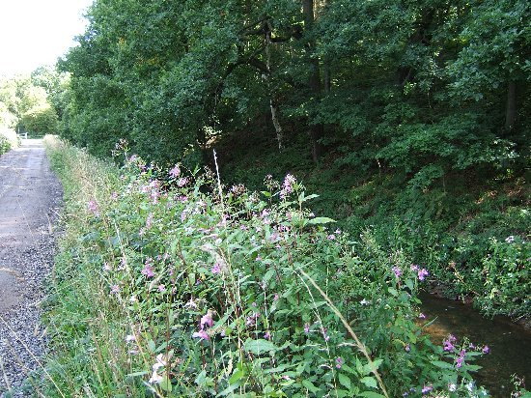 | NCC Landscape Type: Meadowlands with Plantations  Landscape Policy Zone: S LPZ 15  Land Cover Parcel: S27 S28
 | Condition
 | Good | REINFORCE |  | CONSERVE & REINFORCE | CONSERVE
 | Moderate | CREATE & REINFORCE |  | CONSERVE & CREATE | CONSERVE & RESTORE
 | Poor | CREATE |  | RESTORE & CREATE | RESTORE
CHARACTERISTIC VISUAL FEATURES  - Narrow meandering river valley  - West of Edwinstowe - low lying fields to the north and steeper wooded valley side to the south  - Occasional sandstone outcrops to the southern bank  - Arable farming on flatter areas to the east  - Some willow, alder and riparian vegetation along the banks adjacent to the river  - Some views out to built edges railway, embankments, and woodland edges |  | Low |  | Moderate | High
 |  |  |  | Sensitivity
LANDSCAPE ANALYSIS | SUMMARY OF ANALYSIS
Landscape Condition | Condition |  | Good
The Landscape Condition is defined as good. The Landscape Policy Zone contains a coherent pattern of elements with a few detracting features. These include the urban fringe, sewage works, pylons, and busy roads crossing the valley. Overall the landscape is visually unified.  The River Maun is a moderate habitat for wildlife with some areas of broadleaved woodland and outgrown hedgerows with trees along parts of the narrow valley. There are several SINC sites but ecological value has been reduced in areas of arable farming. Flood meadow has been lost to intensive arable farming and some straight sections of river suggest that the profile has been engineered. Hedgerows vary in condition, with some outgrown or fragmented and some stronger and trimmed.  The condition of heritage features is variable. There are some small areas of flood meadow and historic field boundaries. The location of the water meadows is still evident in the field pattern to the north of the river from Warren Farm to the east of Lamb Pens Farm. These meadows were created between 1816 and 1837 and they released water and sewage over farmland, greatly increasing agricultural production. Most of the farmhouses adjacent to this Landscape Policy Zone also date from this time.  Recent isolated development has generally had a negative impact on the valley.  Overall, this is a visually unified area with a coherent functional integrity which gives a good landscape condition. | Pattern of Elements: |  | Coherent
 | Detracting Features: |  | Few
 | Visual Unity: |  | Unified
 | Ecological Integrity: |  | Moderate
 | Cultural Integrity: |  | Variable
 | Functional Integrity: |  | Coherent
Landscape Sensitivity | Sensitivity |  | Moderate
The Landscape Sensitivity is defined as moderate.  The components of this landscape such as tree cover, patches of heathy vegetation and the generally undeveloped land within the river corridor are characteristic features of Sherwood Landscape Character Area. However, the historic time–depth has largely been degraded by intensive arable farming, and some localised development around Edwinstowe, and Ollerton. Views are generally contained by the low landform and intermittent tree cover and visibility is moderate.  A moderate sense of place combined with a moderate visibility gives a moderate landscape sensitivity overall. | Distinctiveness: |  | Characteristic
 | Continuity: |  | Historic
 | Sense of Place: |  | Moderate
 | Landform: |  | Apparent
 | Extent of Tree Cover |  | Intermittent
 | Visibility: |  | Moderate
ACTIONS - Conserve and reinforce
Landscape Features
- Conserve and reinforce the pastoral character of the river valley.
- Promote measures for restoring arable land to pasture and flood meadow.
- Conserve and reinforce river channel diversity and marginal riverside vegetation.
- Conserve and enhance the ecological diversity and character of riparian woodland.
Built Features
- Conserve the sparsely settled character of the river corridor by avoiding development within the immediate flood plain of the River Maun.
- Reinforce the sense of place of the built environment by using materials and design that reflect the local character of the area.
- Contain new small scale development within historical field boundaries.

