Sherwood Landscape Policy Zone 47 - Coxmoor Wooded Farmlands
PHOTOGRAPH | CONTEXT
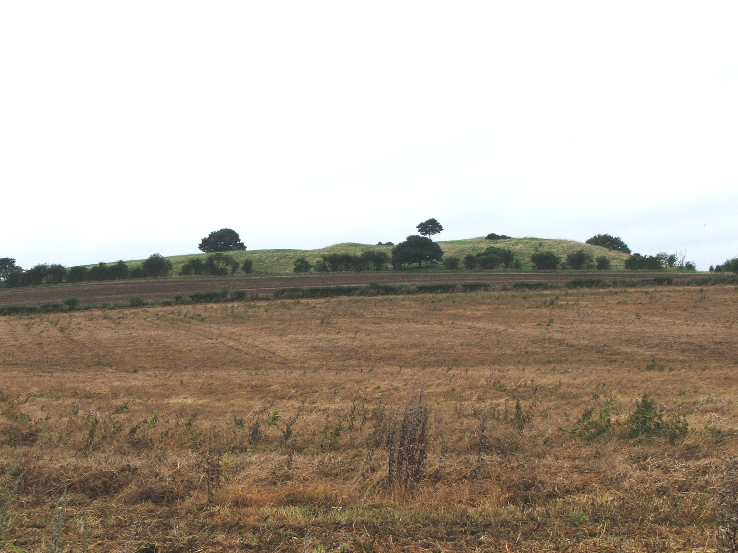 | NCC Landscape Type: Wooded Farmlands  Landscape Policy Zone: S LPZ 47  Landscape Character Parcel: S74,75
 | Condition
 | Good | REINFORCE |  | CONSERVE & REINFORCE | CONSERVE
 | Moderate | CREATE & REINFORCE |  | CONSERVE & CREATE | CONSERVE & RESTORE
 | Poor | CREATE |  | RESORE & CREATE | RESTORE
 |  | Low |  | Moderate  Sensitivity | High
CHARACTERISTIC VISUAL FEATURES

- Gently undulating topography
- Coxmoor golf course with intensively managed but also includes areas of re-created heathland (roughs on golf course with heather, bracken broom, and gorse)
- Permanent unimproved and improved pasture to the centre of the LPZ
- Arable farmland to the centre
- Tall bushy mixed species hedgerows in the centre of the LPZ
- Isolated farms and residential settlements
- Kingsmill Reservoir with fringe of riparian woodland and wetland habitats including reedbeds
- Busy roads - MARR route (A617)
- Industrial and commercial development to north and west of the LPZ

LANDSCAPE ANALYSIS | SUMMARY OF ANALYSIS
Landscape Condition | Condition |  | Moderate
The Landscape Condition is defined as Moderate  The LPZ has a coherent pattern of elements that can be divided into three distinct sections: 1) Kingsmill Reservoir to the north; 2) a central area of pasture; and 3) Coxmoor Golf Course to the south. There are some detracting features, these include industrial and commercial development to the west and north and the busy A617 MARR route passing through the central pastoral area. Overall, the LPZ is a visually coherent area, although this is being broken down by development along the A617 MARR route. Coxmoor golf course is designated as SINC 2/225 for its heathland habitats. Kingsmill Reservoir is also a SINC (Ref 2/226). The mosaic of heathland, acid grassland and woodland to the golf course and the aquatic reservoir habitat make this LPZ a moderate habitat for wildlife. Cultural integrity is variable in that the historic field patterns (Sanderson Plan of 1835) have been removed through the development of the golf course. The central area of the LPZ is intact through the earlier, through the recreation of historic landscape patterns.  A visually unified area with a moderate functional integrity gives a moderate landscape condition. | Pattern of Elements: |  | Coherent
 | Detracting Features: |  | Some
 | Visual Unity: |  | Coherent
 | Ecological Integrity: |  | Moderate
 | Cultural Integrity: |  | Variable
 | Functional Integrity: |  | Moderate
Landscape Sensitivity | Sensitivity |  | Moderate
The Landscape Sensitivity is defined as Moderate  The undulating landform is apparent with the bushy hedgerows to the central area giving a moderate visibility into and out of the LPZ. Views are open to the industrial development to the north and west .The sense of place is moderate.  A moderate sense of place with a moderate visibility gives a moderate landscape sensitivity overall | Distinctiveness: |  | Characteristic
 | Continuity: |  | Historic
 | Sense of Place: |  | Moderate
 | Landform: |  | Apparent
 | Extent of Tree Cover |  | Intermittent
 | Visibility: |  | Moderate
ACTIONS – Conserve and Create
Landscape Features
- Conserve the ecological diversity of the mosaic of acid grassland, heath land and woodland within the Coxmoor golf course
- Avoid use of exotic tree species with in the Coxmoor golf course
- Conserve remains of the intact historic field pattern with mature bushy hedgerows to the centre of the LPZ
- Seek opportunities to convert arable land to permanent pasture to the west of the LPZ
- Conserve riparian woodland and other wetland habitats within the Kingmill Reservoir area

Built Features
● Promote measures for reinforcing the traditional character of isolated farm buildings using vernacular building styles
● Promote sensitive sitting of new industrial and commercial buildings
● Contain new development within historic field boundaries where possible
● Create small scale woodland/tree planting to soften new development, preferably in advance of development

