Sherwood Landscape Policy Zone 11 - Lindhurst Wooded Farmlands
PHOTOGRAPH | CONTEXT
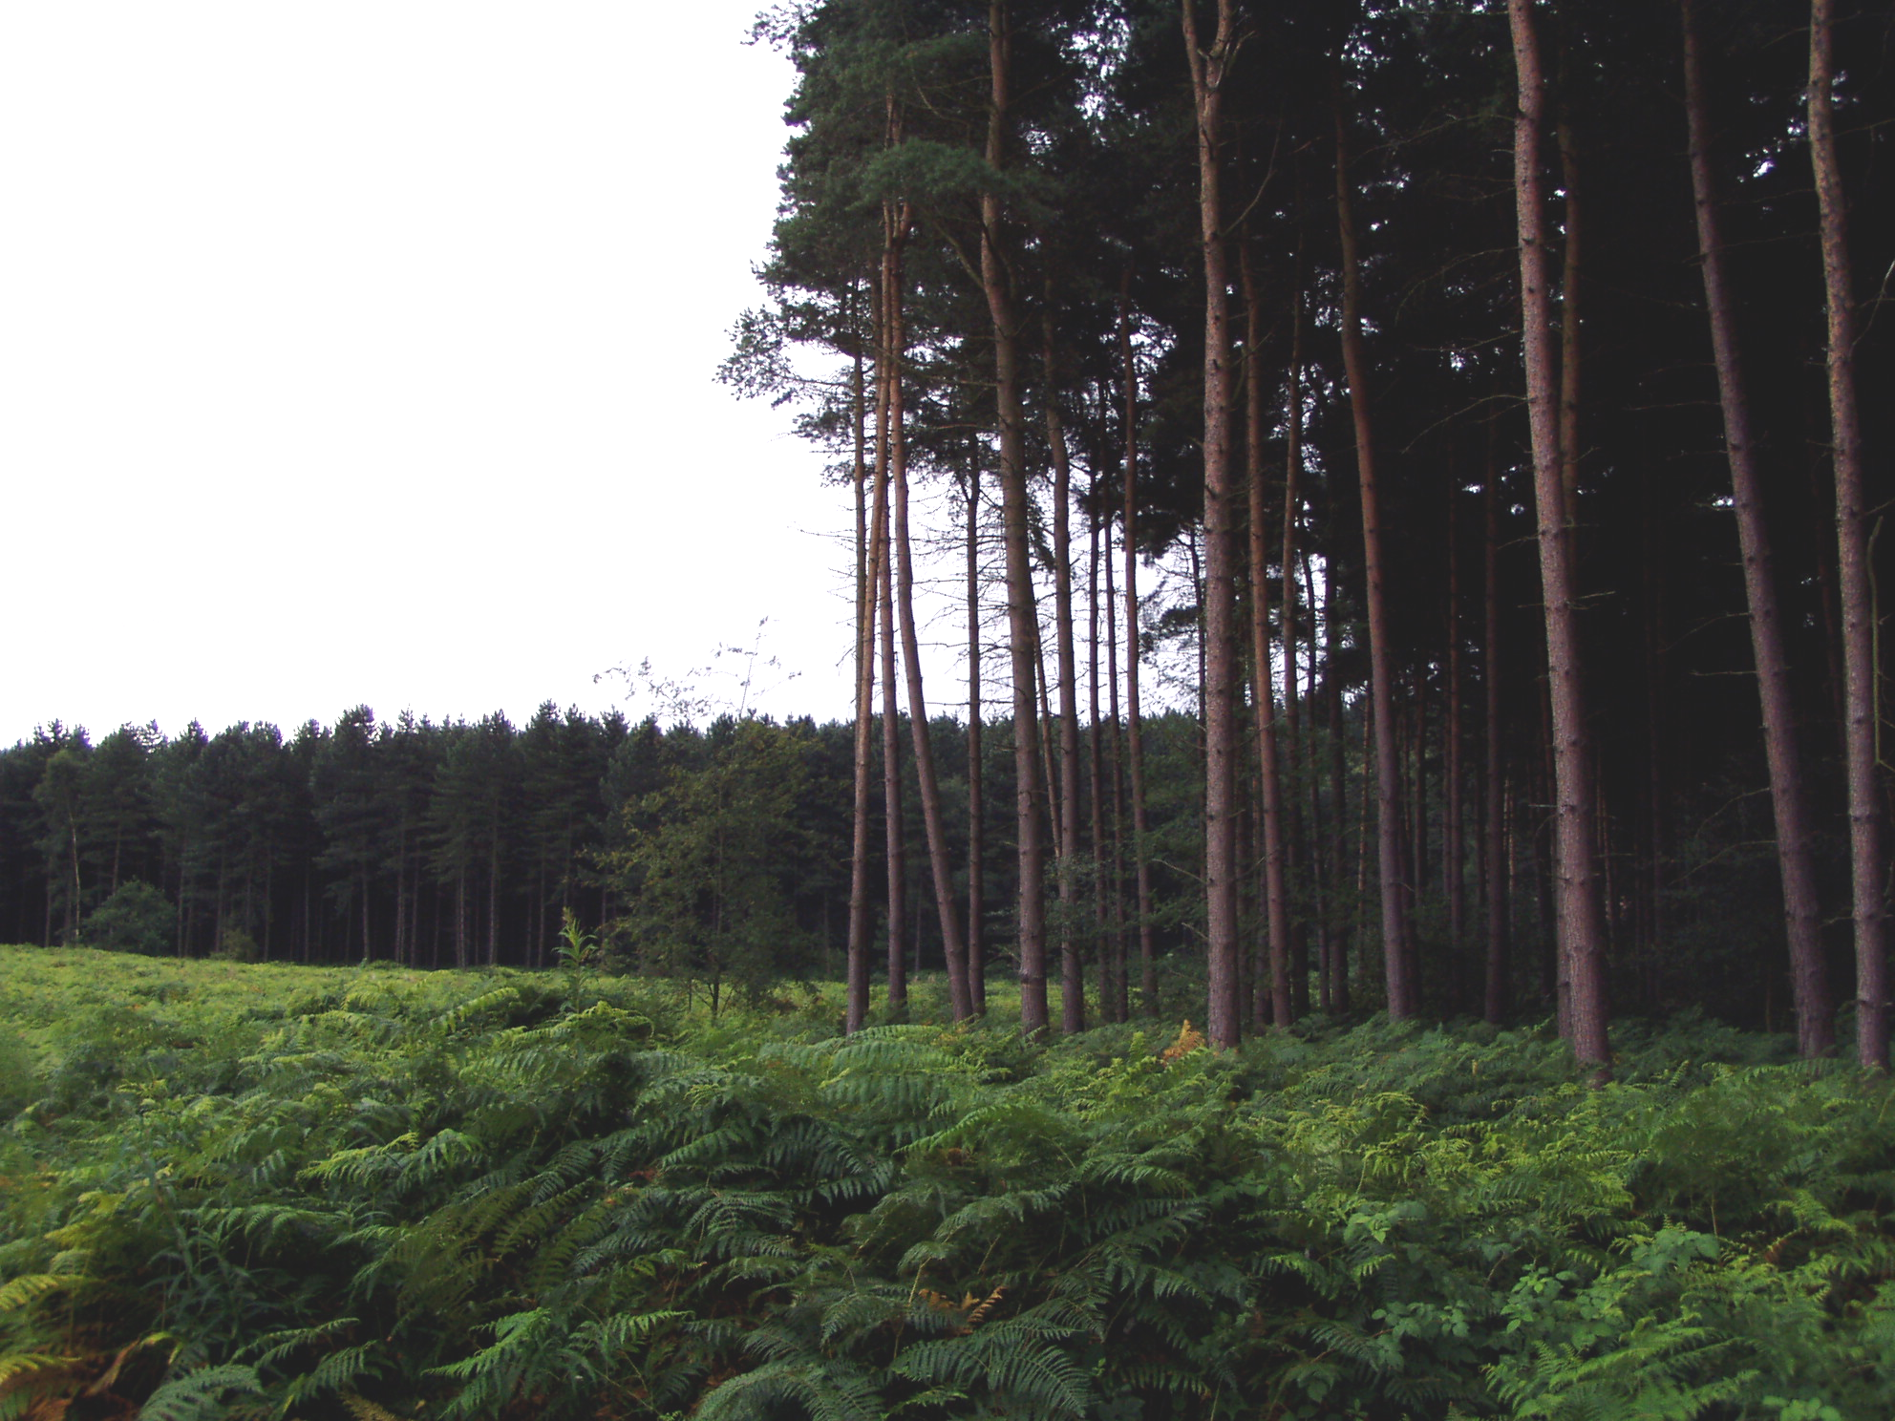 | NCC Landscape Type: Wooded Farmlands  Landscape Policy Zone (LPZ): S LPZ 11  Landscape Character Parcel: S74,S75,S77,S78,S79,S80
 | Condition
 | Good | REINFORCE |  | CONSERVE & REINFORCE | CONSERVE
 | Moderate | CREATE & REINFORCE |  | CONSERVE & CREATE | CONSERVE & RESTORE
 | Poor | CREATE |  | RESORE & CREATE | RESTORE
 |  | Low |  | Moderate  Sensitivity | High
CHARACTERISTIC VISUAL FEATURES

- Gently undulating topography
- Coniferous forestry plantations with deciduous margins to road edges
- Deciduous woodlands with Oak, Sweet Chestnut dominant
- Intensive arable farming in large geometric fields
- Mixed species hedgerows with mature trees to farm tracks
- MARR route crosses the north of the area
- Built edge of Mansfield and Kirkby in Ashfield to the north and west
- Isolated farms and limited settlement.
- Heath land character, particularly to road verges ,heath land species present on woodland rides.

LANDSCAPE ANALYSIS | SUMMARY OF ANALYSIS
Landscape Condition | Condition |  | Moderate
The Landscape Condition is defined as Moderate  The area has a coherent pattern of elements mainly large geometric arable fields and blocks of plantation woodland, there are some detracting features these include telecommunications masts on high points, busy roads including the A60 and MARR route and the built edge of nearby urban areas. Overall this gives a visually coherent area. There are a number of SINCs and heathland sites in the area. Overall this is a moderate habitat for wildlife, although connectivity is reduced by poor hedgerows and busy roads. Cultural integrity is variable in that the land use pattern is still recognisable to the west from Sanderson’s plan of 1835 but many hedgerows have been removed. Many of the woodlands existed at the time of Sanderson’s Plan but they have been more infilled with conifer planting in recent times so that only their boundary shape remains.  A visually coherent area with a coherent functional integrity gives a moderate landscape condition | Pattern of Elements: |  | Coherent
 | Detracting Features: |  | Some
 | Visual Unity: |  | Coherent
 | Ecological Integrity: |  | Moderate
 | Cultural Integrity: |  | Variable
 | Functional Integrity: |  | Coherent
Landscape Sensitivity | Sensitivity |  | Moderate
The Landscape Sensitivity is defined as Moderate  The components of the landscape are characteristic of the Sherwood LCA. The time depth is historic (post 1600) giving a moderate sense of place overall. There is evidence of the pre-enclosure heathland character in the presence of heathland species to road edges and woodland rides.  The undulating landform is apparent with intermittent areas of woodland giving a moderate visibility of features in and out of the LPZ. There are dominant views of the urban edges of Mansfield and Kirby in Ashfield.  A moderate sense of place and a moderate visibility leads to a moderate landscape sensitivity overall. | Distinctiveness: |  | Characteristic
 | Continuity: |  | Historic
 | Sense of Place: |  | Moderate
 | Landform: |  | Apparent
 | Extent of Tree Cover |  | Intermittent
 | Visibility: |  | Moderate
ACTIONS – Conserve and Create
Landscape Features
- Conserve the ecological diversity of small deciduous woodlands throughout the area
- Conserve farm track hedgerows with mature trees including Holly
- Create and reinforce field boundary and road hedgerows where these have become degraded or lost
- Create opportunities for restoring areas of heath land where appropriate
- Create small deciduous woodlands where appropriate

Built Features
- Conserve the sparsely settled character of the landscape by concentrating new developments around the existing urban fringe of Mansfield and Kirkby in Ashfield to the north and west.
- Create small scale woodland/tree planting to soften new development, preferably in advance of development
- Conserve the existing field pattern by locating new small scale development within the existing field boundaries
- Promote measures for reinforcing the traditional character of farm buildings using vernacular building styles.
- Promote sensitive design and sitting of new agricultural buildings

