Sherwood Landscape Policy Zone 8 - Vicar Water and Rainworth Heath Wooded Estatelands
PHOTOGRAPH  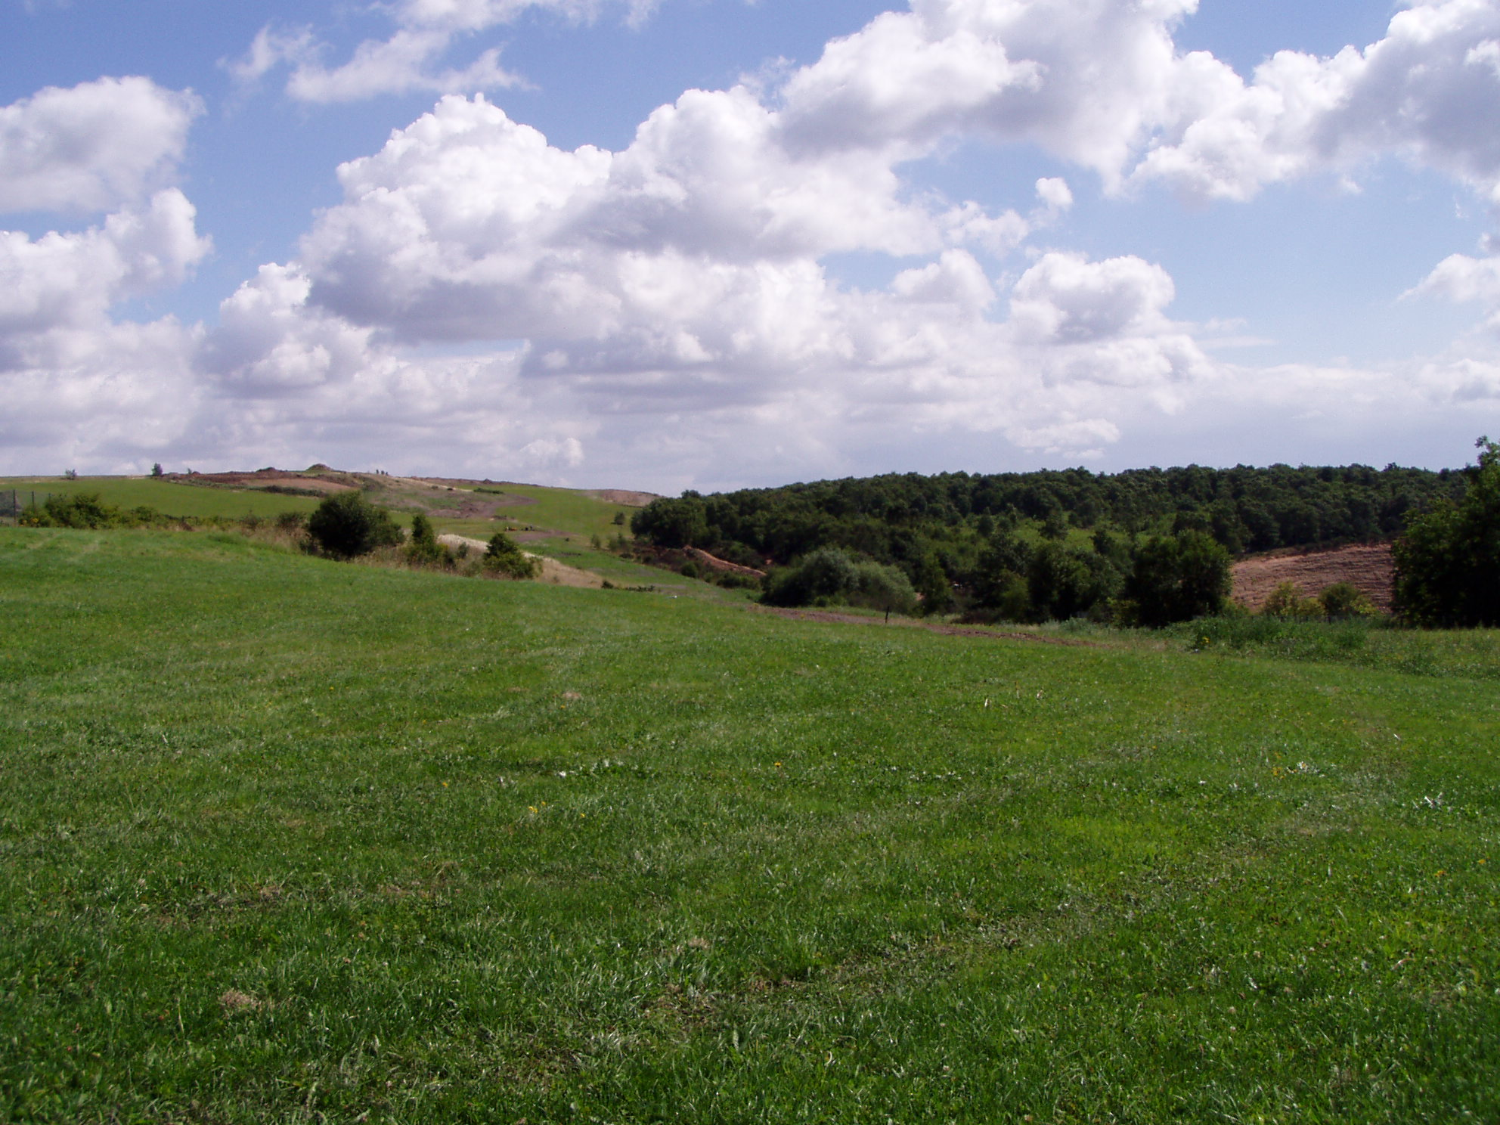 | CONTEXT  NCC Landscape Type: Wooded Estatelands  Landscape Policy Zone: S LPZ 8  Land Cover Parcels: S20 and S21  Condition
 | Good | REINFORCE |  | CONSERVE & REINFORCE | CONSERVE
 | Moderate | CREATE & REINFORCE |  | CONSERVE & CREATE | CONSERVE & RESTORE
 | Poor | CREATE |  | RESTORE & CREATE | RESTORE
CHARACTERISTIC VISUAL FEATURES  - Landscape altered by mineral extraction and quarrying activity  - Large scale commercial and industrial/business parks on the urban fringes of Mansfield, Mansfield Woodhouse & Rainworth  - Busy roads – Mansfield and Ashfield Regeneration Route (A617)  - Large scale pine plantations and smaller deciduous blocks of woodland  - Heathland areas with bracken, gorse and heather  - Fishing lake at Vicar Pond |  | Low |  | Moderate | High
Sensitivity

N.B. Where one criterion is ‘very poor’ this pushes the policy description into the next lowest category.
LANDSCAPE ANALYSIS | SUMMARY OF ANALYSIS
Landscape Condition | Condition |  | Very Poor
The Landscape condition is defined as very poor. The area has an incoherent pattern of elements with many detracting features such as mineral extraction sites and industrial estates. Visual unity is significantly interrupted.  Rainworth Heath is a SSSI and there are many SINCs and Heathland Register sites. Ecological integrity is strong, there are good wildlife corridors within the site and linking to adjacent areas. Areas of unrestored colliery workings and recently restored areas are considered to have moderate ecological value.  Cultural integrity is poor. The historic pattern of unenclosed heathland landscape has largely been destroyed by mineral activity.  A significantly interrupted area with a coherent functional integrity/ habitat for wildlife gives a very poor landscape condition. | Pattern of Elements: |  | Incoherent
 | Detracting Features: |  | Many
 | Visual Unity: |  | Significantly interrupted
 | Ecological Integrity: |  | Moderate/Strong
 | Cultural Integrity: |  | Poor
 | Functional Integrity: |  | Coherent
Landscape Sensitivity | Sensitivity |  | Moderate
Sandersons Plan of 1835 shows the Landscape Policy Zone largely as unenclosed heathland. This has largely been disturbed, but heathland has successfully established on some restored mineral sites.  Overall the features are characteristic of Sherwood with an historic time depth (post 1600) and the area has a moderate sense of place.  An open panoramic view is possible from the top Vicar Pond Country Park. Views within the site are enclosed by landform and woodland. The apparent landform and intermittent tree cover give a moderate visibility within the site.  A moderate sense of place with a moderate visibility gives a moderate landscape sensitivity. | Distinctiveness: |  | Characteristic
 | Continuity: |  | Historic
 | Sense of Place: |  | Moderate
 | Landform: |  | Apparent
 | Extent of Tree Cover |  | Intermittent
 | Visibility: |  | Moderate
LANDSCAPE ACTIONS – Create
Landscape Features

- Create heathland habitats with Oak/Birch woodland and open acid grassland/heathland
- Create natural rolling landforms in keeping with the Sherwood region when restoring mineral and quarry sites - avoid unnatural, engineered landforms
- Create woodland to help restore unity to the landscape – medium to large-scale planting would be appropriate in this area
- Conserve existing heathland habitats

Built Features

- Concentrate new development around the existing settlements of Mansfield, Mansfield Woodhouse, Clipstone and Rainworth to conserve the remote rural character of the landscape
- Promote sensitive siting of new industrial and commercial buildings
- New development should respect the local character in scale and design
- Promote measures for reinforcing the traditional character of isolated farm buildings using vernacular designs
- Create woodland to contain and soften urban development, preferably in advance of new development

