Sherwood Landscape Policy Zone 12 - Cavendish Wooded Estatelands and Wooded Farmlands
PHOTOGRAPH | CONTEXT
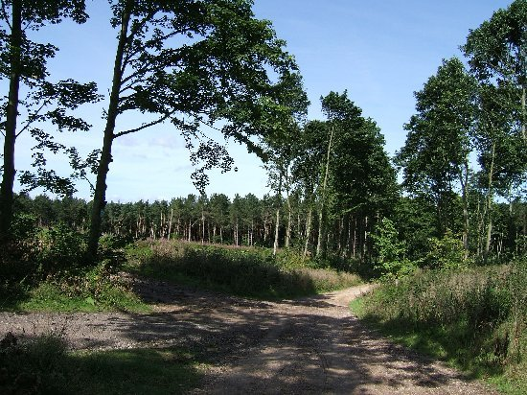 | NCC Landscape Type: Wooded Estatelands and Wooded Farmlands  Landscape Policy Zone: S LPZ 12  Landscape Character Parcel: SH22 and SH66
 | Condition
 | Good | REINFORCE |  | CONSERVE & REINFORCE | CONSERVE
 | Moderate | CREATE & REINFORCE |  | CONSERVE & CREATE | CONSERVE & RESTORE
 | Poor | CREATE |  | RESTORE & CREATE | RESTORE
 |  | Low |  | Moderate  Sensitivity | High
CHARACTERISTIC VISUAL FEATURES

- Gently undulating topography
- Coniferous plantations with broadleaf margins
- Irregular medium sized arable fields
- Scattered tree cover and heathy vegetation along railway embankment to the eastern edge of Vicar Water
- Isolated farms and traditional village core of Kings Clipstone
- New housing development in Intake Wood
- Small fields of unimproved pasture against Vicar Water
- Views often contained by urban edges or coniferous plantations

LANDSCAPE ANALYSIS | SUMMARY OF ANALYSIS
Landscape Condition | Condition |  | Poor
The Landscape Condition is defined as poor. The Landscape Policy Zone contains an incoherent pattern of features with some detracting features such as industrial sheds and sub stations around Baulker Farm, pylons and power lines, and the spoil heaps of Clipstone Colliery to the south. Overall the landscape is visually interrupted.  Tree cover within this area is largely pine and concentrated within woodland blocks. Field boundaries vary throughout the Landscape Policy Zone with many gappy and in decline hedges, particularly to the south western edge against Mansfield Woodhouse. The traditional red brick core of Kings Clipstone is intact with some limited recent infill and peripheral development adjacent to it. Cavendish Lodge is a Grade II listed building and the field pattern is largely intact within this area. New housing development has taken place within the area of Cavendish Park to the north of New Mill Lane. The overall cultural integrity is variable.  The SINC sites tend to be concentrated along the southern bank of the River Maun with small sections of woodland, but also include Spa Ponds east of Warren Farm and grassland SINCs. Fragmented hedges and some intensive arable hedges particularly to the west, give an overall moderate ecological integrity.  The functional integrity is coherent with some productive arable land.  A visually interrupted area with a coherent functional integrity gives a poor landscape condition. | Pattern of Elements: |  | Incoherent
 | Detracting Features: |  | Some
 | Visual Unity: |  | Interrupted
 | Ecological Integrity: |  | Moderate
 | Cultural Integrity: |  | Variable
 | Functional Integrity: |  | Coherent
Landscape Sensitivity | Sensitivity |  | Moderate
The Landscape Sensitivity is defined as moderate.  The components of this area characteristic of the Sherwood region and the continuity / time depth is historic (post 1600) which gives a moderate sense of place.  The larger scale blocks of woodland plantation around Cavendish Woods and Newlands and the larger size fields reflect the historic tree coverage and relative lack of enclosure shown on the Sanderson Plan of 1835. The hedges around Cavendish Lodge also reflect the historic pattern shown in the plan.  The undulating landform is apparent with some intermittent views out of the area to the west of Mansfield Woodhouse and to the north west from Clipstone Drive to wooded skylines.  A moderate sense of place combined with a moderate visibility gives a moderate landscape sensitivity overall. | Distinctiveness: |  | Characteristic
 | Continuity: |  | Historic
 | Sense of Place: |  | Moderate
 | Landform: |  | Apparent
 | Extent of Tree Cover |  | Intermittent
 | Visibility: |  | Moderate
ACTIONS - Restore and Create
Landscape Features

- Restore the historic field pattern particularly primary hedgerows and those close to urban settlement of Mansfield Woodhouse.
- Restore the heathy character to woodland margins, tracks and roadside edges.
- Create heathland habitat within new areas of public open space where appropriate.
- Create new areas of oak woodland linking up with existing areas of woodland.

Built Features

- Restore the vernacular character and architectural style of Kings Clipstone.
- Create new areas of oak and birch woodland to help integrate new and existing urban development.
- Promote measures for reinforcing the traditional character of farm buildings using vernacular building styles.
- Promote sensitive design and siting of new agricultural buildings.
- Conserve the integrity and rural character of the landscape by concentrating new development around the existing urban edge of Mansfield Woodhouse.

